Supplementary data
Structural and Electronic Properties of Iodine-Intercalated Carbon Nanotube Fibers and Their Conductivity Mechanism
Satoshi Yamazaki ^{a,}*, Takahiro Morimoto ^{b}, Yoko Iizumi ^{b}, Takumi Inaba ^{c}, Kazufumi Kobashi ^{b}, and Toshiya Okazaki ^{b,}*
ª Research Association of High-Throughput Design and Development for Advanced Functional Materials, Tsukuba, Ibaraki, 305-8565, Japan
^{b} Nanocarbon Materials Research Institute, National Institute of Advanced Industrial Science and Technology (AIST), Tsukuba Central 5, 1-1-1 Higashi, Tsukuba, Ibaraki 305-8565, Japan
^{c} Semiconductor Frontier Research Center, National Institute of Advanced Industrial Science and Technology (AIST),

AUTHOR INFORMATION
Corresponding Authors. satoshi.mayama.yamazaki@furukawaelectric.com (Satoshi Yamazaki), toshi.okazaki@aist.go.jp (Toshiya Okazaki)

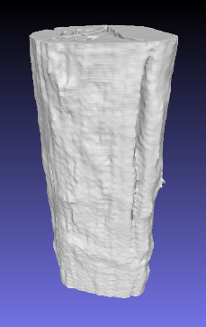

Fig. S1. 3D-X-ray CT image of as-received DexMat fiber.

(a)
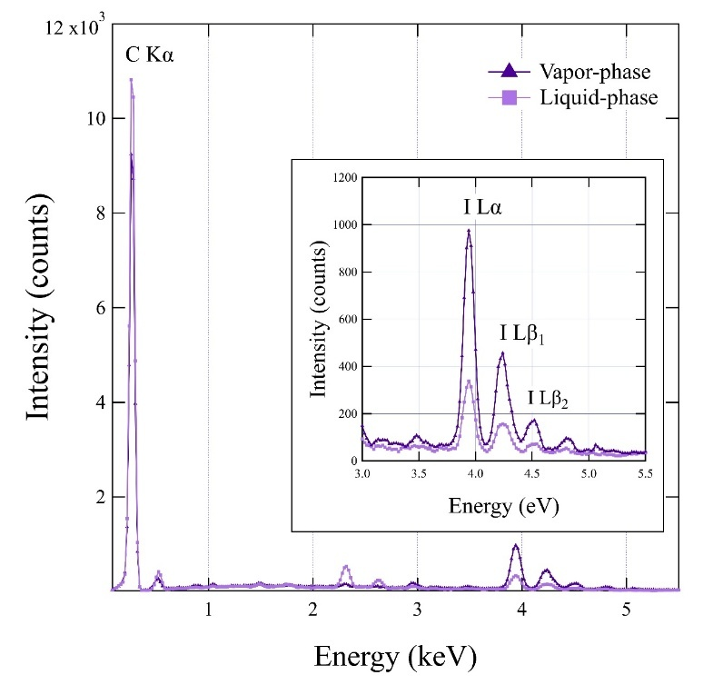
(b)
intercalation method | Atomic %
 | C | O | S | Cl | Fe | I
Vapor phase | 93.44 | 3.36 | 0.14 | 0.04 | - | 3.00
Liquid phase | 92.21 | 5.96 | 0.79 | 0.32 | - | 0.72

Fig. S2. (a) Typical EDS spectra of I-doped CNT fibers by liquid and gas phase intercalation. (b) Elemental analysis shows that the stoichiometry of the liquid and gas phase intercalated fibers is C₁₂₈I and C₃₁I, respectively.

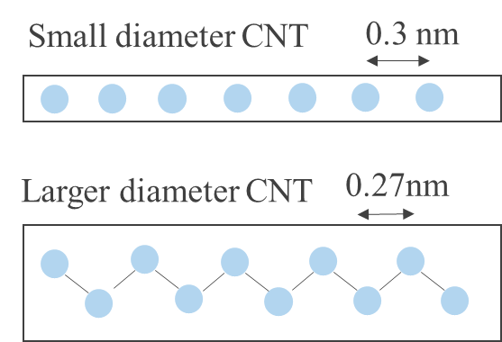

Fig. S3. Schematic illustration of the iodine chain structures in small and large diameter tubes.

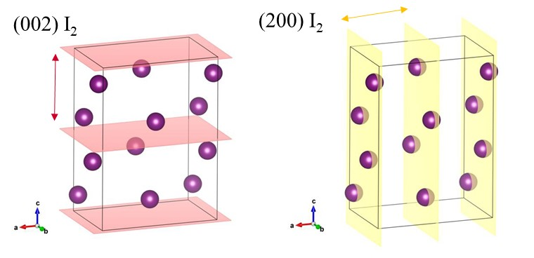

Fig. S4. Schematic illustration of the molecular iodine crystal structure, indicating the (002) and (200) planes.

Fig. S5. Linear-combination fitting of the XAFS spectra for CNT fibers, using molecular iodine dimers and ionic iodine trimers as reference species. The fitting results indicate apparent spectral contributions of 82:18 (dimer:trimer) for the liquid-phase–intercalated sample and 95:5 for the vagpor-phase–intercalated sample.

