- Natural Numbers – N(double line N) – 0 to n


- Integer – Z (double line Z)- Includes negative ( -n to n )
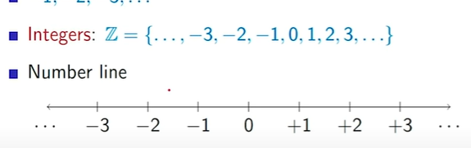
- Multiplication
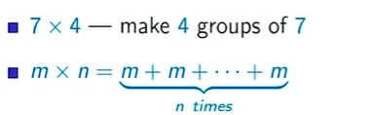

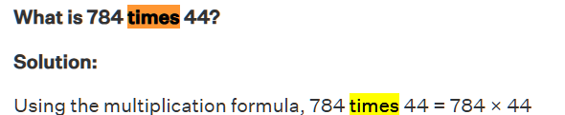

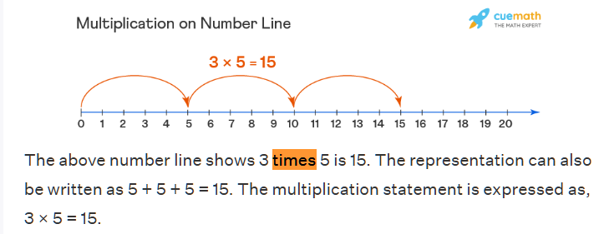

3 times 5 => 5 + 5+ 5 => 3 * 5

ii)m to the power of k
m times m times m , k times
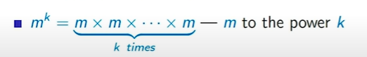

- Division : repeated subtraction
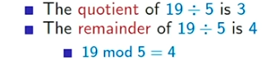
Quotient and remainder.
- Factor : if a number(a) divides another number(b) without remainder is called factor.
If b mod a = 0 , then a is one of factor of b.
i.e a divides b means => b / a. (it may represent in another way using vertical line a|b i.e a divides b) .
b divided by a => b/a.
a divides b => a|b (vertical line, not slash)
4 divides 20.
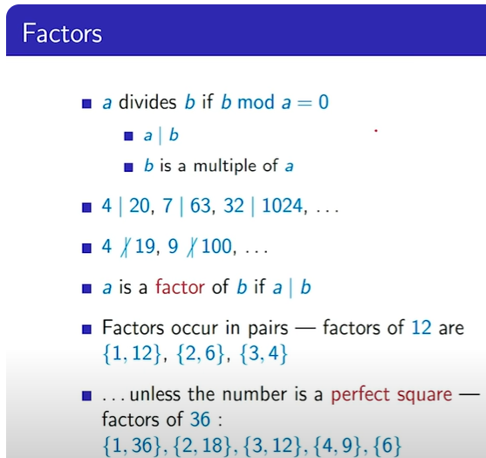

Prime Numbers :
p is prime number if only have 2 factor, that is {1, p}.
i.e if the factor is 1 and it-self.

Rational number: Any number in the form of p/q where p and q are integers and q is not equal to 0 is a rational number. Just represented as, p/q i.e numerator/denominator; Double line Q.
In addition to all the fractions, the set of rational numbers includes all the integers, each of which can be written as a quotient with the integer as the numerator and 1 as the denominator.
Fractions => p/q form rational number, where p mod q is not 0.
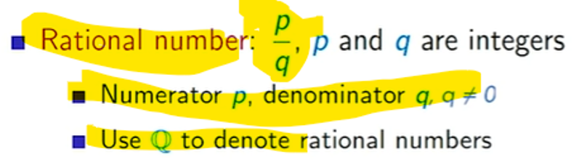
And, Integers are special rational number , i.e in reduced form 7/1 is rational number, so all integers also includes as rational number.



Rational numbers, the word Rational comes from the “Ratio”.

Real number :
R (Double line R) – All rational and irrational numbers are real numbers.

Irrational : A number can not be written in form of p/q , i.e (root of 2) can not specify in p/q form.
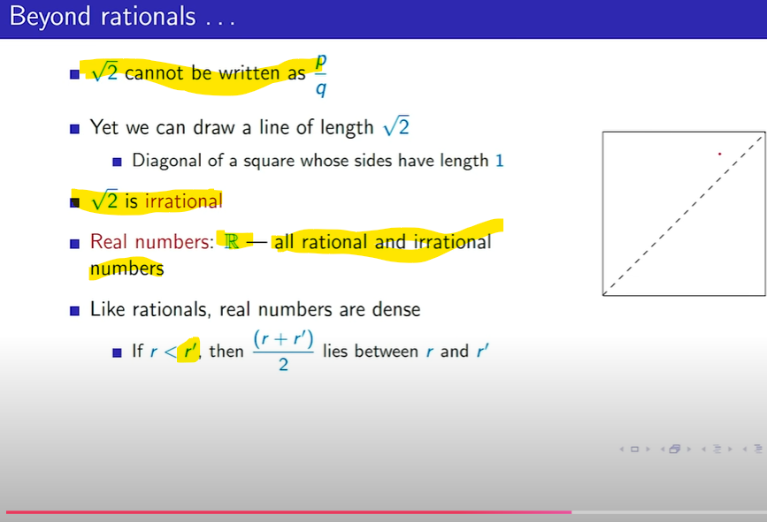

r’ (r prime means , reverse of r) -- meaning change on each area of maths or science.
In probability P(A’) = 1 – P(A)
In matrix : a’ = Transpose of a.
In vector , v’ denotes -v.
Finally,
Real and complex number :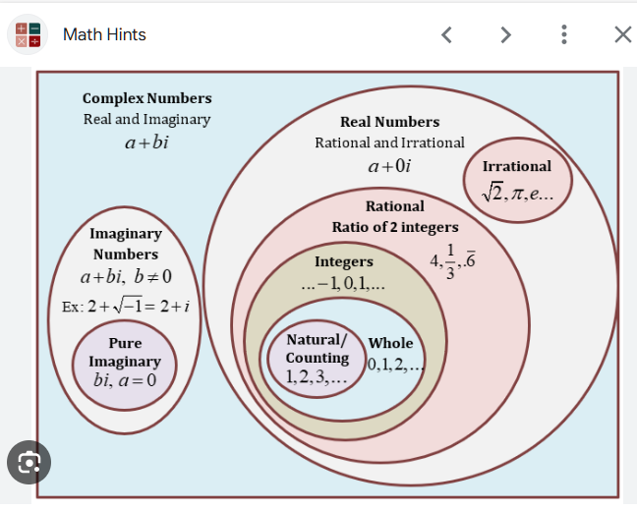

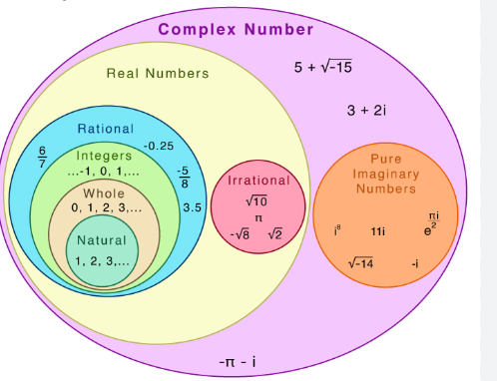

Zzzzzzzzzzzzzzzzzzzzzzzzzzzzzzzzzzzzzzzzzzzzzzzzzzzzzzzzzzzzzzzzzzzzzzzzzzzzzzzzzzzzzzzzzz

A negative exponent takes us to the inverse of the number. In other words, a^{-n} = 1/a^{n} and 5⁻³ becomes 1/5³ = 1/125.
- Radicals – square-roots (or other roots) are called radicals.
- Exponentials - b^{n} (b to the power of n) - b is base , n is exponent
- Pi – 3.141
- e – 2.718
- x to the power of -n is 1/(x to the power of n).

A complex number is an expression of the form a + bi, where a and b are real numbers, and i is an abstract symbol, the so-called imaginary unit. For example, 2 + 3i is a complex number, here 3 is coefficient.]]
[[complex numbers : a + bi
a is real and b is imaginary part
(a and b are real numbers)
i is imaginary unit , and i = -1

In mathematics, a polynomial is a mathematical expression consisting of indeterminates (also called variables) and coefficients.
For example, the polynomial 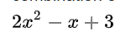 has coefficients 2, −1, and 3.

Linear equation :
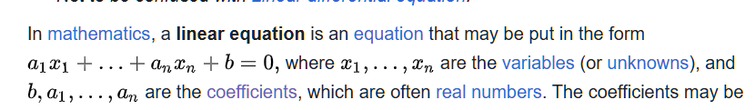
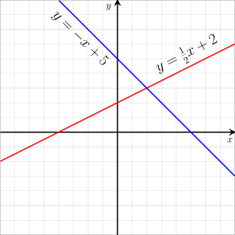
See here, x1 to xn are variables (or unknown).
b and a1, a2 to an are coefficients, often real-numbers.
So, y =-x + 5 (-x is variable, 5 is b i.e. coefficient real number)
When substitute x as 0 , get y = 5 , so (0,5) in graph, and when substitute y = 0 , then x =5
So (5, 0) in graph, draw a linear line which intersect (0,5) and (5,0).

Linear algebra is the branch of mathematics concerning linear equations such as: 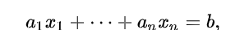

- The graph of a degree 1 polynomial (or linear function) :
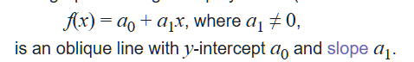
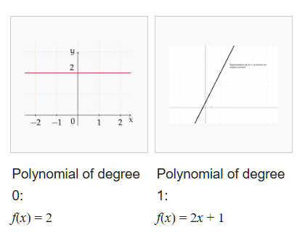
Euclidean space :
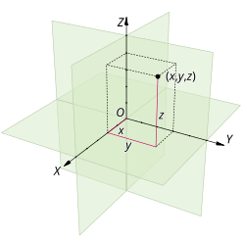
In geometry, a polygon (/ˈpɒlɪɡɒn/) is a plane figure made up of line segments connected to form a closed polygonal chain.
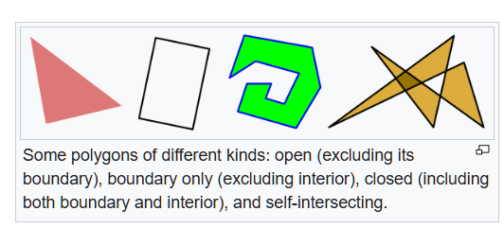
11111111111111111111111111111111111111111111111111111111111111111111111111111111
Set Theory :
- Collection of items.
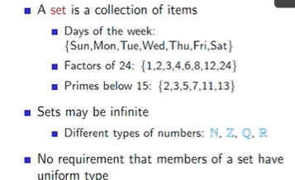

(remember in python set has no duplicates and ordered by nature)
- Cardinality - describes a relationship between sets which compares their relative size. For example, the sets and are the same size as they each contain 3 elements.
A = {2,3,1} ; |A| =3
Elements or not an element in set are represented using symbol E(belongs to).
 5 is an element of integer set, square-root of 2 is not an element of rational numbers.
Subset – if every element of set X is also the element of set Y.
Written using subset notation :
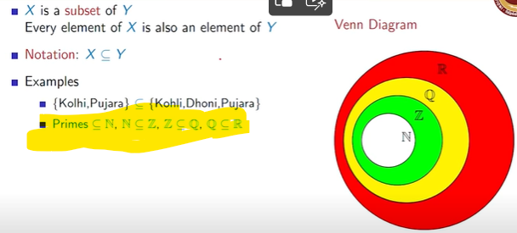
Proper subset may define without underline in “subset of” symbol.

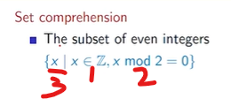

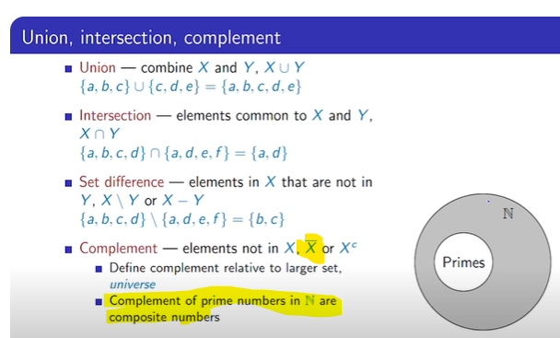

X bar is denoted as complement – means element not in X denotes as .
Composites numbers are non-prime numbers in Natural numbers.

* greatest common divisor (GCD) or HCF -Highest common factor
*LCM – Least common multiple or LCD-least common devisor.

000000000000000000000000000000000000000000000000000000000000
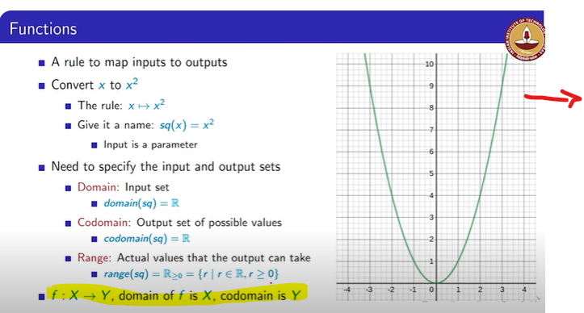
Inverted parabola diagram.
f:x->y x is input set and y is output set.

Please read notes.

111111111111111111111111111111111111111111111111111111111111111111111111111

Lecture 12 – Rectangular coordinate system.
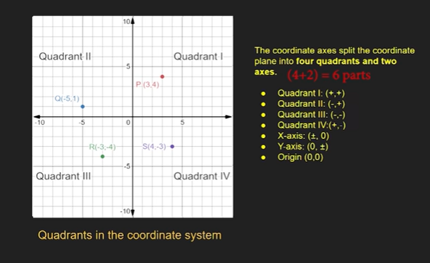
Lect-13:
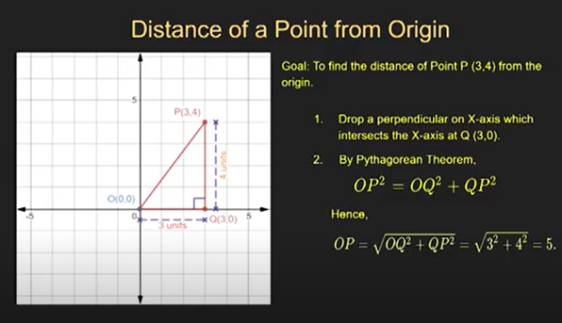
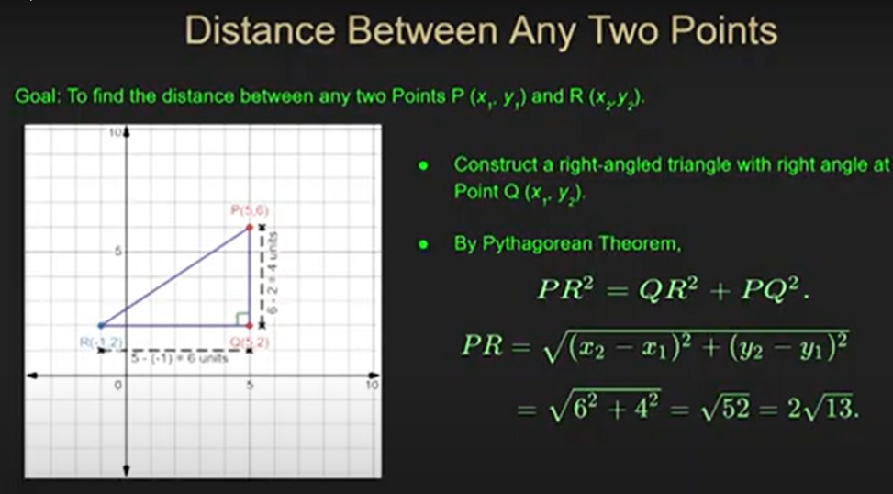

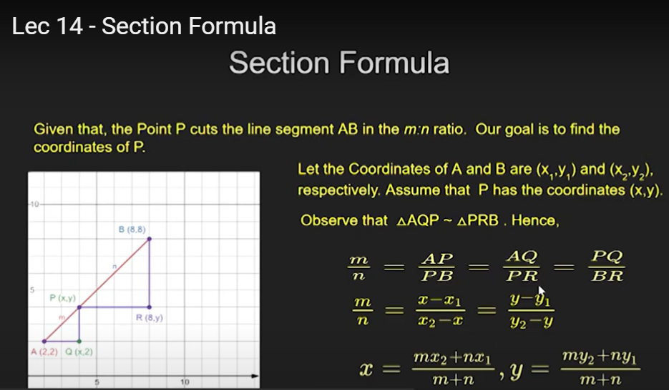

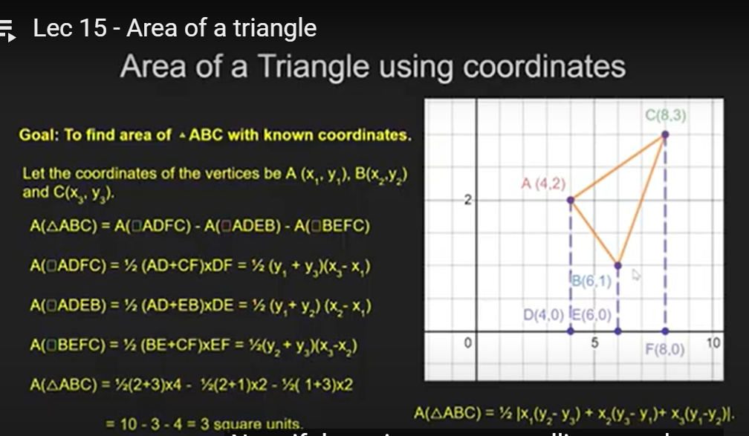
In mathematics, the slope or gradient of a line is a number that describes the direction of the line on a plane. Often denoted by the letter m, slope is calculated as the ratio of the vertical change to the horizontal change ("rise over run") between two distinct points on the line, giving the same number for any choice of points.
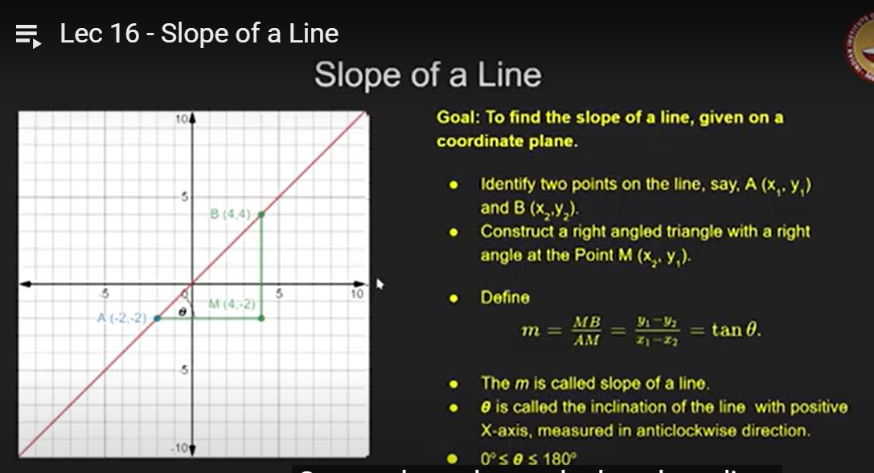

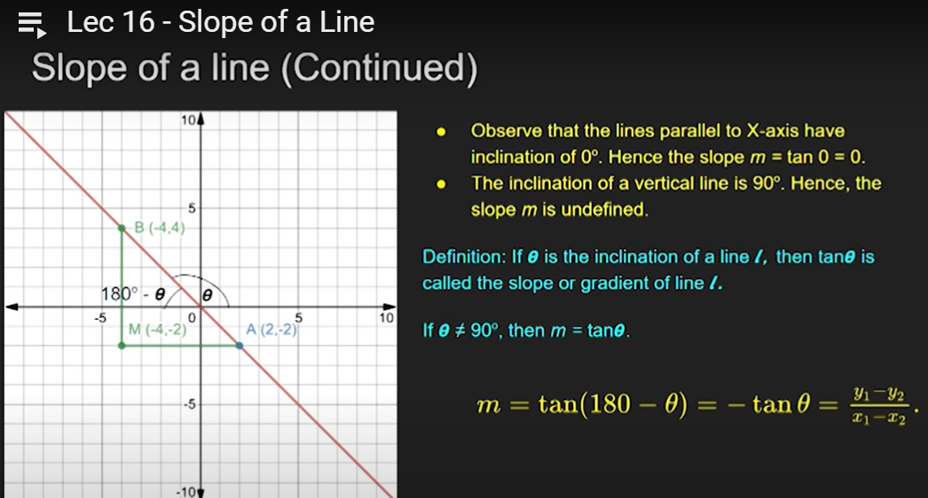
(quadrilateral , equilateral triangle , perpendicular(90 degree line) , right-angle triangle)
(collinear points, non-collinear points)
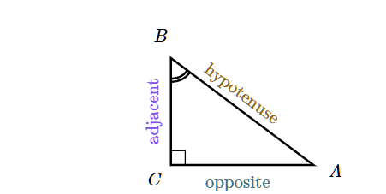

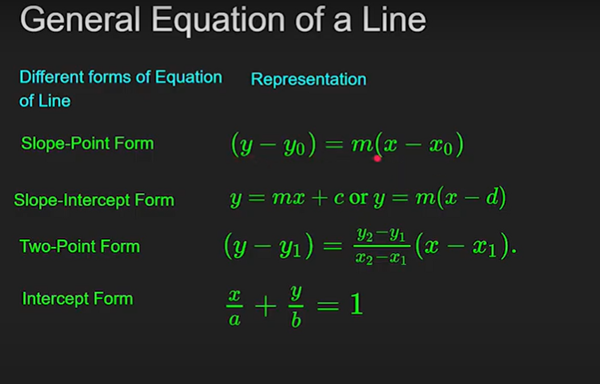

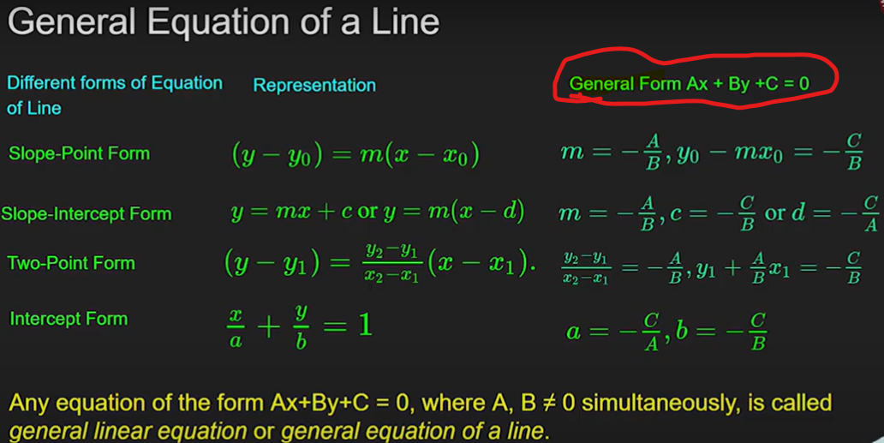

Right hand side equations, those are also capable to handle vertical line.
In summary, Polynomial in 2 variables or general linear equation in 2 variables gives you a line.

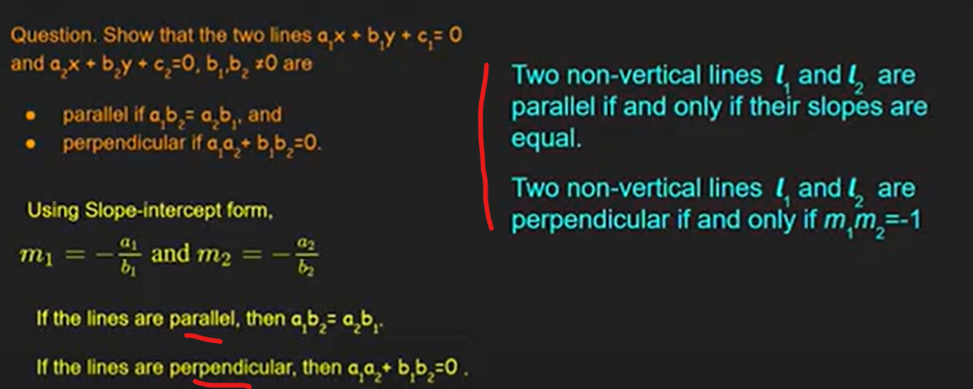

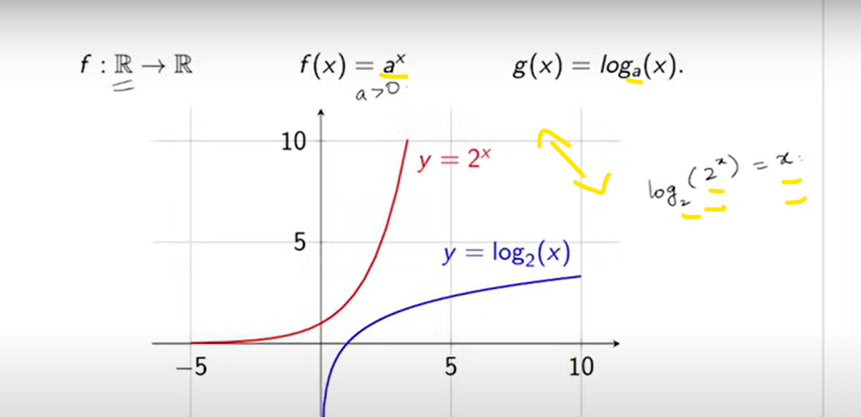

-----Logarithm is another way of expressing exponents---------
2⁵ = 32 => log2 32 = 5
And,
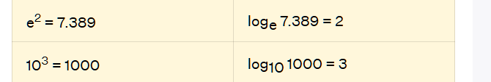
- log_{e} is called the natural log
- log₁₀ is called the common log
- log_{e} = ln
- e^{x} = 2 => log_{e} 2 = x (or) ln 2 = x.

- log₁₀ = log
- 10² = 100 => log₁₀ 100 = 2 (or) log 100 = 2

---
Mean : average
x̄ = (∑x_{i} f_{i})/(∑f_{i})
x – observations , f – frequency.

Median :
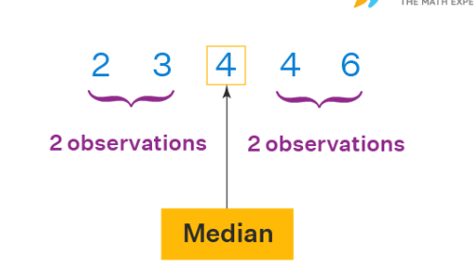

Mode : The value which appears most often in the given data.

Variance and Standard deviation:
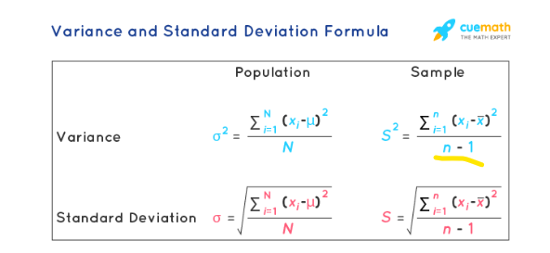
1. Variance of the data set is the average square distance between the mean value and each data value. According to layman’s words, the variance is a measure of how far a set of data are dispersed out from their mean or average value. σ2=1N∑Ni=1(Xi−μ)2 ;; s2=1n−1∑ni=1(xi−¯x)2
2. Standard deviation measures the spread of a data distribution. The more spread out a data distribution is, the greater its standard deviation. σ=√1N∑Ni=1(Xi−μ)2 ;; s=√1n−1∑ni=1(xi−¯x)2
For example, the blue distribution on bottom has a greater standard deviation (SD) than the green distribution on top:
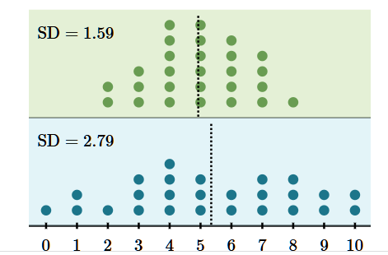
Can not be -ve, lowest is 0, means no difference b/w the data. Higher value means highly dispersed or spread among data.
Normal distribution (also known as the Gaussian distribution):
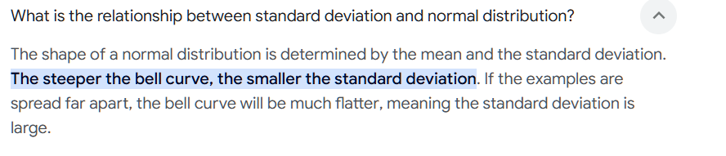
(peak – sigaram , steeper – irakkam,)
percentile is a relative quantity that shows us a comparison of the given value with the rest of the data. [(Number of values below 'x') ÷ (Total number of values)] × 100, ; If 80% mark student 4th place (rank) in 40 people population. (40-4/40)*100 = 90 percentile.
Mode means a value or a number that appears most frequently in a dataset.
Right or left skewed data :
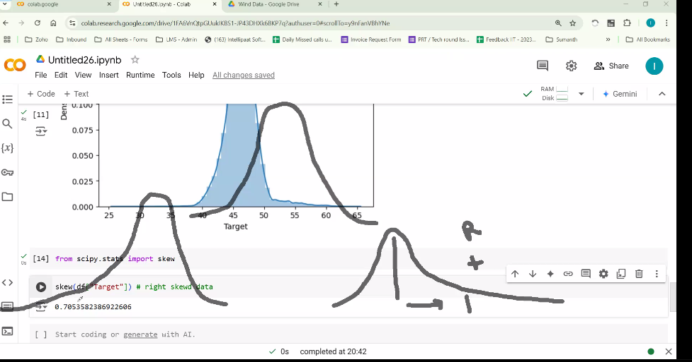
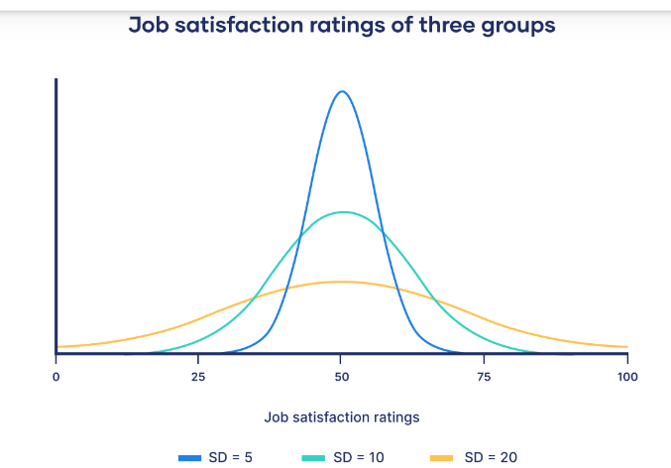
See, the lowest SD is highest peak.
Range : difference b/w maximum and minimum value in data set.

Statistics – Mathematical method to learn data to drive a conclusion.
Descriptive statistics – Collect ,organize and describing the data.
Inferential statistics – analyse and get a conclusion on data.

--
Trail and Event : Trail – performing; Event - is Outcome.
Trials are the experiments being performed, and events are the possible outcomes of those trials. Probability is the measure of how likely a specific event is to occur during a trial.
--

--
Bernoulli Distribution
- Definition: Models a single trial with only two possible outcomes: success (1) or failure (0).
Binomial Distribution
- Definition: Models the number of successes in n independent Bernoulli trials with the same success probability p. (if Binomial n=1 , then it is Bernoulli)
Bernoulli(p)=Binomial(n=1,p)
--

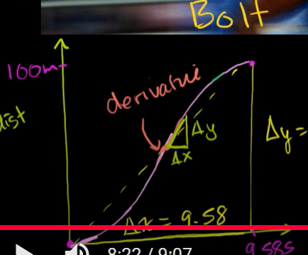
X = time, y = distance. Bolt 100 m in 9.58s
Tangent line / hypotense is the slope, ie. Average speed 100/9.58 = 10.4m/s
10.4 is the slope : ie: it tells you how much y changes on average for a one-unit change in x.
i.e 10.4 m distance (y) change per one (second) time (x) change.
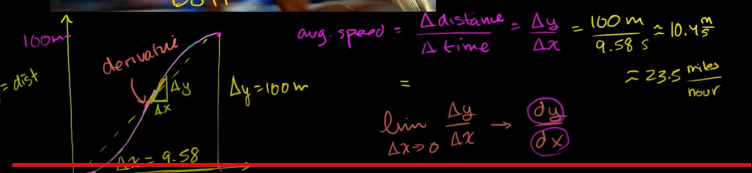

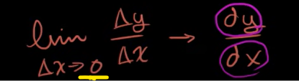
Because dx could not be zero, since anything divide by zero is undefined.
So, what is the speed of at instant time, not about the average , what is the exact speed of at particular instant time, this is derived using differential , i.e limit delta-X towards to zero , the change on y over change on y, also written as , dy/dx
i.e instantaneous slope is the derivative. (the tangent line(hypotenuse) of the small triangle.) Accurate slope find, while lesser and lesser delta-x and delta-y.

A derivative measures how a function changes when its input changes — the slope of a function at a point.
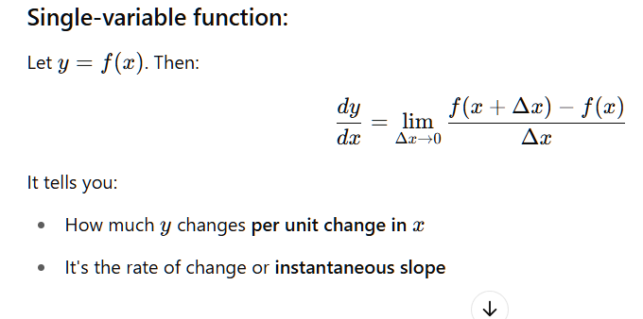

A partial derivative measures how a multivariable function changes with respect to one variable, keeping all others constant.
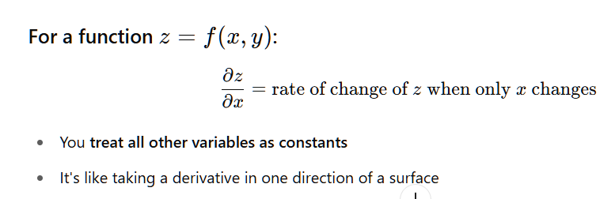
The chain rule is used when one variable depends on another, which in turn depends on a third — a composition of functions.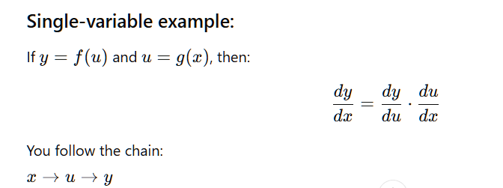
Ex:2 :
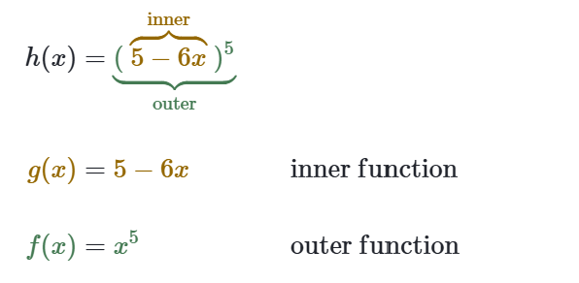
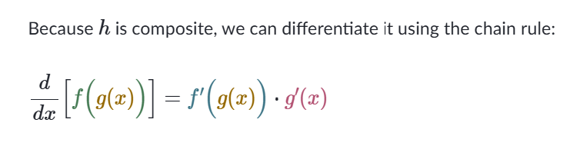
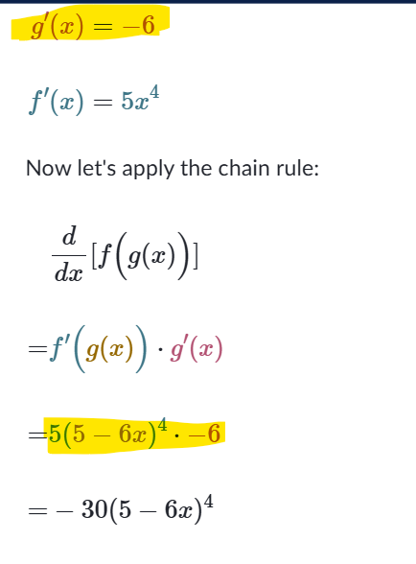
--
The derivative of a constant is always zero. This is because a constant function represents a horizontal line, and the slope of a horizontal line is zero, which is the rate of change (derivative).
The derivative of x with respect to x is 1. This is because the power rule of differentiation dictates that the derivative of x^n is nx^(n-1), and when n = 1, this becomes 1 * x^(1-1), which simplifies to 1 * x^0, and x^0 is 1. Simply as below:
dx^{n}/dx = nx^{n-1}
--
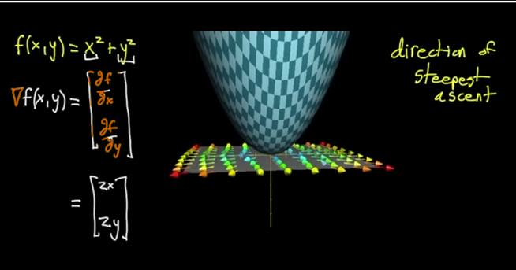
Derivation of function f(x,y), partial derivation with respect to x, partial derivation with respect to y.
--
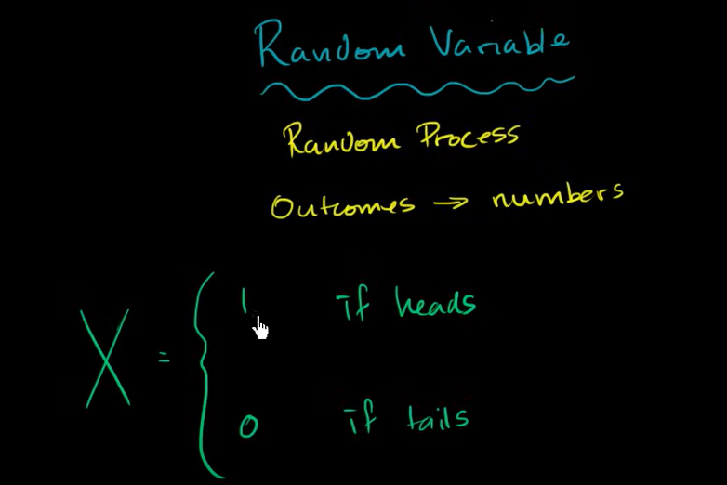

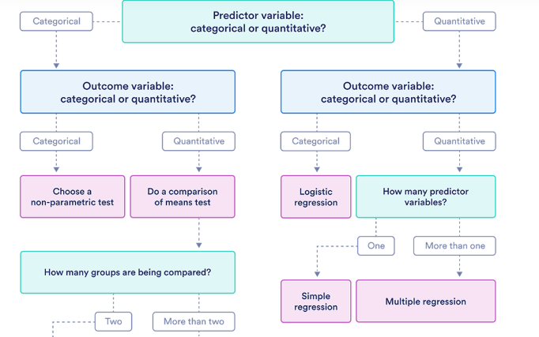
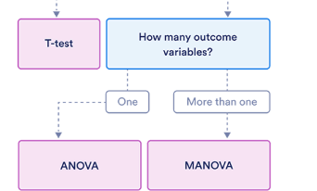

--
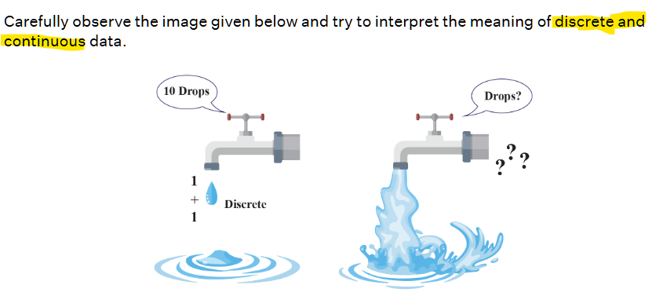
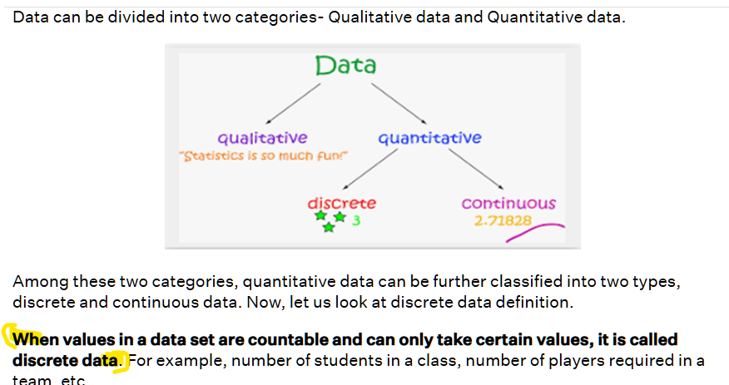
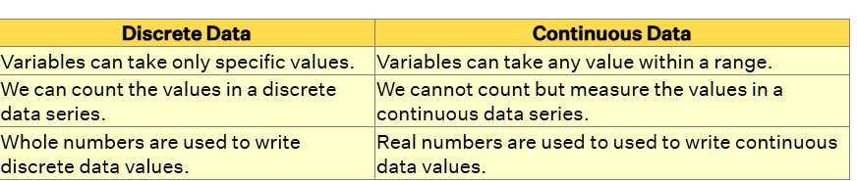


Nominal data is labelled into mutually exclusive categories within a variable. These categories cannot be ordered in a meaningful way. Ex: Gender (Male, Female, Other)
- Labelled data
- Cannot be ordered
- Mutually exclusive categories in population or sample .
Ordinal data is classified into categories within a variable that have a natural rank order. However, the distances between the categories are uneven or unknown.
Pain scale: Nopain (), mildpain () , severe pain () , Extreme pain( :’( )
- Can be categorised with in a variable.
- Can be ordered (different from nominal) , having scale.

- A pain rating scale from 0 (no pain) to 10 (worst possible pain) is interval. (have equal spacing or interval)
- A pain rating scale that goes from no pain, mild pain, moderate pain, severe pain, to the worst pain possible is ordinal . (labelled and ordered)

While nominal and ordinal variables are categorical, interval and ratio variables are quantitative. Many more statistical tests can be performed on quantitative than categorical data.
Types of Variables in Research & Statistics | Examples

Correlation: Understanding the Relationship Between Variables
Correlation measures the strength and direction of the relationship between two variables. It helps determine how one variable changes in response to another.
Types of Correlation
Type | Meaning
Positive Correlation | As one variable increases, the other also increases.
Negative Correlation | As one variable increases, the other decreases.
No Correlation | No relationship between the variables.
🔹 Example
- Height & Weight → Positive Correlation
- Study Time & Exam Score → Positive Correlation
- Temperature & Jacket Sales → Negative Correlation
- Shoe Size & Intelligence → No Correlation

The correlation coefficient (𝑟) measures the strength and direction of the linear relationship between two variables. It ranges from -1 to 1.
Pearson's Correlation Coefficient (r):
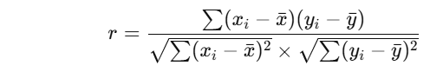

Correlation Coefficient (r) | Interpretation
r = 1 | Perfect Positive Correlation ✅
0.7 ≤ r < 1 | Strong Positive Correlation
0.3 ≤ r < 0.7 | Moderate Positive Correlation
0 < r < 0.3 | Weak Positive Correlation
r = 0 | No Correlation ❌
-0.3 < r < 0 | Weak Negative Correlation
-0.7 < r ≤ -0.3 | Moderate Negative Correlation
-1 < r ≤ -0.7 | Strong Negative Correlation
r = -1 | Perfect Negative Correlation ❌

-------X-------
A confusion matrix is a performance evaluation tool used in classification tasks. It is a table that compares the predicted labels of a model with the actual labels, helping to assess how well the model distinguishes between different classes.
Structure of a Confusion Matrix:
For a binary classification problem, the confusion matrix looks like this:
Actual \ Predicted | Positive (P) | Negative (N)
Positive (P) | True Positive (TP) | False Negative (FN)
Negative (N) | False Positive (FP) | True Negative (TN)
Explanation of Terms:
- True Positive (TP): Model correctly predicts positive class.
- False Negative (FN): Model incorrectly predicts negative when it is actually positive.
- False Positive (FP): Model incorrectly predicts positive when it is actually negative.
- True Negative (TN): Model correctly predicts negative class.
Key Performance Metrics Derived from Confusion Matrix
- Accuracy: Measures overall correctness.
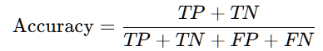​
- Precision (Positive Predictive Value): How many predicted positives are actually positive?
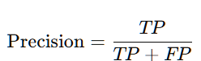
- Recall (Sensitivity, True Positive Rate): How many actual positives were correctly predicted?
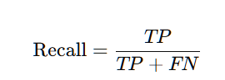
- F1-Score: Harmonic mean of Precision and Recall.
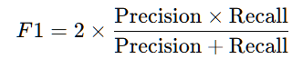
- Specificity (True Negative Rate): How many actual negatives were correctly predicted?
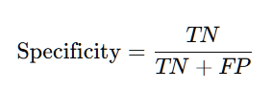
For multi-class classification, the confusion matrix extends to an NxN table, where N is the number of classes.
FPR (False Positive Rate) : 1 – specificity i.e. 1 – True Negative Rate
ROC – Receiver Operator Characteristic plot based on FPR(x-axis) and TPR(y-axis).
Confusion Matrix → TP, FP, TN, FN ↓
┌─────────────────────────────────────┐
│ Accuracy = (TP+TN)/(TP+FP+TN+FN) │
│ Precision = TP/(TP+FP) │
│ Recall = TP/(TP+FN) = TPR │
│ F1 = 2*(Prec*Rec)/(Prec+Rec) │
│ FPR = FP/(FP+TN) │
│ FNR = FN/(TP+FN) = 1-Recall │
│ TNR = TN/(TN+FP) = 1-FPR │
└─────────────────────────────────────┘
Finding optimum Threshold (to classify) based on ROC curve: here, either (FPR/x=0.4, TPR/y=1) or (x=0, y=0.75) to be chosen, each point is denoting TPR/FPR for specific threshold value to classify (in right side logistic regression):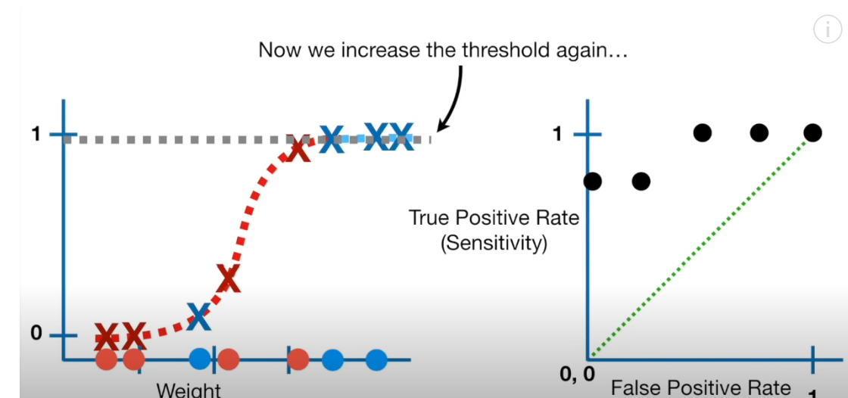
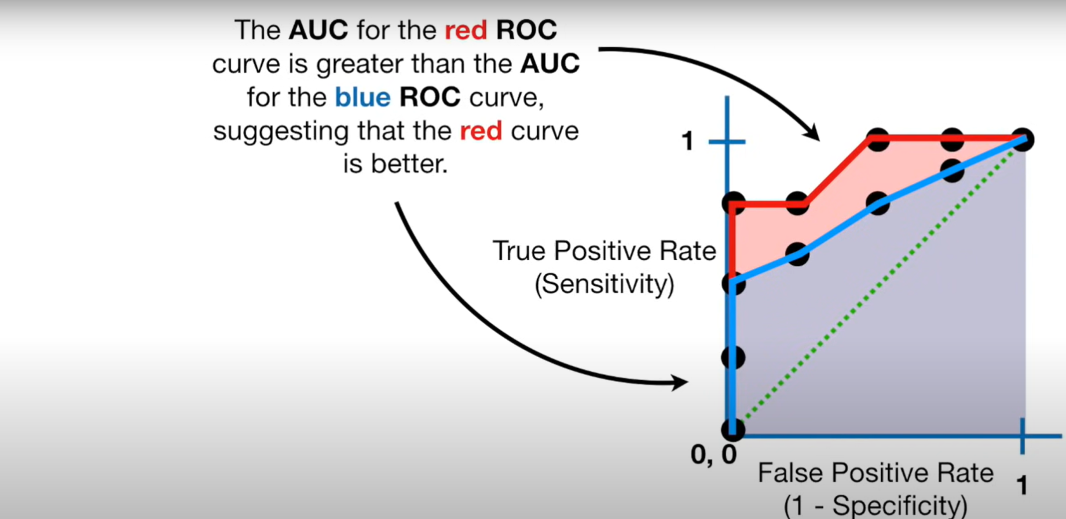

Statistics :
Normal distribution (also known as the Gaussian distribution):
Normal distribution or Gaussian distribution is a common probability distribution.
In a normal distribution, data is symmetrically distributed with no skew.
The farmer weighs 100 random eggs and describes their frequency distribution using a histogram.

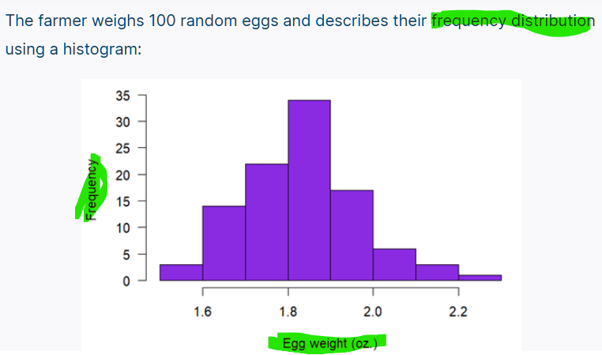
A better option is to recognize that egg size appears to follow a common probability distribution called a normal distribution.
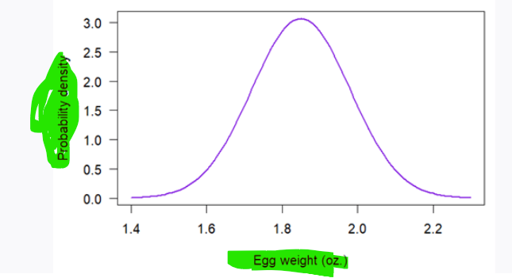
“the random variable X follows a normal distribution with a mean of µ and a variance of σ².”

Discreate Probability distribution and Continuous Probability distribution:
Probability tables can also represent a discrete variable with only a few possible values or a continuous variable that’s been grouped into class intervals.
A probability mass function (PMF) is a mathematical function that describes a discrete probability distribution. It gives the probability of every possible value of a variable. A probability mass function can be represented as an equation or as a graph.

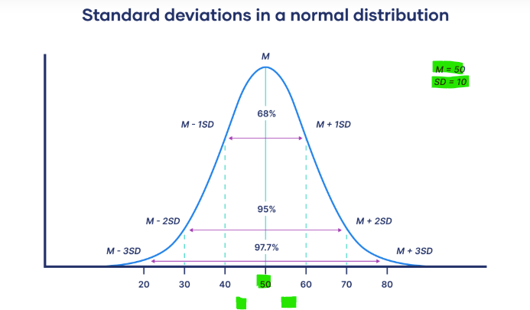
The probability mass functions and probability density functions of common probability distributions
Distribution | Formula | Type of formula
Binomial | 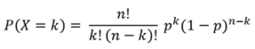 | Probability mass function
Discrete uniform | 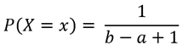 | Probability mass function
Poisson | 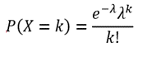 | Probability mass function
Normal | 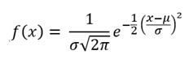 | Probability density function
Continuous uniform | 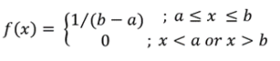 | Probability density function
Exponential | 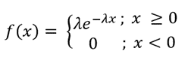 | Probability density function

One definition of an outlier is any observation that is more than 1.5 IQR away from the first or third quartile.
Interquartile range
The distance between the first and third quartiles—the interquartile range (IQR)—is a measure of variability. It indicates the spread of the middle 50% of the data.
IQR = Q3 − Q1
The IQR is an especially good measure of variability for skewed distributions or distributions with outliers. IQR only includes the middle 50% of the data, so, unlike the range, the IQR isn’t affected by extreme values.
Data type | Mathematical operations | Measures of central tendency | Measures of variability
Nominal | - Equality (=, ≠) | - Mode | - None
Ordinal | - Equality (=, ≠)  - Comparison (>, <) | - Mode  - Median | - Range  - Interquartile range
Interval | - Equality (=, ≠)  - Comparison (>, <)  - Addition, subtraction (+,−) | - Mode  - Median  - Arithmetic mean | - Range  - Interquartile range  - Standard deviation  - Variance
Ratio | - Equality (=, ≠)  - Comparison (>, <)  - Addition, subtraction (+,−)  - Multiplication, division (×, ÷) | - Mode  - Median  - Arithmetic mean  - *Geometric mean | - Range  - Interquartile range  - Standard deviation  - Variance  - **Relative standard deviation

A test statistic is a number calculated from your sample data during a hypothesis test.
It tells you how far your observed data is from what you'd expect under the null hypothesis.
What is a Test Statistic (z-test value, t-test value,F-value, X2-test value): It's a summary value that helps decide whether to reject the null hypothesis. And it helps to identify the p-value (probability value which is the area of range calculated using integral in probability distribution plot using PDF- probability density function), the p-value helps to reject or accept the null-hypothesis.
Generally, the test statistic is calculated as the pattern in your data (i.e., the correlation between variables or difference between groups) divided by the variance in the data (i.e., the standard deviation). It is formula.

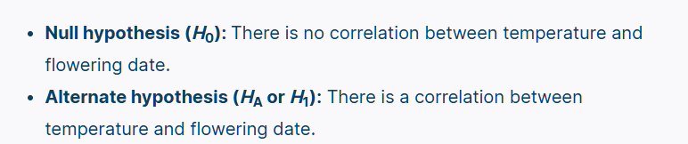
In Hypothesis Testing:
We usually set up:
- Null hypothesis (H₀):
The population mean is equal to a specific value
→ H0:μ=μ0H_0: \mu = \mu_0H0​:μ=μ0​
- Alternative hypothesis (H₁):
The population mean is not equal, greater, or less than that value

🧪 Example:
Suppose a cereal brand claims that the average weight in each box is 500g.
- Then:
  - μ0=500\mu_0 = 500μ0​=500
  - Null hypothesis: H0:μ=500H_0: \mu = 500H0​:μ=500
Now, you collect a sample and want to test:
"Is the average really 500g, or is it different?"
In this test:
- You use μ0=500\mu_0 = 500μ0​=500 in your test statistic formula (like Z or T)
- You compare your sample mean to this claimed value

• Null Hypothesis (H0H_0H0​): There is no effect or no difference. (negative , i.e null is true)
• Alternative Hypothesis (H1H_1H1​): There is an effect or a difference. (positive, null is false)
Hypothesis is an urge to proof a different or effect. So if P < 0.05 (or critical value(large value) far away from mean) reject the null-hypothesis , i.e it is difference or far away from mean, i.e. both are not same probably.

Test statistic | Null and alternative hypotheses | Statistical tests that use it
t value | Null: The means of two groups are equal  Alternative: The means of two groups are not equal | - T test  - Regression tests
z value | Null: The means of two groups are equal  Alternative:The means of two groups are not equal | - Z test
F value | Null: The variation among two or more groups is greater than or equal to the variation between the groups  Alternative: The variation among two or more groups is smaller than the variation between the groups | - ANOVA  - ANCOVA  - MANOVA
X²-value | Null: Two samples are independent  Alternative: Two samples are not independent (i.e., they are correlated) | - Chi-squared test  - Non-parametric correlation tests

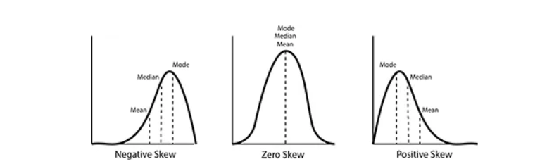
Y is frequency, (distribution is about frequency)

IQR=Q3 − Q1 : the difference b/w Q3 and Q1. i.e how far apart from each other (i.e. Q3 and Q1)
- Q1 (1st quartile) = 25th percentile = value below which 25% of data falls
- Q3 (3rd quartile) = 75th percentile = value below which 75% of data falls
• Resistant to outliers (unlike range or standard deviation)
• Helps in box plots
• Used to detect outliers:
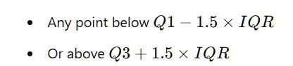
Percentile = P = n/N * 100
Poisson Distribution is a discrete probability distribution. It gives the probability of an event happening a certain number of times (k) within a given interval of time or space.
For example, probability of certain number of horse kick death happens in a year. (i.e No. of events (no. of horse kick death) in a time interval (in a year) or space.
- A death by horse kick is an “event.”
- The time interval is one year.
- The mean number of events per time interval, λ, is 0.61.
- The number of deaths by horse kick in a specific year is k.
Other example :
- Text messages per hour
- Tigers per hectare (so it is counting)
- Machine malfunctions per year
- Website visitors per month
- Influenza cases per year

Chi-square distribution :
Χ²_{k} = (Z₁)² + (Z₂)² + … + (Z_{k})²

The null hypothesis is the default position, while the alternative hypothesis is the claim that is being tested.
A null hypothesis claims that there is no effect in the population, while an alternative hypothesis claims that there is an effect.
The null hypothesis is the assumption you try to disprove. So it's usually:
- A statement of no effect or status quo.
- Something you assume true unless strong evidence says otherwise.
So if you say “the coin is unfair” as H0H_0H0​, you are assuming bias until proven fair, which is opposite of the usual statistical default.

🌳 Null Hypothesis as a Universal Assumption
Think of the null hypothesis (H0)(H_0)(H0​) as the default belief or common assumption — much like:
- "Trees are green"
- "The sun rises in the east"
- "This machine is working fine"
- "The coin is fair"
These are things you assume to be true until you have evidence to doubt them.

What a Low p-value Really Means
A low p-value (e.g., less than 0.05) means:
📉 "The sample result is far from what we’d expect under the null hypothesis."
So if you're assuming the mean is 100 (null hypothesis), and your sample mean is very different from that — then:
- The z- or t-score (test statistic) becomes large
- Which leads to a small area (probability) in the tails of the distribution
- ➡️ That small area = the p-value

From z = 2.1, you get the right-tail area using a Z-table or norm.cdf. that is p-value (probability value).
Multiply by 2 for a two-tailed test.( Because in a two-tailed test, you’re also interested in equally extreme values on the left side (i.e., z < −2). Result: p-value ≈ 2×0.0179 ≈ 0.0358
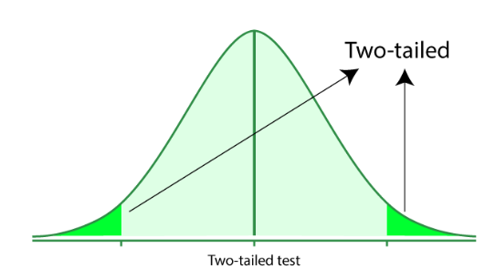

A type I error (false-positive) occurs if an investigator rejects a null hypothesis that is actually true in the population; a type II error (false-negative) occurs if the investigator fails to reject a null hypothesis that is actually false in the population.
i.e A type I error (false-positive) occurs if an investigator rejects a null hypothesis that is actually true in the population . ex : mean of pop is 70 (h0), but rejected , but actually this is error since mean of population is 70 (should have accepted the null hypothesis)

• Null Hypothesis (H0H_0H0​): There is no effect or no difference. (negative , i.e null is true)
• Alternative Hypothesis (H1H_1H1​): There is effect or a difference. an (positive, null is false)
This is called a false positive because you're detecting something (a "positive" result, like an effect or a difference) when in reality, there isn't one (the null is actually true).
Hypothesis is an urge to proof a different or effect. So if P <= 0.05 reject the null hypothesis, (i.e critical value(large value) far away from mean, so reject the null-hypothesis, i.e. it is difference or far away from mean, i.e. both are not same probably.

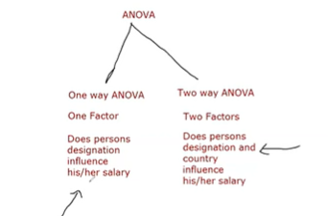
Sampling : Probability sampling and non-probability sampling:

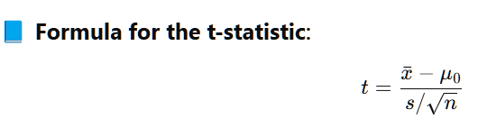
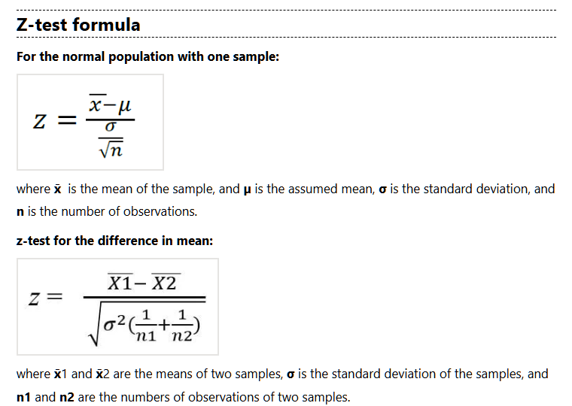
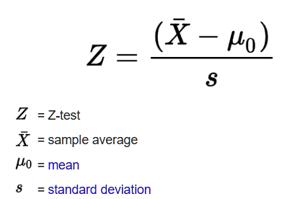
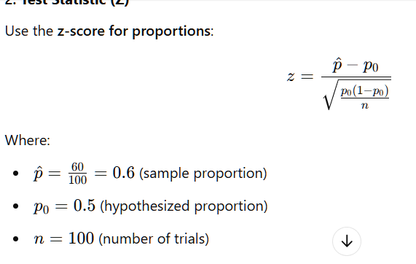
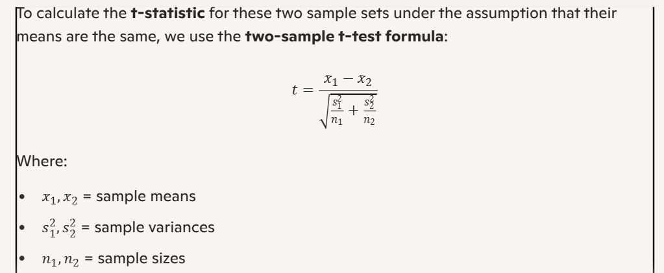
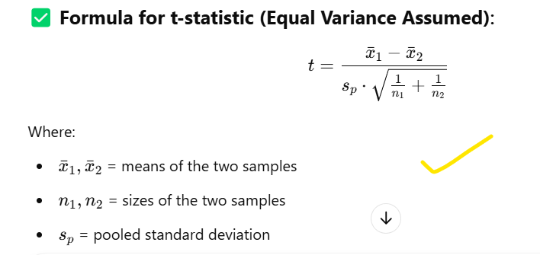
Another formula 2-sample ttest:
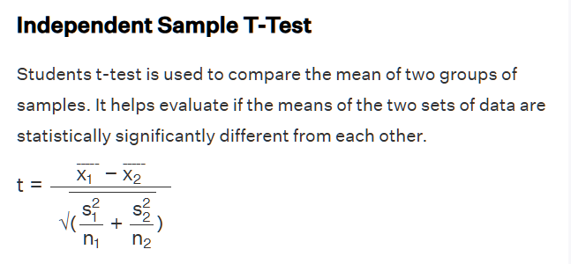
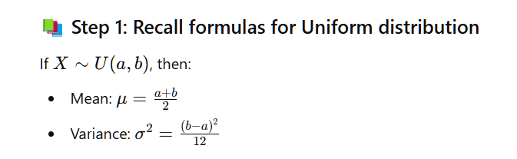
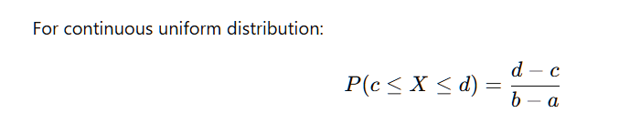

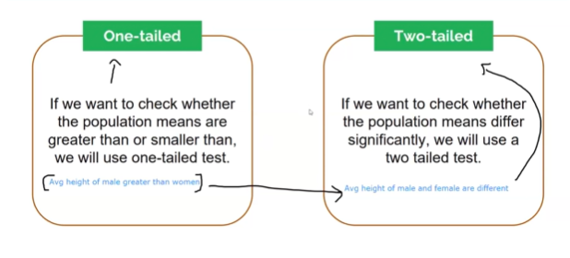

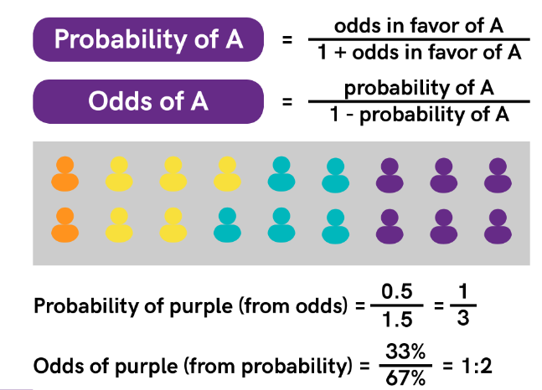
-----
- Probability is like predicting the weather tomorrow.
- Likelihood is like assessing how well a weather model predicted the weather today, given the actual weather conditions.
Likelihood focuses on how well a model or hypothesis explains the observed data.
• Probability: You know the model → What’s the chance of seeing this data (in a fair coin or fair dice)?
• Likelihood: You know the data → How likely is a particular model (or parameters) (i.e whether the coin or dice is fair or not, comparing with good coin or dice distribution)?

Using Maximum likelihood (of mean and standard deviation) fixing the distribution: (i.e. fit the distribution of given data): https://www.youtube.com/watch?v=XepXtl9YKwc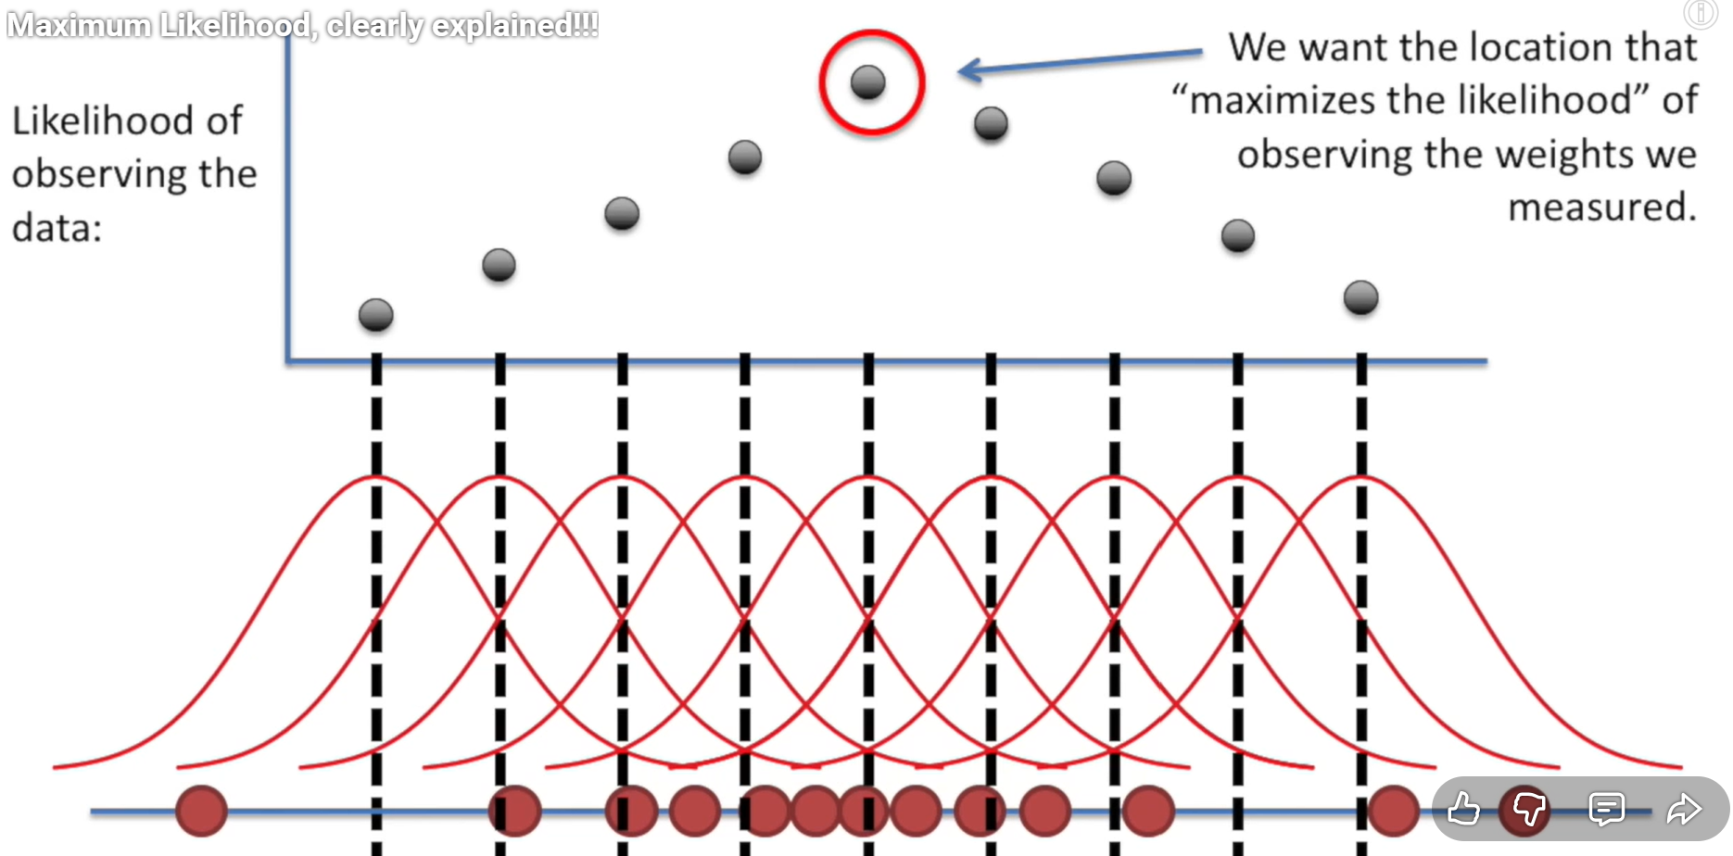
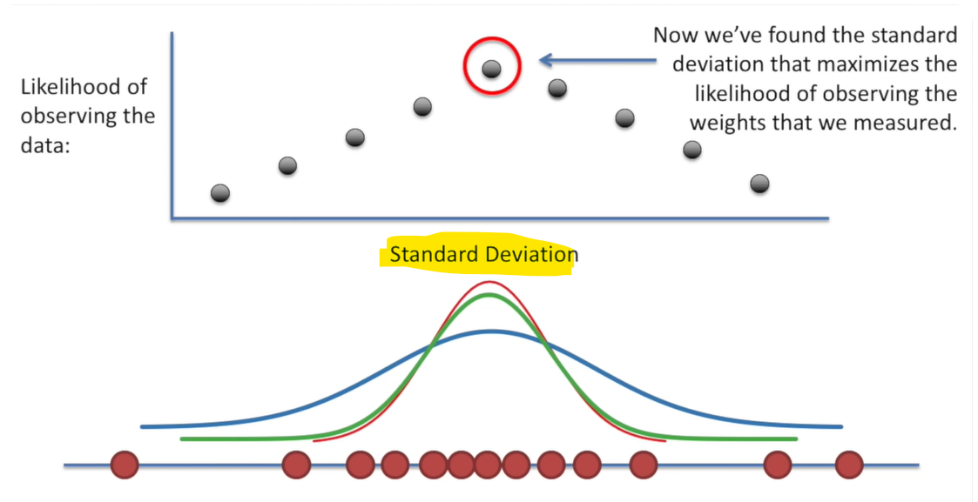
Where maximum likelihood falls for the mean and following SD, that is the mean and SD for the distribution (i.e. that the distribution of the data):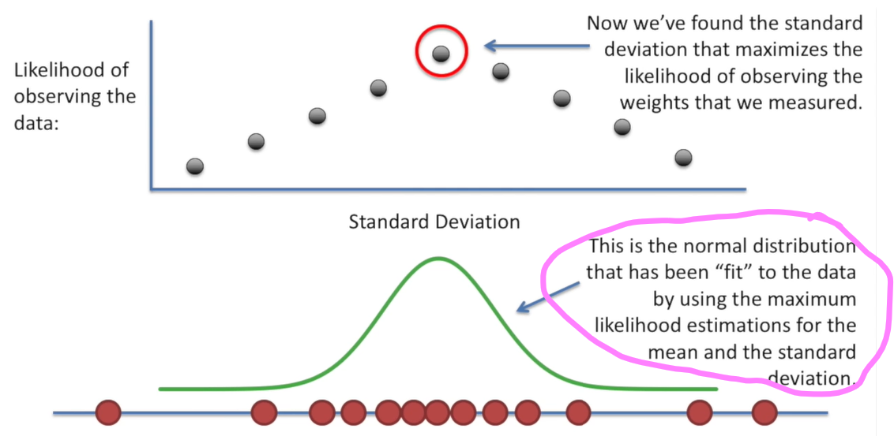

Both formulas same : but, in likelihood data is fixed and try to fit the distribution, in probability find the prob(data) given distribution(mean and SD): https://www.youtube.com/watch?v=Dn6b9fCIUpM
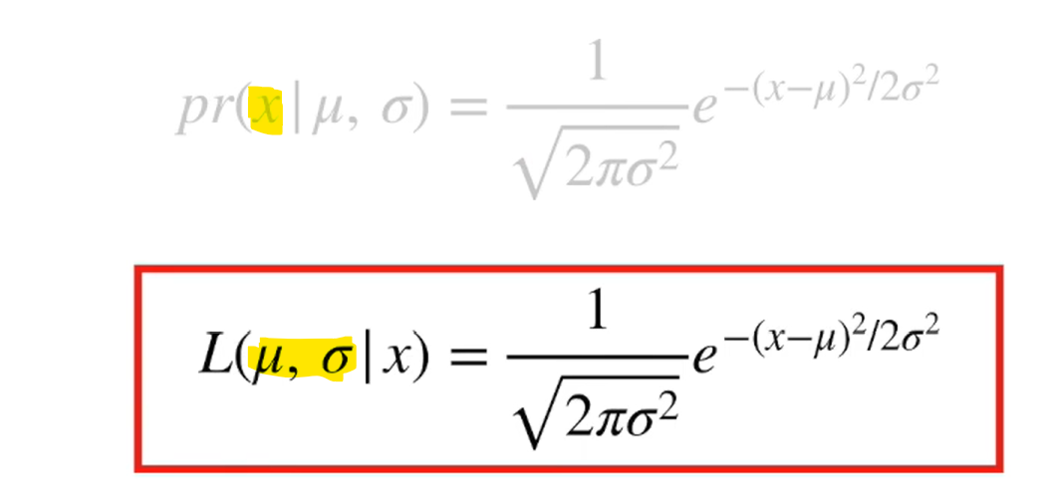

L(b,w) = Likelihood = How probable is the data under parameters b and w?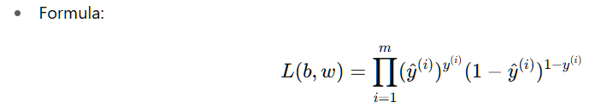We often optimize the log-likelihood, which leads directly to the cross-entropy loss in logistic regression.

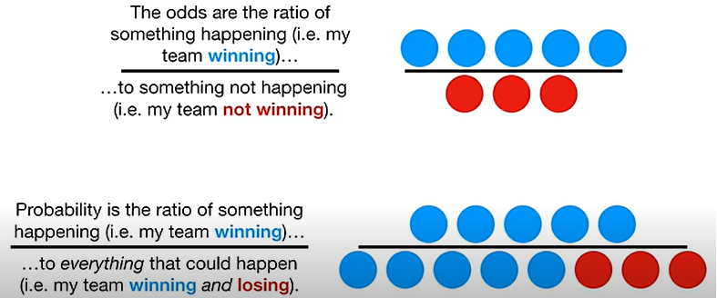

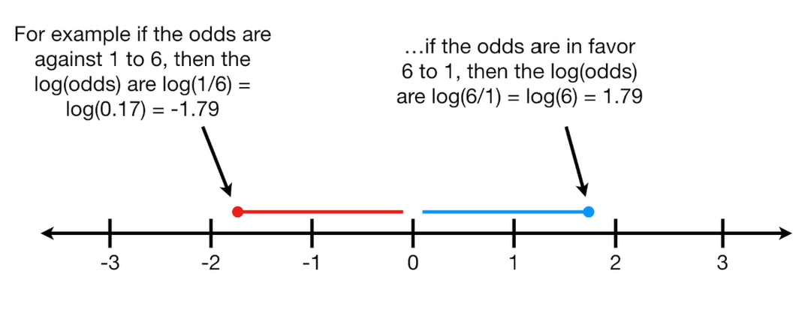

Expected values : , here x is possible out come, i = m, m = tot. no. of possible out come.
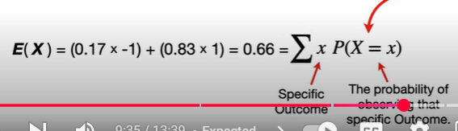
Expected value (its an average), tells that overall experiment near to which outcome , 0.66 tells its near to $1 bet.

Expected value ( of surprise) = Entropy :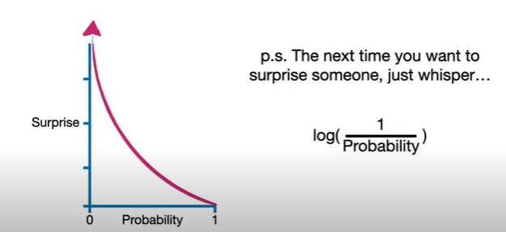
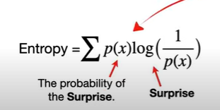
Here, surprise is inverse of probability i.e. if probability low , surprise will be high, and if probability is high and surprise is low. (since 1/1 gives 1, log has been added in the inverse).
And, x is possible out come, i= 1 to m; m number of possible out come(not on data points).
Like Residual is calculated (y – y-hat) and marked for each observation, cross entropy calculated for predicted and observed (using observed probability distribution and predicted probability distribution) , so this is used like residual , i.e. just yet another loss function and calculates the loss.
Reduced to below form:
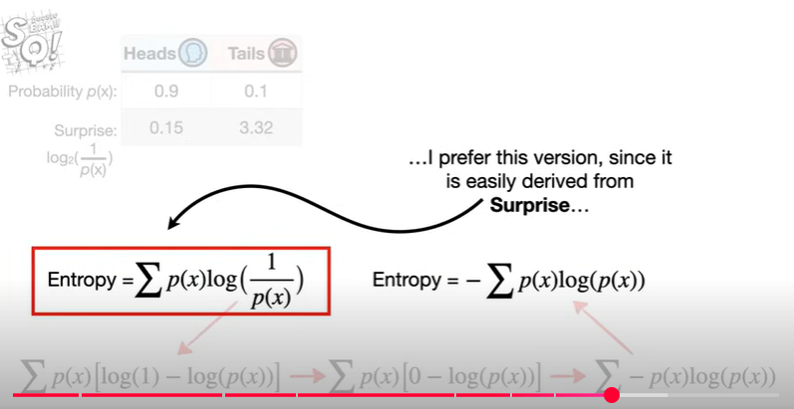
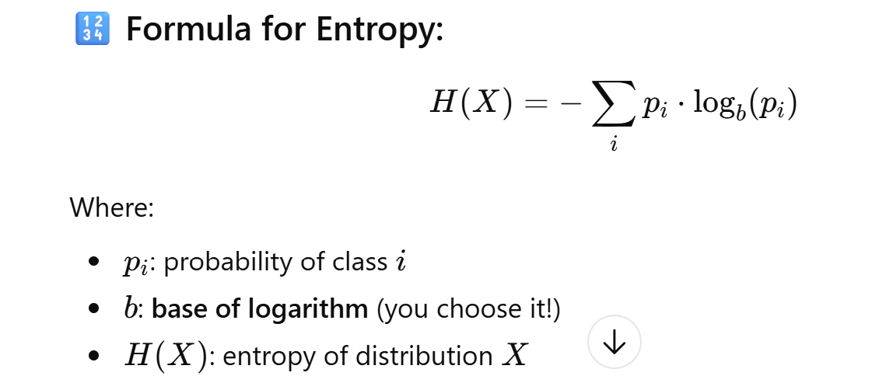

Box A : 1 blue chicken, 6 orange chicken , tot 7:
Entropy - Expected value of surprises. Sum of [P(x) * Surprise(x)] for all outcome. (so probability and its inverse is multiplied , and able to get the measurement where its stand or near to)
Entropy – measure of uncertainty.
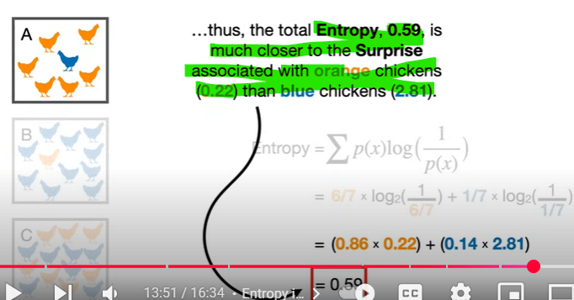

Cross Entropy : 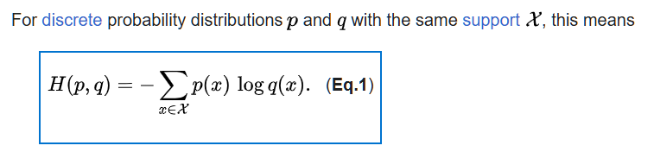
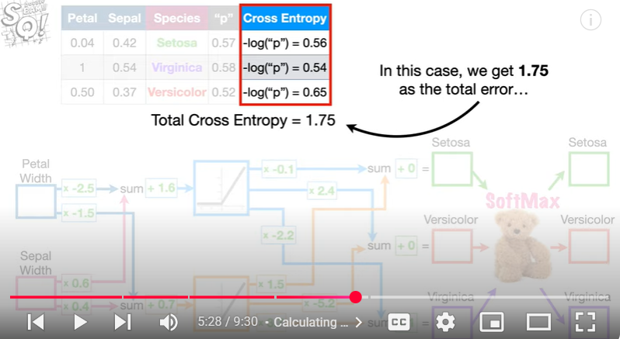
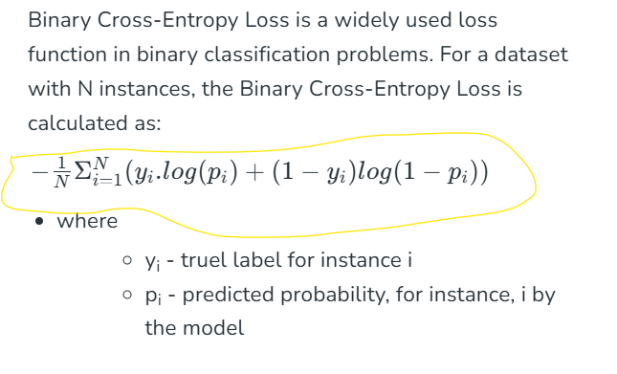
If positive class observed, first part (yi.log(pi) activated, the second part become zero (i.e. + (1-yi.log(1-pi) = 1-1.log(1-pi) , here yi=1 positive-class).
Vise versa, If negative class observed first part become zero i.e yi.log(pi) = 0.log(pi) = 0, second part only taken for summarization.
Why this is: in multi-class second part not available, because we are observing each class and its probability, in binary-classification , we taken [1 – probability] if negative class observed or positive class not observed.
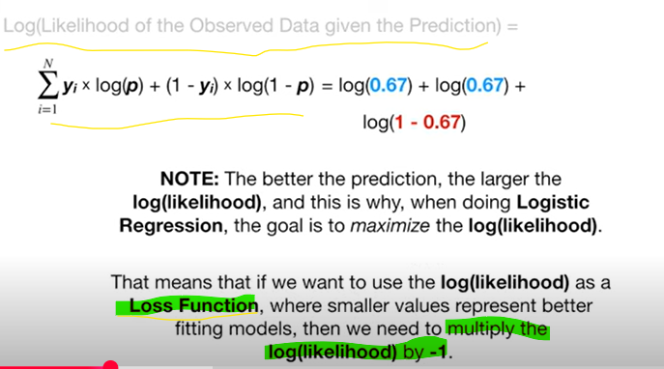
RSS (Residual Sum of Square) or SSE (Sum of Square Error) is also a loss function used in Machine learning. Derivate loss function to zero to fit the best fit line.
In the gradient descent update rule:
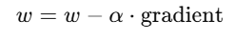
the "gradient" refers to the derivative of the loss function with respect to the parameters (here, w).

Quotient rule :
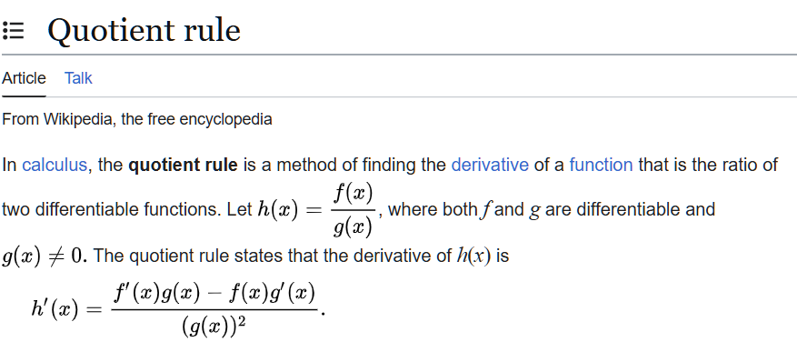

1. Euclidean Distance
📌 What it is:
- The straight-line distance between two points in space (a scalar).
- Based on the Pythagorean theorem. 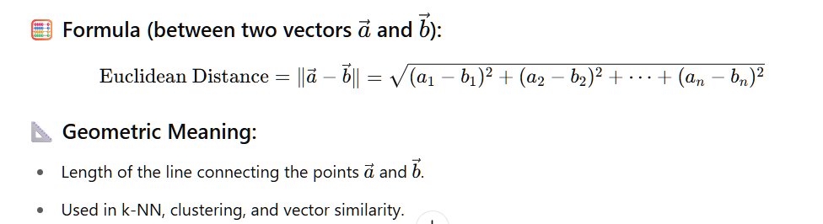
--

1)Basis vectors (unit vectors)
i and j are basis vectors of xy co-ordinate system, also called unit vectors: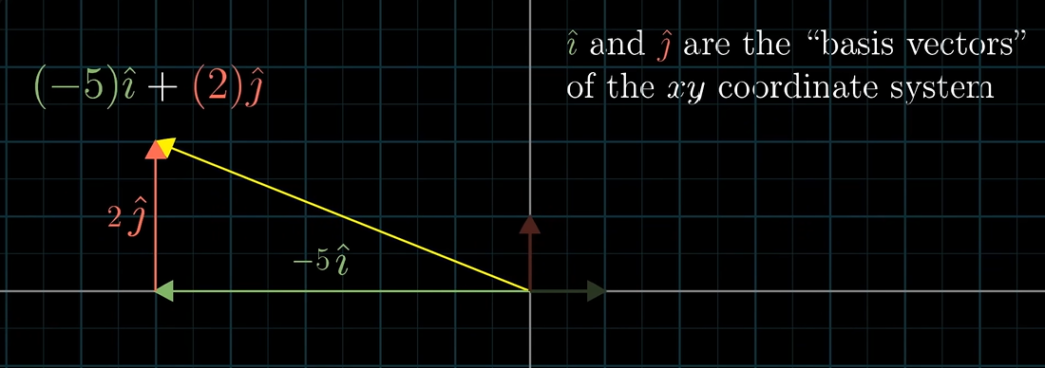
2) scaling 2 vectors and adding them is called as linear combination of the 2 vectors.
linear combination or superposition is an expression constructed from a set of terms by multiplying each term by a constant and adding the results (e.g. a linear combination of x and y would be any expression of the form ax + by, where a and b are constants):
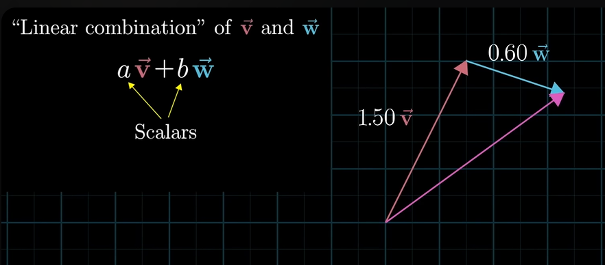
In different scaling, linear combination can touch all the points in vector space. However, if both vectors are in same direction then, the combinations also stuck in same direction. 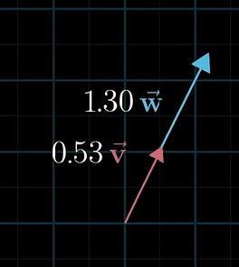
3) set of all possible vectors that can reach with linear combinations of pair of vectors is called as “Span” of the two vectors: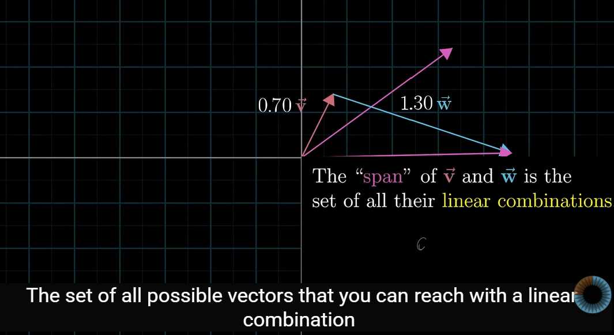

Linear Combination :
linear combination or superposition is an expression constructed from a set of terms by multiplying each term by a constant and adding the results (e.g. a linear combination of x and y would be any expression of the form ax + by, where a and b are constants).
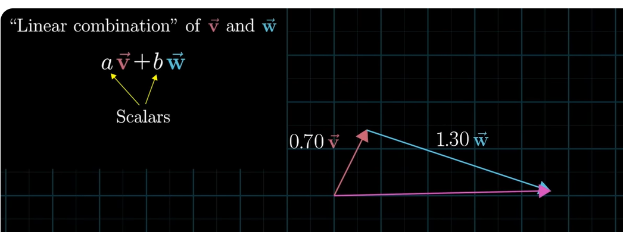
Note: the new vector also starts from orgin. (all vectors are start in orgin)
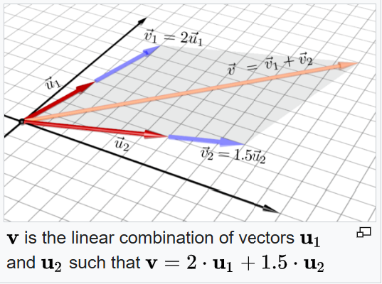
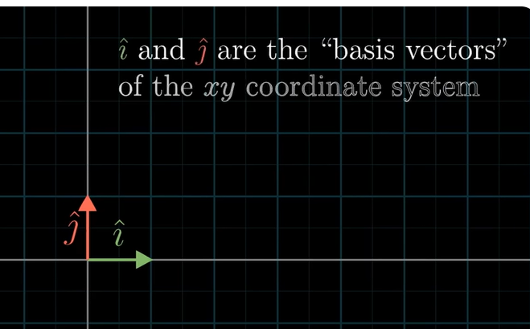
Linearly independent : A set of vectors is linearly independent if no vector in the set can be expressed as a linear combination of the others. In simpler terms, if you can't reach one vector by scaling and adding the others, they are linearly independent. If a set of vectors is not linearly independent, it is called linearly dependent.
Linearly Dependent : one vector is able to reach another vector on scaling, then it is linearly dependent.

Linear Transformation
In definition, Linear transformation is function having a input as a vector and give o/p as a vector.
  - First, matrices are ‘transformations of space’. Matrix multiplication itself is just the transformation of a vector.
In general , basis vectors are [1,0] and [0,1] can name i and j.
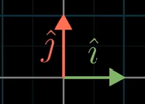 i vector in x axis 1, y axis 0. And j vector length is in x axis 0 and y axis 1. Just think, how if the basis vector is transforming to different length, that means, the entire ‘vector space’ itself transforming, in below picture see that,
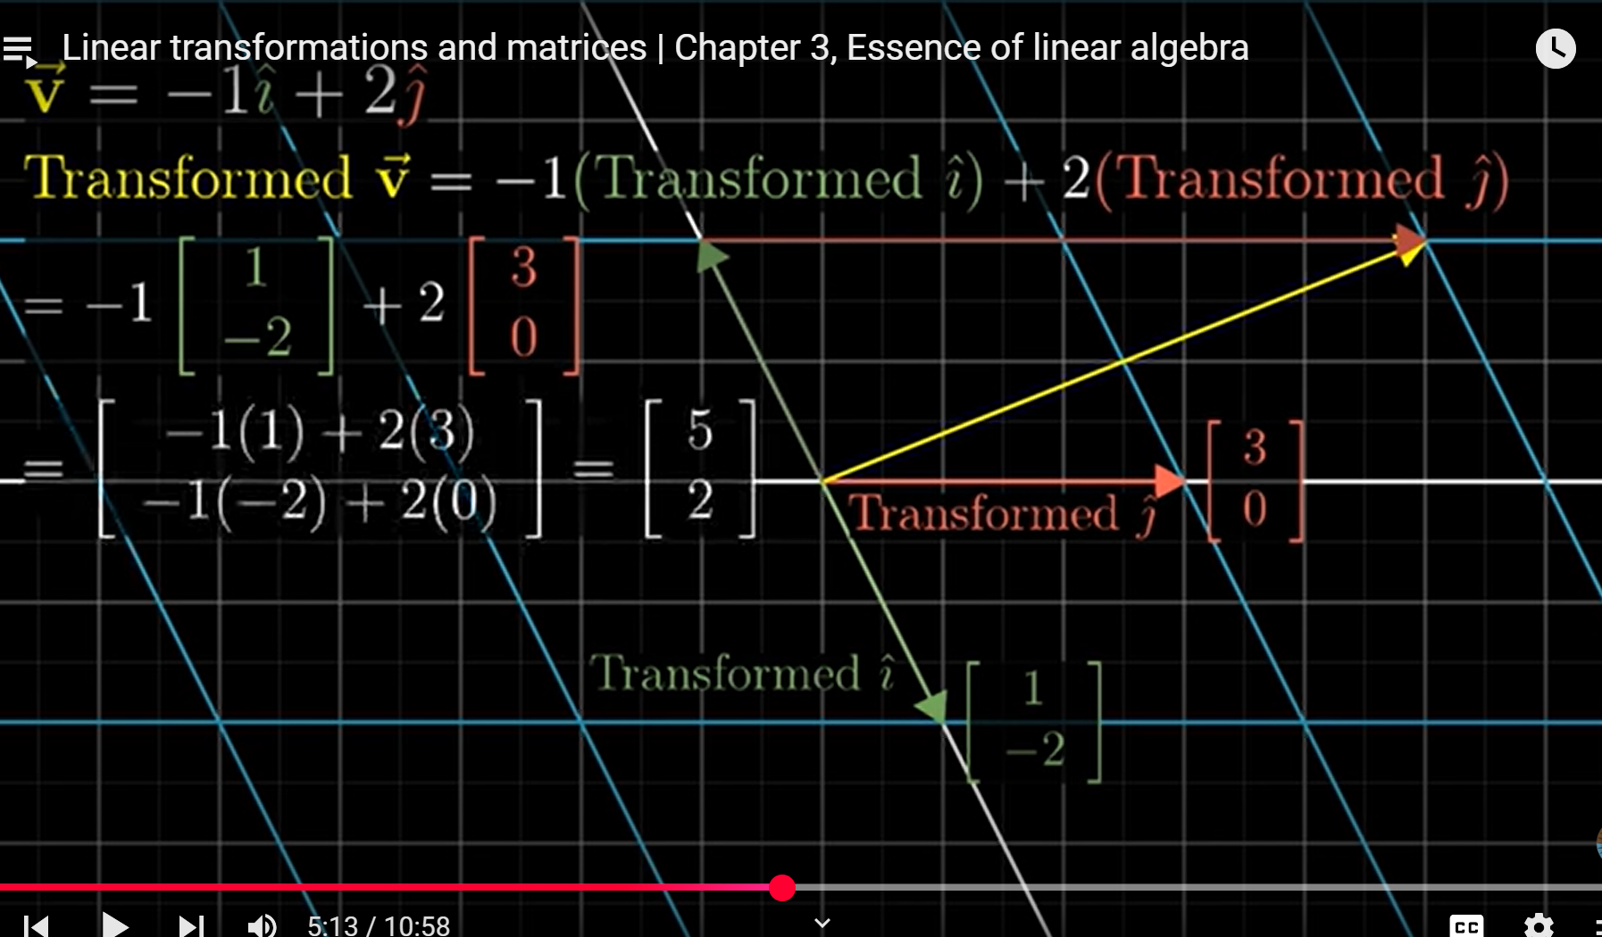
the green i vector(basis vector) transformed as [1 ,-2] , and j (orange vector) transformed as [3,0], the entire vector space itself starched and squished.
(so the starching, squishing and rotating the vector space along with the basis vector is the linear transformation. remember, curving or changing origin in the space is not considered as linear transformation).
Here importantly, while vector space transformed, an existing vector (yellow vector V in below picture) in the original (or general) vector space also transformed in the new vector space, i.e. that vector also linearly transformed.
So the [1,-2] i vector, and [3,0] j vector (in origin those are [1,0] and [0,1]) can be taken as a square matrix, and do the matrix multiplication , here the basis vectors matrix act like function and the yellow vector V is input, so in the matrix multiplication we get the output vector [5,2] where V landed.
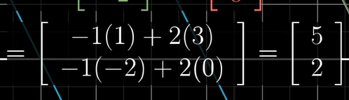
See in the below picture [5,2] is the coordinate for V vector in original space (old grid without color), and exactly in new space, the place where V land is, -1 times of the vector i landed plus 2 times the vector where j landed:
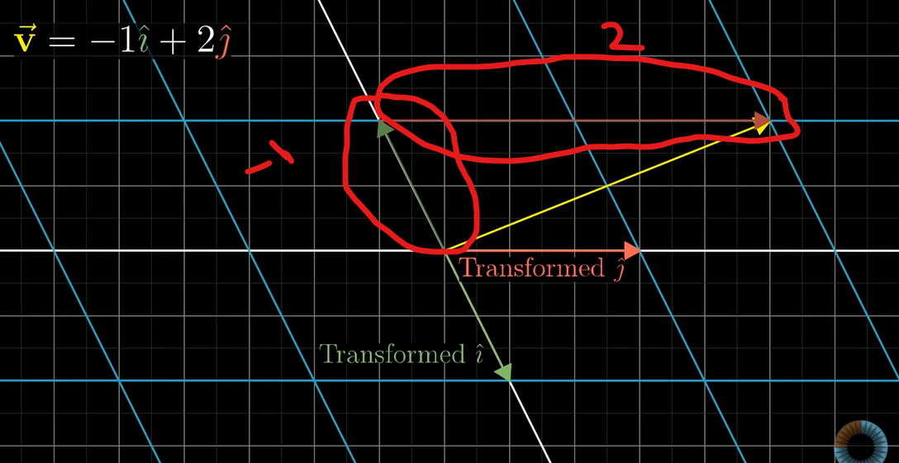

In numerically, we can achieve that via matrix multiplication, so the simple matrix multiplication is actually (intuitively or graphically) is the linear transformation, so whenever the matrix multiplication is happening you have to see the linear transformation in your mind. (just the usual simple row cross column matrix multiplication):
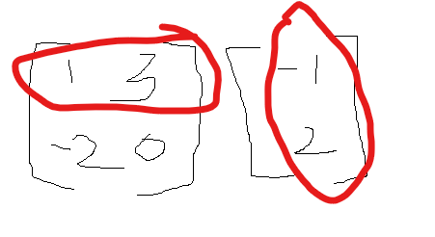 [ 1*-1 + 3*2 , -2*-1 + 0*2 ] = [5 , 2]

And one more example : i as [1 , -2] and j as [3, 0] :
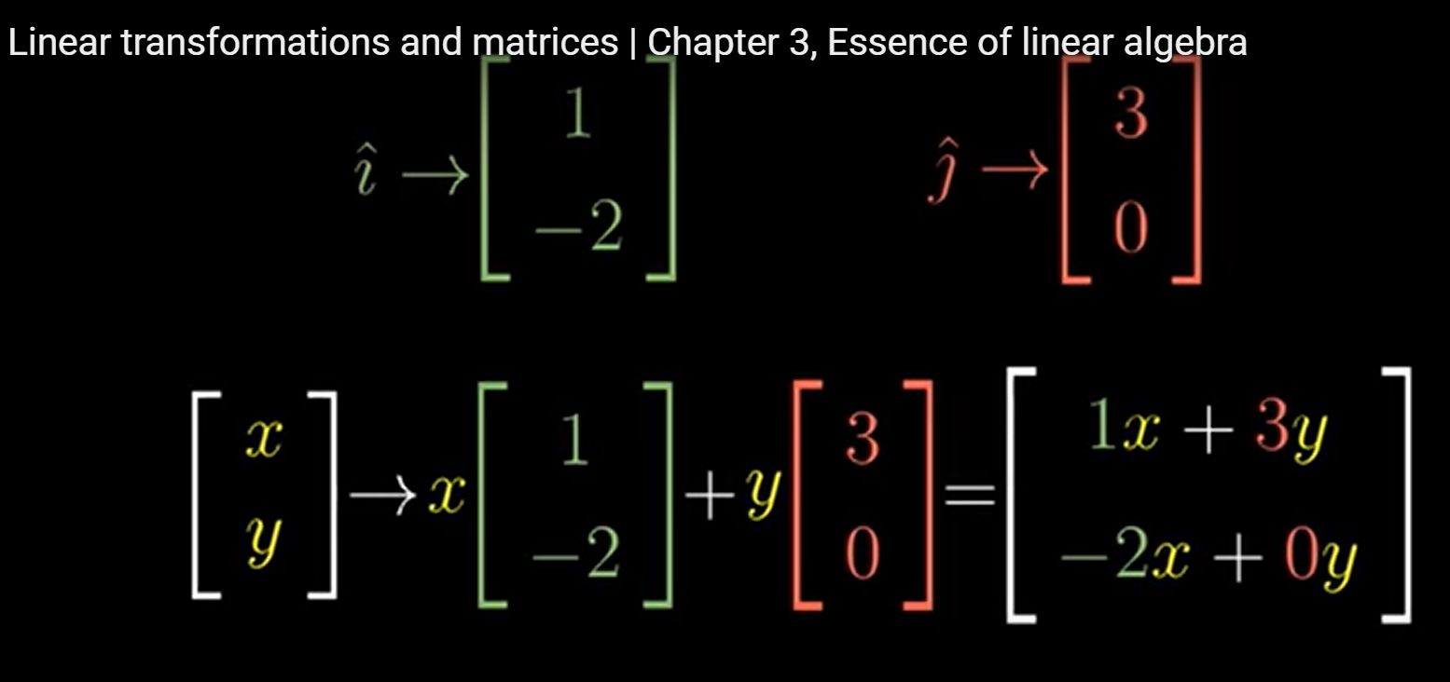
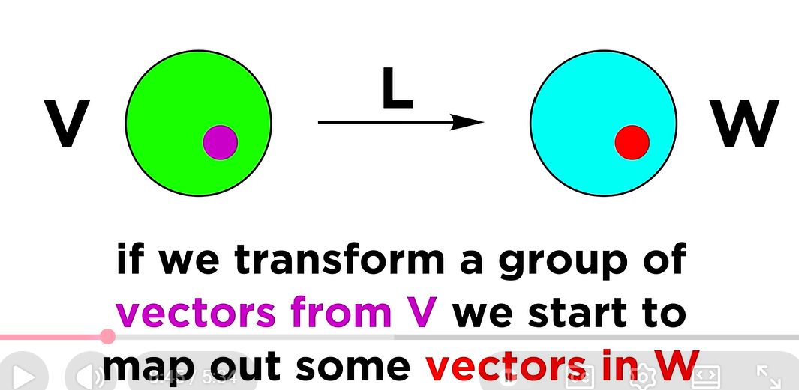

Image – transformed vectors subspace is image, i.e., after few vectors transformed from one space to another space, the subspace (in the new space) of those transformed vectors called as image. i.e. can think like reflection of subspace from the origin space into subspace of transformed space where the transformed vectors are placed.
Kernal –
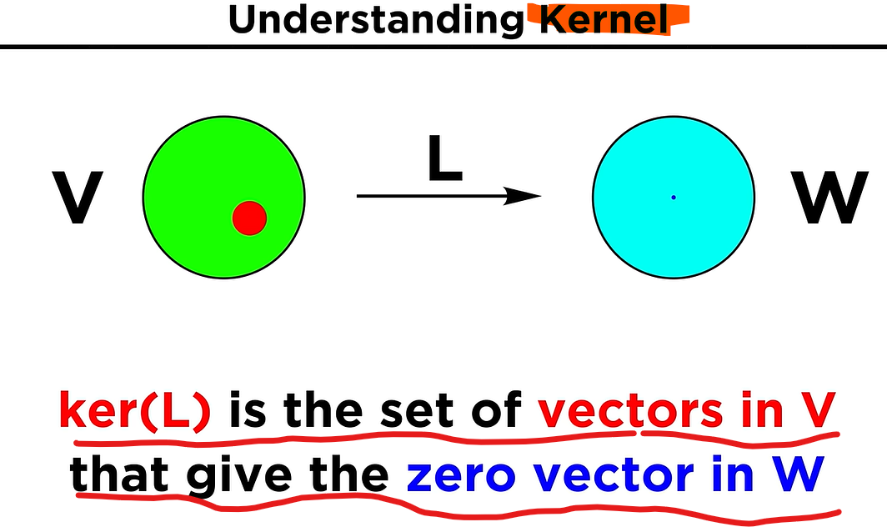
A zero vector or null vector is a vector that has a zero magnitude and no direction
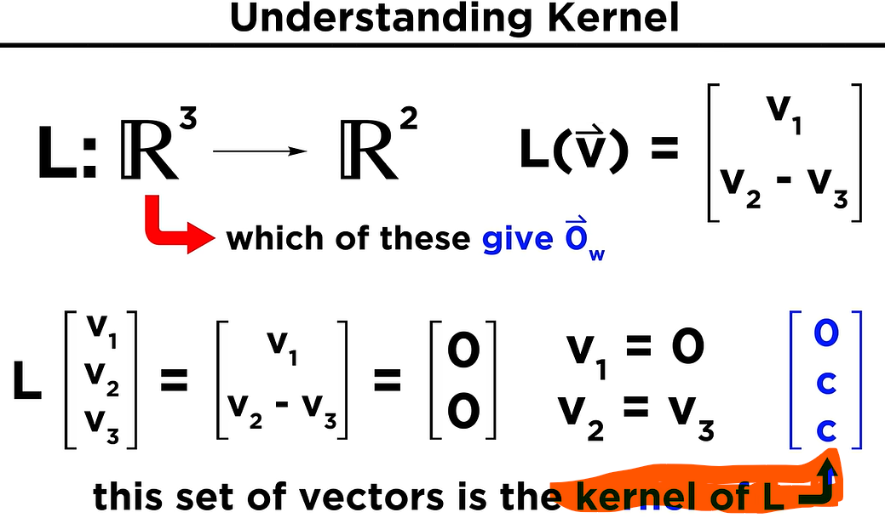
--
The inverse matrix is also found using the following equation:
A⁻¹= adj(A)/det(A),
where adj(A) refers to the adjoint of a matrix A, det(A) refers to the determinant of a matrix A.

Intuitively, the inverse of a matrix is another matrix that, when multiplied by the original, results in the identity matrix. This is analogous to the reciprocal of a number, where multiplying a number by its reciprocal yields 1. The inverse "undoes" the transformation performed by the original matrix.
Reciprocal of x is 1/x , i.e x product of 1/x gives 1. ;; 1/x = x⁻¹
Similarly inverse of matrix A⁻¹ undo the transformation performed by the A.
So obvious, A. A⁻¹ = I (identity matrix, all diagonal 1, other elements are 0).

Intuitively, the adjoint of a matrix (also known as the adjugate) can be thought of as a "helper" matrix that aids in finding the inverse of a matrix. It's closely related to the inverse but exists even when the matrix is not invertible (i.e., has a determinant of zero). Specifically, it's the transpose of the matrix of cofactors.

The determinant of a matrix is a scalar value that can be computed from the elements of a square matrix. It provides information about the matrix's properties, such as whether it is invertible. For a 2x2 matrix [[a, b], [c, d]], the determinant is calculated as ad - bc.
A non-zero determinant indicates that the matrix is invertible (has an inverse), while a zero determinant means the matrix is singular and non-invertible.
In 2d space – it is area ;; in 3d space – it is volume.
|A| = 0; then A is singular matrix. Determinant only for square matrix.

co-factor matrix – helps to find adjoint of matrix, inverse matrix and determinant of matrix.

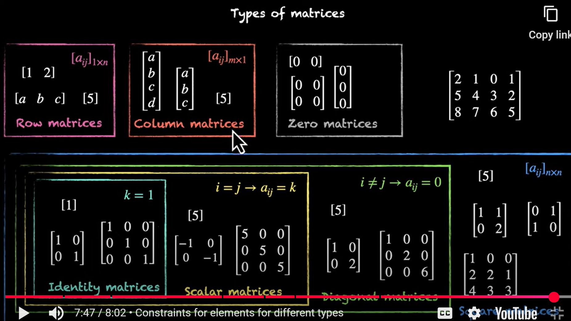

AB is not equal to BA ; multiplication of matrices not commutative.
(A*B)*C=A*(B*C) ; matrix multiplication is associative.
A(B+C) is not the same as (B+C)A. distributive property of multiplication of matrices.
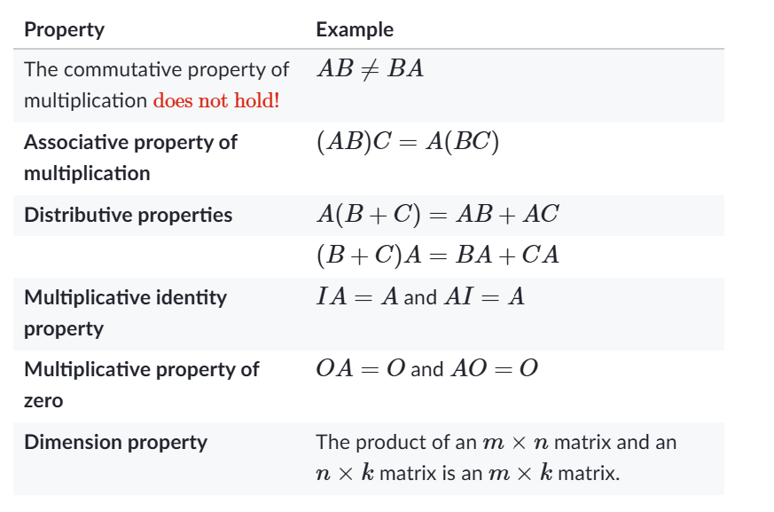
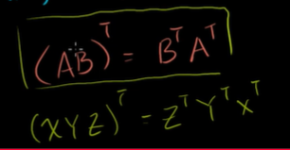 reverse order.

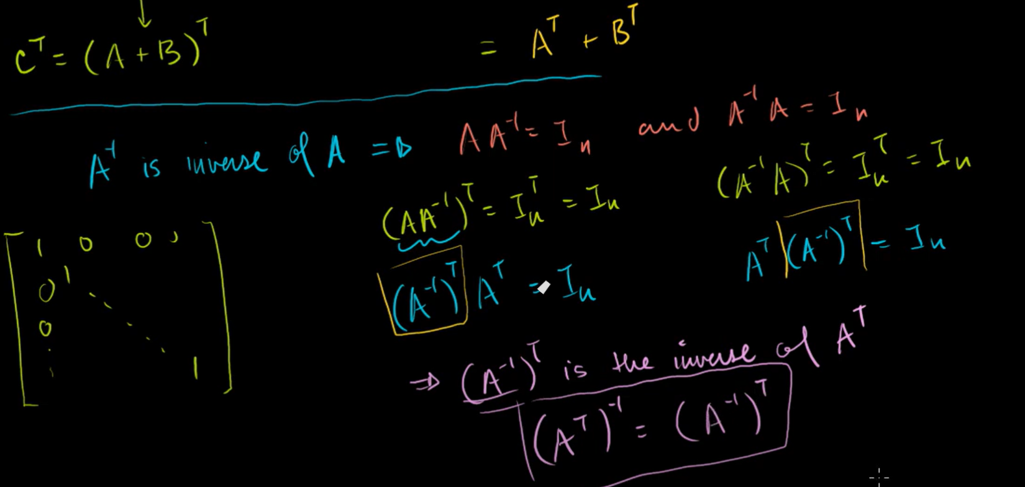
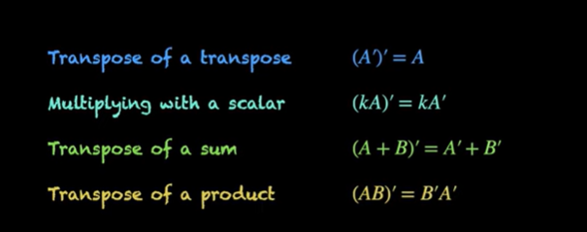
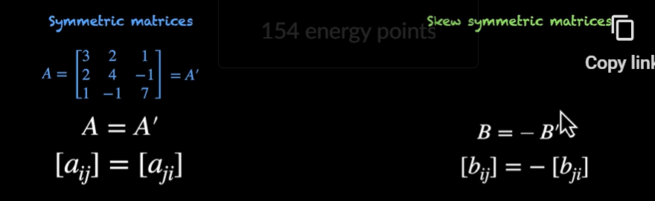
Here A-dash is transpose of A.

Singular matrix : (determinant =0, why determinant zero and why no inverse for singular, and how inverse become undefined as determinant is zero)
https://youtu.be/UqyN7-tRS00
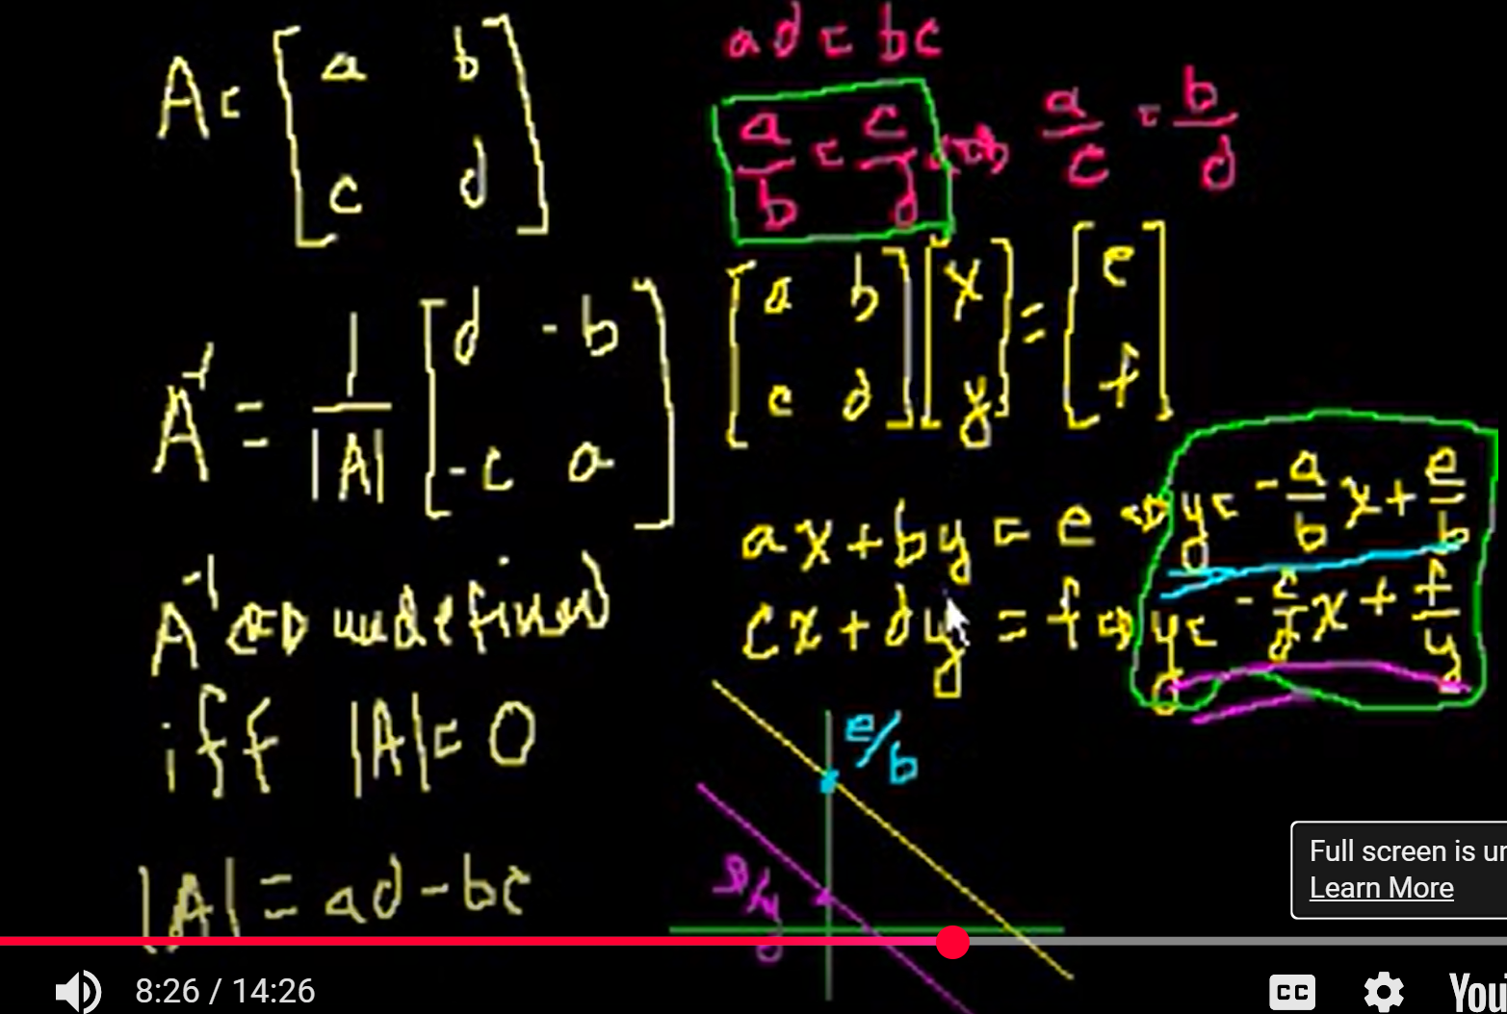
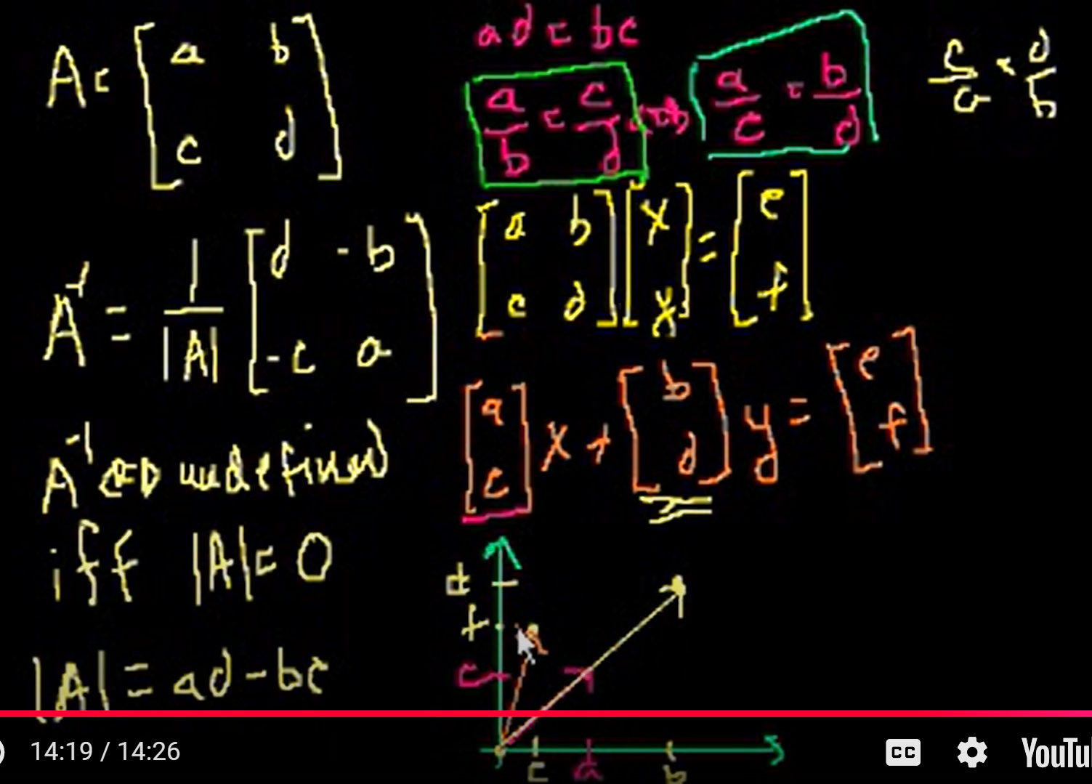
--
Eigen vector : if scaled vector not change the span in column space, that is eigen vector.

- Matrix transformation (3b1b)
- Statquest, projecting, projecting is the dot matrix. Rotation, singular vector, eigen vector. Singular value and singular vector. How ss(d) related to lambda in formula.
- Chatgpt and google ml docs.

PCA can be done using :
- SVD – singular value decomposition
- Weighted Matrix Factorization
There are two ways to do PCA:
1) The old way, which applies eigen-decomposition to the covariance matrix and
2) The new way, which applies singular value decomposition to the raw data.

--

A quadratic equation is a polynomial equation of the second degree, meaning the highest power of the variable is 2. It can be written in the standard form: ax² + bx + c = 0, where a, b, and c are coefficients (constants) and 'a' cannot be zero.

sin(θ) | ☁️ Sky guy | - Vertical component

cos(θ) | 🌍 Earth guy | - Horizontal component

tan(θ) | 🧗 Climber | - Steepness (slope or incline)
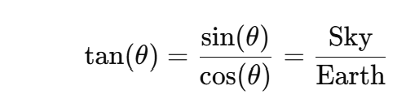
Dot product / inner product : (dot matrix)
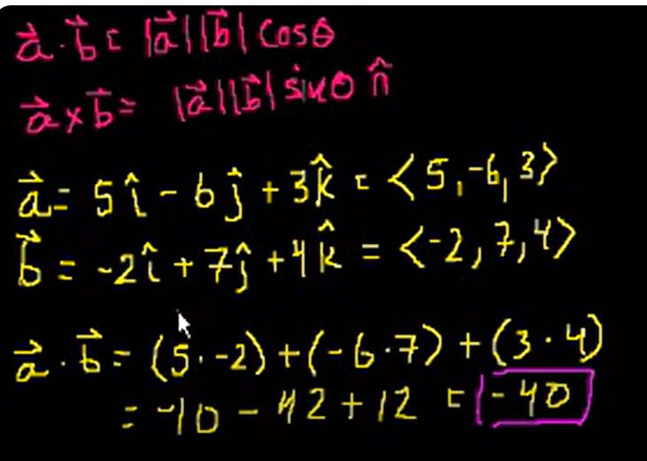

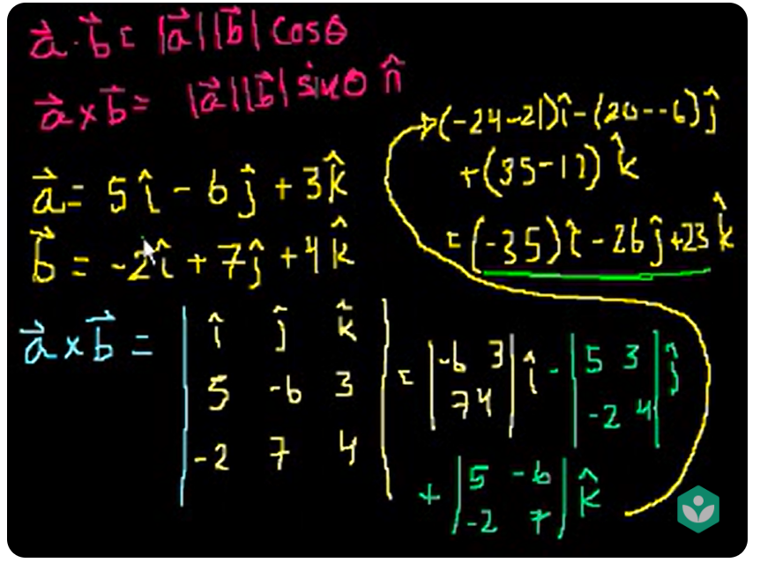
The result vector perpendicular (right hand rule) to the both a and b vectors.




