Group by rewind:
The problems look like group by mostly resolved by .idxmax() or drop_duplicates(subset=[‘col’])

df2[df2[col]==’Company’]
--
numpy as np:
=============
arr.shape ; np.shape(arr) ;; arr.size; np.size(arr);
arr.ndim ; np.ndim(arr);
arr.sort() # inplace sort
np.sort(arr) # return copy of sorted array.
np.array_equal(a,s) # can be series, or pandas array or index or np array. Return T/F scalar.
np.arange(10,100,5) ;
np.linespace(10,20,30)
np.random.random((2,3)) ;; np.random.seed(456);
np.random.randint(1,100,(2,3)) # create 2,3 array
np.full((2,3),6)
np.eye(3); 3 x 3 identity matrix
np.reshape(arr,(2,3)) , arr.reshape((2,3)) : both returns copy of reshaped array, no inplace change.
Np.ones((3,2)) ; np.zeros((3,2))

np.matrix([[1,2,3,np.nan], [4,5,6,7], [7,8,9,9]]) ;; numpy.matrix
arr = np.array([[1,2,3,4], [4,5,6,7], [7,8,9,9]]) ;; numpy.ndarray
arr1 @ arr2 # dot product ; matrix multiplication ??
matrix1 * matrix2 # dot product. ??
arr.dot(arr2)

arr[:, :] # Rows indexing, Column Indexing ; arr[0] – first row
np.concatenate([arr[0:1], arr[2:4], arr[5:]]) # UNION ALL operation in SQL
# Boolean indexing: returns id array with values (True) satisfied in condition
arr[(arr > 90) | (arr % 5 == 0)] # And-&, OR - |, NOT - ~

arr.sum() # scalar value return sum of all values.
Generic python iterables : lis1 * 2 ; ‘ww’ * 2; # expands object n time
arr + 5; arr – 5; arr * 5 , arr/5; math operation to each element in array.
np.around(arr / 3, 2) ; np.around(np.array([2.5, 3.5,4.5])) # Bankers rounding
np.add(arr, 5); np.subtract(arr, 5); np.divide ; np.multiply; np.power(arr, 3);
np.quantile(arr,.5); np.quantile(arr,.25); np.quantile(arr,.75);
arr.sum ; arr.min; arr.max;
arr.mean(); arr.mean(axis=0); arr.sum(axis=1); arr.std(); arr.var();
np.concatenate([a, b]) # vertical joining ;; np.concatenate([a, b.T], axis = 1) # horizontal joining;;
np.vsplit(arr,3); np.hsplit(arr,3);
np.hstack() ; np.vstack();
for i in np.nditer(arr):
arr3 = np.array([[[1,2,3], [4,5,6]],[[1,2,3], [4,5,6]]]) ;;; arr3[:, :, 2:]
arr.flatten();; arr.ravel()
np.array([1,3,5,6,8,9], ndmin=3) #array([[[1, 3, 5, 6, 8, 9]]]) # minimum dimension.
np.array([1, 2, 3], dtype=complex);; array([ 1.+0.j, 2.+0.j, 3.+0.j]);;

a = np.array([1, 2, 3])
b = np.array([4, 5, 6])
c = np.array([[1], [2], [3]])
d = np.array([[4], [5], [6]])
np.column_stack((a,b)) # [[1,4],[2,5],[3,6]]
np.hstack((a,b)) # [1,2,3,4,5,6]
np.row_stack((a,b)) # [[1],\n[2],\n[3],\n[4],\n[5],\n[6]]
np.vstack((a,b)) # [[1,2,3],[4,5,6]]
np.column_stack((c,d)) # [[1,4],[2,5],[3,6]]
np.hstack((c,d)) # [[1,4],[2,5],[3,6]]
np.row_stack((c,d)) # [[1],\n[2],\n[3],\n[4],\n[5],\n[6]]
np.vstack((c,d)) # [[1],\n[2],\n[3],\n[4],\n[5],\n[6]]

a = np.array([0, 1, 2, 3, 4, 5, 6, 7, 8, 9]);; Clip (limit) the values
np.clip(a, [3, 4, 1, 1, 1, 4, 4, 4, 4, 4], 8) ;; np.clip(arr, a_min, a_max, out=arr)
array([3, 4, 2, 3, 4, 5, 6, 7, 8, 8]);;
a = np.arange(10);; np.where(a < 5, a, 10*a) ;; np.where(condition, if-true, else);; array([ 0, 1, 2, 3, 4, 50, 60, 70, 80, 90]);;
np.where([[True, False], [True, True]], [[1, 2], [3, 4]], [[9, 8], [7, 6]]) ;; array([[1, 8], [3, 4]])
a = np.array([[0, 1, 2], ... [0, 2, 4], ... [0, 3, 6]]) ;; np.where(a < 4, a, -1) ;; array([[ 0, 1, 2], [ 0, 2, -1], [ 0, 3, -1]])

np.insert ;; np.append; np.delete;;
a = np.array([[1, 1], [2, 2], [3, 3]]) ;; # np.insert(arr, position, value)
np.insert(a, 1, 5) # flatten and insert
np.insert(a, 1, 5, axis=1) ;; array([[1, 5, 1], [2, 5, 2], [3, 5, 3]])
array([[1, 5, 1],
[2, 5, 2],
[3, 5, 3]])

# Reshape using -1 to automatically determine the first dimension:
data = np.arange(24);; array_2 = data.reshape(-1, 4);
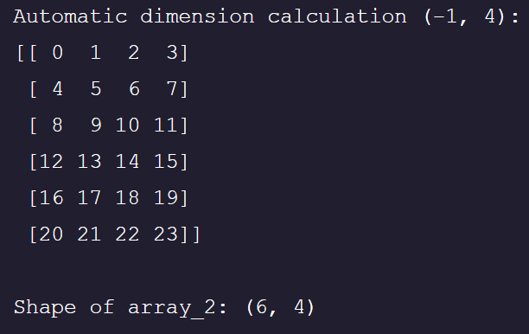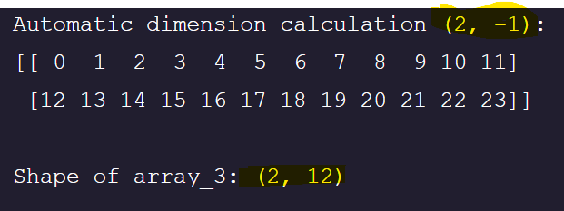

pandas as pd:
=============
pd.read_excel(‘’) ;
pd.read_csv(‘’);
pd.DataFrame() #can be ndarray, series, dictionary
df.info()
df.describe()
df.nunique() # column wise unique value count (no. of unique value column wise return as Series)
df[‘column’].nunique() # scalar value – no of unique value in the column return.
df[‘column’].unique() # like distinct, list of distinct values for this column. Return as array.
(same as df[‘column’].value_counts().index)
df[‘column’].value_counts() # each values count in the column, return as Series
df.duplicated() # bool series df index(0 to 6528) as series index.
For check column level duplicate Transpose the df.
Df[ALWAYS BOOLEAN SERIES ITS INDEX MATCHES df INDEX]
df['Shipping Cost'] and df['Shipping Cost'].T are same, similar to np.array([1,2,3]) and np.array([1,2,3]).T

pd.read_excel(‘Dmart.xlsx’, sheet_name=’sheet1’) ;; df.to_excel(‘Dmart.xlsx’,sheet_name = ‘sheet1’)
with ExcelWriter(‘Dmart.xlsx’) as writer:
df1.to_excel(writer, sheet_name=’wholesale’)
df2.to_excel(writer, sheet_name=’retail’)

df2.loc[df2['B'] == 45, ['C', 'D']]; i.e. [index, col]
df2[df2['B'] == 45][['C', 'D']]
df2.isnull().sum().sum();; df2.duplicated().sum();;
df_ins.isnull().sum(axis=1).sum()
df_ins.duplicated().sum()

df_nulls.drop(index = df_nulls[df_nulls['Name'].isnull()].index)
df_nulls.dropna(how = 'all', axis = 1)
df_nulls['Age'] = df_nulls['Age'].fillna(avg_age, inplace=True)
df_ins[df_ins.isnull().sum(axis=1) > 0]

drop, dropna, fillna, replace, rename, sort_index, sort_values
dfs['Name'].replace({"Peta" : "Imtiaz"}, inplace = True)
df.drop(columns = 'Student ID', inplace = True)
df2.sort_index(ascending=False, inplace=True)
df2.sort_values(by='r1', axis=1, ascending=True, inplace=True)
df_ins['region'].value_counts().reset_index().sort_index(axis=1, ascending=True)

df3.apply(lambda c: np.around(c) if 'float' in str(c.dtype) else c)
np.around(df2['A']);; df2[‘A’].round();; df2.round(1)
df3 = df3.astype({'maths': 'int32', 'phys': 'float32'})
df3[['maths', 'chem', 'phys']] = df3[['maths', 'chem', 'phys']].astype(int)

df3.groupby(by=['district', 'subdivision'],sort=True, as_index=False).first()
df3.groupby(by=['district', 'subdivision'], dropna=False).sum(numeric_only=True)
day4 day5
dropna , join, merge - how
df2 = pd.DataFrame({'A':[34, 78, 54], 'B':[12, 67, 43]}, index=['r1', 'r2', 'r3'])
df2.loc['r2':'r3', 'B']
df2['r2':'r2'] # slicing for index only .
df[:] # slicing only for index
df[''] # constant only for column(key)
df[: , :] # no 2d slicing, TypeError
df.loc[index:index, column:column] # exact value
df.loc['r2'], df.loc['r2':] df2.loc[['r2','r1']] # looking for index
df.iloc[index:index, column:column] # only integer positional values
df2.iloc[0:] #fetch 0th index
df2.loc['r2'] = [45,51] # update the row r2 (i.e. index r2)
df2.loc[:,’A’] = [] # no effect since slicing returns copy
housing.loc[(housing["yr_built"] < 1980) & (housing['floors'] > 2) & (housing['bedrooms'] > 2)]

pd.options.display.float_format = '{:.2f}'.format

updating a value :
df.at[row_label, 'column_name'] = new_value
df.iat[row_index, column_index] = new_value
df.loc[row_label, 'column_name'] = new_value
df.iloc[row_index, column_index] = new_value
but entire column can be updated in assignment , as like below:
df_bank[c] = le.fit_transform(df_bank[c])
df_bank[c] = 1 # same value for all row in the column.

df_ins['region'].value_counts().sort_values(axis=0); below output is a Series, with region as series :
Remember Series / Frame can have the labelled index:
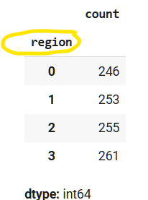
df_bank[df_bank.isnull().any(axis=1)]
df_bank[~df_bank.isnull().any(axis=1)]

# returns pd.Series
series_range = pd.cut(df_bank['duration'], bins=[1,10,200,500,1000,2000,5000], right=False)
pd.DataFrame(series_range).groupby(by='duration')['duration'].count()
drop inplace == del df[c]
--
df_emp.groupby(by=(df_emp['YearsExperience']//1))['Salary'].transform('mean')
--
Df_num_temp = Df_.select_dtypes(exclude=[‘object’])
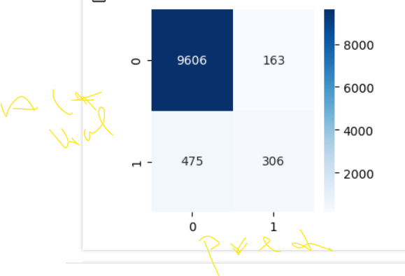Confusion matrix : rows – Actual, columns - predicted

Matplotlib.pyplot as plt
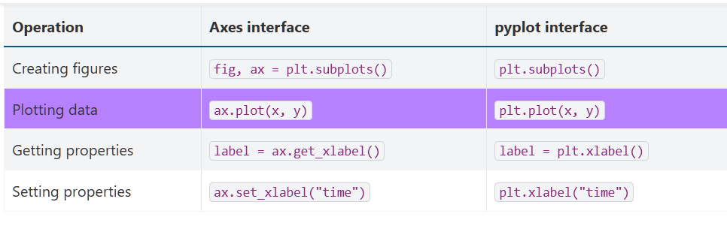

x = np.linspace(0,50,100)
fig, ax = plt.subplots(1,2,figsize=(10,5))
ax[0].plot(x,x)
ax[0].legend(['Linear'])
ax[0].set_xlabel('X')
ax[0].set_ylabel('Y')
ax[1].plot(x,x*x)
ax[1].legend(['Sq'])

x = np.linspace(0,50,100)
fig, ax = plt.subplots(1,1,figsize=(10,5))
ax.plot(x,x)
ax.set_xlabel('X')
ax.set_ylabel('Y')
ax.plot(x,x*x)
ax.legend(['Linear','sq'])

--
import matplotlib.pyplot as plt
plt.figure(figsize=(10, 6))
plt.title('Top 10 Cities by Sales')
plt.xlabel(‘X’)
plt.ylabel(‘Y’)
plt.plot(df[‘Order Date’], df[‘Sales’])
plt.xticks(rotation=’vertical’)
plt.legend(labls=[‘Sales Plot’ , ’Profit Plot’])
plt.yticks([0,1,2], [‘Jan’,’Feb’,’Mar’], rotation=45); rotation=’vertical’ ;;plt.yticks([]) # Disable yticks
plt.ylim(100, 5000)
plt.show()
--
plt.plot(x, y, ‘g:o’, lw=3, ms=5, mfc=’b’, mec=’r’) # line plot; ls=’—’ ; ls=’:’
# alphabetical order
#bar plot
# barh ;
#box plot : plt.boxplot(weight);
#plt.fill_between(x, y, alpha = 0.75 , color = 'r');
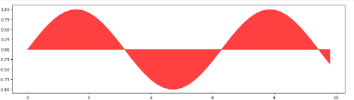
#Histogram ; plt.hist(sales, bins=5); sales.sort_values(ascending=True)
# pie chat ; plt.pie(reg_df['Sales'], labels = reg_df['Region'], autopct = "%1.2f%%");
#scatter plot ; plt.scatter(df['Sales'], df['Profit'], color = 'm')
#bubble plot ;; plt.scatter(df['Sales'][:1000], df['Profit'][:1000], s = df['Profit'][:1000]*0.05)
# # violin plot

Import seaborn as sns
plt.figure(figsize = (15, 4))
#Seaborn plots alphabetical order
sns.barplot(x = 'Month', y = 'Sales', data = trend, hue = 'Month', palette = 'viridis'); palette=’seismic’
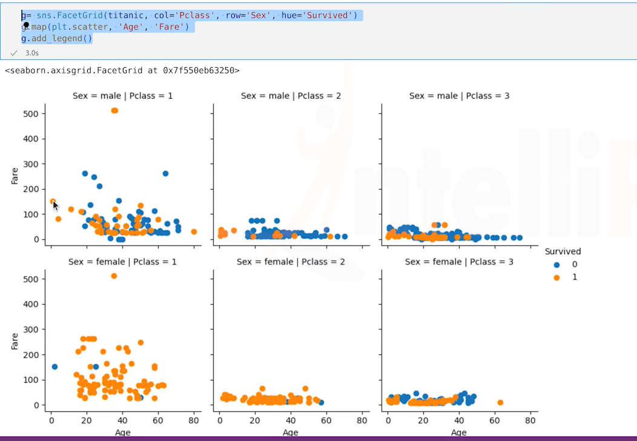
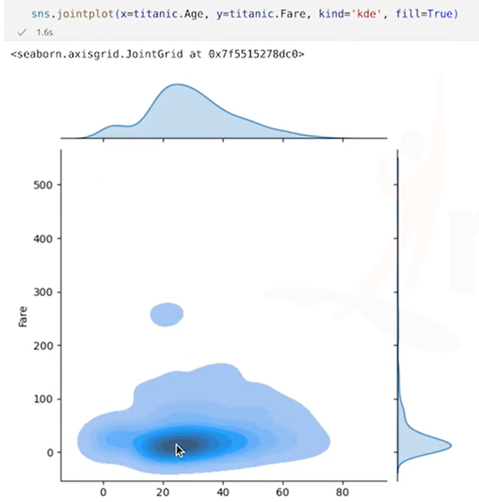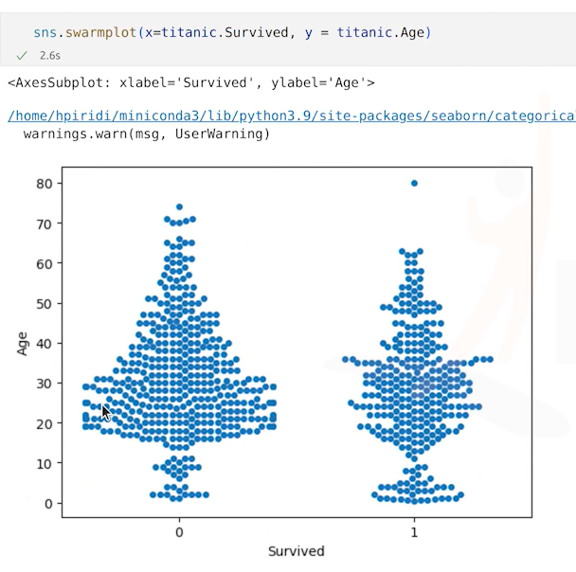
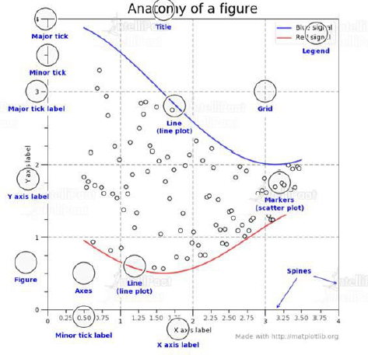
- Bar plot is used to represent categorical data (like names, types, groups).
- Histogram is for continuous numerical data (grouped into bins).
- Area plot shows trends over time (good for continuous data).
- Quiver plot is used to show vectors (like direction and magnitude).

--
import os
os.listdir()
os.getcwd()
--

Box plot:
- Box: spans from Q1 to Q3 (interquartile range, or IQR. IQR=Q3−Q1)
- Line in box: median (Q2)
- Whiskers: extend from the box to min and max values within 1.5×IQR (i.e Whiskers – line till 1.5 x IQR)
- Dots outside whiskers: outliers
from matplotlib import colormaps
['magma', 'inferno', 'plasma', 'viridis', 'cividis', 'twilight', 'twilight_shifted', 'turbo', 'Blues', 'BrBG', 'BuGn', 'BuPu', 'CMRmap', 'GnBu', 'Greens', 'Greys', 'OrRd', 'Oranges', 'PRGn', 'PiYG']
sns.heatmap(df_cc.corr(), annot=True, cmap='viridis')

--
Insert/append rows in data frame, series with index:
Series row insert using pd.concat:
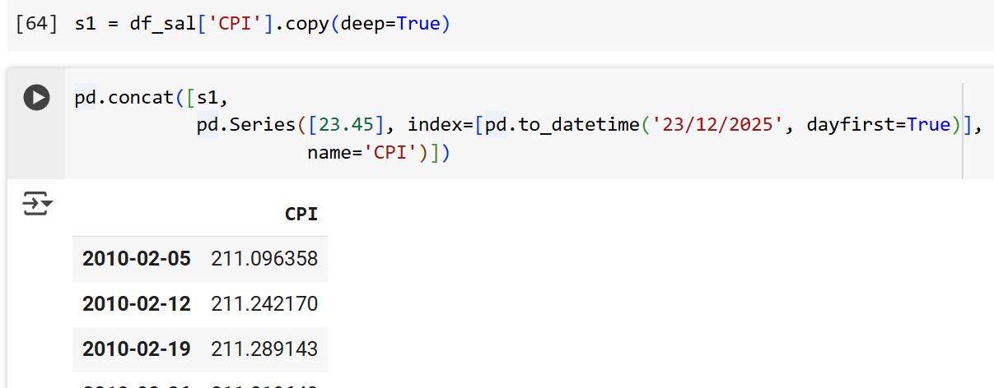
pd.concat([s1, #original series
pd.Series([23.45], index=[pd.to_datetime('23/12/2025', dayfirst=True)],
name='CPI')])
other ways : s1.loc[pd.to_datetime("23/12/2025", dayfirst=True)] = 23.45 ;; s1.append -deprecated.
Series.combine_first():
new_points = pd.Series(
[23.45, 27.10, 30.55],
index=pd.to_datetime(["23/12/2025", "25/12/2025", "31/12/2025"], dayfirst=True),
name="CPI"
);;
s1 = s1.combine_first(new_points) # keeps both old + new data

--
pd.concat can be used for insert row In DF.
And join 2 DFs:
df_fc = pd.DataFrame({
"Forecast": fc, # forecast series
"Store": 1
}, index=fc.index)
df_fc = fc.to_frame(name="Forecast")
df_fc["Store"] = 1

Transform : Call function producing a same-indexed DataFrame/Series on each group.
mask = df.groupby("Country/Region")["Province/State"].transform(lambda x: x.isna().any())
pandas.core.groupby.generic.SeriesGroupBy.transform():
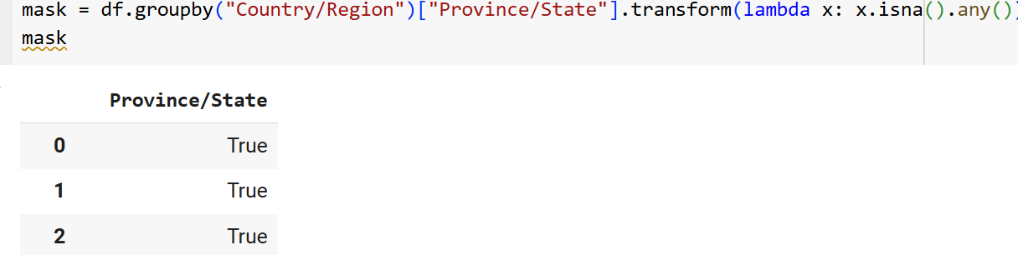

df.groupby("Country/Region").transform(lambda x: x.isna().any())
pandas.core.groupby.generic.DataFrameGroupBy. transform():
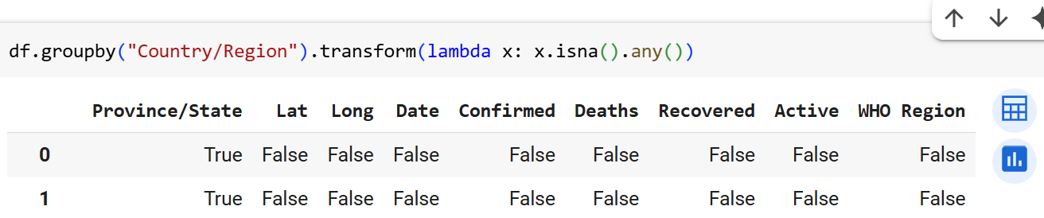
Returns a Series having the same indexes as the original object
filled with the transformed values.
--
--
Df group by :
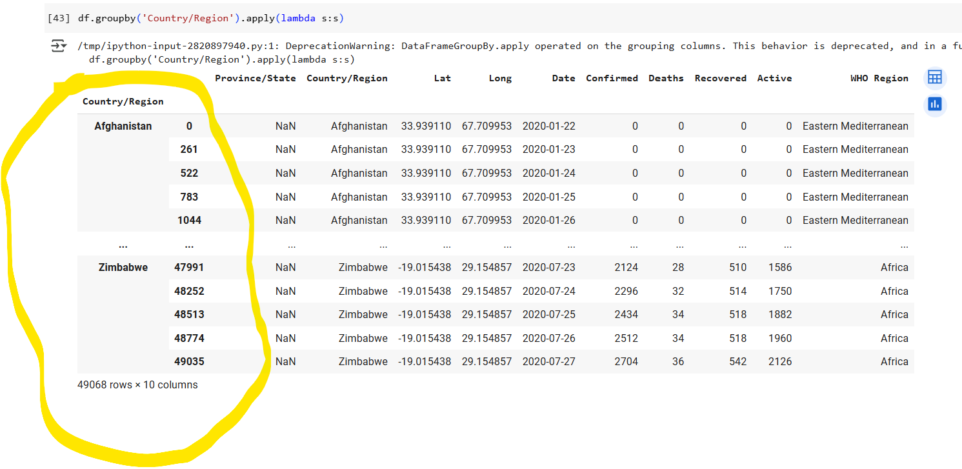

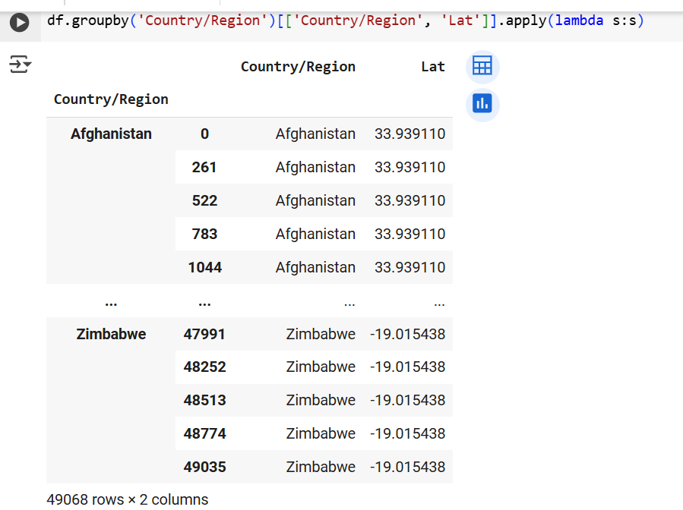
--
np.var(a) | All values together | 1.25

np.var(a, axis=0) | Column-wise (per feature) | [1. , 1. ]

np.var(a, axis=1) | Row-wise (per sample) | [0.25, 0.25]

--

No scaling before split :
If you scale all of them together, the mean becomes higher because of the test values — so your training data gets scaled based on information it shouldn't have.

--

An embedding is a vector representation of data in embedding space. Generally speaking, a model finds potential embeddings by projecting the high-dimensional space of initial data vectors into a lower-dimensional space
embedding space
The d-dimensional vector space that features from a higher-dimensional vector space are mapped to. Embedding space is trained to capture structure that is meaningful for the intended application. The dot product of two embeddings is a measure of their similarity.
--
numpy.quantile() - 50th percentile (median); np.quantile(a, 0.5)
a = np.array([ [14, 17, 12, 33, 44],
[15, 6, 27, 8, 19],
[23, 2, 54, 1, 4]
])

# Median of all elements
print(np.quantile(a, 0.5))
# 25th percentile of each column
print(np.quantile(a, 0.25, axis=0))
# Median of each row
print(np.quantile(a, 0.5, axis=1))
--

# Step 1: Normalize movie names
normalized_names = df_movies['Movie Name'].str.lower().str.strip()

# Step 2: Find duplicated names (names with count > 1)
duplicate_names = normalized_names[normalized_names.duplicated(keep=False)]

# Step 3: Filter original DataFrame where normalized names are duplicated
df_duplicates = df_movies[normalized_names.isin(duplicate_names)]

# Show the result
print(df_duplicates)

better:
df_movies = df_movies.drop(
index=df_movies[df_movies['Movie Name'].str.lower().str.strip().duplicated(keep='first')].index
)
--
missing_genres = df_movies[df_movies.isna().any(axis=1)]['Genre'].unique()

df_movies.groupby(by=['Genre'], as_index=False)[['GenreCode']].first() \
.query("Genre in @missing_genres")
--
mask = df_movies['GenreCode'].isna()
df_movies.loc[mask, 'GenreCode'] = df_movies.loc[mask, 'Genre'].map(dict_genre_map)

genre_masked = df_movies.isna().any(axis=1)
df_movies.loc[genre_masked, ['GenreCode']] = df_movies[genre_masked]['Genre'].map(dict_genre_map) # map function with a series/dict and return replaced-value series. Given [a, b, c] return [1, 2, 3] if dict is {‘a’: 1, ‘b’: 2, ‘c’: 3 }
Ah, even in fillna , can pass dict/series apart from scaler value like 0.
df_movies['GenreCode'].fillna(
df_movies['Genre'].map(
df_movies.dropna(subset=['GenreCode'])
.drop_duplicates('Genre')
.set_index('Genre')['GenreCode']
)
)
--
Np.random.randint
Np.random.choice

--

**3. .max()
This applies the max function per column, per group.
For each genre_code:
- It finds the maximum movie_name alphabetically (because max on strings compares lexicographically).
- It finds the maximum predicted_rating numerically.
⚠ Important Thing to Notice
- It does not return the movie with the highest rating unless the movie_name and predicted_rating maxima happen to occur for the same row.
--
REMEMBER : any axis with user function, apply gives full df as result :
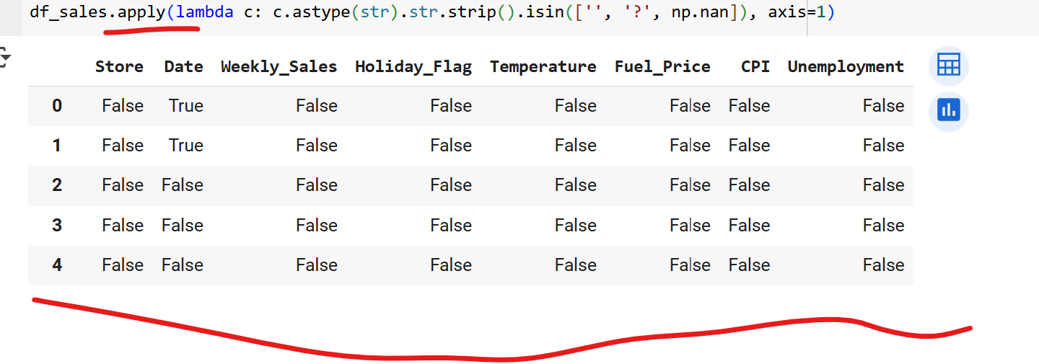
Can use any function to shrink as column-boolean series or index-boolean series.

df_sales.groupby(df_sales['Date'].dt.to_period('M'))['Weekly_Sales'].sum()
This way, Pandas keeps it in chronological(sequential) order.
--

(df.groupby(by='Country/Region')['Province/State']
.apply(lambda s: True if s.any() else np.nan)
.dropna())
--
df['tenure'].shape → (1000,)
X = df[['tenure']].shape → (1000, 1)
--

