Linear Combination :
linear combination or superposition is an expression constructed from a set of terms by multiplying each term by a constant and adding the results (e.g. a linear combination of x and y would be any expression of the form ax + by, where a and b are constants).
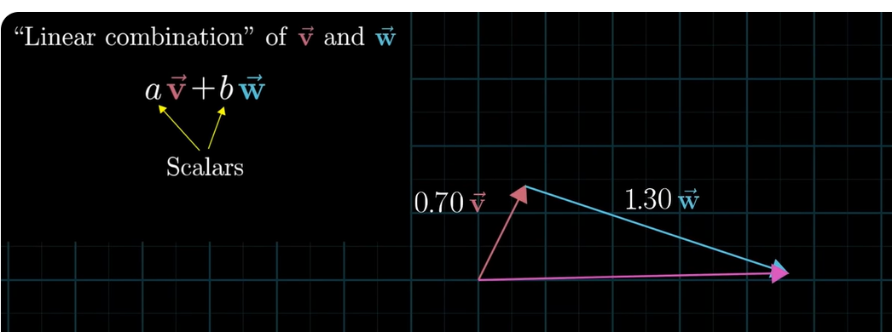
Note: the new vector also starts from orgin. (all vectors are start in orgin)
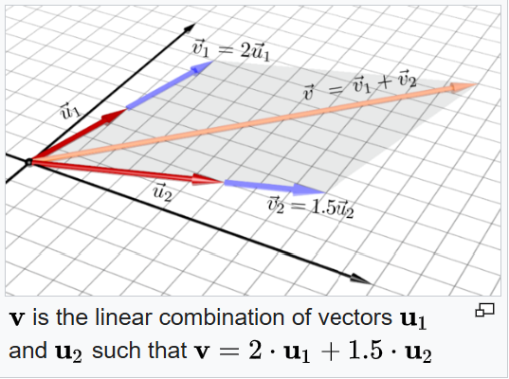
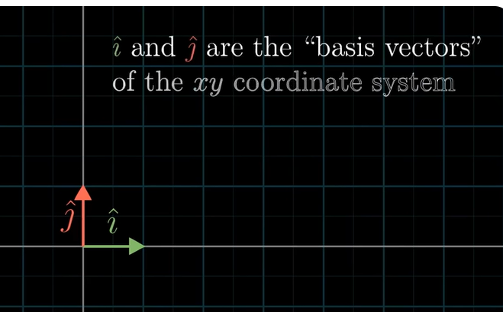
A set of vectors is linearly independent if no vector in the set can be expressed as a linear combination of the others. In simpler terms, if you can't reach one vector by scaling and adding the others, they are linearly independent. If a set of vectors is not linearly independent, it is called linearly dependent.
Linearly Dependent : one vector is able to reach another vector on scaling, then it is linearly dependent.

Linear Transformation:
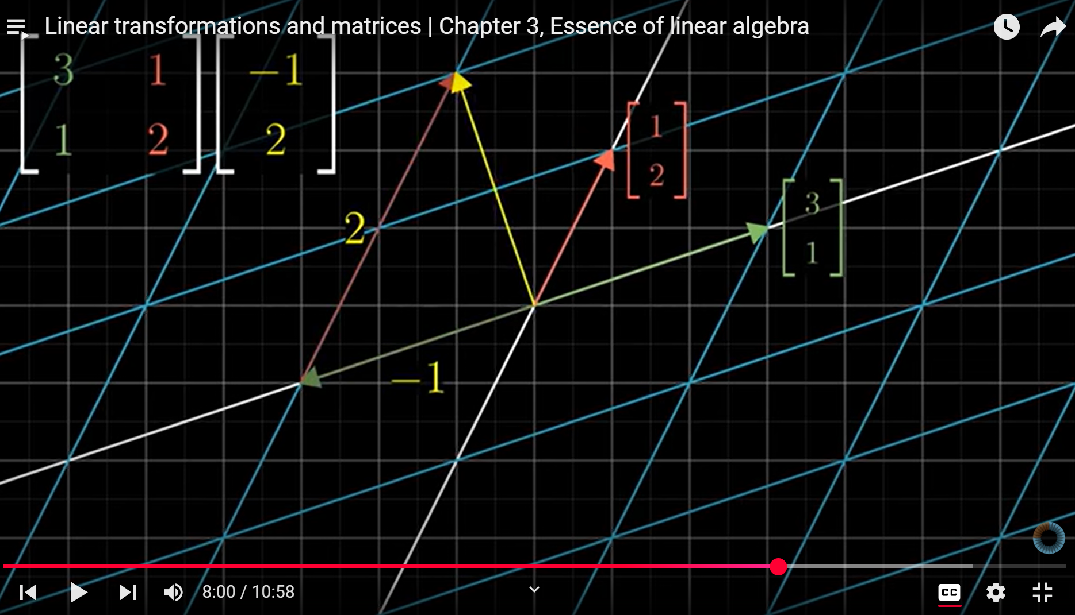
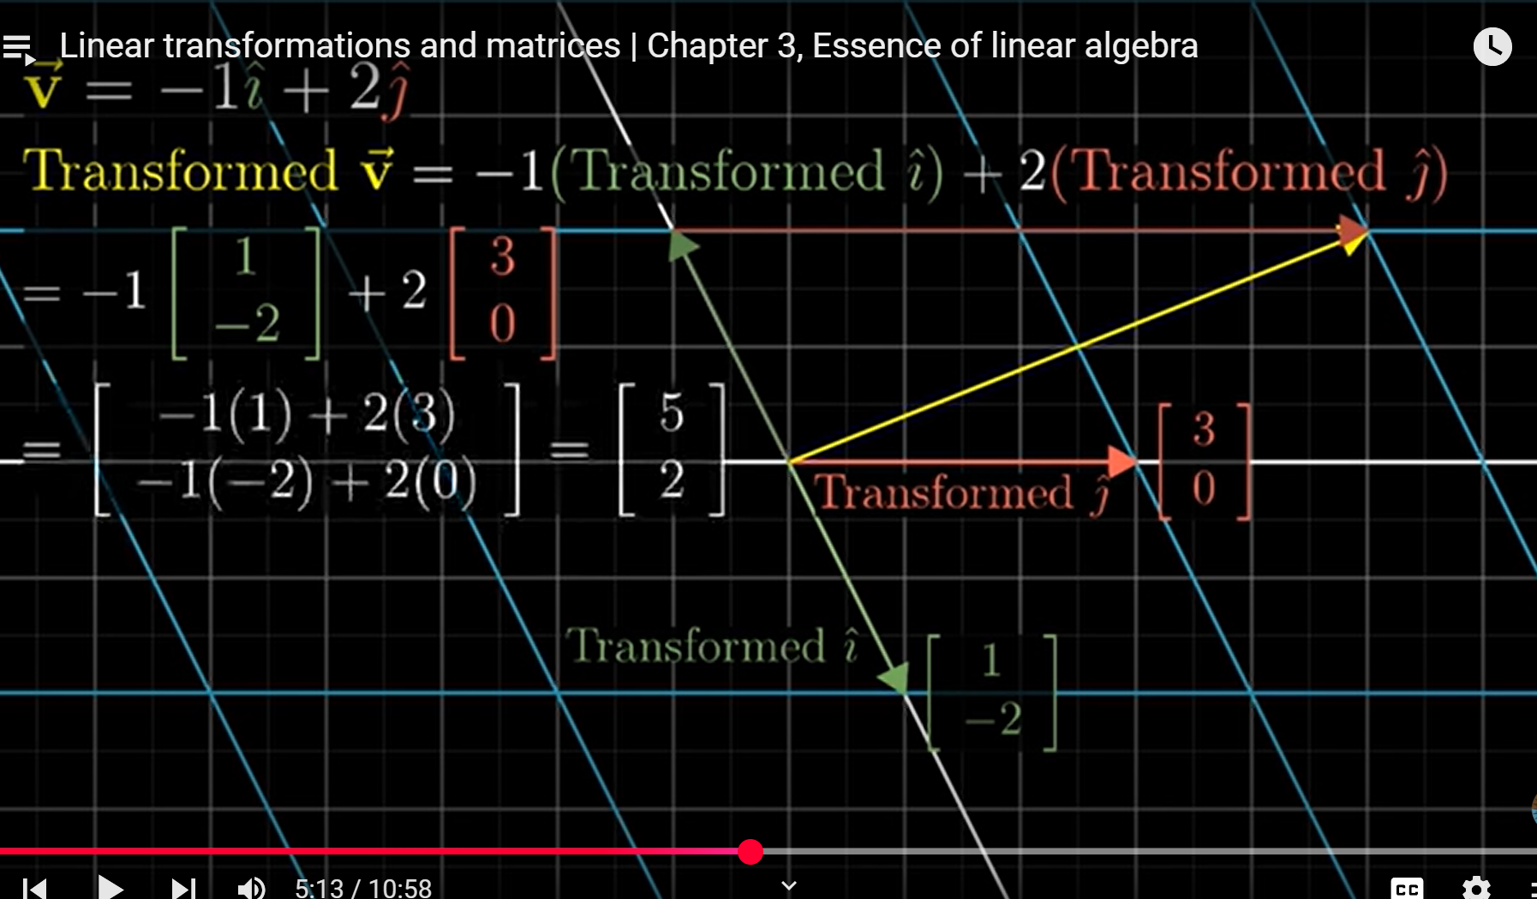

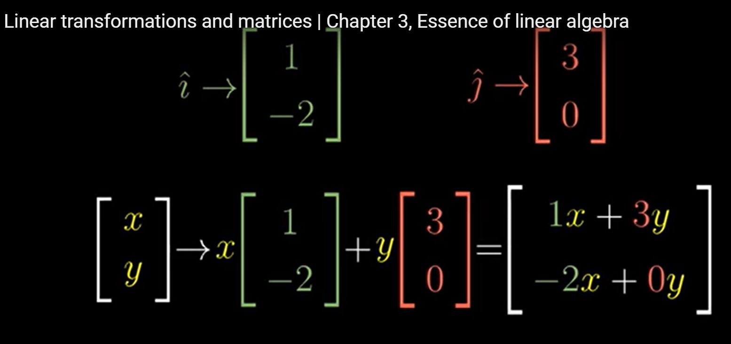

--
- The inverse matrix is also found using the following equation:
A⁻¹= adj(A)/det(A),
where adj(A) refers to the adjoint of a matrix A, det(A) refers to the determinant of a matrix A.

Intuitively, the inverse of a matrix is another matrix that, when multiplied by the original, results in the identity matrix. This is analogous to the reciprocal of a number, where multiplying a number by its reciprocal yields 1. The inverse "undoes" the transformation performed by the original matrix.
Reciprocal of x is 1/x , i.e x product of 1/x gives 1. ;; 1/x = x⁻¹
Similarly inverse of matrix A⁻¹ undo the transformation performed by the A.
So obvious, A. A⁻¹ = I (identity matrix, all diagonal 1, other elements are 0).

Intuitively, the adjoint of a matrix (also known as the adjugate) can be thought of as a "helper" matrix that aids in finding the inverse of a matrix. It's closely related to the inverse but exists even when the matrix is not invertible (i.e., has a determinant of zero). Specifically, it's the transpose of the matrix of cofactors.

The determinant of a matrix is a scalar value that can be computed from the elements of a square matrix. It provides information about the matrix's properties, such as whether it is invertible. For a 2x2 matrix [[a, b], [c, d]], the determinant is calculated as ad - bc.
A non-zero determinant indicates that the matrix is invertible (has an inverse), while a zero determinant means the matrix is singular and non-invertible.
In 2d space – it is area ;; in 3d space – it is volume.
|A| = 0; then A is singular matrix. Determinant only for square matrix.

co-factor matrix – helps to find adjoint of matrix, inverse matrix and determinant of matrix.

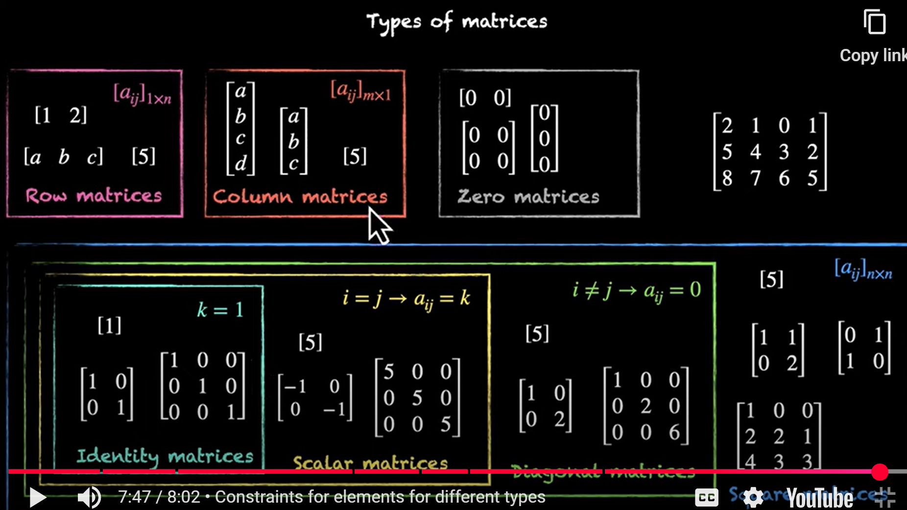

AB is not equal to BA ; multiplication of matrices not commutative.
(A*B)*C=A*(B*C) ; matrix multiplication is associative.
A(B+C) is not the same as (B+C)A. distributive property of multiplication of matrices.
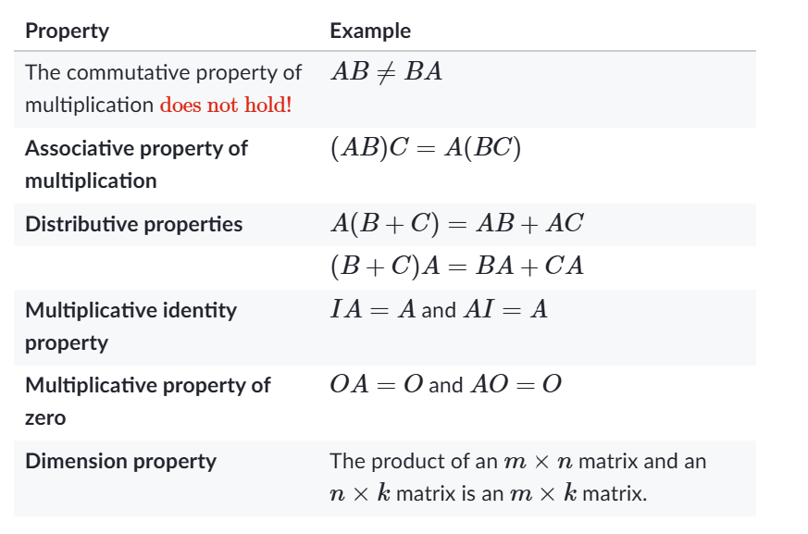
 reverse order.

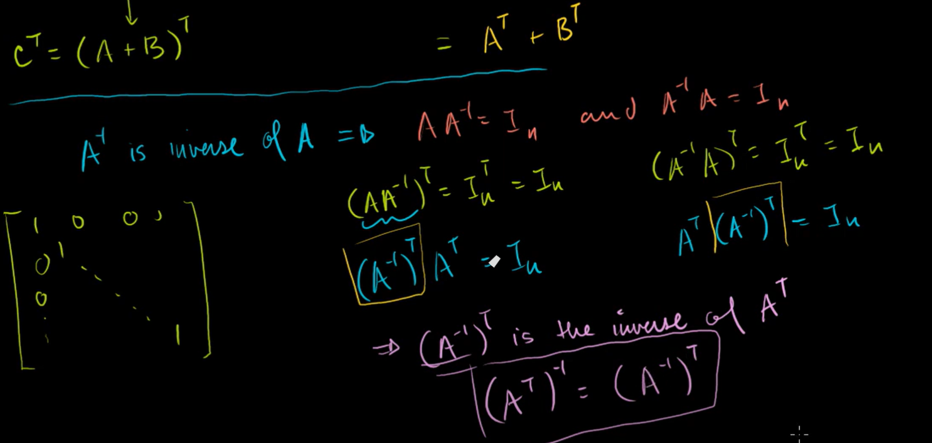
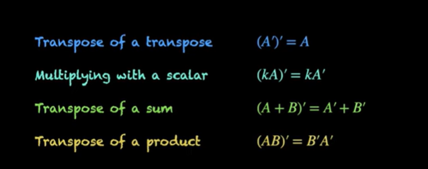
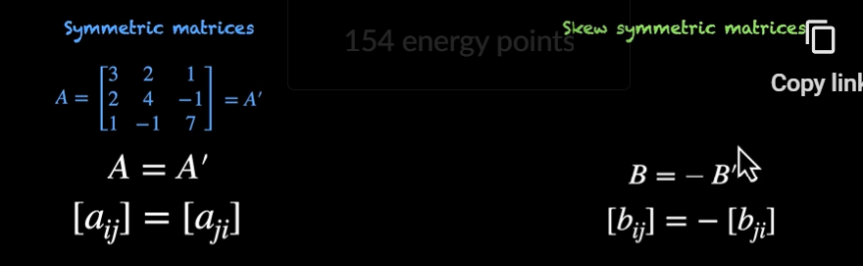
Here A-dash is transpose of A.

Singular matrix : (determinant =0, why determinant zero and why no inverse for singular, and how inverse become undefined as determinant is zero)
https://youtu.be/UqyN7-tRS00
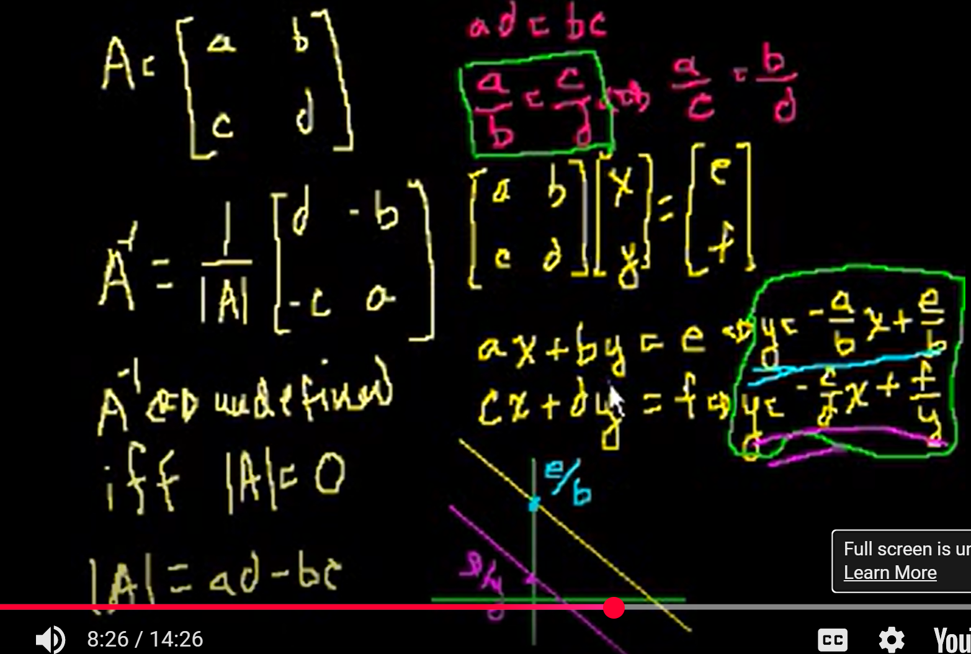
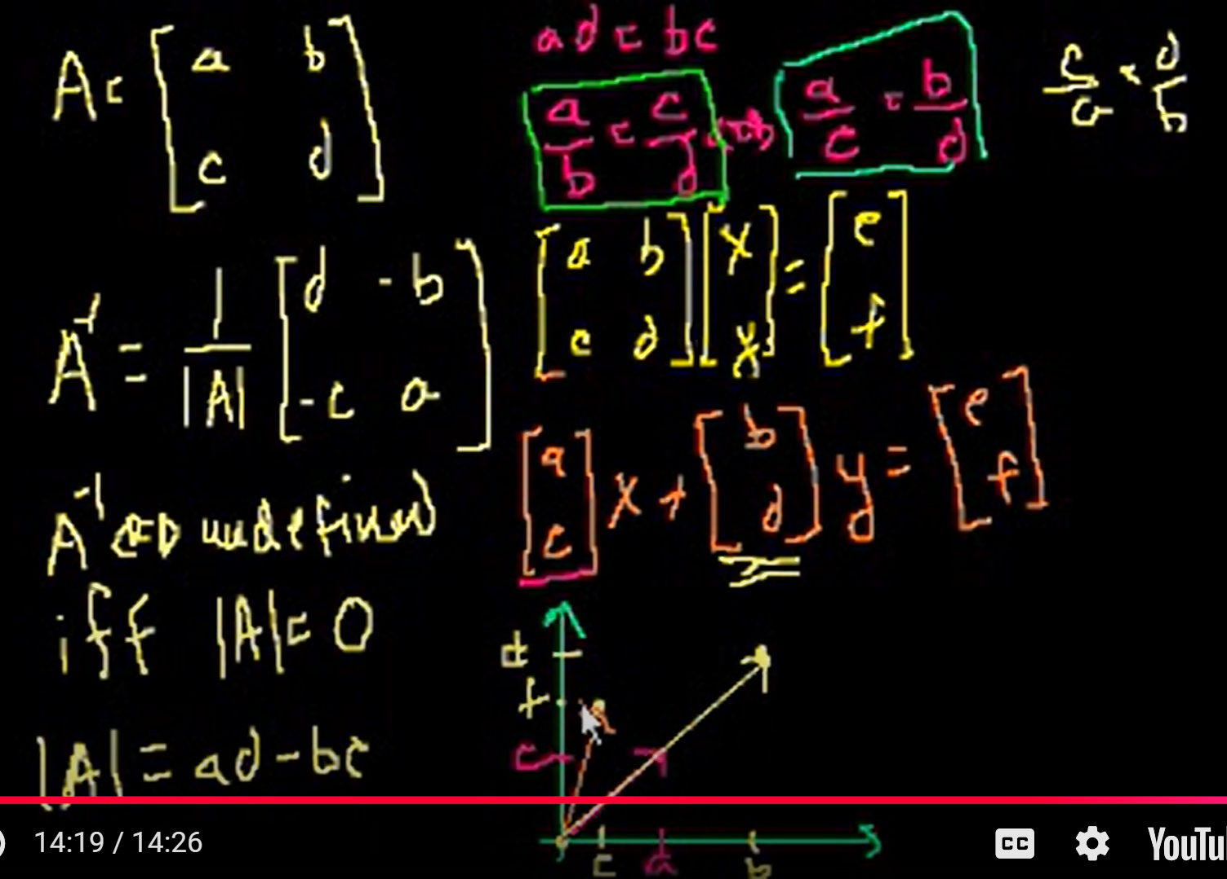
--
Eigen vector : if scaled vector not change the span in column space, that is eigen vector.

- Matrix transformation (3b1b)
- Statquest, projecting, projecting is the dot matrix. Rotation, singular vector, eigen vector. Singular value and singular vector. How ss(d) related to lambda in formula.
- Chatgpt and google ml docs.

PCA can be done using :
- SVD – singular value decomposition
- Weighted Matrix Factorization
There are two ways to do PCA:
1) The old way, which applies eigen-decomposition to the covariance matrix and
2) The new way, which applies singular value decomposition to the raw data.

--

A quadratic equation is a polynomial equation of the second degree, meaning the highest power of the variable is 2. It can be written in the standard form: ax² + bx + c = 0, where a, b, and c are coefficients (constants) and 'a' cannot be zero.

sin(θ) | ☁️ Sky guy | - Vertical component

cos(θ) | 🌍 Earth guy | - Horizontal component

tan(θ) | 🧗 Climber | - Steepness (slope or incline)
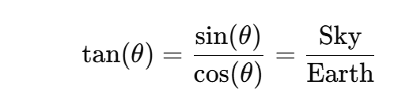
Dot product / inner product :
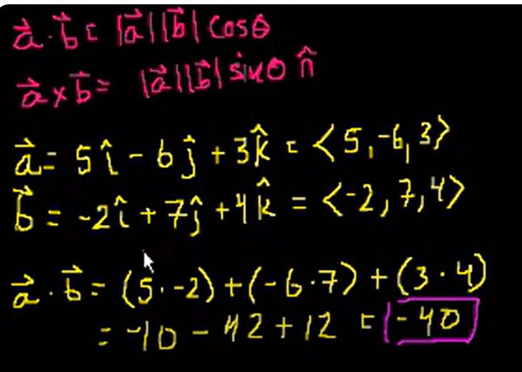

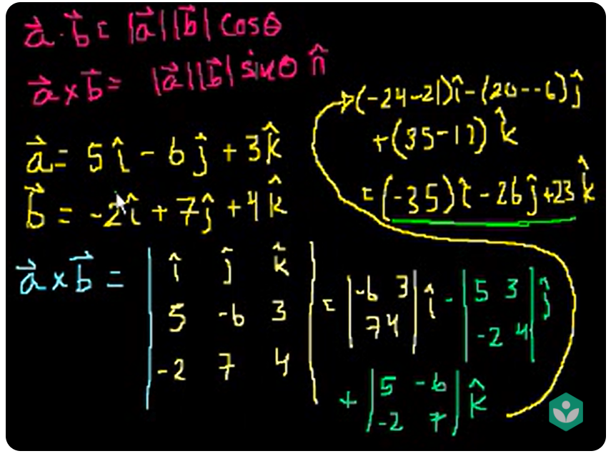
The result vector perpendicular (right hand rule) to the both a and b vectors.

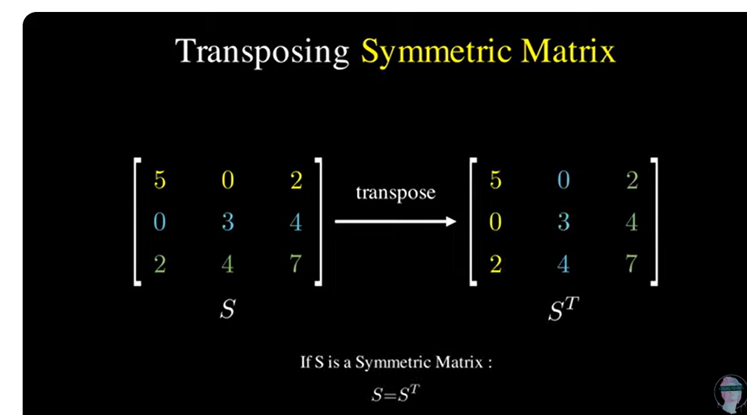
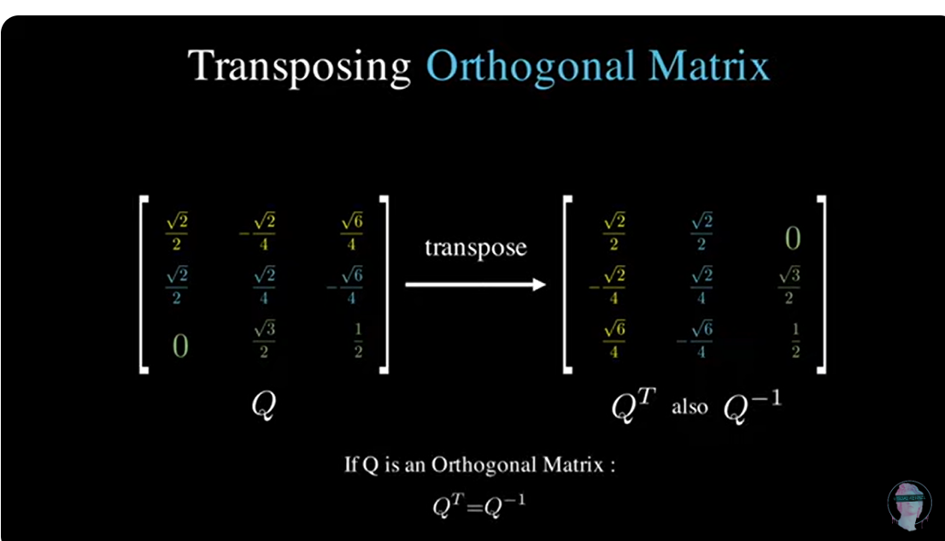

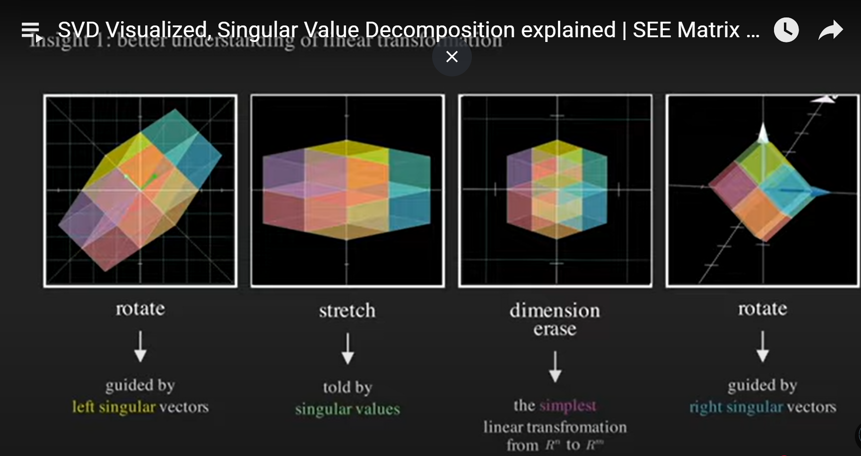

np.var(a) | All values together | 1.25

np.var(a, axis=0) | Column-wise (per feature) | [1. , 1. ]

np.var(a, axis=1) | Row-wise (per sample) | [0.25, 0.25]

--

No scaling before split :
If you scale all of them together, the mean becomes higher because of the test values — so your training data gets scaled based on information it shouldn't have.

--

An embedding is a vector representation of data in embedding space. Generally speaking, a model finds potential embeddings by projecting the high-dimensional space of initial data vectors into a lower-dimensional space
embedding space
The d-dimensional vector space that features from a higher-dimensional vector space are mapped to. Embedding space is trained to capture structure that is meaningful for the intended application. The dot product of two embeddings is a measure of their similarity.
--
numpy.quantile() - 50th percentile (median); np.quantile(a, 0.5)
a = np.array([ [14, 17, 12, 33, 44],
[15, 6, 27, 8, 19],
[23, 2, 54, 1, 4]
])

# Median of all elements
print(np.quantile(a, 0.5))
# 25th percentile of each column
print(np.quantile(a, 0.25, axis=0))
# Median of each row
print(np.quantile(a, 0.5, axis=1))
--

# Step 1: Normalize movie names
normalized_names = df_movies['Movie Name'].str.lower().str.strip()

# Step 2: Find duplicated names (names with count > 1)
duplicate_names = normalized_names[normalized_names.duplicated(keep=False)]

# Step 3: Filter original DataFrame where normalized names are duplicated
df_duplicates = df_movies[normalized_names.isin(duplicate_names)]

# Show the result
print(df_duplicates)

better:
df_movies = df_movies.drop(
index=df_movies[df_movies['Movie Name'].str.lower().str.strip().duplicated(keep='first')].index
)
--
missing_genres = df_movies[df_movies.isna().any(axis=1)]['Genre'].unique()

df_movies.groupby(by=['Genre'], as_index=False)[['GenreCode']].first() \
.query("Genre in @missing_genres")
--
mask = df_movies['GenreCode'].isna()
df_movies.loc[mask, 'GenreCode'] = df_movies.loc[mask, 'Genre'].map(dict_genre_map)

genre_masked = df_movies.isna().any(axis=1)
df_movies.loc[genre_masked, ['GenreCode']] = df_movies[genre_masked]['Genre'].map(dict_genre_map) # map function with a series/dict and return replaced-value series. Given [a, b, c] return [1, 2, 3] if dict is {‘a’: 1, ‘b’: 2, ‘c’: 3 }
Ah, even in fillna , can pass dict/series apart from scaler value like 0.
df_movies['GenreCode'].fillna(
df_movies['Genre'].map(
df_movies.dropna(subset=['GenreCode'])
.drop_duplicates('Genre')
.set_index('Genre')['GenreCode']
)
)
--
Np.random.randint
Np.random.choice

--

**3. .max()
This applies the max function per column, per group.
For each genre_code:
- It finds the maximum movie_name alphabetically (because max on strings compares lexicographically).
- It finds the maximum predicted_rating numerically.
⚠ Important Thing to Notice
- It does not return the movie with the highest rating unless the movie_name and predicted_rating maxima happen to occur for the same row.
--
REMEMBER : any axis with user function, apply gives full df as result :
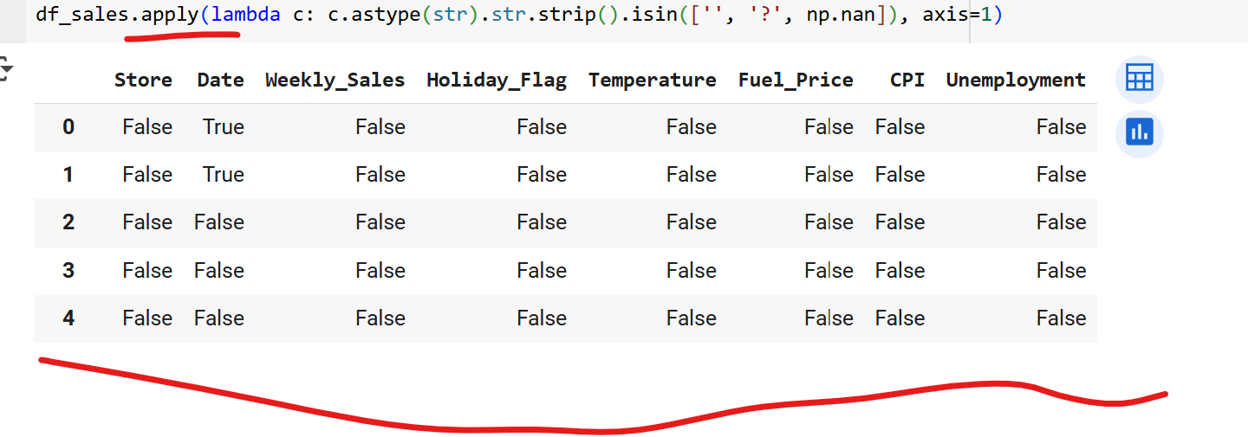
Can use any to shrink as column-boolean series or index-boolean series.

df_sales.groupby(df_sales['Date'].dt.to_period('M'))['Weekly_Sales'].sum()
This way, Pandas keeps it in chronological(sequencial) order.

