import mysql.connector as conn
my_db = conn.connect(host='', user='', passwd='')
cur = my_db.cursor()
cur.execute('show databases')
for r in cur:
print(r)

my_db = conn.connector(host='localhost', user='', passwd='', database='')
cur = my_db.cusrsor()
cur.execute('show tables')

for r in cur:
print(r)

# insert many
qur = "insert into employee(empid, name) values(%s, %s)"
val = (101, 'Govind')
cur.execute(qur, val)
my_db.commit()
sql = "insert into employee(empid, name) values(%s, %s)"
val = [(102, 'Shankar'), (103, 'Swamy'), (104, 'Govind')]
cur.executemany(sql, val)
my_db.commit()

Thread :
from threading import Thread
t = Thread(target=target_func, args=(1,))
t.start()
t.join() #join with main thread, and main thread will wait here till the thread complete.

Multi threading :
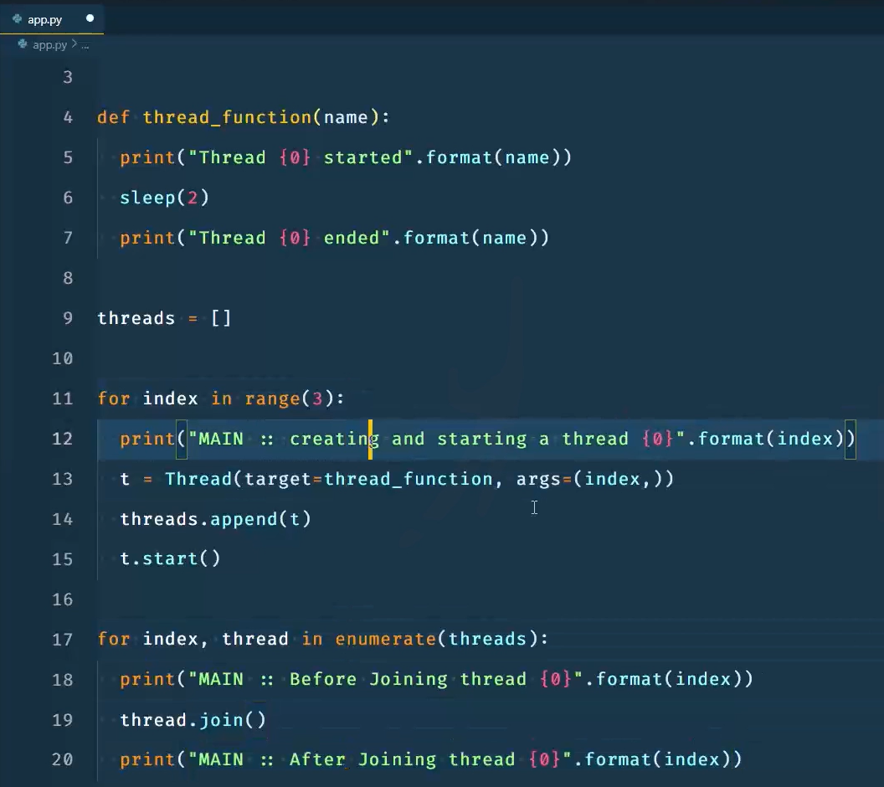

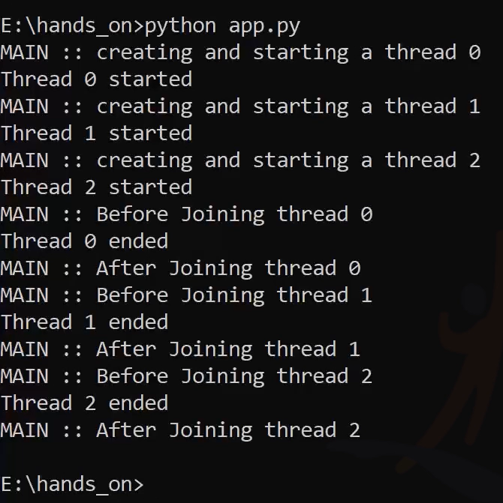

--

PySpark:
SparkContext - Main entry point for Spark functionality. A SparkContext represents the connection to a Spark cluster, and can be used to create :class:`RDD` and broadcast variables on that cluster.
- at least the master and app name should be set, either through the named parameters here or through `conf`.
- SparkContext(master, appName) :
master -Cluster URL to connect to (e.g. mesos://host:port, spark://host:port, local[4]); appName-A name for your job, to display on the cluster web UI.
- SparkFiles class is a handle, to deal with files added in the current SparkContext (using sc.addFile()), e.g. SparkFiles.getRootDirectory()

REST
Django
8000

---
Flask
5000
from falsk import Flask
from flask import request

app = Flask(__name__)

@app.route("/list_images")
def list_images():
request.form[]

res = make_response(render_template('error.html'), 404)
return res

----
Pyramid
6543

from wsgiref.simple_server import make_server
from pyramid.config import configurator
from pyramid.response import Response

def list_imags(request):
return Response(images)

def main():
with Configurator() as config:
config.add_route('route_name', 'pathinfo')
config.add_view(list_images, 'route_name')
app = config.make_wsgi_app()

server = make_server('ip', 6543, app)
server.server_forever()

----
Rabitmq

dramatiq

---

