Assignment 14

Entering,Deleting, and Changing Field Values.

Question 1 = Write a command that puts the following values,in their given order, into the salespeople table: city- San Jose, name – Blanco, comm – NULL , Snum - 1100.

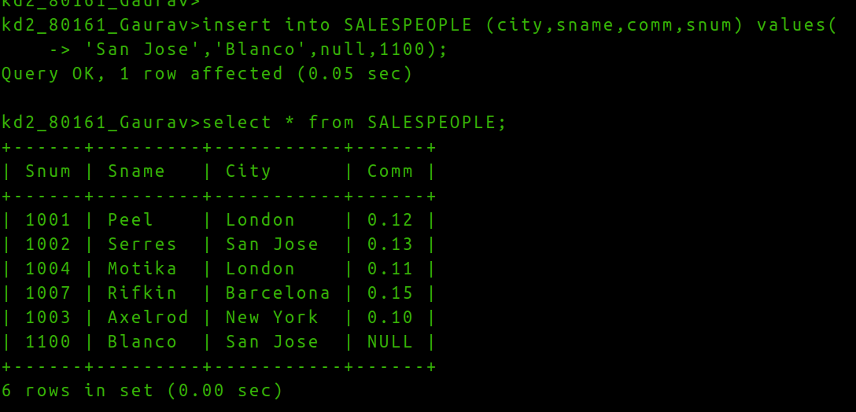

Question 2 = Write a command that removes all orders from customer Clemens from the Orders table.

Question 3. Write a command that increases the rating of all customers in rome by 100.
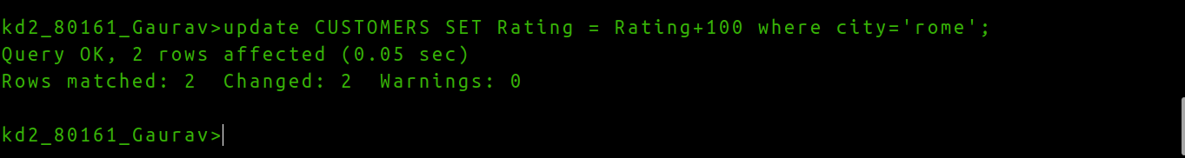

Question 4. Salesperson serres has left the company. Assign her customers to motika.

