Assignment-4
Q1
Write a select command that produces the order number, amount, and date for all rows in Orders table.

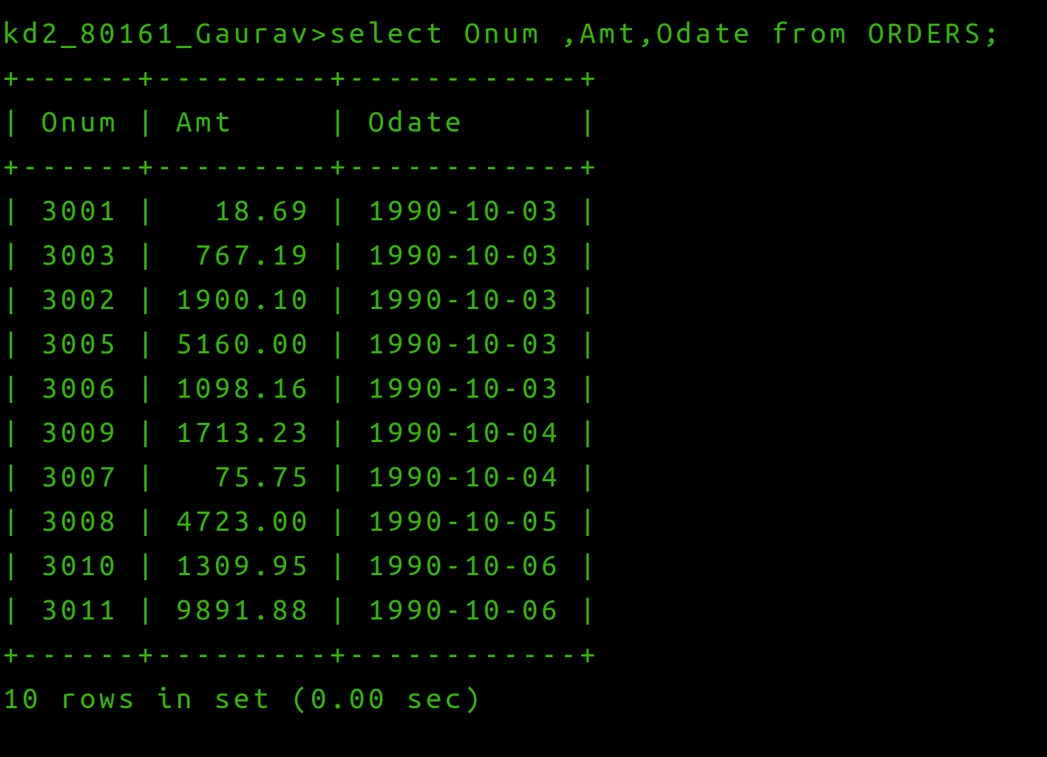

Q2 Write a query that produces all rows from the Customers table for which thhe salesperson’s number is 1001.

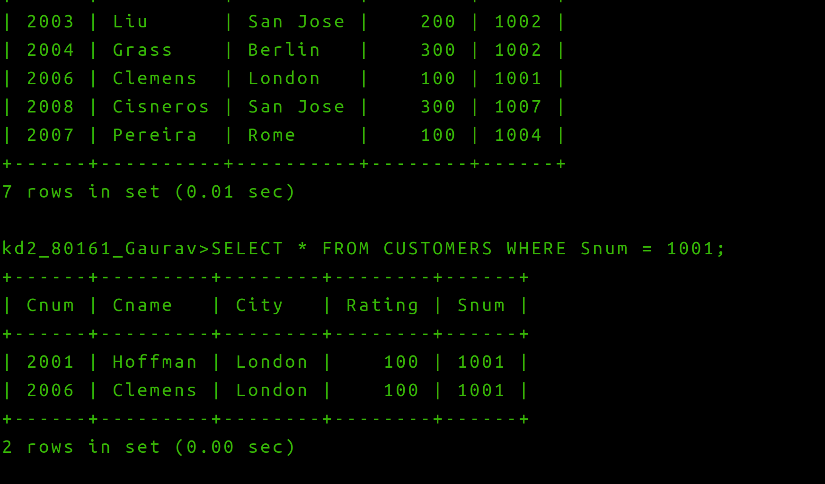
3) Write a query that displays the Salespeople table with columns in the following order:
city, sname, snum, comm.
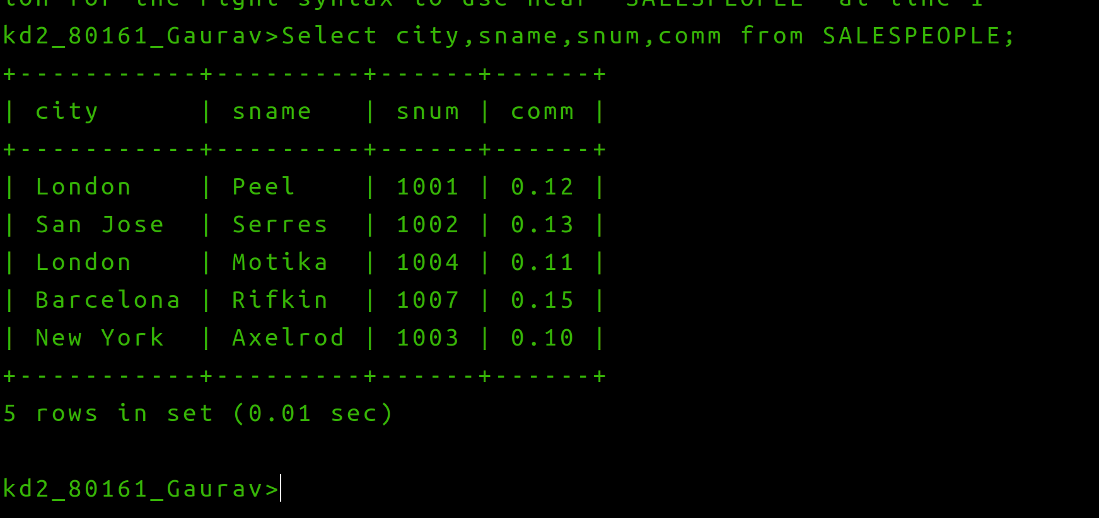
4) Write a selelct command that produces the rating followed by the name of each customer in San Jose
