Assignment 5
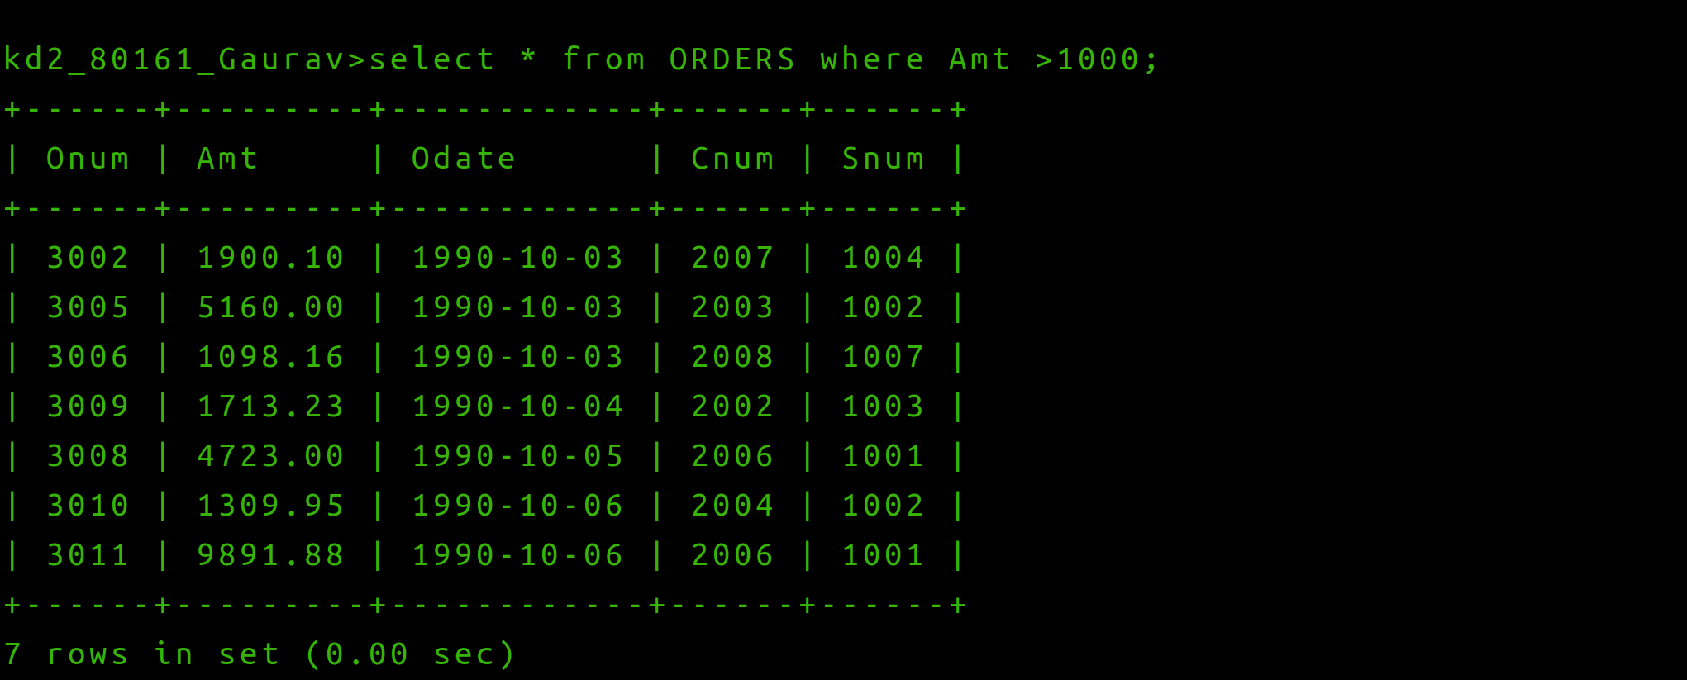
Q1 ) Write a query that will give you all orders for more than Rs. 1000.

Q2) Write a query that will give yo the names and cities of all salespeople in London with a commission above .10.
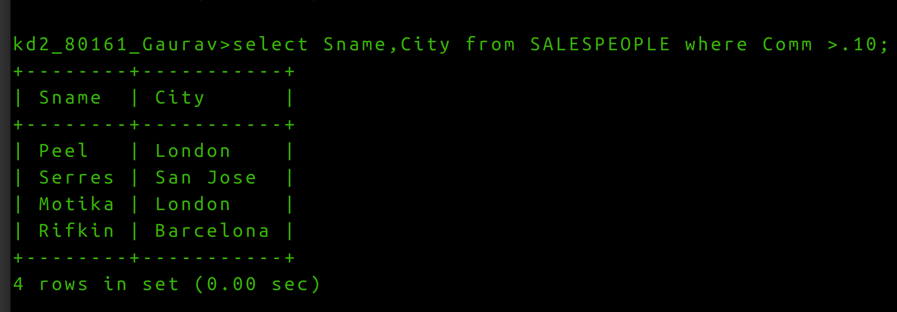
Q3) Write a query on the Customers table whose output will exclude all customers with an ratings <= 100, unless they are located in Rome.
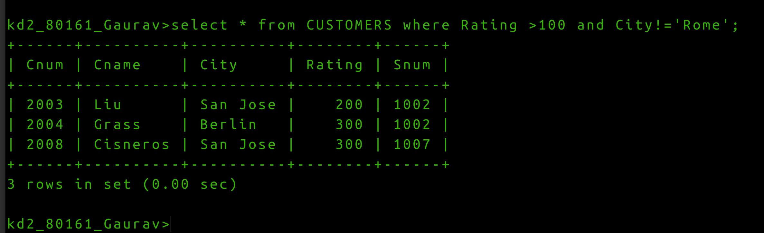

Q4) What will be the output from the following query?
Select * from Orders
where (amt< 1000 OR)
NOT (Odate = ‘1990-10-03’
AND (cnum > ‘1990-10-03’));

Q5) What wil be the output of the following query ?
Select * from Orders
where NOT ((odate = ‘1990-10-03’ OR snum
>1006) AND amt >=1500);
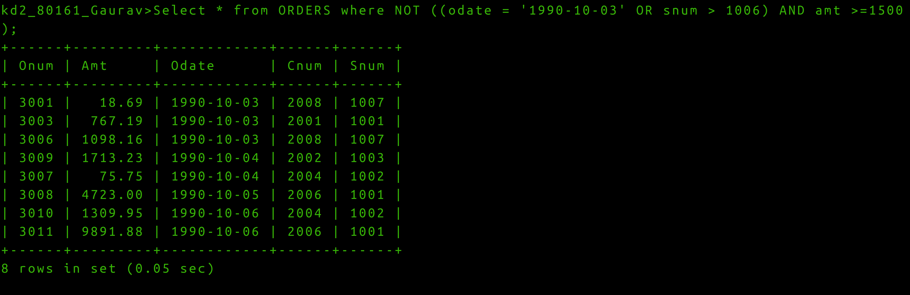
Q6 ) What is a simpler way to write this query?
Select snum, sname ,city,comm From Salespeople where (comm >.12 OR comm<.14);
