Assignment 11

Q1.Write a query that uses a subquery to obtain Orders for the customer named Cisneros. Assume you do not know his customer number(cnum).
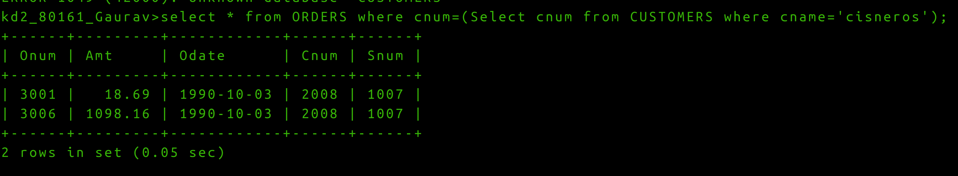

Q2. Write a query that produces the name and ratings of all customers who have above average orders.
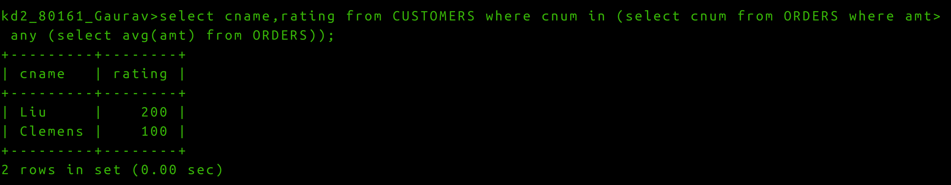

Q3 Write a query that selects the total amount in Orders for each salesperson for whom this total is greater that the amount of largest order in table.
