Assignment – 12
Q1) Write a query that selects all customers whose ratings are equal to or greater than ANY of Serres’.
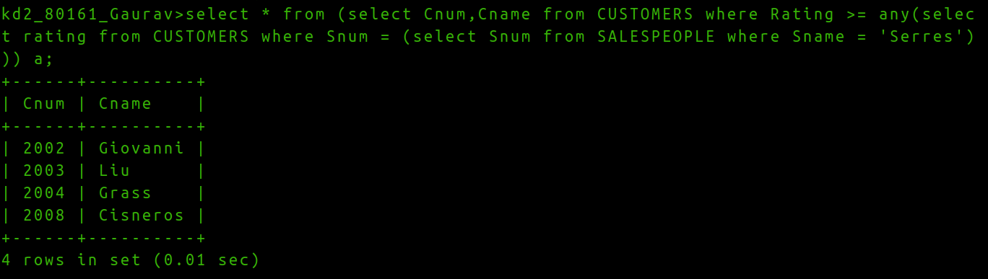

Q2) Write a query using ANY or ALL that will find all salespeole who have no customers located in their city.
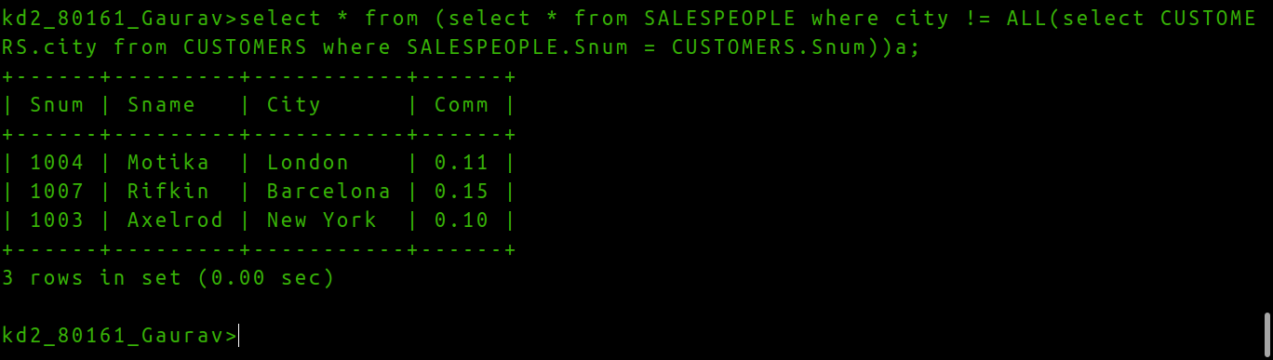

Question 3. Write a query that selects all orders for amounts greater than any for the customers in london.

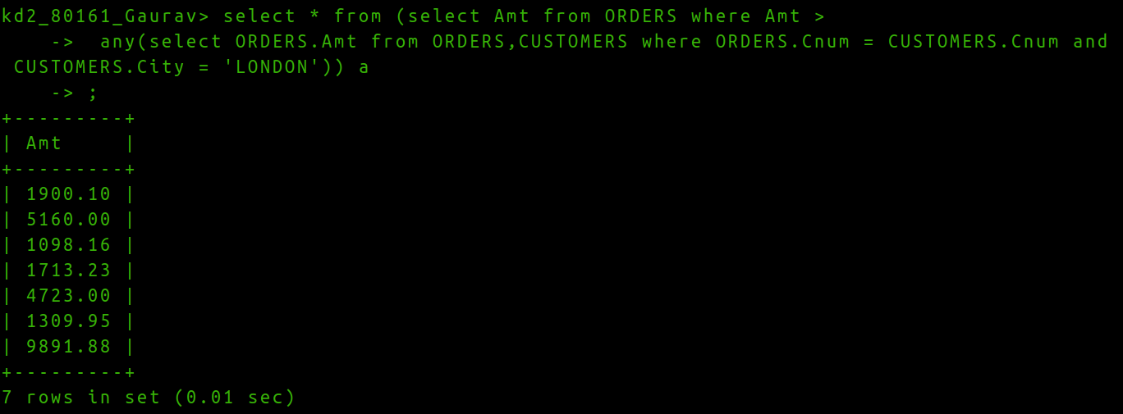

Question 4.Write the above query using MIN or MAX.

