Assignment – 6

Q1- Write two different queries that would produce all orders taken on October 3rd or 4th ,1990;

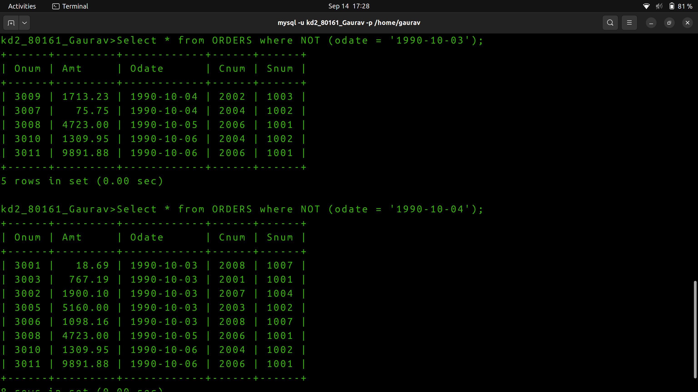
Q2 -Write a query that selects all of the customers serviced by Peel or Motika .(Hint: the snum field relates the two tables to one another).
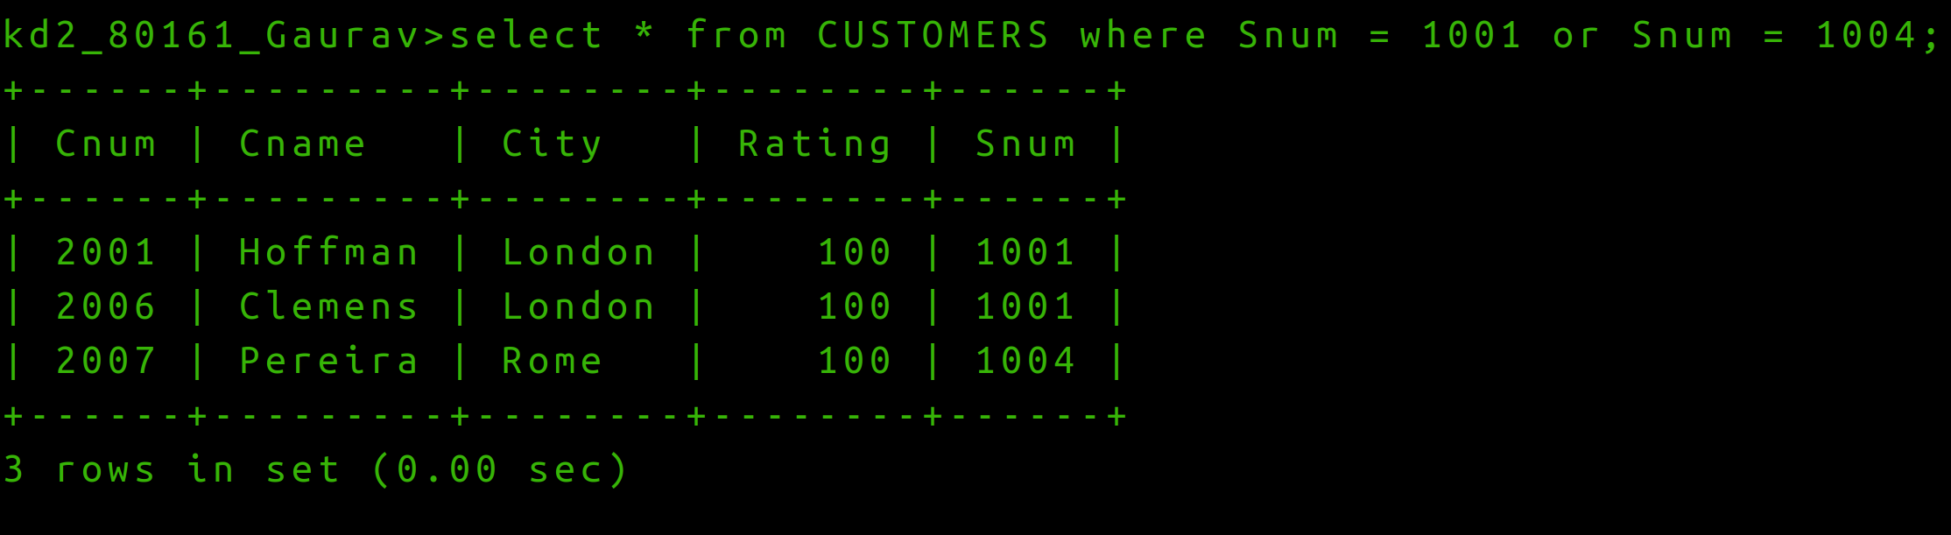

Q3,) Write a query that will produce all the customers whose names begin with a letter from ‘A’ to ‘G’.

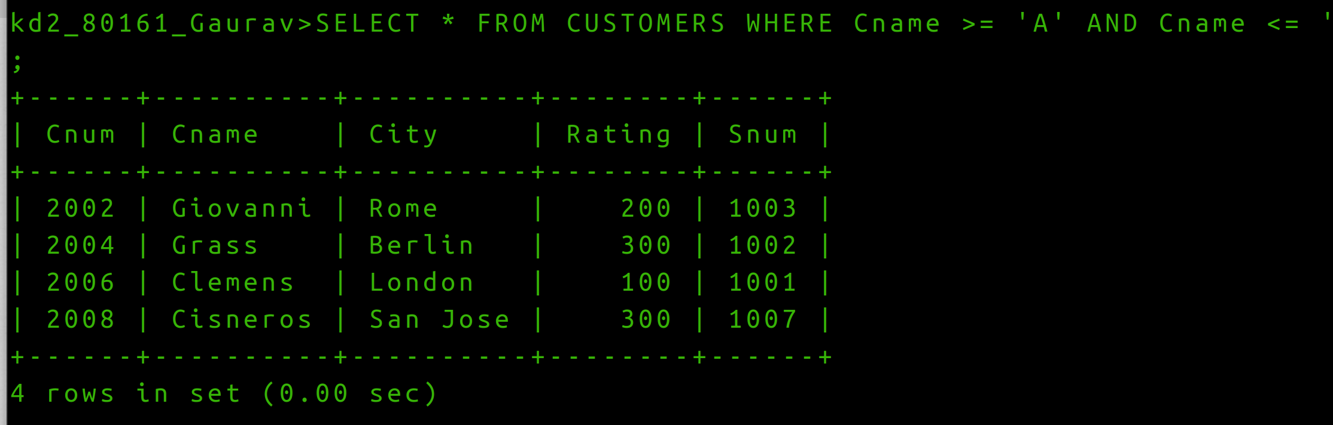

Q4 Write a query that selects all customers whose names begin withh the letter ‘C’.
Ans4)
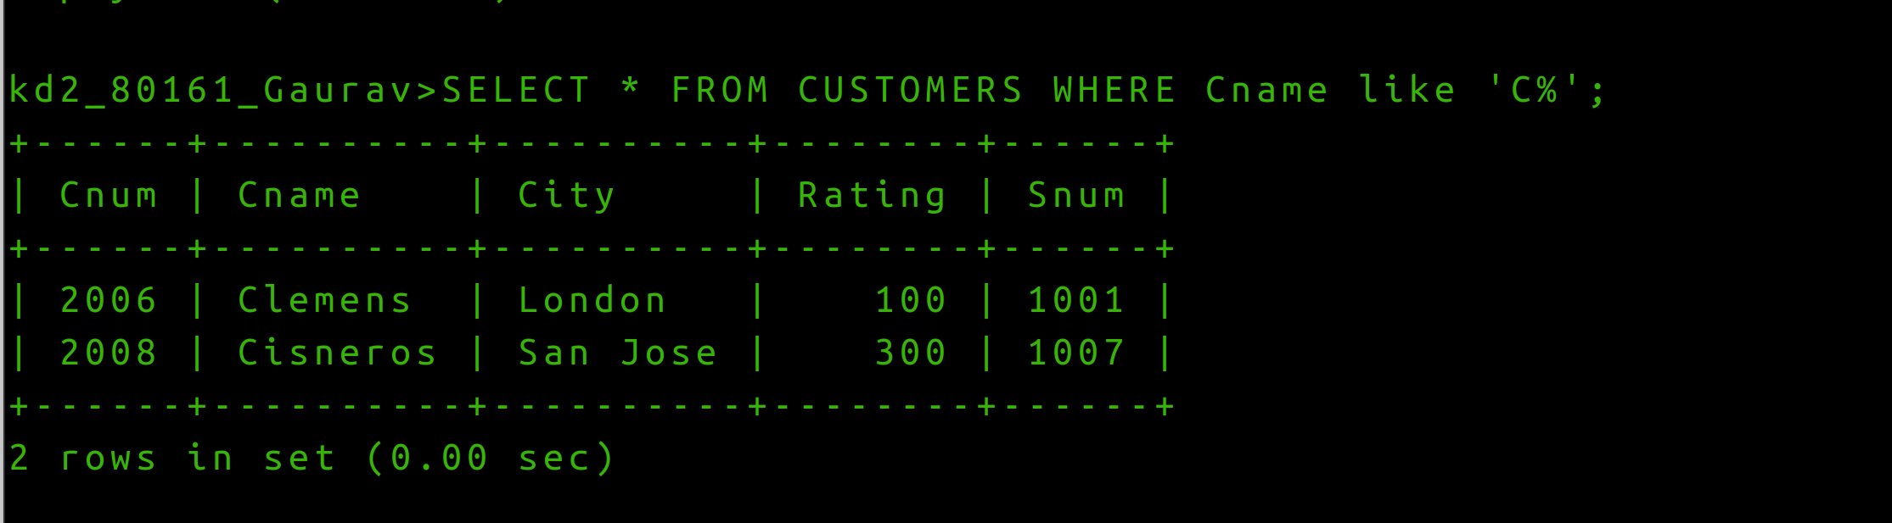

Q5) Write a query that selects all orders except those with zeros or NULLs in the amt field.
Ans 5)
