Assignment 7

Q1 Write a query that counts all orders for Ocotober 3;
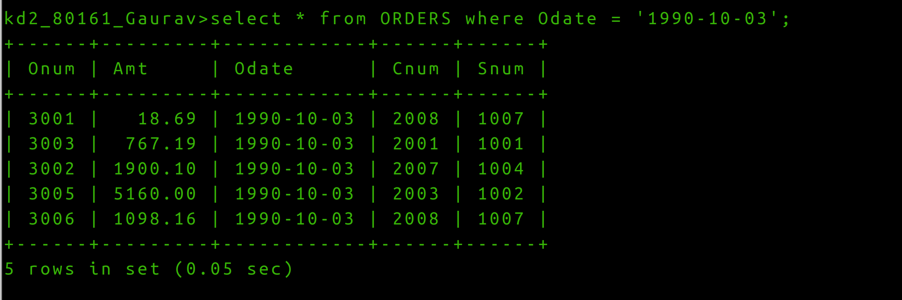
Q2 Write a query that counts the number of different non-NULL city values in the Customers table.
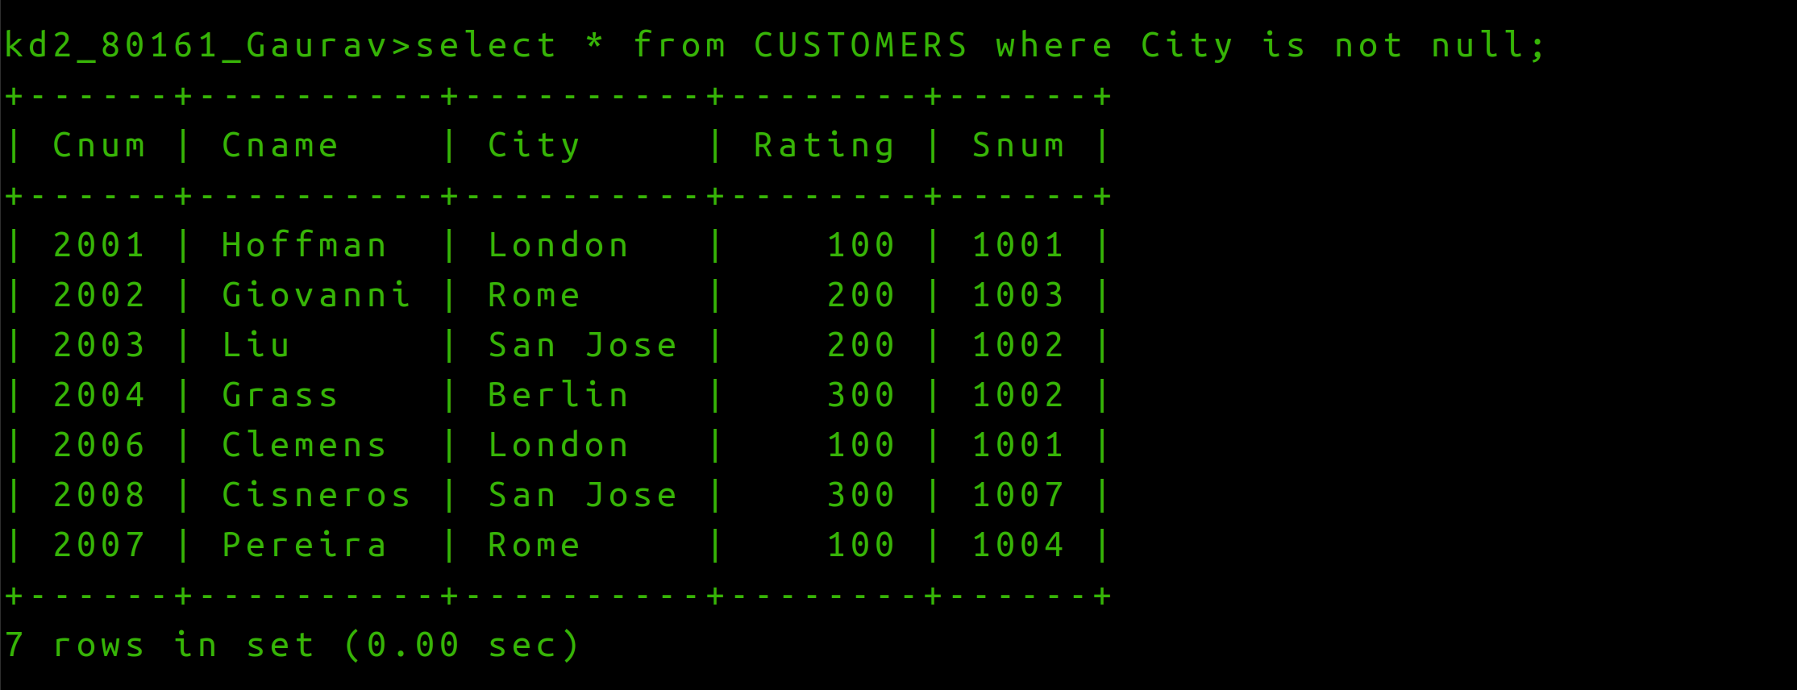
Q3 Write a query that selects each customer’s smallest order.
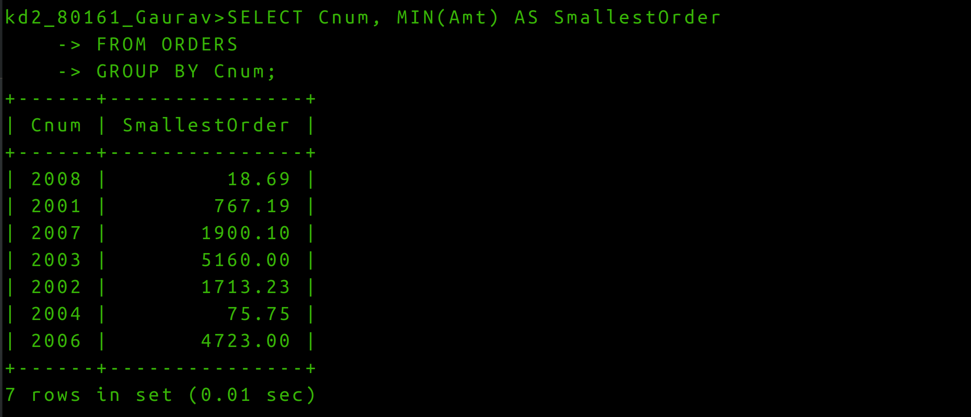

Q4 Write a query that selects the first customer, alphabetical order, whose name begins with G.
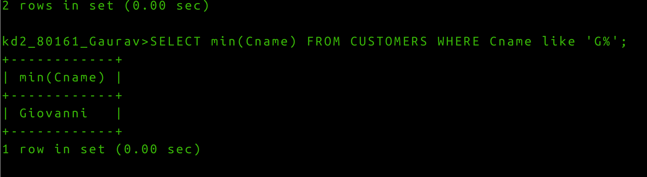
Q5) Write a query that selects the highest rating in each city.
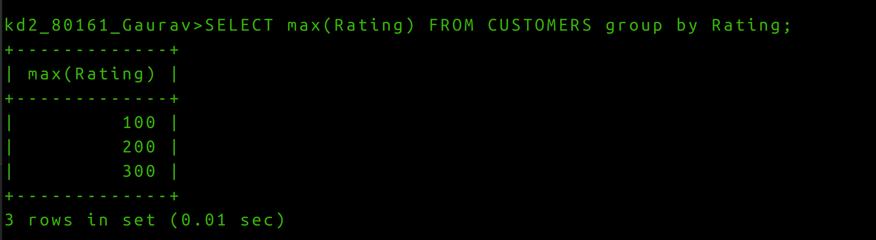
Q6 Write a query that counts the number of Salespeople registering orders for each day. (If a Salesperson has more tha one order on given day , he or she should be counted only once.).

