Assignment – 9

Q1) Write a query that lists each order number followed by the name of the customer who makde the order.
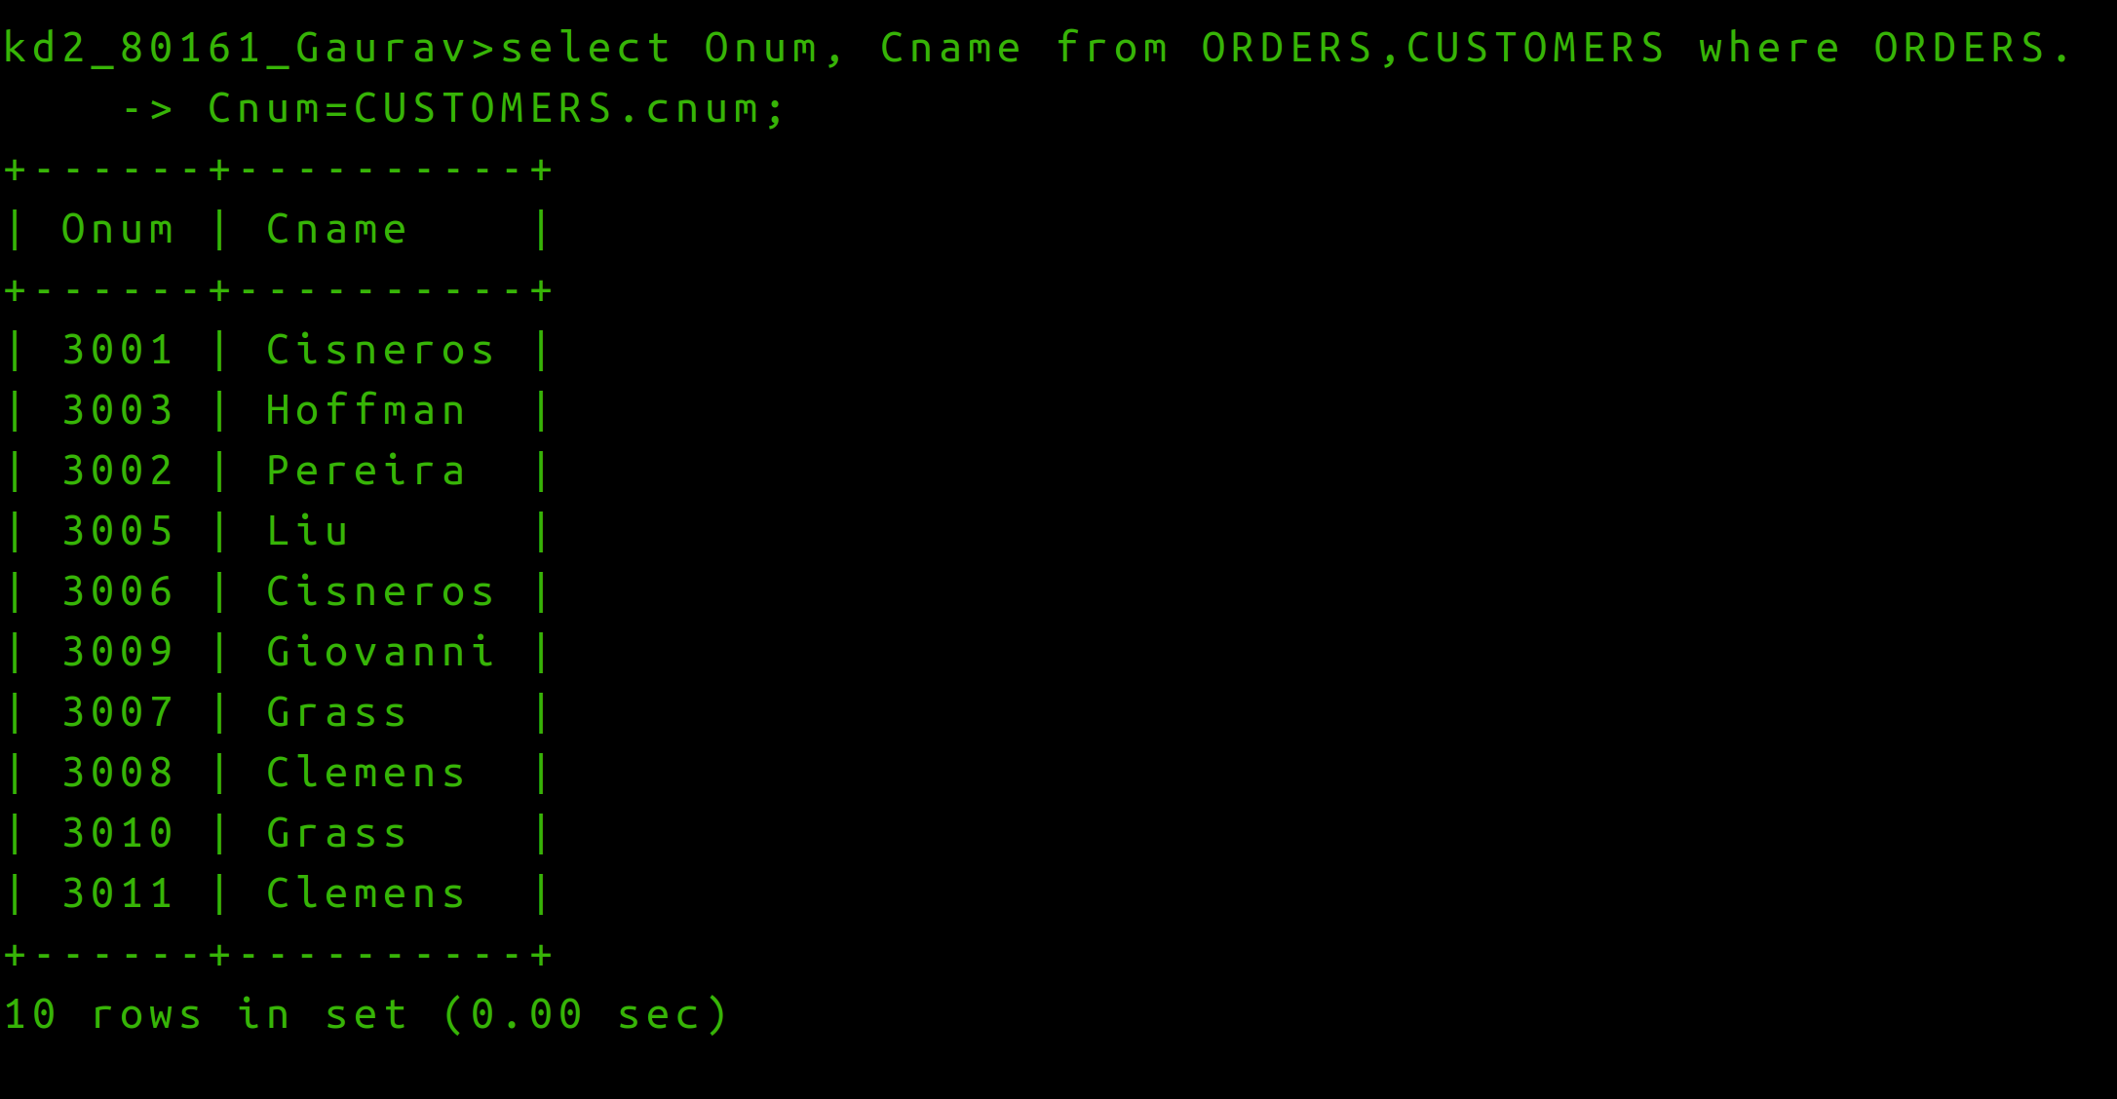
Q2) Write a query that gives the name of both the salesperson and the cuustomer for each order along with ther order number.
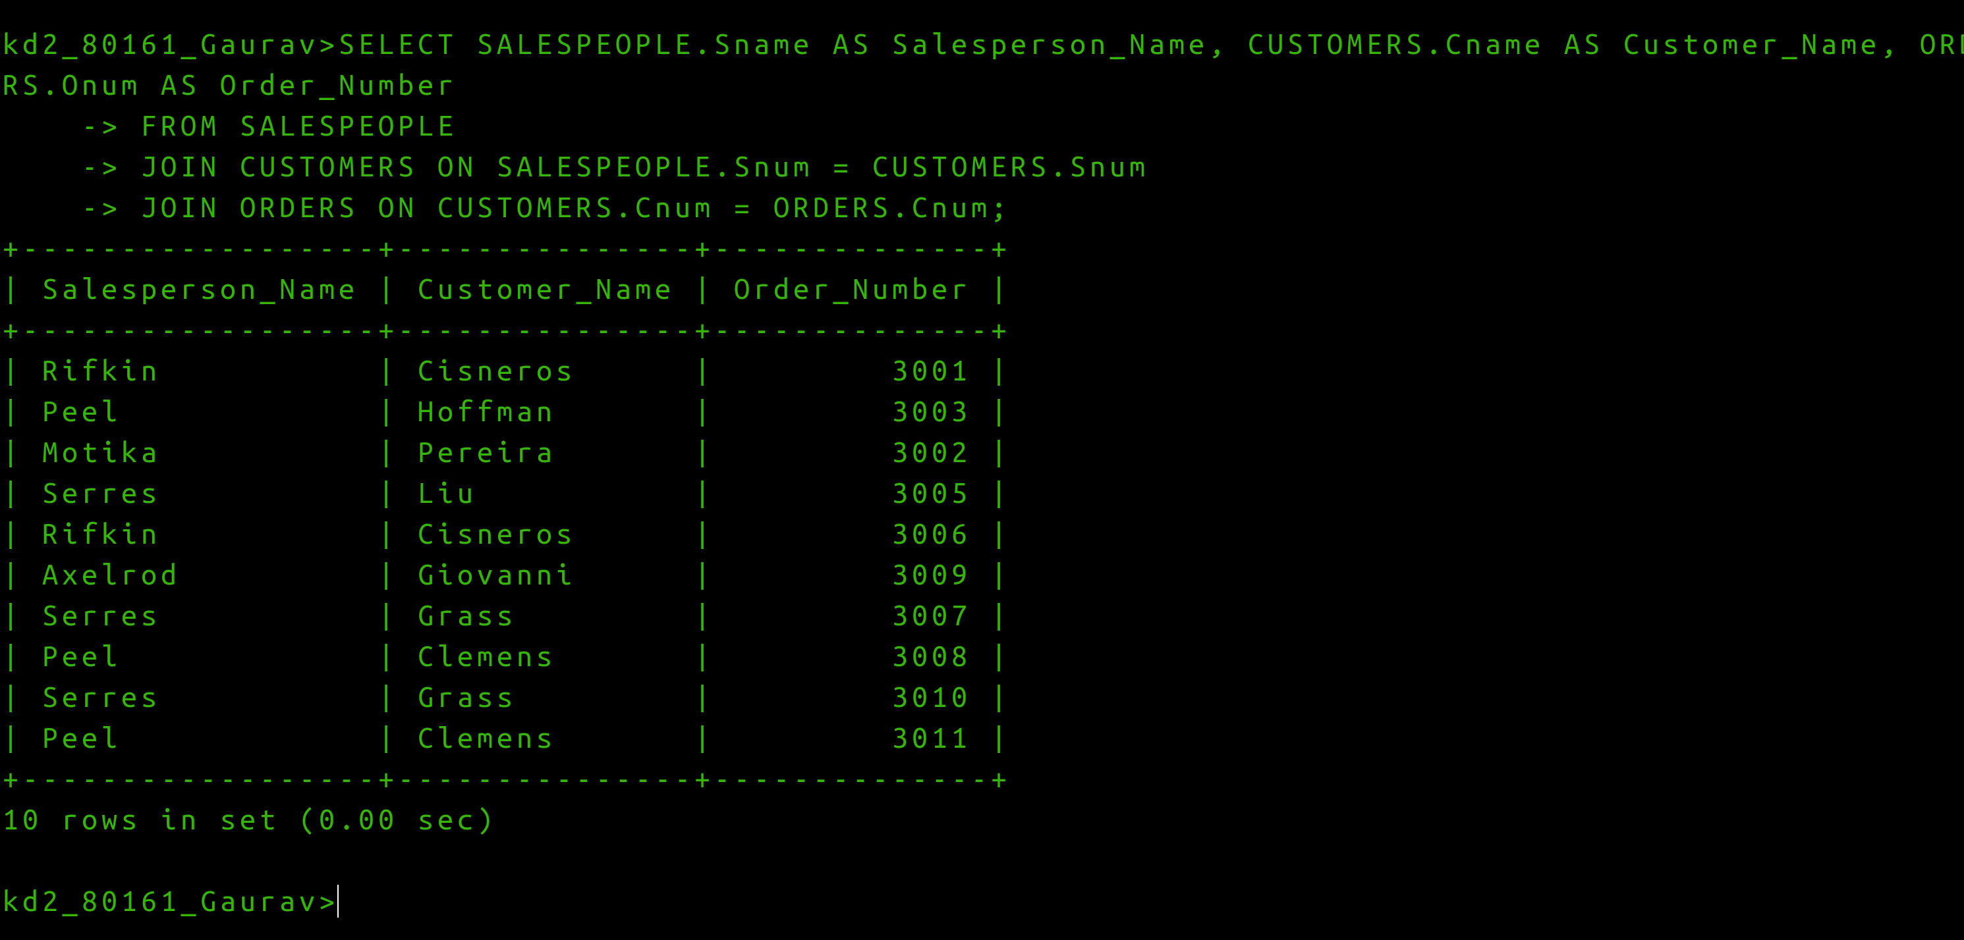

Q3 Write a query that produces all customers serviced by salespeople with a commission above 12%.Output the customer’s name the salesperson’s name, and the salesperson’s rate of commission.

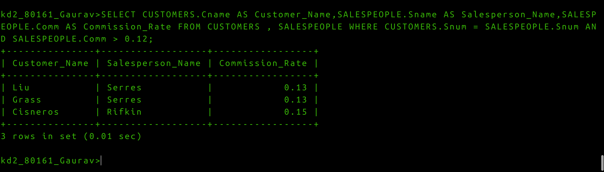
Question 4. Write a query that calculates the amount of the salesperson’s commission on each order by customer with a rating above 100.

