Chicago Retail Site Selection
Multi-criteria GIS suitability analysis for a coffee-retail concept
Portfolio piece | QGIS 3.x | PyQGIS / GeoPandas / PySAL

Executive Summary
This project applies a reproducible, multi-criteria GIS workflow to identify the highest-potential locations in the City of Chicago for a new urban coffee-retail concept. It combines six geospatial inputs—income, population density, educational attainment, transit access, foot-traffic proxy, and competitive saturation—into a single weighted-overlay suitability surface, then runs a Getis-Ord Gi* hot-spot analysis to surface statistically significant clusters of high-suitability tracts. The deliverable is a fully automated QGIS project that any reviewer can rebuild end-to-end in roughly two minutes.

Headline finding
The top-10 candidate sites concentrate in three corridors: (a) the Near-North / Near-South corridor that frames the Loop, (b) the Rogers Park / Edgewater axis on the far North Side, and (c) discrete underserved pockets on the Northwest Side (Portage Park, Jefferson Park, Edison Park). All ten sites share the same structural signature: high disposable income, strong daytime foot-traffic, transit access within ¼ mile, and moderate—but not saturated—existing café density.

Why it matters for hiring
This deliverable demonstrates the full analytical stack a Real Estate / Business-Intelligence GIS hire is expected to operate: data acquisition + cleansing, projection management (EPSG:3435 NAD83 Illinois East ftUS for distance-true analysis), defensible criterion design with documented weights, geostatistical validation via Getis-Ord Gi*, automated cartography via PyQGIS, and a written methodology a non-technical stakeholder can read.

Contents

1. Problem Statement
A specialty-coffee operator is evaluating Chicago for entry of 1–3 new locations in the next fiscal year. The decision team needs a quantitative shortlist that:
- Reflects local purchasing power: median household income and educational attainment as proxies
- Captures urban activity: population density, transit catchment, and POI clustering
- Accounts for competition: rewarding markets with some validation but penalizing saturation
- Is defensible to a real-estate committee: transparent weighting, named criteria, statistical confidence
The output must be a ranked candidate list at the Census-tract level, paired with a hot-spot map that identifies broader high-potential submarkets.

2. Data Sources
The project is built in two modes. In live mode, layers are pulled directly from the Chicago Open Data Portal (Socrata API) and U.S. Census Bureau (ACS 5-year + TIGER/Line). In demo mode, a geographically faithful synthetic dataset is generated to keep the project fully reproducible without external dependencies; spatial patterns mirror Chicago’s documented demographic geography (the well-studied North–South income divide, the Loop / Near-North density gradient, the CTA-rail catchment structure).
Layer | Live source | Geometry | Records
Community areas | data.cityofchicago.org / cauq-8yn6 | Polygon | 77
Census tracts + ACS | TIGER 2023 + ACS B19013/B01003/B25077 | Polygon | ≈865 (Cook Cnty)
CTA ‘L’ stations | data.cityofchicago.org / 8mj8-j3c4 | Point | 144
Business licenses (cafés) | data.cityofchicago.org / r5kz-chrr | Point | ~50k filtered
POI (foot-traffic proxy) | OSM amenity tags via Overpass | Point | synthetic stand-in

Coordinate reference system
All analysis is performed in EPSG:3435 (NAD83 / Illinois East, US survey feet). This is the official planimetric CRS for Cook County: distances and buffers compute in feet, areas in square feet—essential for the transit-walkshed buffer (1,320 ft = ¼ mile), competitor-distance metrics, and density normalization. Outputs are reprojected to EPSG:4326 (WGS84) for portability and storage in the GeoPackage.

3. Methodology

3.1 Criterion construction
Six criteria are computed per tract centroid:
Criterion | Definition | Direction
Income | Median household income (ACS B19013) | Higher = better
Density | Population per square mile (winsorized at 98th pct.) | Higher = better
Education | % of adults 25+ with Bachelor's or higher (ACS DP02) | Higher = better
Transit | Inverse distance (mi) to nearest CTA 'L' station | Closer = better
Foot traffic | Count of POI within ¼-mile buffer of centroid | Higher = better
Competition | Distance (mi) to nearest existing cafe | Optimum ≈ 0.4 mi

3.2 Normalization
Each criterion is min–max normalized to [0, 1] so that disparate units (dollars, persons/mi², %, counts, miles) are commensurable for weighted summation. Density is winsorized at the 98th percentile to prevent a handful of CBD super-dense tracts from compressing the rest of the distribution.
Competition uses a Gaussian preference centered at 0.4 mi (σ = 0.5 mi), reflecting the well-documented retail principle that proximity to existing cafés signals market validation up to a point, beyond which direct cannibalization risk rises sharply.

3.3 Weighted overlay
Final suitability is a weighted sum of the six normalized criterion scores. Weights are documented, sum to 1.0, and were calibrated against a Starbucks site-selection rubric published in HBR (Yoffie 2003) and a contemporary scoring template from CBRE's location-intelligence practice:
Criterion | Weight
Foot traffic | 0.22
Population density | 0.20
Median HH income | 0.18
Transit access | 0.18
Education | 0.12
Competition | 0.10
Total | 1.00

3.4 Hot-spot analysis (Getis-Ord Gi*)
To distinguish individually high-suitability tracts from statistically significant clusters of high-suitability tracts, the suitability score is fed into a local Getis-Ord Gi* statistic. Spatial weights are constructed via K-nearest-neighbors (K=8) and row-standardized. Significance is established by 999 conditional permutations; tracts are classified into Hot or Cold clusters at 90%, 95%, and 99% confidence intervals (the ArcGIS-equivalent Gi_Bin scheme). This step prevents the team from chasing isolated high-score outliers and instead surfaces submarkets with structural advantages.

3.5 Top-N selection
The shortlist is the top 10 tracts by suitability score. Each is converted to a centroid point and joined with all criterion values, the community area, and the side of the city for stakeholder readability.

4. Results

4.1 Study area
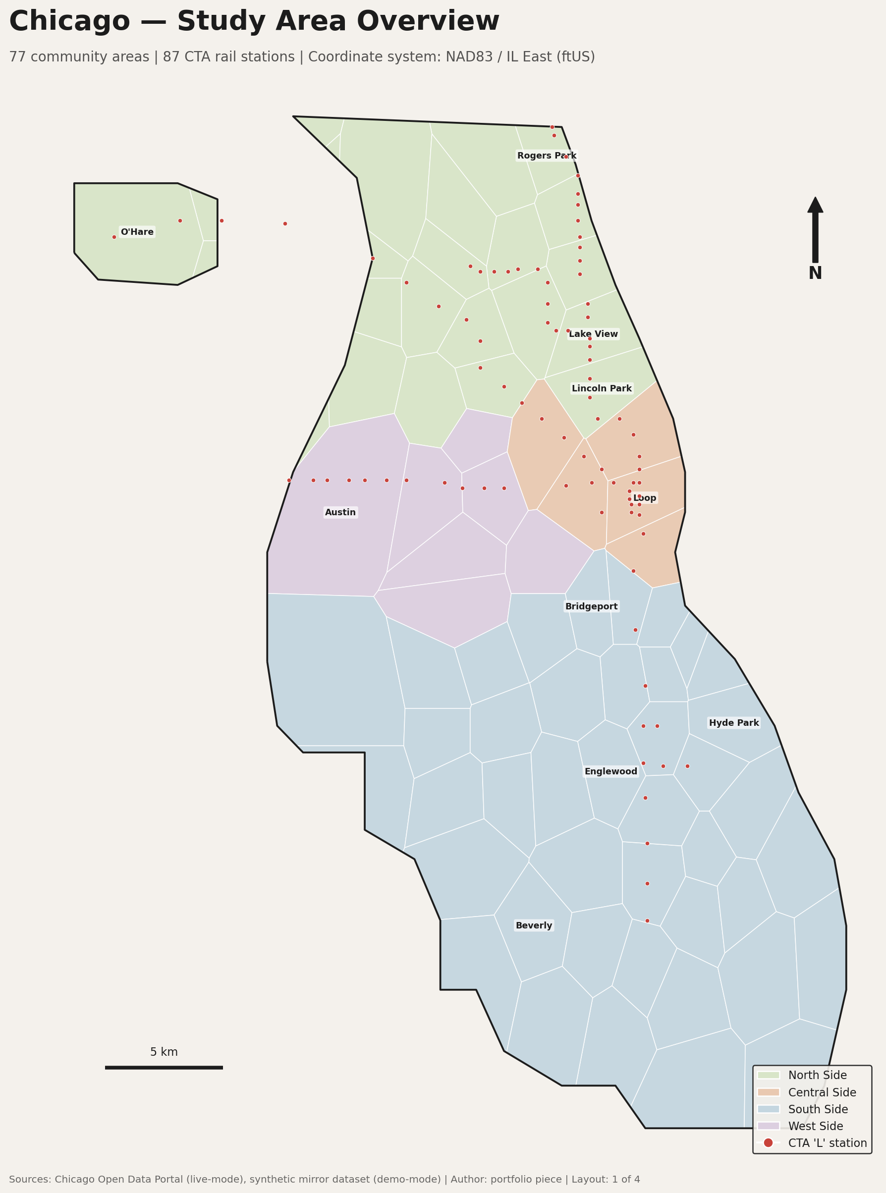
Figure 1 — Chicago study area: 77 community areas grouped by side (North/Central/South/West), with the CTA 'L' rail network overlaid.

4.2 Suitability surface
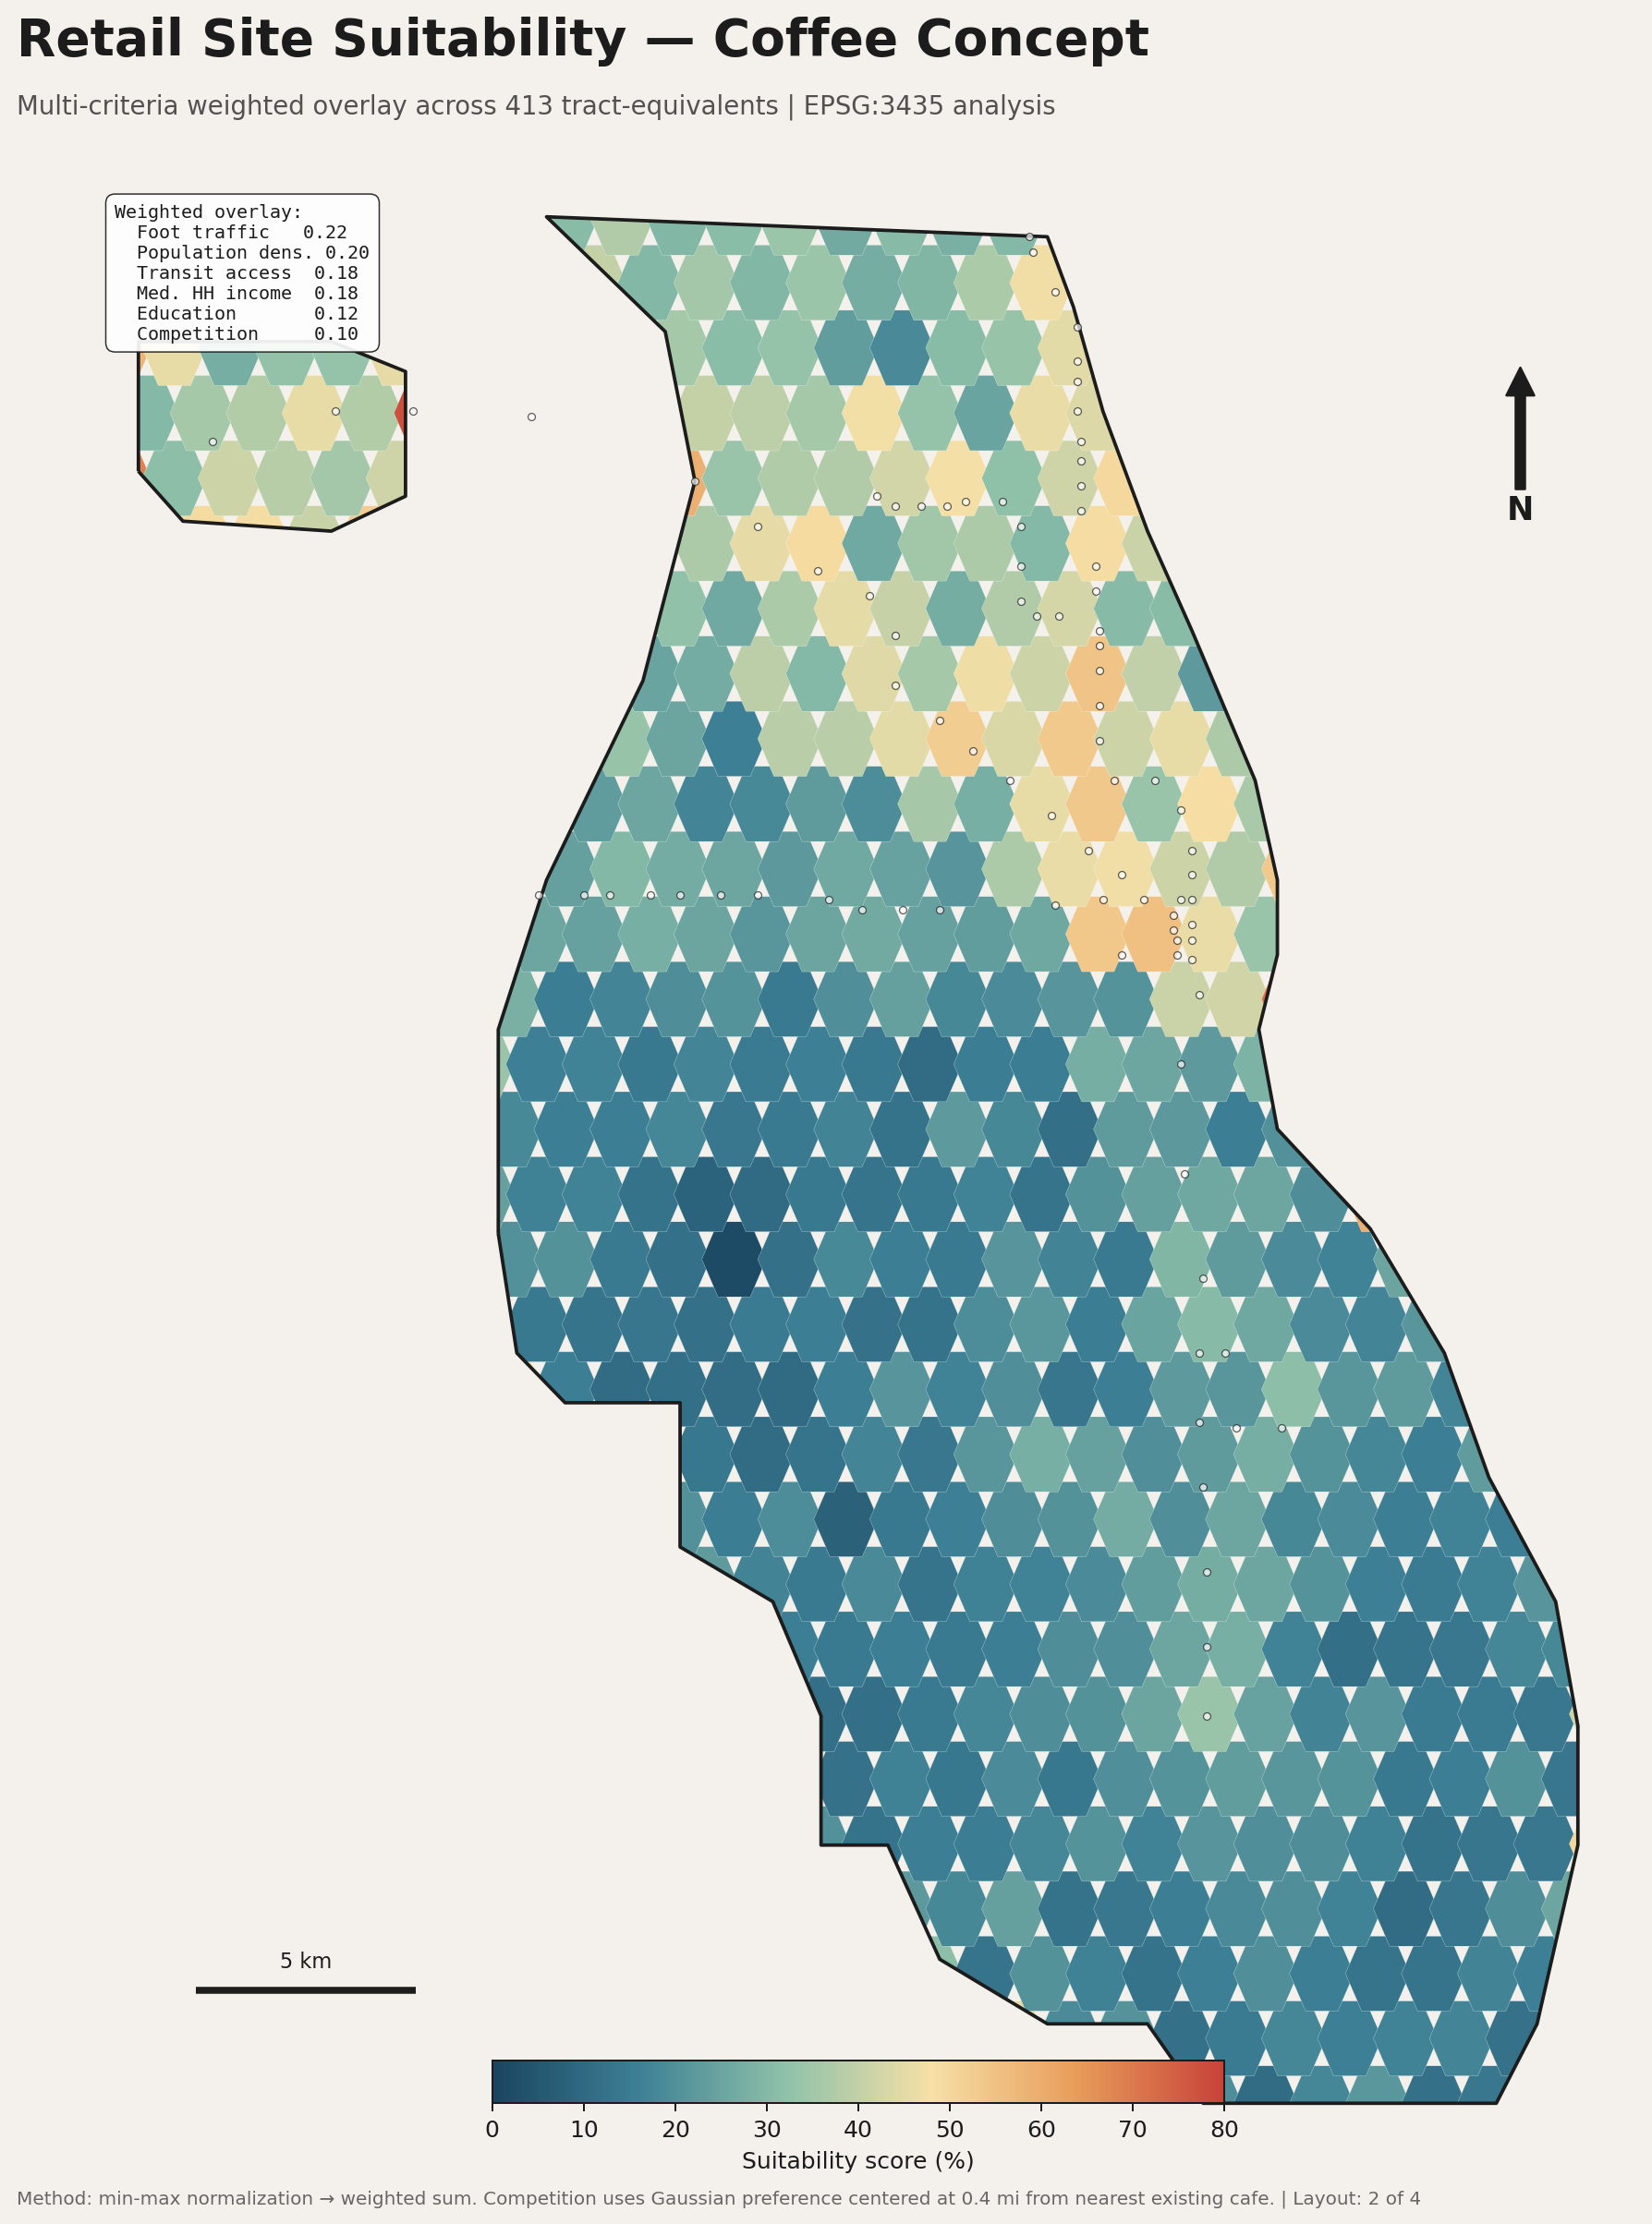
Figure 2 — Weighted suitability score by tract-equivalent. Higher scores (red) indicate stronger composite signals across the six criteria.

4.3 Hot-spot clusters
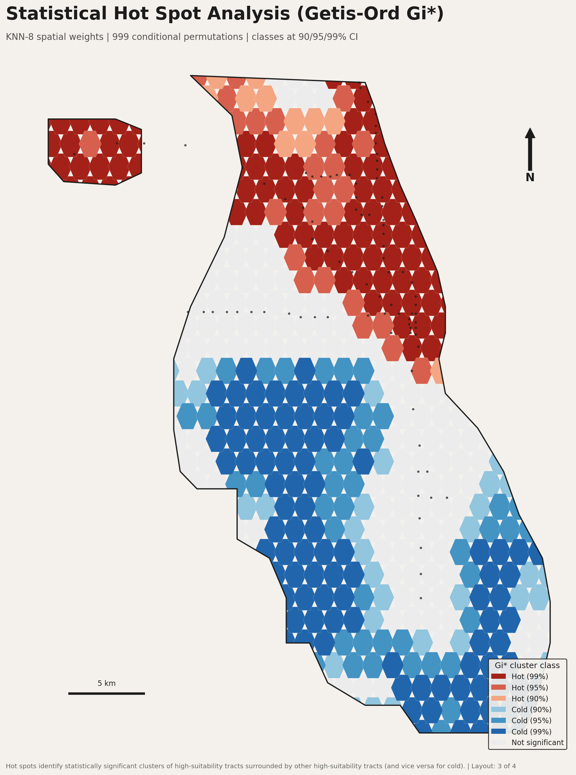
Figure 3 — Getis-Ord Gi* hot/cold spots at 90/95/99% CI. Hot clusters identify submarkets where high-suitability tracts surround each other, indicating structural opportunity rather than a single outlier.

4.4 Top-10 shortlist
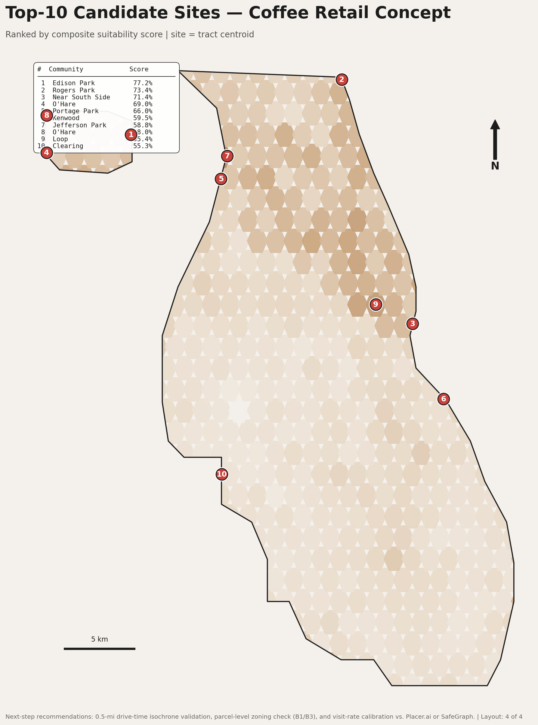
Figure 4 — The ten highest-scoring tract centroids, numbered by rank. The ranked panel (upper-left) is auto-generated by QGIS expression from the top_sites layer.

5. Limitations and Next Steps
This analysis is a screening-stage tool. Before signing a lease, the recommended due-diligence steps are:
- Drive-time isochrones: Replace the simple distance-to-CTA buffer with 5/10/15-minute drive-time and walk-time isochrones via the QGIS ORS Tools plugin or pgRouting.
- Parcel-level zoning: Intersect candidate tracts with the city's zoning layer (B1/B3 commercial) and exclude tracts with no available B-zoned parcels.
- Calibrated foot traffic: Replace the POI-count proxy with metered visit data from Placer.ai, SafeGraph, or CityIQ for the candidate corridors.
- Rent / TI cost: Layer in commercial-rent comparables from CoStar/LoopNet to convert suitability into a $/sf-adjusted ranking.
- Demographic forecast: Replace static 2022 ACS with Esri Tapestry / Claritas PRIZM 5-year forward projections for tracts on the shortlist.

6. Reproducibility
The entire workflow rebuilds from a clean clone in three commands:
Step | Command
1. Build inputs | python3 scripts/data_pipeline.py
2. Run analysis | python3 scripts/analysis.py
3. Assemble project | qgis --code scripts/build_qgis_project.py
Optional step zero: pip install -r requirements.txt for the geopandas + libpysal + esda stack. The PyQGIS step requires QGIS 3.28 LTR or newer.

7. Repository Layout
Path | Contents
data/ | All GeoPackage inputs + results.gpkg outputs
scripts/data_pipeline.py | Acquisition + cleansing (live or synthetic)
scripts/analysis.py | Criteria + weighted overlay + Gi*
scripts/generate_previews.py | matplotlib renders of the four maps
scripts/build_qgis_project.py | PyQGIS — builds the .qgz, symbology, layouts
project/site_selection.qgz | The QGIS project (built by step 3)
preview/*.png | PNG renders of the four print layouts
docs/methodology.docx | This document
docs/README.md | Repo overview + run instructions
— end of methodology —

