#include <stdio.h>

int main()

{

// array declaration

int arr[10], arr_size;

printf("Enter the number of elements \n");

scanf("%d",&arr_size);

printf("Enter the array elements \n");

for(int i=0;i<arr_size;i++)

{

scanf("%d",&arr[i]);

}

printf("The elements are \n");

for(int i=0;i<arr_size;i++)

{

printf("%d\t",arr[i]);

}

printf("\nThe even numbers in the array are\n");

for(int i=0;i<arr_size;i++)

{

if(arr[i]%2==0)

printf("%d\t", arr[i]);

}

return 0;

}

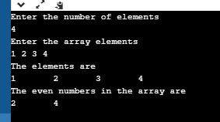

#include <stdio.h>

//function prototypes

void read_arr(arr [], int );

void print_arr(arr [], int );

int ret_max(arr[], int );

int main()

{

// array declaration

int arr[10], arr_size;

printf("Enter the number of elements \n");

scanf("%d", &arr_size);

printf("Enter the elements\n");

read_arr(arr, arr_size);

printf("The array elements are \n");

print_arr(arr, arr_size);

printf("\nThe maximum element in the arrays is %d\n", ret_max(arr, arr_size));

return 0;

}

void read_arr(int arr [],int n )

{

for(int i=0;i<n;i++)

{

scanf("%d",&arr[i);

}

}

void print_arr(int arr[], int n )

{

for(int i=0;i<n;i++)

{

printf("%d",&arr[i]);

}

}

int ret_max(int arr[],int n )

{

int max=arr[0];

.

.

.

return max;

}

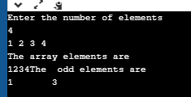

#include <stdio.h>

//function prototypes

void read_arr(int [], int );

void print_arr(int [], int );

int ret_max(int [], int );

int main()

{

// array declaration

int arr[10], arr_size;

printf("Enter the number of elements \n");

scanf("%d", &arr_size);

printf("Enter the elements\n");

read_arr(arr, arr_size);

printf("The array elements are \n");

print_arr(arr, arr_size);

printf("\nThe maximum element in the arrays is %d\n", ret_max(arr, arr_size));

return 0;

}

void read_arr(int arr [],int n )

{

for(int i=0;i<n;i++)

{

scanf("%d",&arr[i]);

}

}

void print_arr(int arr[], int n )

{

for(int i=0;i<n;i++)

{

printf("%d\t",arr[i]);

}

}

int ret_max(int arr[],int n )

{

int max=arr[0];

for(int i=0;i<n;i++)

{

if(max<arr[i])

max=arr[i];

}

return max;

}

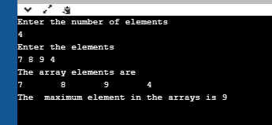

#include<stdio.h>

void main(){

int arr[20], key,n,count=0;

printf("enter number of elements:\n");

scanf("%d",&n);

printf("enter array elements");

for(int i=0;i<n;i++){

scanf("%d",&arr[i]);

}

printf("enter key ele");

scanf("%d", &key);

for(int i=0;i<n;i++){

if(arr[i]==key){

printf("Search is successful\n");

printf("first occurence of %d is %d\n",key,i);

count++;

break;

}

}

if(count==1){

for(int j=n-1;j>=0;j--){

if(arr[j]==key){

printf("last occurence of %d is %d",key, j);

break;

}

}

}

else

printf("search failure");

}

