Program 1:

. Write a program that declares and intializes a strucutre variable.

print the values of that structure variable

Consider :: the use case of a book stall and following details

book_id, book_title, author, price*

#include<stdio.h>

struct stall{

int bookid;

char title[10];

char author[10];

int price;

}a1;

void main(){

printf("enter the book id, title, author and price");

scanf("%d%s%s%d",&a1.bookid,a1.title,a1.author,&a1.price);

printf("book is %s \n its id is %d, its author is %s, its price is %d ",a1.title,a1.bookid, a1.author, a1.price);

}

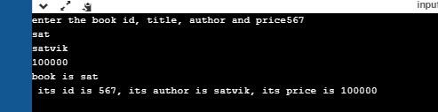

Program 2:

Write a program to do the following (Use array of structures)

a. Create a book database (title, author, rice, no_pages)

b. Update the book price based on the title.

c. Display appropriate message if updation fails.

#include <stdio.h>

#include<stdlib.h>

#include<string.h>

#define SIZE 3

struct bookstall

{

int pages,price;

char book_title[20];

char author[20];

};

void insert(struct bookstall *s)

{

int i=0;

for(i=0;i<SIZE;i++)

{

printf("Book %d :",i+1);

printf("\nenter the pages, price,book_title,author \n");

scanf("%d",&s[i].pages);

scanf("%d",&s[i].price);

scanf("%s",s[i].book_title);

scanf("%s",s[i].author);

}

}

void display(struct bookstall *z)

{

int i;

for(i=0;i<SIZE;i++)

{

printf("Book %d :",i+1);

printf("\nthe book details are:\npages :%d\nbook_title :%s\nauthor :%s\nprice :%d\n",z[i].pages,z[i].book_title,z[i].author,z[i].price);

}

}

void update(struct bookstall *t)

{

char name[20];

int i,n;

printf("enter book name whose price needs to be changed\n");

scanf("%s",name);

for(i=0;i<SIZE;i++)

{

n=strcmp(t[i].book_title,name);

if(n==0)

{

printf("enter the amount \n");

scanf("%d",&t[i].price);

printf("the amount is updated\n");

display(t);

}

}

}

int main()

{

struct bookstall a[SIZE];

insert(a);

display(a);

update(a);

return 0;

}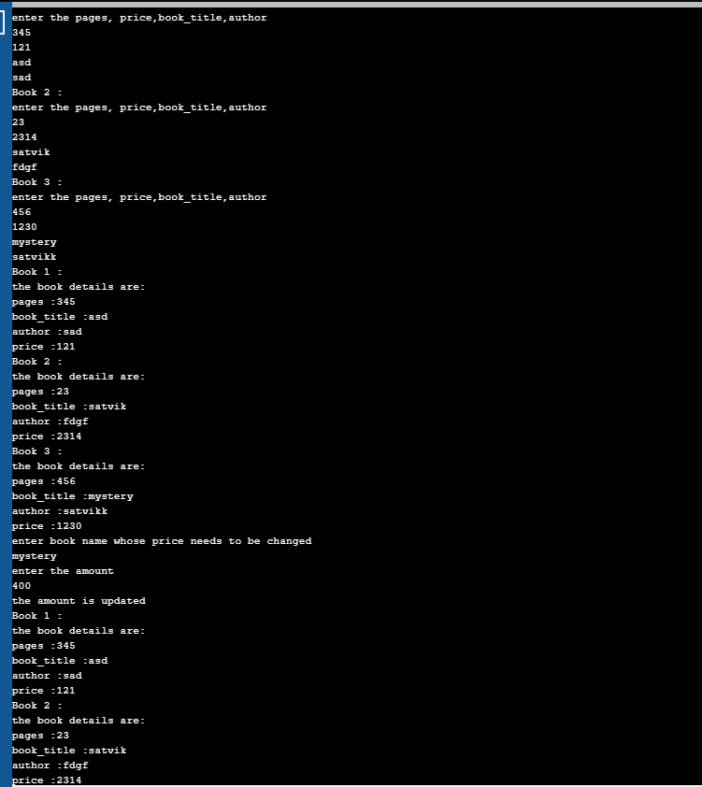



Program 3:

#include<stdio.h>

#include<stdlib.h>

struct book

{

char title[10];

char author[10];

float price;

int no_pages;

};

void read(struct book*);

void print(struct book*);

int main()

{

struct book bk;

struct book *sptr=&bk;

read(sptr);

print(sptr);

return 0;

}

void read(struct book *sptr)

{

printf("Enter the title,author name,price and number of pages in order\n");

scanf("%s%s%f%d",(sptr->title),(sptr->author),&(sptr->price),&(sptr->no_pages));

}

void print(struct book *sptr)

{

printf("The book details are\n");

printf("%s\t%s\t%f\t%d\n",(sptr->title),(sptr->author),(sptr->price),(sptr->no_pages));

}

