**Computational generation and characterization of IsdA-binding aptamers with single-molecule FRET analysis**

Godfred O. Sabbih1, Kalani M. Wijesinghe2, Chamika Algama2, Soma Dhakal2 and Michael K. Danquah1*

1 University of Tennessee, Chattanooga, TN 37403, USA; fzp281@mocs.utc.edu

2 Virginia Commonwealth University, VA 23284, USA; sndhakal@vcu.edu

**\*** Correspondence: michael-danquah@utc.edu; Department of Chemical Engineering, University of Tennessee at Chattanooga, 615 McCallie Ave, Chattanooga, TN, 37403, United States.; Tel. +1-432-425-5459



**Figure 1.** Typical field of view for both the donor (Cy3) and acceptor (Cy5) channels. (A) Field of view in the absence of IsdA protein and H1 strand. (B) Field of view in the presence of IsdA protein and H1 strand. Each bright spot in the respective channels represents the fluorescence of Cy3 and Cy5 fluorophores on the individual DNA constructs.

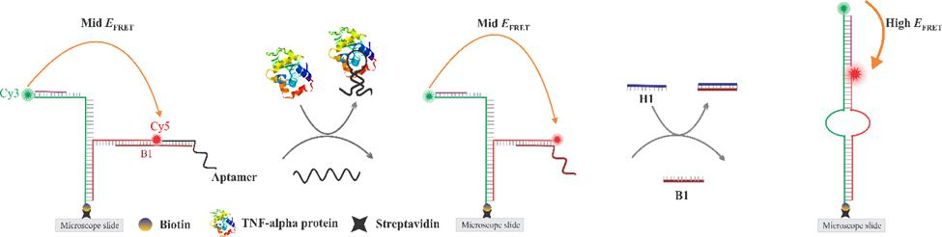

**Figure 2.** DNA construct based single-molecule FRET sensitivity. The DNA construct is composed of 5 different oligonucleotides two of which are labeled with a Cy3 or a Cy5 fluorophore.The construct assumes a mid-FRET state but switches to a high-FRET state when IsdA pulls out the aptamer upon binding to it and thereby letting the H1 strand to bind and displace the B1 strand - ultimately switching the construct to a high-FRET state (detection).