WIEN2k mstar GaAs Tutorial

January 24, 2026

The following was used to try to reproduce the GaAs results given in the article titled “Perturbation approach to ab initio effective mass calculations”:
https://arxiv.org/abs/2007.03816v1

or

https://doi.org/10.1016/j.cpc.2020.107648

username@computername:~/wiendata$ lsb_release -a
No LSB modules are available.
Distributor ID: Ubuntu
Description: Ubuntu 24.04.3 LTS
Release: 24.04
Codename: noble
username@computername:~/wiendata$ cat $WIENROOT/WIEN2k_VERSION
WIEN2k_24.1 (Release 1/8/2024)
username@computername:~/wiendata$ mkdir GaAs
username@computername:~/wiendata$ cd GaAs
username@computername:~/wiendata/GaAs$ makestruct
...
TITLE :GaAs
...
Would you like to enter Spacegroup or Lattice (S/L)(def=S)? L
LATTICE TYPE: F
Units of lattice parameters (Bohr/Angstrom) (b/A) (def=ANG):A
Lattice PARAMETERS as a b c (1 or 3 numbers - if you specify only 1 number, a cubic system is assumed):
5.653
ANGLES BETWEEN lattice vectors, as alpha beta gamma (def=90.0 90.0 90.0):90.0 90.0 90.0
NUMBER INEQUEVALENT ATOMS :2
ATOM 1 (ELEMENT): Ga
NUMBER OF EQUIVALENT ATOMS (MULT) OF Ga :1
POSITION OF ATOM Ga-1 as X,Y,Z (def=0 0 0) :0 0 0
ATOM 2 (ELEMENT): As
NUMBER OF EQUIVALENT ATOMS (MULT) OF As :1
POSITION OF ATOM As-1 as X,Y,Z (def=0 0 0) :0.25 0.25 0.25
...
SPECIFY possible REDUCTION of SPHERE RADII in % (def=0)
0
...
rerun setrmt ?(y,N) (def=N):
N
...
username@computername:~/wiendata/GaAs$ cp init.struct GaAs.struct
username@computername:~/wiendata/GaAs$ init_lapw -b -vxc 13 -rkmax 7 -numk 500
...
init_lapw finished ok
username@computername:~/wiendata/GaAs$ run_lapw -ec 0.00001 -cc 0.0001
...
in cycle 14 ETEST: .0000093150000000 CTEST: .0001261 STRTEST: 0
STOP LAPW0 END
STOP LAPW1 END
STOP LAPW2 END
STOP CORE END
STOP MIXER END
ec cc fc and str_conv 1 1 1 1
> stop
username@computername:~/wiendata/GaAs$ save_lapw -d noSOC
...
username@computername:~/wiendata/GaAs$ init_so_lapw
...
---->Please select the direction of the moment ( h k l )
(For R-lattice in R coordinates)(default 0 0 1): 1 0 0
...
Select atom-numbers (1,2,3) or "ranges of atoms" (1-3,9-12) (without blanks)
for which you would NOT like to add SO interaction
(default none, just press "enter" ):
...
---->Please enter EMAX(default 5.0 Ryd): 5.0
...
---->Add RLO for NONE, ALL, CHOOSE elements? (N/a/c) : N
...
Check the generated GaAs.inso file (RLOs,...) => Closed window without any changes
Check the generated GaAs.in1c file (Emax and nband (if ELPA is used)
at the bottom of the file) => Closed window without any changes
...
Do you have a spinpolarized case (and want to run symmetso) ? (y/N)N
...
username@computername:~/wiendata/GaAs$ run_lapw -ec 0.00001 -cc 0.0001 -so
...
in cycle 7 ETEST: .0000001950000000 CTEST: .0000753 STRTEST: 0
STOP LAPW0 END
STOP LAPW1 END
STOP LAPWSO END
STOP LAPW2 END
STOP CORE END
STOP MIXER END
ec cc fc and str_conv 1 1 1 1
> stop
username@computername:~/wiendata/GaAs$ grep Emax GaAs.inso
-10 1.9 Emin, Emax
username@computername:~/wiendata/GaAs$ sed -i '3s/1.9/5.0/g' GaAs.inso
username@computername:~/wiendata/GaAs$ grep Emax GaAs.inso
-10 5.0 Emin, Emax
username@computername:~/wiendata/GaAs$ xcrysden -v
XCrySDen version: 1.6.2
username@computername:~/wiendata/GaAs$ xcrysden --wien_kpath GaAs.struct
...
Selected kpath for L, GAMMA, and X:
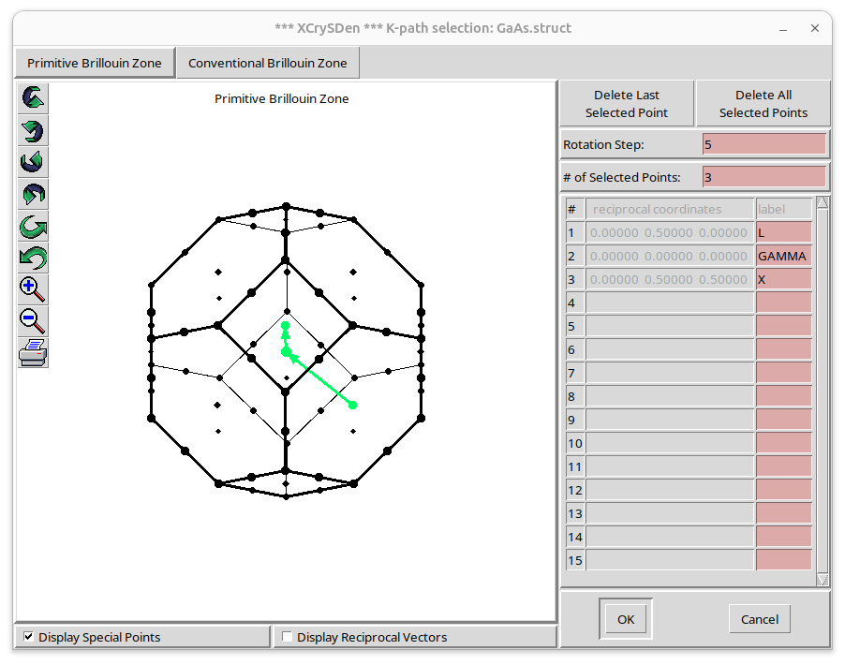
Clicked OK

Typed 100 for “Total number of k-points along the path”:
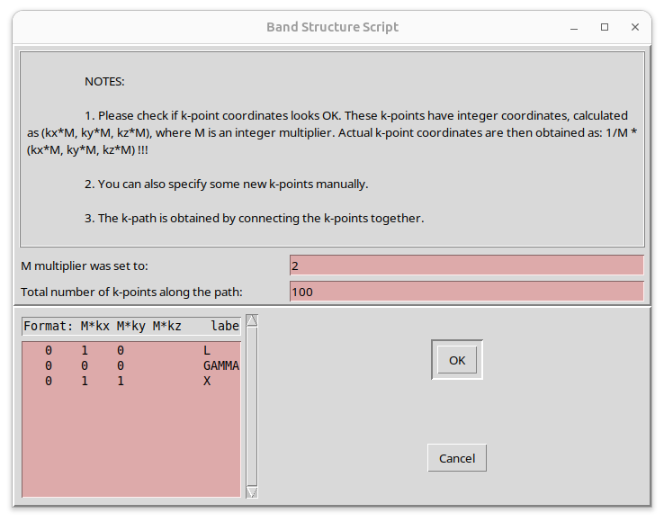
Clicked OK

Typed “GaAs.klist_band” for the File name:
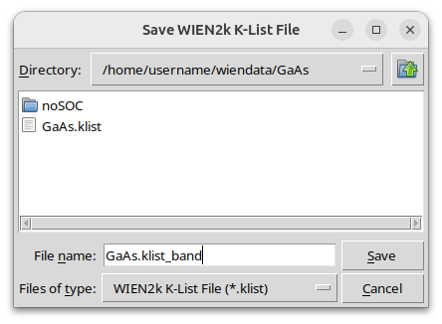

Clicked Save
username@computername:~/wiendata/GaAs$ ls -l GaAs.klist_band
-rw-rw-r-- 1 username username 3682 Jan 23 23:36 GaAs.klist_band
username@computername:~/wiendata/GaAs$ x lapw1 -band
...
username@computername:~/wiendata/GaAs$ x lapwso
...
username@computername:~/wiendata/GaAs$ cp GaAs.vsp GaAs.vspup
username@computername:~/wiendata/GaAs$ cp GaAs.vsp GaAs.vspdn
username@computername:~/wiendata/GaAs$ cp GaAs.vectorso GaAs.vectorsoup
username@computername:~/wiendata/GaAs$ cp $WIENROOT/SRC_templates/case.inop GaAs.inop
username@computername:~/wiendata/GaAs$ grep Emax GaAs.inop
-5.0 3.0 9999 Emin, Emax for matrix elements, NBvalMAX
username@computername:~/wiendata/GaAs$ sed -i '2s/3.0/5.0/g' GaAs.inop
username@computername:~/wiendata/GaAs$ grep Emax GaAs.inop
-5.0 5.0 9999 Emin, Emax for matrix elements, NBvalMAX
username@computername:~/wiendata/GaAs$ grep ON GaAs.inop
OFF ON/OFF writes MME to unit 4
username@computername:~/wiendata/GaAs$ sed -i '6s/OFF/ON/1' GaAs.inop
username@computername:~/wiendata/GaAs$ grep ON GaAs.inop
ON ON/OFF writes MME to unit 4
username@computername:~/wiendata/GaAs$ x optic -so -up
...
username@computername:~/wiendata/GaAs$ x mstar -up -settol 1.0e-5
Detected input arguments = 2
Input mommat file = ./GaAs.mommat2up
Degeneracy tolerance dEtol = 1.0e-5 [Ha]
Confirming text-to-number conversion dEtol = 1.00000E-05 [Ha]
The input file ./GaAs.mommat2up was found.
number of lines in mommat file = 1054452
Entering the main loop...
KP: 1 bands: 148 progress: 1%
...
KP: 101 bands: 146 progress: 100%
Summary of the output:
(1) Components of the (m0/m*_ij) tensor are stored in file minv_ij-up.dat
(2) The conductivity inverse eff. masses m0/m_c = 1/3*Tr(m0/m*_ij)
are stored in file minv_c-up.dat
(3) Principal components of the (m0/m*_ij) tensor
are stored in file minv_pr-up.dat
(4) Density of states inverse effective mass
m0/m*_d = m0/(m_1*m_2*m_3)**(1/3) are stored in file minv_d-up.dat
See the file header for the description
Suggested reference:
[1] O. Rubel, F. Tran, X. Rocquefelte, and P. Blaha "Perturbation
approach to ab initio effective mass calculations"
Comp. Phys. Commun. 261, 107648 (2021).
https://doi.org/10.1016/j.cpc.2020.107648
38.940u 0.247s 0:39.21 99.9% 0+0k 32+3976io 0pf+0w
username@computername:~/wiendata/GaAs$ grepline_lapw :FER GaAs.scf 1
in 1 files:
GaAs.scf::FER : F E R M I - ENERGY(TETRAH.M.)= 0.3359376580
username@computername:~/wiendata/GaAs$ grep Fermi-level GaAs.insp
1 x.xxxx # Fermi switch, Fermi-level (in Ry units)
username@computername:~/wiendata/GaAs$ sed -i '9s/x.xxxx/0.3359376580/g' GaAs.insp
username@computername:~/wiendata/GaAs$ grep Fermi-level GaAs.insp
1 0.3359376580 # Fermi switch, Fermi-level (in Ry units)
username@computername:~/wiendata/GaAs$ x spaghetti -up -so
...
username@computername:~/wiendata/GaAs$ xmgrace -free GaAs.bandsup.agr
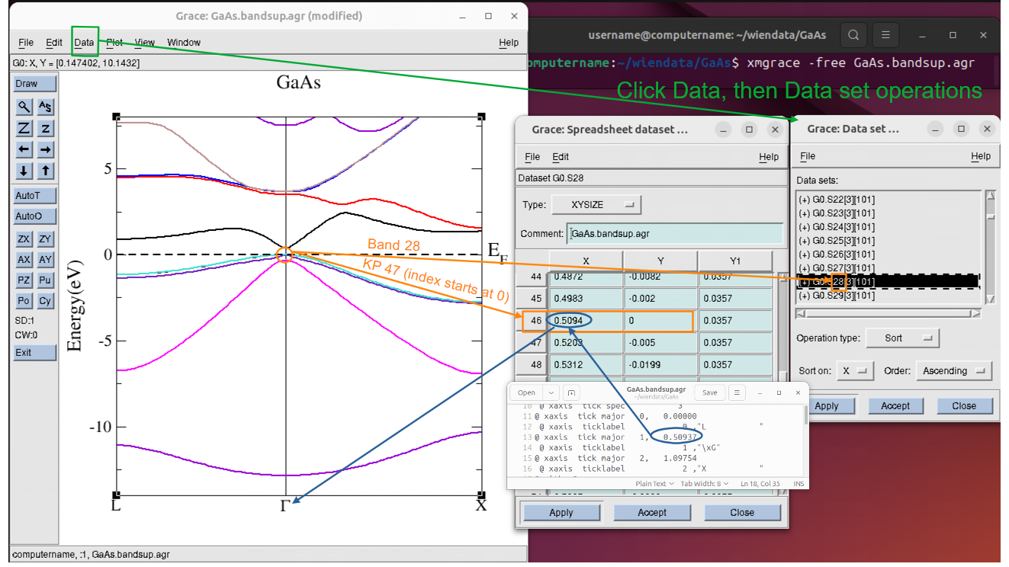

username@computername:~/wiendata/GaAs$ gedit minv_c-up.dat

