Name: G Sadwik
Reg.no:23MIS0541
agile lab fat
github repo:

Maven folder structure in vs code :
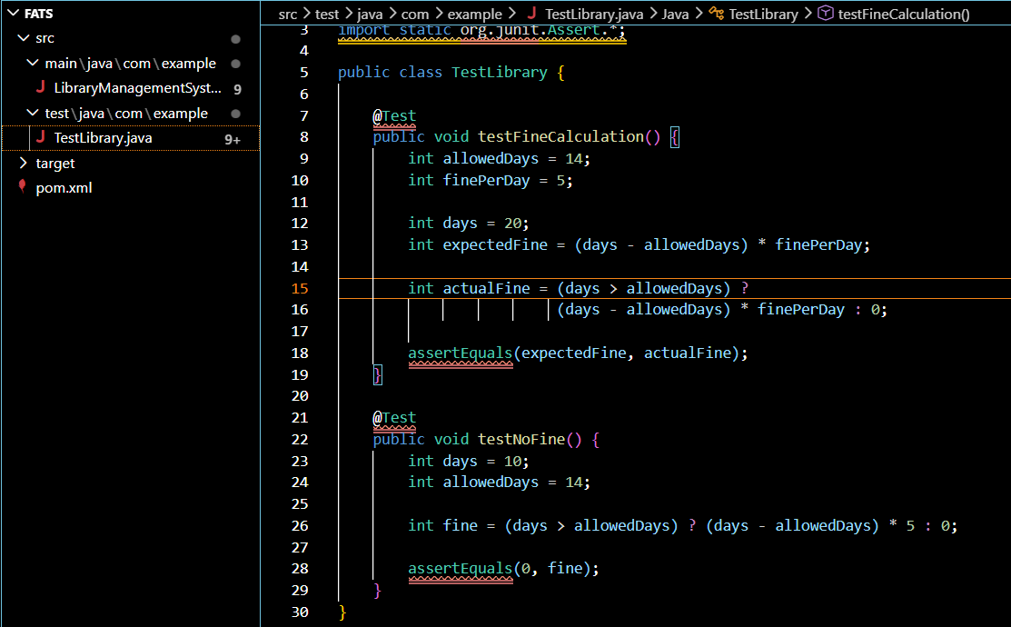
Git commands to push in github
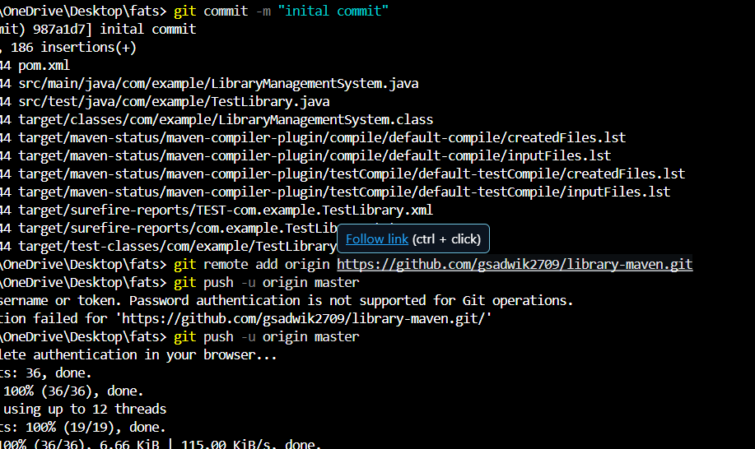
Github repository
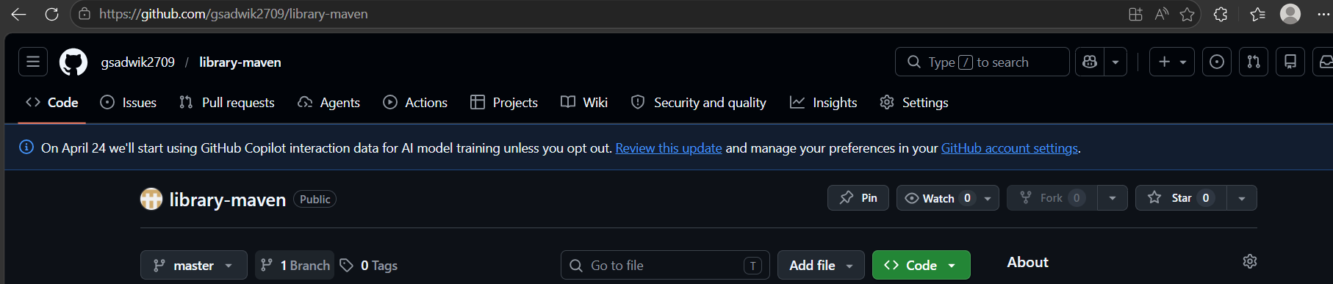
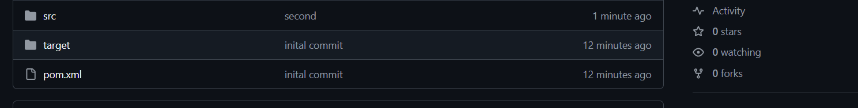
Build success using maven in vs code :
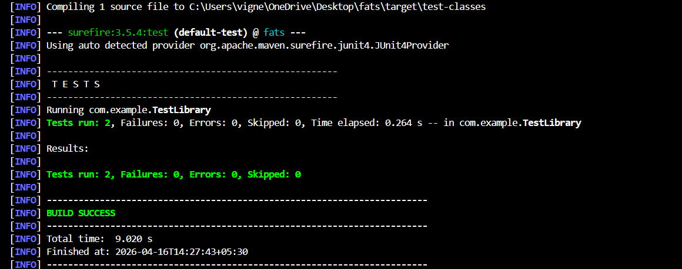
Commit changes to second commit:
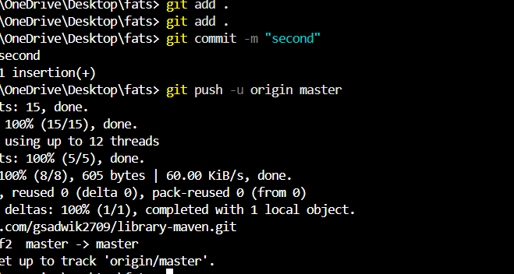

Using Jenkins pipeline script by maven :
Pipeline script:
pipeline {
agent any

tools {
jdk 'JAVA_HOME' // Name configured in Jenkins Global Tool Configuration
maven 'M3' // Name configured in Jenkins
}

stages {

stage('Clone Repository') {
steps {
git 'https://github.com/gsadwik2709/library-maven'
}
}

stage('Build') {
steps {
bat 'mvn clean compile'
}
}

stage('Test') {
steps {
bat 'mvn test'
}
}

stage('Package') {
steps {
bat 'mvn package'
}
}
}

post {
success {
echo 'Build Successful!'
}
failure {
echo 'Build Failed!'
}
}
}
