Title in the original language (Style: Título1)

Title in Spanish (Título1)
Author (Style: Autor)
Email (Style: Email y universidad)
University

Date of reception: XXXXX
Date of acceptance: XXXXXXXXX

Abstract: (Style: Resumen_Abstract) The word Abstract will be in Arial (bold) size 10. The first summary will be written in English if the original language is English, containing between 200 and 300 words, in Arial size 10. In the style sheet, it appears under the name “Resumen_Abstract.” The summary is a synthesis of the paper, so it must include information from all its sections, such as objectives, methodology, and results (IMRaD format).

Abstract abstract abstract abstract abstract abstract abstract abstract abstract abstract abstract abstract abstract abstract abstract abstract abstract abstract abstract abstract abstract abstract abstract abstract abstract abstract abstract abstract abstract abstract abstract abstract abstract abstract abstract abstract

Keywords: (Style: Resumen_Abstract) 5 keywords separated by commas. Each keyword begins with a capital letter, and there is no final period. Please avoid matching the keywords with the terms in the title.

Resumen: (Style: Resumen_Abstract) The word Resumen will be in Arial (bold) size 10. The second abstract will be written in Spanish (if the original language is English), containing between 200 and 300 words, in Arial size 10. In the style sheet, it appears under the name “Resumen_Abstract.”

Abstract abstract abstract abstract abstract abstract abstract abstract abstract abstract abstract abstract abstract abstract abstract abstract abstract abstract abstract abstract abstract abstract abstract abstract abstract abstract abstract abstract abstract abstract abstract abstract abstract abstract abstract abstract

Keywords: (Style: Resumen_Abstract) 5 keywords separated by commas. Each keyword begins with a capital letter, and there is no final period. Please avoid matching the keywords with the terms in the title.

Introduction (Style: Título 2 Unnumbered)
First-level headings within the article will be in Arial, 10-point size, in small caps, and justified alignment. In the template’s style sheet, they correspond to the “Título 2” style.
The text of the different sections will be written in Arial 10 points, with justified alignment. In the template’s style sheet, it corresponds to the “Normal” style. Page numbering must remain as provided in this template.
Some recommendations for writing in English:
- Use British English.
- Footnote references should place the superscript after the quotation mark (”.1).
- Use English quotation marks without spaces (“ ”).
- Use a period for decimals in English, e.g., 0.23.
Normal normal normal normal normal normal normal normal normal normal normal normal normal normal normal normal normal normal normal normal normal normal normal normal normal normal normal normal normal

First-level heading: Style: Título 2
Normal normal normal normal normal normal normal normal normal normal normal normal normal normal normal normal normal normal normal.

Second-level heading: Style: Título 3
Second-level headings within the chapter (format 1.1.) will be in Arial (italics), 10-point size, and justified alignment. In the template’s style sheet, they correspond to the “Título 3” style.
It is recommended to always include some text between sections, i.e., you should not have consecutive section headings without text in between. Likewise, quotations of three lines or fewer will appear within the main text in English quotation marks. These are the quotation marks to be used in any case where needed. However, quotations exceeding three lines should appear in Arial, 9-point size, justified alignment, with a 2.54 cm left indent. In the template’s style sheet, these correspond to the “Citas” style:
Literal or direct quotations:
These reproduce the material exactly, without changes or additions. The author, year, and page number must be indicated. If the cited source has no pagination, then the paragraph number should be used. If the quotation has fewer than 40 words, it is placed in the text body, in quotation marks, and at the end, in parentheses, the reference data are indicated. (Machado, 2010, p. 74)

Third-level heading (Style: Título 4)
Tables will have their title at the bottom using the “Tabla título” style, which is Arial (bold) in 9-point size and centered alignment. The source of the data will appear at the bottom in Arial, size 9, and centered alignment (style “Tabla fuente”). The body text of the table should be in Arial 9-point size (or 8 if necessary). As with equations, we recommend using the Word option (References – Insert title) for table titles, labeling them “Tabla” and numbering them consecutively. Then apply the “Tabla título” style so that it appears as specified.
It is recommended that charts/graphs be presented in an editable format.
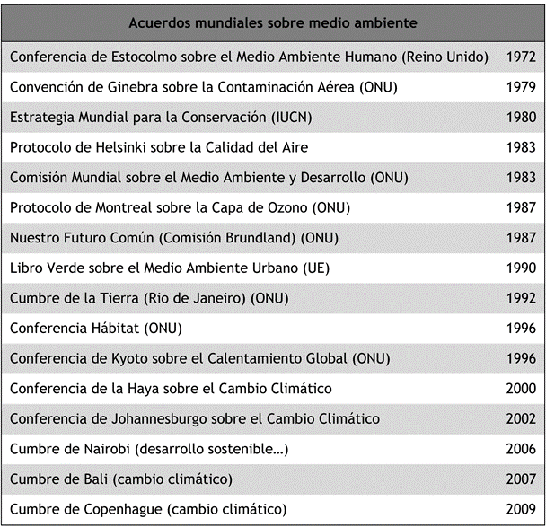
Table 1. Sustainability agenda
Source. Edwards (2005) o Elaborated by the author
Figures or images will have their title at the bottom using the “Tabla título” style, which is Arial (bold) in 9-point size and centered alignment. The source of the data will appear at the bottom in Arial, size 9, and centered alignment (style “Tabla fuente”). The body text of the table should be in Arial 9-point size (or 8 if necessary). The resolution and definition of the images should be appropriate for printing (300 pixels) and you must have the rights required for publication if they are not your own. As with equations, we recommend using the Word option (References – Insert title) for table titles, labeling them “Table” followed by the chapter number and a period. Then apply the appropriate style so that it appears as specified.

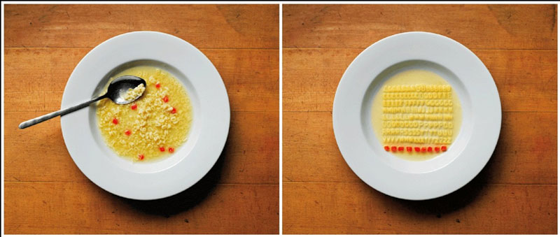
Image 1.1. When we become Germans
Source. Edwards (2005)
If more sections or lists are needed, they should have a left indent and a symbol or letter to enumerate the different items in the list. In the style sheet, there is a style called “Viñetas/listas” that can be used for this purpose.
- Temporibus autem quibusdam.
- Et aut officiis debitis aut rerum necessitatibus saepe eveniet ut et vo-luptates repudiandae sint et molestiae non recusandae.
- Itaque earum rerum hic tenetur a sapiente delectus.
- Ut aut reiciendis voluptatibus maiores.

Conclusions (Style: Título 2 Unnumbered)
Normal normal normal normal normal normal normal normal normal normal normal normal normal normal normal normal normal normal normal normal normal normal normal normal normal normal normal normal normal normal normal normal normal normal normal normal normal normal normal

References (Style: Título 2 Unnumbered)
For inserting bibliographic citations in the text, we recommend using the Microsoft Word function for that purpose (References – Insert quote), applying APA 7th style. (Examples available at https://apastyle.apa.org/style-grammar-guidelines/references/examples)
The arrangement of the References will be formatted with the Word style: “Referencias.”
In a paper written in English, special attention must be paid to the names of publication locations and other details, which must appear in English (London and not Londres).
EXEMPLES:
Book
Sapolsky, R. M. (2017). Behave: The biology of humans at our best and worst. Penguin Books.
e-Book
Jackson, L. M. (2019). The psychology of prejudice: From attitudes to social action (2nd ed.). American Psychological Association. https://doi.org/10.1037/0000168-000
Book chapter
Aron, L., Botella, M., & Lubart, T. (2019). Culinary arts: Talent and their development. In R. F. Subotnik, P. Olszewski-Kubilius, & F. C. Worrell (Eds.), The psychology of high performance: Developing human potential into domain-specific talent (pp. 345–359). American Psychological Association. https://doi.org/10.1037/0000120-016.
Journal Article
Grady, J. S., Her, M., Moreno, G., Perez, C., & Yelinek, J. (2019). Emotions in storybooks: A comparison of storybooks that represent ethnic and racial groups in the United States. Psychology of Popular Media Culture, 8(3), 207–217. https://doi.org/10.1037/ppm0000185.
Newspaper Article
Carey, B. (2019, March 22). Can we get better at forgetting? The New York Times. https://www.nytimes.com/2019/03/22/health/memory-forgetting-psychology.html
Published Dissertations or Thesis References
Kabir, J. M. (2016). Factors influencing customer satisfaction at a fast food hamburger chain: The relationship between customer satisfaction and customer loyalty (Publication No. 10169573) [Doctoral dissertation, Wilmington University]. ProQuest Dissertations & Theses Global.

Footnotes should not include URLs. Their purpose is to provide relevant but secondary glosses or comments on the topic at hand. Links should only be included in the bibliographical references.

