**QUERY-1 (BONUS REPORT)**

**Business Requirement:**

Time has come for the HR Manager of BlackChip semiconductors to roll-out the annual bonus for every employee. He has decided to set around 3% on overall profit generated by the projects worked by the employee as a bonus.

**Description:**

For every employee in every department, based on the number of orders he has worked on, we calculated the total profit generated across the orders. Further we computed the annual bonus of an employee by considering 3% of total profit generated by the projects worked by the employee as bonus.

**Query used:**

**SELECT** * FROM

(

**SELECT** tab3.employee_id,e.EMPLOYEE_FIRST_NAME,e.EMPLOYEE_LAST_NAME, e.Department_name, COUNT(*) **AS** "Number of projects",

**CONCAT**('$',**round**(SUM((s.Profit_percentage*tab3.budget)/100),2)) **AS** "Net profit",

**concat**('$',**round**((SUM((s.Profit_percentage*tab3.budget)/100)*0.03),2)) **AS** Annual_bonus FROM

(

**SELECT** o.order_id, d.employee_id, o.budget **FROM** orders o **INNER JOIN** design d ON o.order_id=d.order_id

**UNION all**

**SELECT** o.order_id, l.employee_id, o.budget **FROM** orders o **INNER JOIN** layout l **ON** o.order_id=l.order_id

**UNION all**

**SELECT** o.order_id, v.employee_id, o.budget **FROM** orders o **INNER JOIN**  verification v **ON** o.order_id=v.order_id

**UNION all**

**SELECT** o.order_id, s.employee_id, o.budget **FROM** orders o **INNER JOIN** sales s **ON** o.order_id = s.order_id) AS tab3

**JOIN**

sales s **ON** s.order_id=tab3.order_id

**JOIN**

employees e **ON** tab3.employee_id=e.employee_id

**GROUP BY** tab3.employee_id **ORDER BY** Annual_Bonus DESC ) **AS** tab33;

**Functions used:**

GROUP BY, ORDER BY, UNION ALL, JOIN, SUBQUERIES, SUM, CONCAT, ROUND.

**Sample Report:**

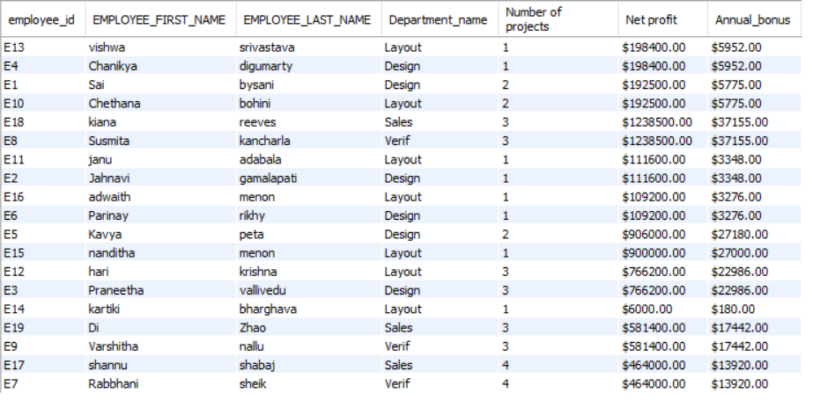

**Query-2 (DESIGN TRACKING REPORT)**

**Business Requirement:**

Blackchip semiconductors company wants to track their hardware designs, specifications, design cycle time, bugs resolving time as well as layout specifications in order to optimize their time and scope.

**Description:**

* Based on the design start date and design end date, the design duration for each design has been determined. This will be utilized when the organization receives a new project and needs to pick which design team to assign it to finish it on time.
* We've also computed the duration for each bug to be resolved, using the bugs logged in date and bugs logged out date as inputs. This time frame will assist the organization in determining how long it takes to fix a bug. The company will be able to estimate the time it will take to remedy the problem and the root cause of the problem by comparing it to the bugs description.
* It also depends on the metal layer utilized for the chip and the voltage domain of the device in most circumstances. The company will get an idea about the faults that happened in a certain range by dividing the voltage domain into various ranges and comparing it to the bugs description.

**Query :**

**SELECT** d.design_id,**DATEDIFF**(d.dend_date,d.dstart_date) **AS** 'design_duration (days)',

features,**DATEDIFF**(v.Bugs_logged_out_date,v.Bugs_logged_in_date) **AS** 'bug_resolving_duration (days)',

v.bugs_description, l.layout_plan_description, l.metal_layer, l.voltage_domain **FROM** design d

**JOIN** layout l **ON** d.design_id=l.design_id

**JOIN** verification v **ON** l.design_id=v.design_id;

**Functions used:**

JOINS, DATEDIFF

**SAMPLE REPORT:**

**Query-3 (CLIENT SUMMARY REPORT)**

**Business Requirement:**

The sales team of Blackchip semiconductors company is given a task of finding high profitable clients among the existing ones.

**Description:**

* In our database, we have four clients belonging to either one or more locations. In our report, we reported profit that is generated by every client, this profit information is obtained from the sales table, since there are multiple locations from a single client, we also found the total number of locations for each client.
* Finding this is critical for the company to prioritize and plan their future client assignments and deliverables.

**Query:**

**SELECT** client_id,

**IF**(client_id='C1','Dell',if(client_id='C2','Toshibha',if(client_id='C3','Seagate','Western Digital'))) **AS** client_name,

no_of_locations,

no_of_orders,SUM_of_order_size,

Clients_total_budget_$,profit_$

FROM (

**SELECT** o.client_id,**COUNT**(o.location_id) AS no_of_locations,

**COUNT**(o.order_id) **AS** no_of_orders,

**SUM**(o.order_size) **AS** SUM_of_order_size,

**round**(SUM(o.budget),2) **AS** Clients_total_budget_$,

**round**(SUM((s.budget*s.profit_percentage)/100),2) **AS** profit_$

FROM sales s

**JOIN** orders o **ON** s.order_id=o.order_id

**GROUP BY** o.client_id **ORDER BY** profit_$ DESC

) **AS** t2 ;

**Functions used:**

SUBQUERY, CONCAT, GROUP BY, ORDER BY, SUM, JOINS

**Sample Report:**

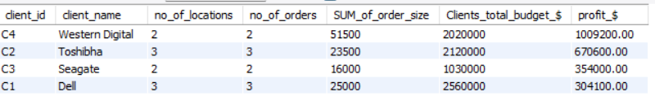

**Query-4 (DEPARTMENT STATISTICS REPORT)**

**Business Requirement:**

The HR manager of Blackchip semiconductors wants to keep track of resources and their salary allocation across the several verticals of the company to make more informed decisions when hiring and allocating new resources to a team.

**DESCRIPTION:**

* The number of employees in the design, layout, sales, and verification departments has been calculated.
* Each employee's salary has been computed, and the salaries of each department's employees have been included. Here salary is computed by multiplying hourly rate, number of hours worked per day and number of days in a month (20 working days).
* For each department, summary statistics such as the sum, average, minimum, and maximum salaries have been determined.
* Various of these will help the organization understand the differences in pay across all departments. They can determine whether to increase or decrease their salary based on these statistics and the department's performance. The number of employees in each department will be useful in determining if the department requires additional or less staff to perform their assigned tasks.

**SOLUTION 1:**

**SELECT** department_name,**IF**(department_name='Design',**COUNT**(employee_id),

**IF**(department_name='Verif',**COUNT**(employee_id),

**IF**(department_name='Layout',**COUNT**(employee_id),

**IF**(department_name='Sales',**COUNT**(employee_id),0)))) **AS** Total_no_employees,

**IF**(department_name='Design',**SUM**(hrs_worked_per_day*20*hourly_rate),

**IF**(department_name='Verif',**SUM**(hrs_worked_per_day*20*hourly_rate),

**IF**(department_name='Layout',**SUM**(hrs_worked_per_day*20*hourly_rate),

**IF**(department_name='Sales',**SUM**(hrs_worked_per_day*20*hourly_rate),0)))) AS Total_Salary,

**IF**(department_name='Design',**AVG**(hrs_worked_per_day*20*hourly_rate),

**IF**(department_name='VerIF',**AVG**(hrs_worked_per_day*20*hourly_rate),

**IF**(department_name='Layout',**AVG**(hrs_worked_per_day*20*hourly_rate),

**IF**(department_name='Sales',**AVG**(hrs_worked_per_day*20*hourly_rate),0)))) AS AVG_Salary,

**IF**(department_name='Design',**MAX**(hrs_worked_per_day*20*hourly_rate),

**IF**(department_name='Verif',**MAX**(hrs_worked_per_day*20*hourly_rate),

**IF**(department_name='Layout',**MAX**(hrs_worked_per_day*20*hourly_rate),

**IF**(department_name='Sales',**MAX**(hrs_worked_per_day*20*hourly_rate),0)))) AS MAX_Salary,

**IF**(department_name='Design',**MIN**(hrs_worked_per_day*20*hourly_rate),

**IF**(department_name='Verif',**MIN**(hrs_worked_per_day*20*hourly_rate),

**IF**(department_name='Layout',**MIN**(hrs_worked_per_day*20*hourly_rate),

**IF**(department_name='Sales',**MIN**(hrs_worked_per_day*20*hourly_rate),0)))) AS MIN_salary

**FROM** employees **GROUP BY** department_name;

**SOLUTION 2:**

**SELECT** department_name,**COUNT**(employee_id) **AS** NUMBER_OF_EMPLOYEES,

**SUM**(hrs_worked_per_day*20*hourly_rate) **AS** SUM_OF_SALARIES,

**MAX**(hrs_worked_per_day*20*hourly_rate) **AS** MAXIMUM_OF_SALARIES,

**MIN**(hrs_worked_per_day*20*hourly_rate) **AS** MINIMUM_OF_SALARIES,

**ROUND**(AVG(hrs_worked_per_day*20*hourly_rate),2) **AS** AVERAGE_OF_SALARIES

**FROM** employees **GROUP BY** department_name;

**FUNCTIONS USED:**

COUNT, SUM, MIN, MAX, AVG, GROUP BY

**SAMPLE REPORT:**

**QUERY-5 (REGION WISE PROFIT SUMMARY REPORT)**

**Business Requirement:**

During the pandemic, the sales and profits have gone drastically down, the sales team of Blackchip semiconductors company is given a task of finding high profitable locations among the existing ones to prioritize and plan their future investments.

**Description:**

* In our database, we have six locations from where one or more clients place orders. In our report, we reported profit that is generated from every location, this profit information is obtained from the sales table, since there are multiple clients from a single location, we also found the total number of clients per each location.
* Further we used the following rule to classify the locations as high market, medium market, low market zone. This information is critical to company to prioritize and plan their future investments.

If profit < $100K “Low market”, If profit > 500K “High market”, otherwise it is “Medium market”

**Query used:**

**SELECT**

l.location_id, l.location_name, count(o.client_id) as no_of_clients, SUM(o.order_size) **AS** order_size,

**CONCAT**('$',round(SUM((s.budget*s.profit_percentage)/100),2)) **AS** Profit,

**CONCAT**('$',round((SUM((s.budget*s.profit_percentage)/100))/count(o.client_id),2)) **AS** Normalized_profit_per_order ,

**IF**(round((SUM((s.budget*s.profit_percentage)/100))/count(o.client_id),2) < 100000,

' Low', **IF**(round((SUM((s.budget*s.profit_percentage)/100))/count(o.client_id),2) > 500000 ,

'High', 'Medium')) **AS** category from locations l

**JOIN** orders o **ON** l.location_id=o.location_id

**JOIN** sales s **ON** s.order_id=o.order_id **GROUP BY** l.location_id **ORDER BY** normalized_profit_per_order **DESC**;

**Functions used:**

JOINS, IF, CONCAT, ORDER BY, GROUP BY

**Sample Report:**

