**Sentinelone agent configure in Ubuntu &Linux**

**Ref INC : INC2471643**

Installing the Linux Agent

# Prerequisites

[Make sure the endpoints meet the system requirements [agent-requirements-on- linux.html].](https://usea1-bunge.sentinelone.net/docs/en/agent-requirements-on-linux.html)

[If the endpoints have or will have AIDE, create an exclusion for Sentinelone in AIDE[interoperability-between-aide-and-the-linux-agent.html].](https://usea1-bunge.sentinelone.net/docs/en/interoperability-between-aide-and-the-linux-agent.html)

Get the *Group Token or the Site Token* for Agent registration on the Management Console.

Make sure the endpoint does NOT reboot before you complete the full installation, association, and activation.

# To install the Linux Agent:

1. From the Management Console, download the package for the distro of the endpoints. The Linux Agent uses the standard RPM and DEB package formats for both x86 and ARM.

Important

[Installation of the Linux ARM Agent is the same as for the Linux Agent on x86[installing-the-linux-agent.html], but make](https://usea1-bunge.sentinelone.net/docs/en/installing-the-linux-agent.html) sure you use the correct installer. The x86 package **will not** install on ARM endpoints, and the ARM installer **will not**

install on x86 endpoints.

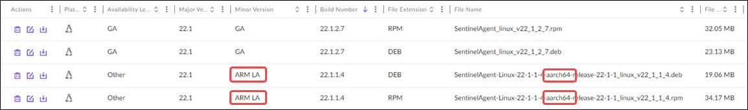

RPM installation requires the --nodigest switch to prevent this error: Package SentinelAgent_linux_*version* does not

verify: no digest .

If you use yum to install on RHEL 8.2, the signed RPM installer is required.

**Step:1** Copy the latest sentinel one RPM package.

I have downloaded and copy to my home dir of lil-ux-1.

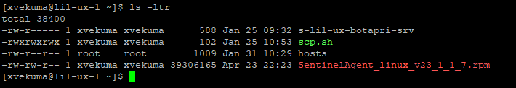

Note :- For Linux servers use RPM package

For Ubuntu servers use DEB package.

**Step:2** I have downloaded and copy to my home dir of lil-ux-1.

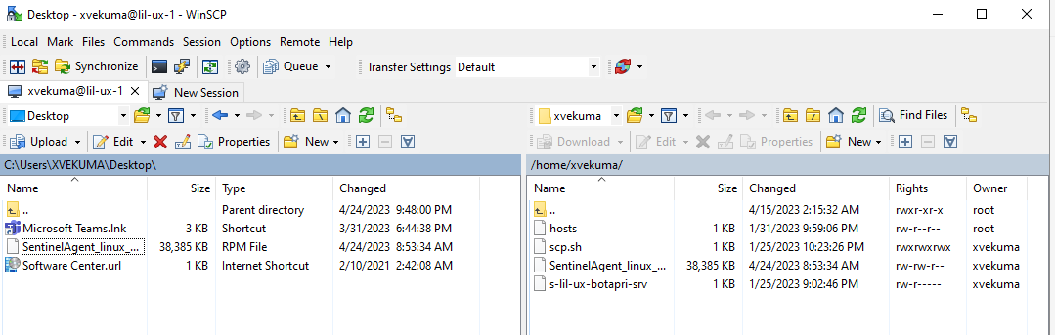

**Step:3** Scp the package from lil-ux-1 server to target server.

Scp –pr SentinelAgent_linux_v23_1_1_7.rpm root@lil-ux-lxtest5:/tmp



**Step:4** Cd to path where we have copied the package.

cd /tmp

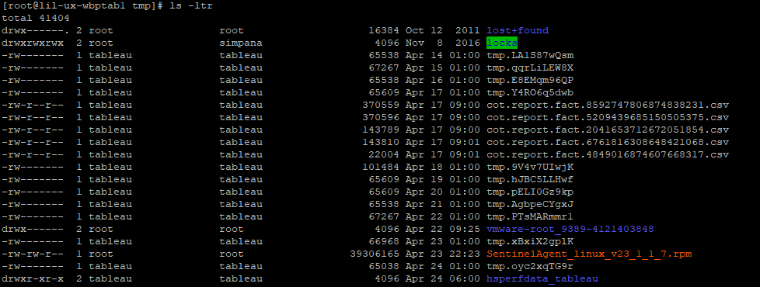

**Step 5**: Provide full permissions(777) to install the agent.

chmod 777 SentinelAgent_linux_v22_1_1_4.rpm



**Step 6:** Now install the package.

rpm -i --nodigest SentinelAgent_linux_v22_1_1_4.rpm



**Step 7**: Associate the Agent with the Management Console with the Group or Site Token.

/opt/sentinelone/bin/sentinelctl management token set eyJ1cmwiOiAiaHR0cHM6Ly91c2VhMS1idW5nZS5zZW50aW5lbG9uZS5uZXQiLCAic2l0ZV9rZXkiOiAiOTgyOTc0YzJjMzYzNDNlOCJ9

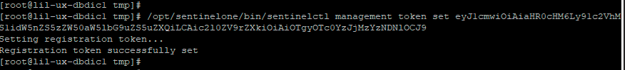

**Step 8**: Start the Agent services.

/opt/sentinelone/bin/sentinelctl control start



**Step 9**: Validate that a new version of the Agent is installed

/opt/sentinelone/bin/sentinelctl version

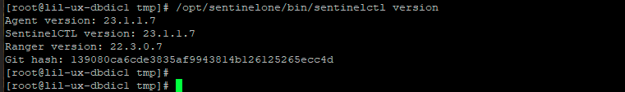

Step:10 check the status of the SentinelOne agent run the below command

/opt/sentinelone/bin/sentinelctl control status

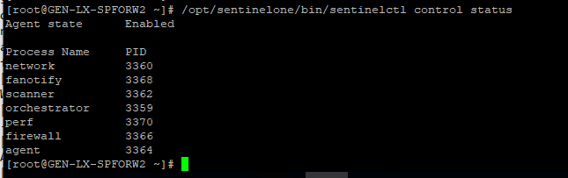

**Step:11** to check management status

#sentinelctl management status

