**To Extend the File system by adding the new Disk**

**Step 1:** As per the requirement, we need to ask the DC Team (windows team) to add a new disk on the server in VM Sphere.

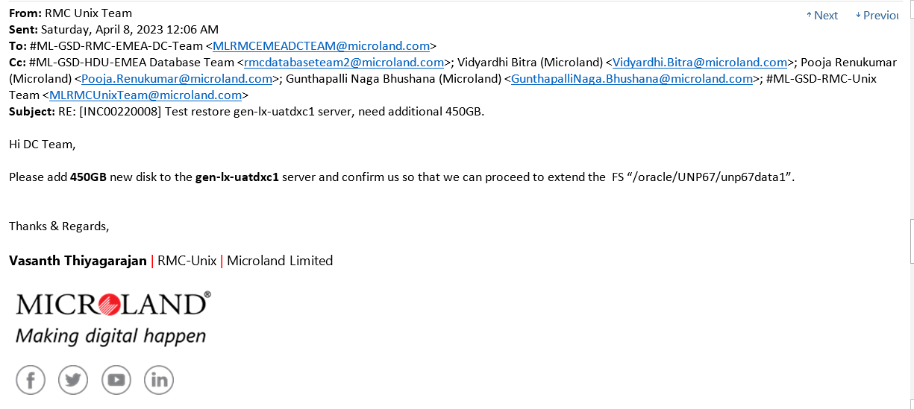

**Step 2:** After the confirmation from the DC team, Log into the server and switch to the root user. Use Command lsblk to check whether the disk is added or not.

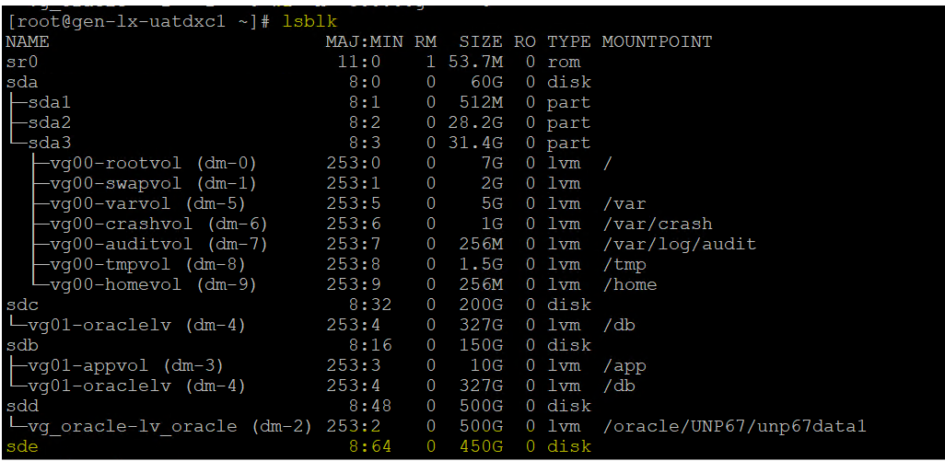

**Step 3:** pvcreate /disk_name – to create physical volume.

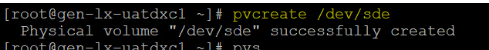

**Step 4:**  pvs – Display physical volume.

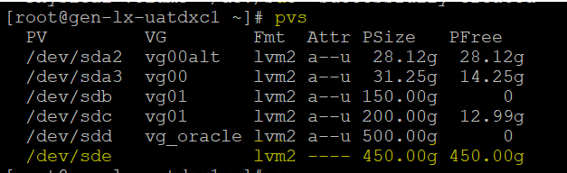

**Step 5:** vgextend vg_oracle /dev/sde – to extend volume group.

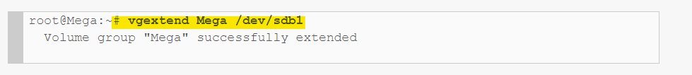

**Step 5:** vgs – Display volume group

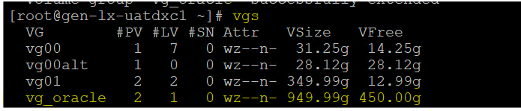

**Step 7:**  lvextend –L +0G /File_sytem – to extend Logical volume.



**Step 8:** lvs – Display Logical volume.

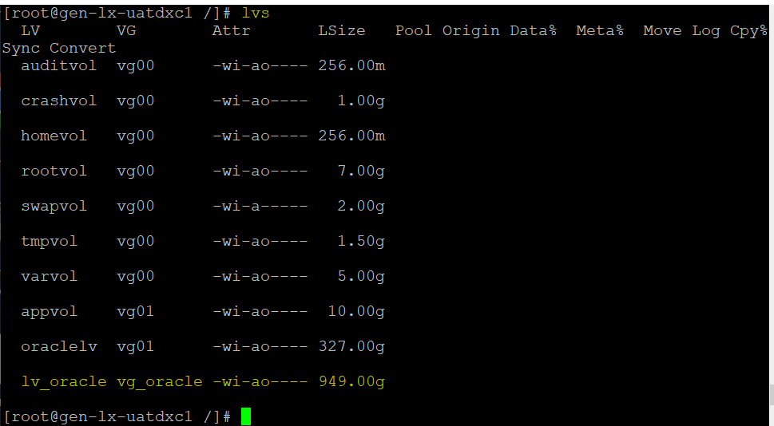

**Step 9:** resize2fs /File_System - used to enlarge or shrink an ext2/3/4 file system on a device.

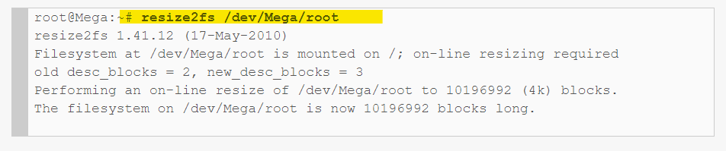

**Step 10:**  df –Th /mountpoint



For Further Reference - [How to Increase the size of a Linux LVM by adding a new disk (rootusers.com)](https://www.rootusers.com/how-to-increase-the-size-of-a-linux-lvm-by-adding-a-new-disk/)