**SOP – TO GENERATE SOSREPORT**

**Step 1:** Log into the server & switch to the root user. Use the command sosreport – to generate the sosreport.

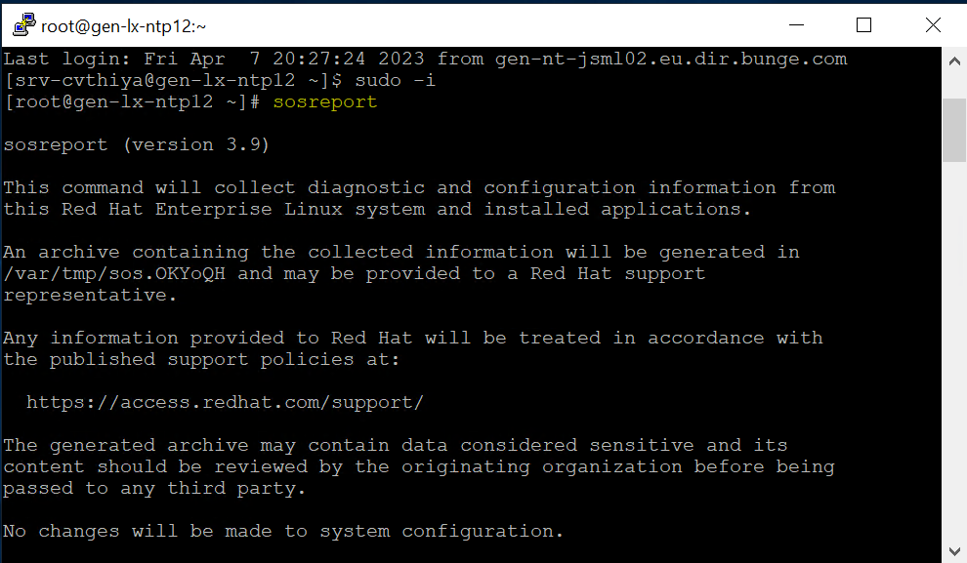

**Step 2:** Press Enter

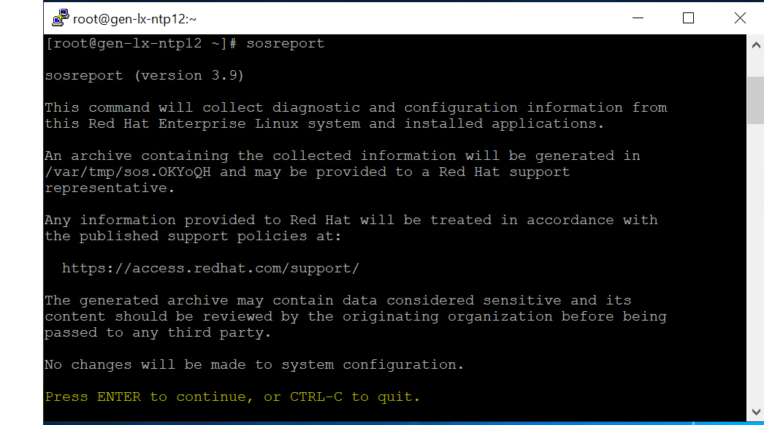

**Step 3:** Enter case ID if you have one or press Enter

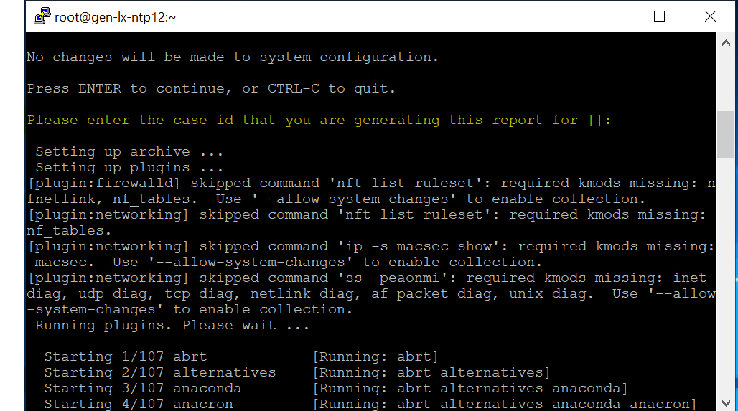

**Step 5:** After generating the sosreport, we can see the File path where the sosreport is saved. Please find the below screenshot for reference.

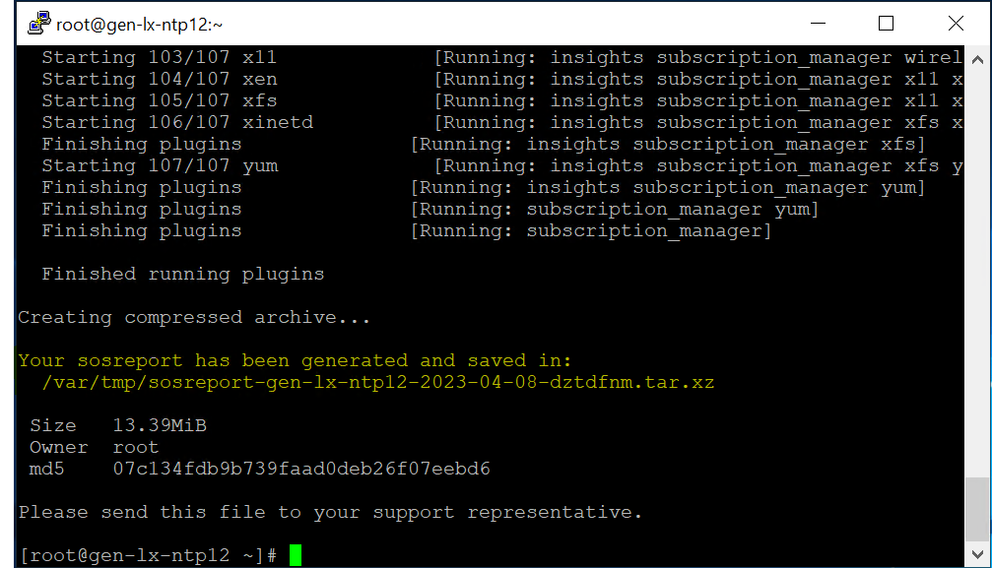

**Step 6:** To transfer the sosreport from the server to the desktop. Open WinSCP, and enter the hostname, User name & credentials.

FYI – Please Install WinSCP, The Package is available under the mentioned path.

WinSCP Location (Path) – This PC 🡪Application (D:)

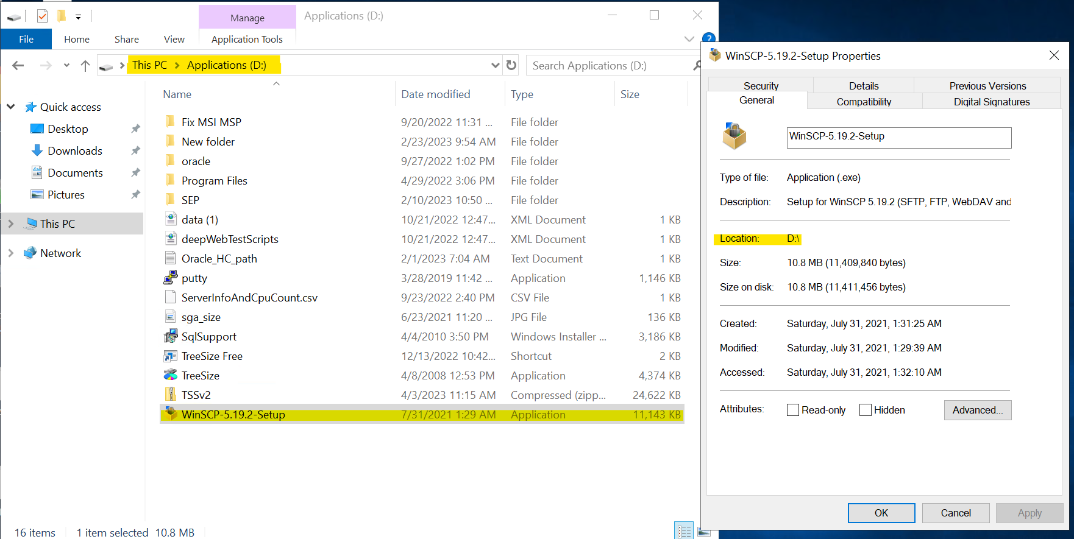 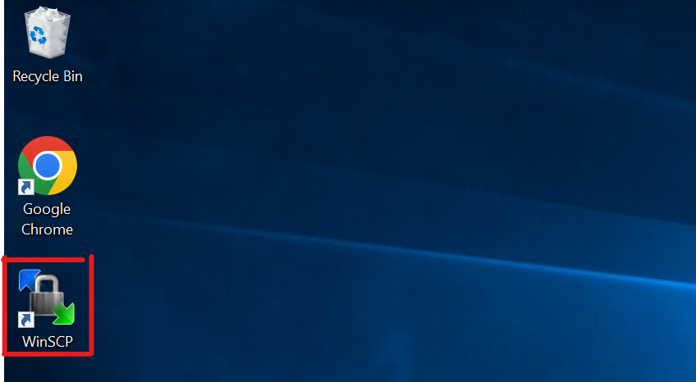

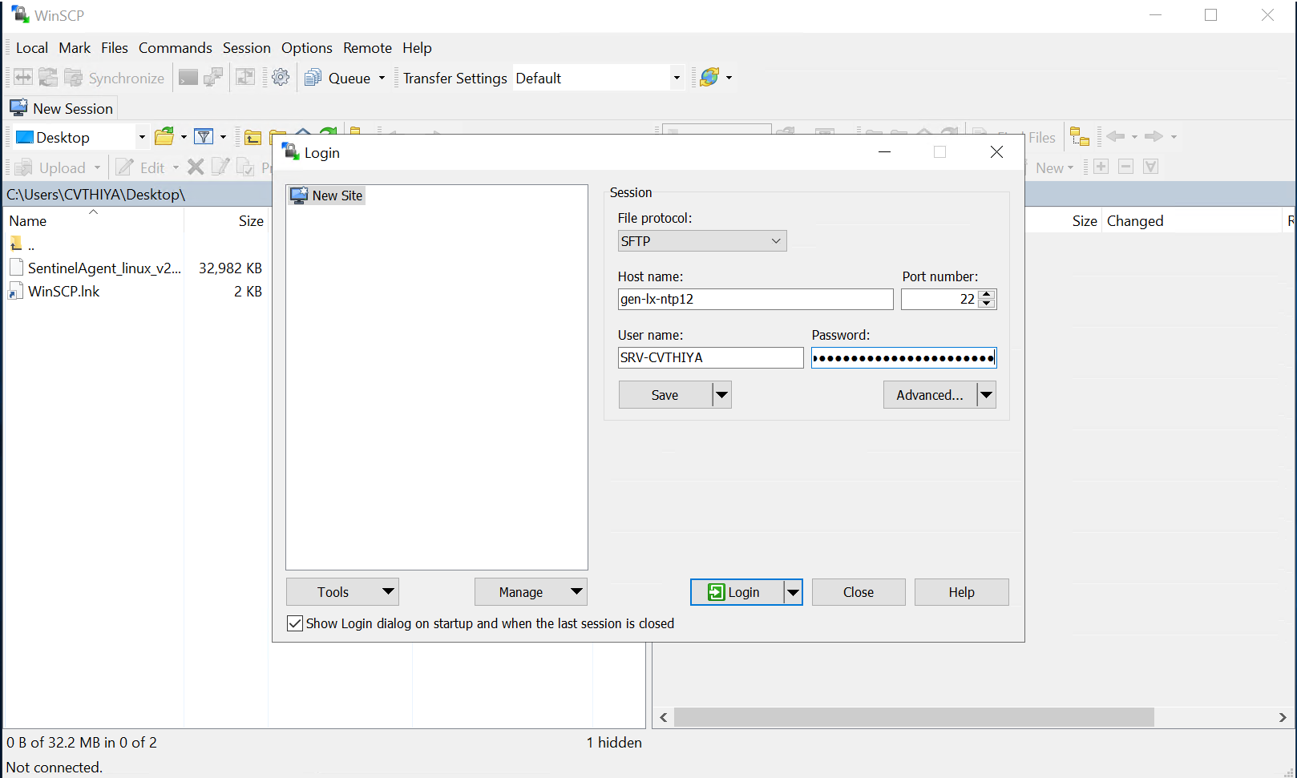

**Step 7:** Select the drop-down list box and select /<root>

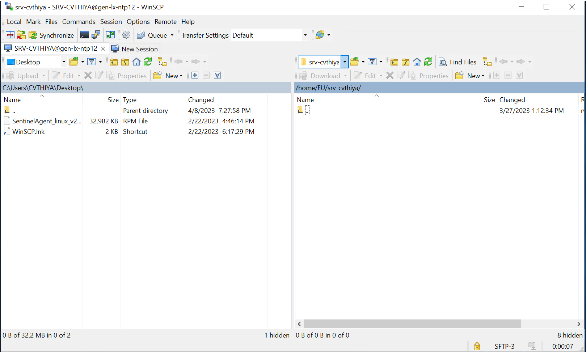 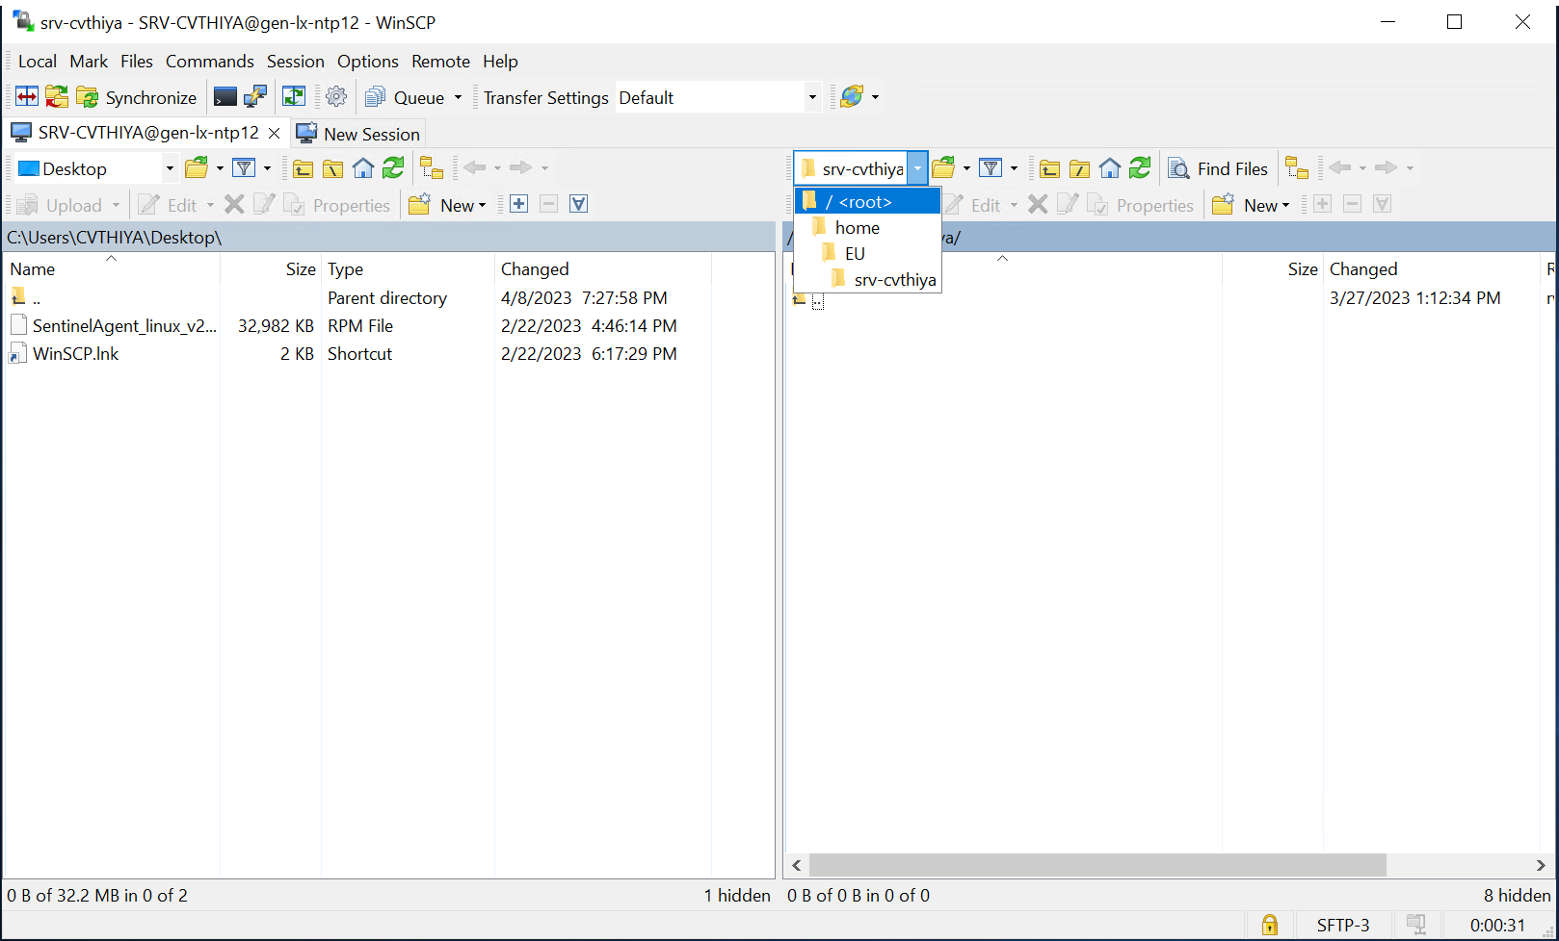

**Step 8**: As per the File path mentioned above, var > tmp > sosreport.

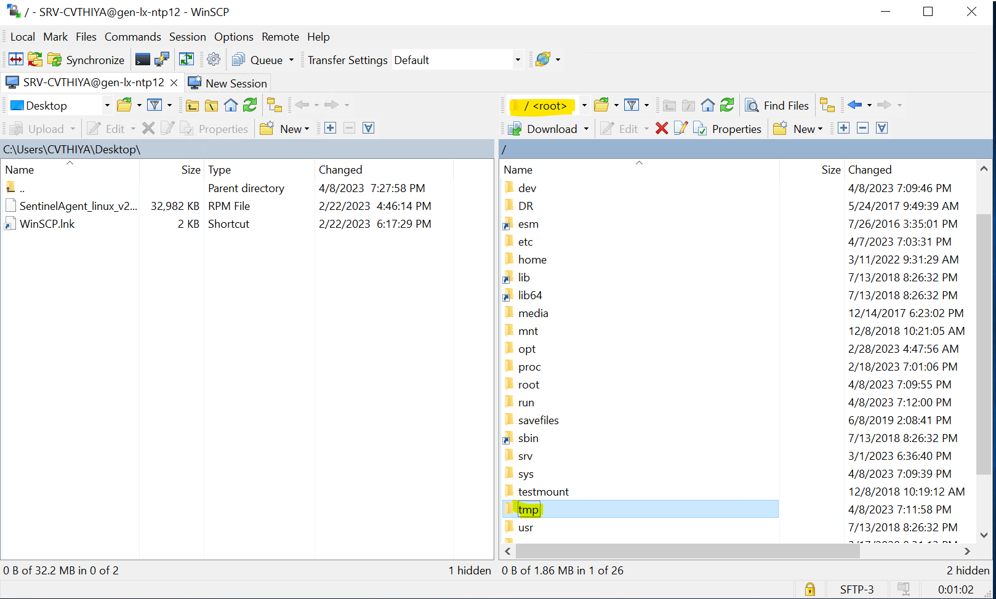 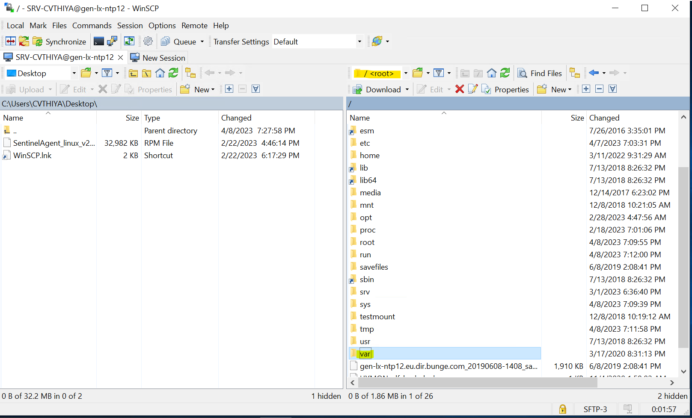

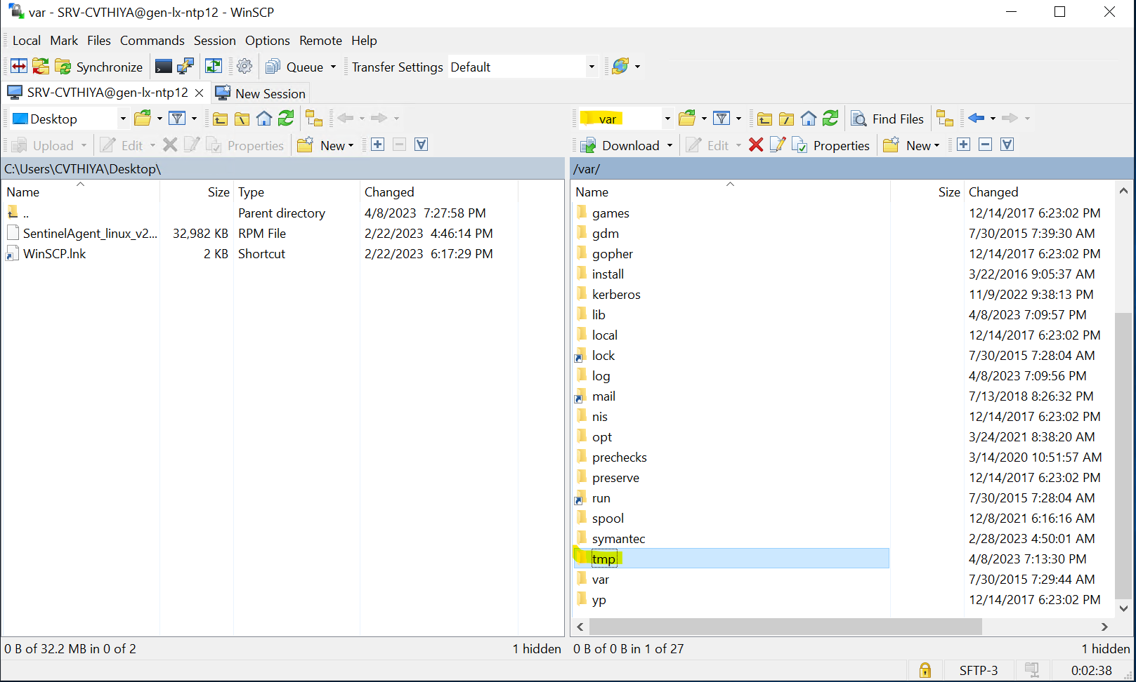 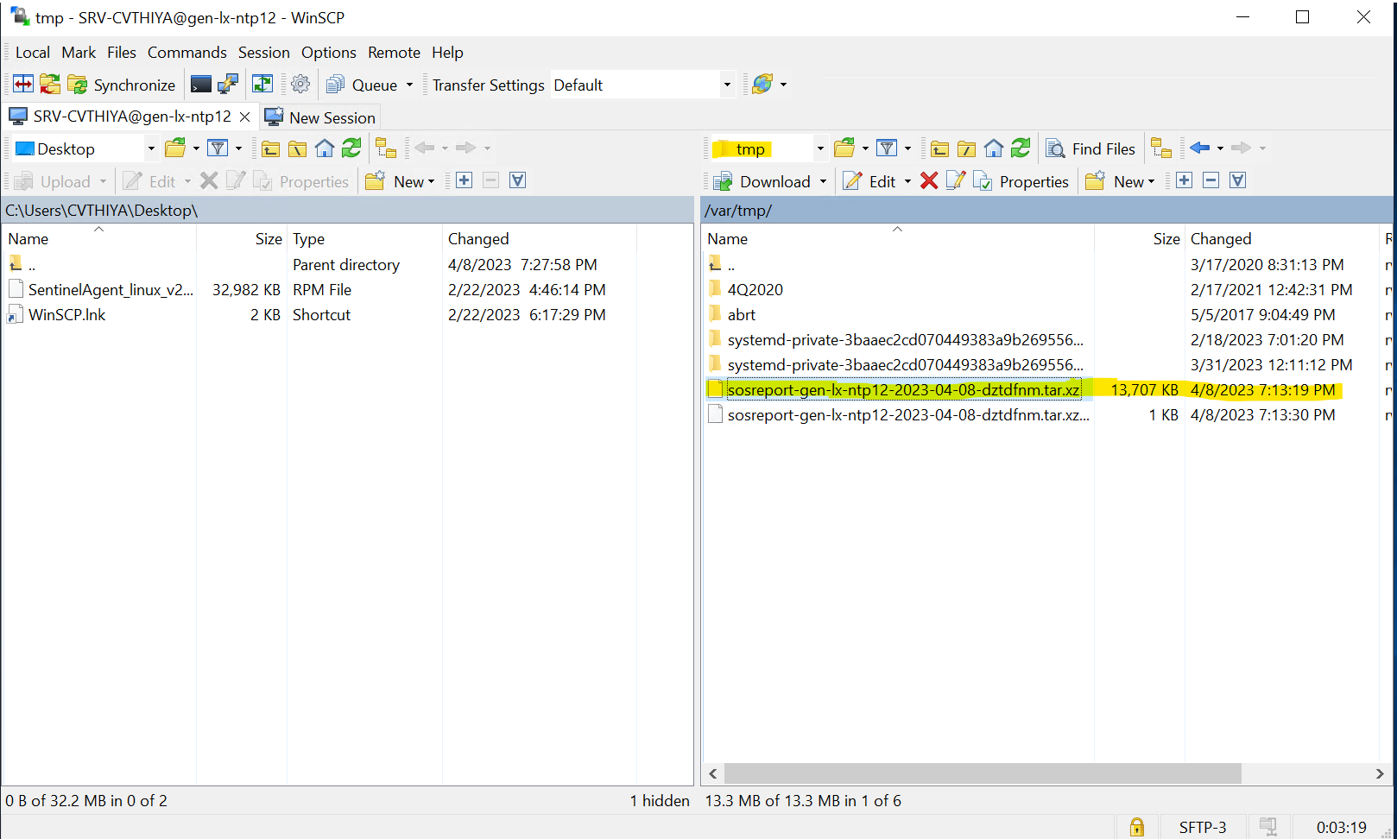

**Step 9:** After finding the sosreport on the mentioned path, copy & paste the file into the desktop.

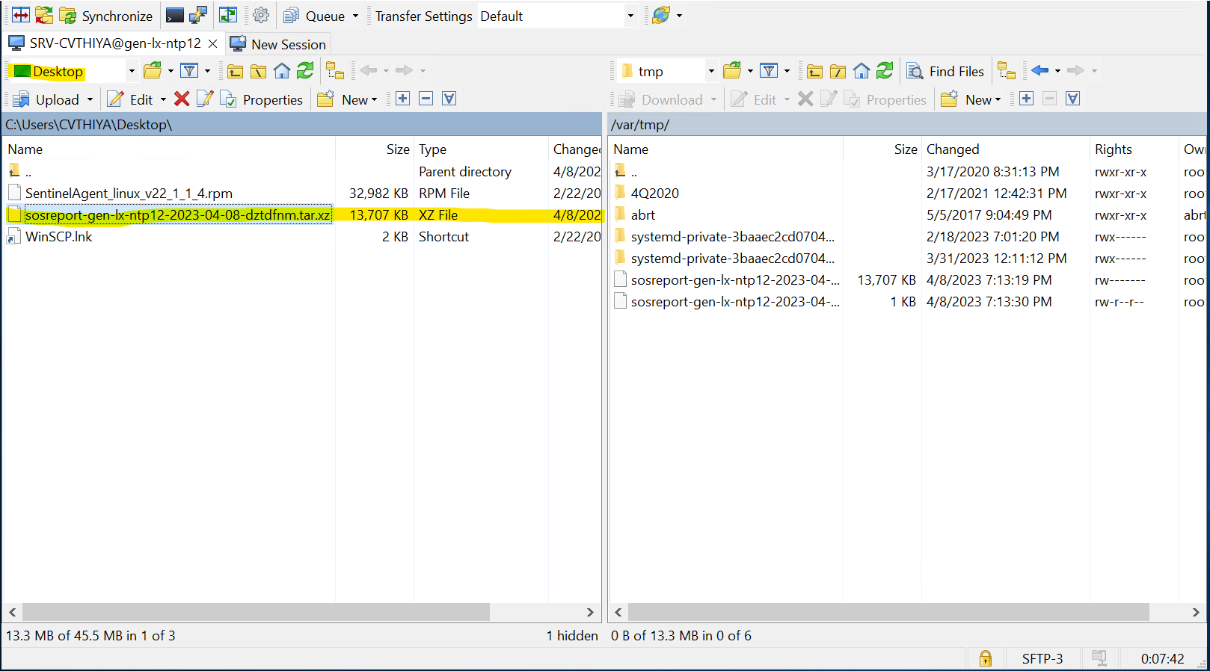

For Further reference - [What is an sos report and how to create one in Red Hat Enterprise Linux? - Red Hat Customer Portal](https://access.redhat.com/solutions/3592)