**BUNGE UK HEALTH CHECK ANALYSIS ON HIGH**

**CPU & MEMORY UTILIZATION**

Please follow the below commands to identify which process is consuming high CPU on Linux System.

1. ps -eo pcpu,pid,user,args | sort -k 1 -r | head -10

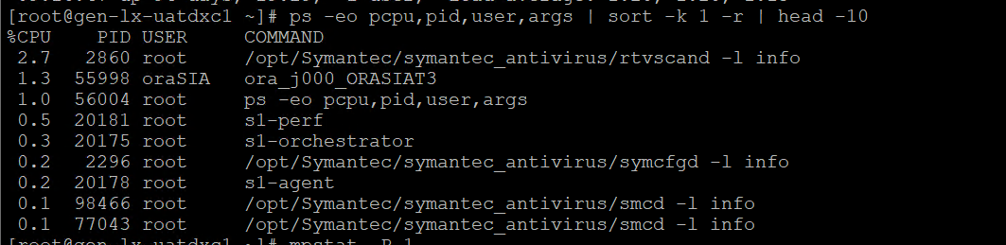

1. grep 'cpu ' /proc/stat | awk '{usage=($2+$4)*100/($2+$4+$5)} END {print usage "%"}'



1. nproc (A command used to print the number of processors in the current system.)

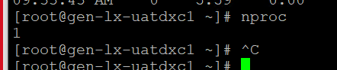

1. mpstat -P 0 (Report processors-related statistics.)

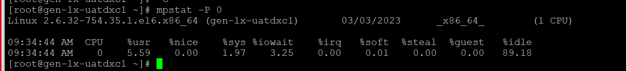

1. iostat –c (used for monitoring system input/output statistics for devices and partitions.)

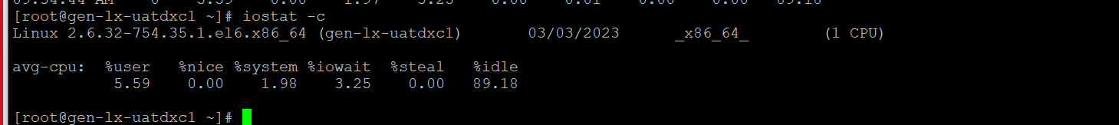

**Steps:**

1. Check Top Processes sorted by RAM or CPU Usage in Linux by running top or below commands.

# ps -eo pid,ppid,cmd,%mem,%cpu --sort=-%mem | head

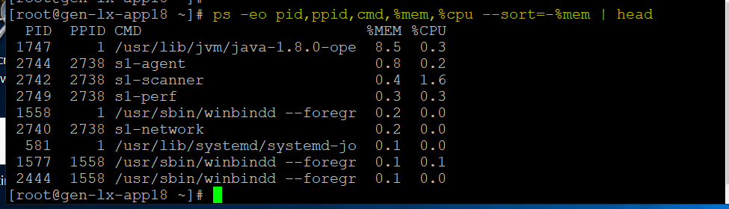

# ps -eo pid,ppid,cmd,%mem,%cpu --sort=-%cpu | head

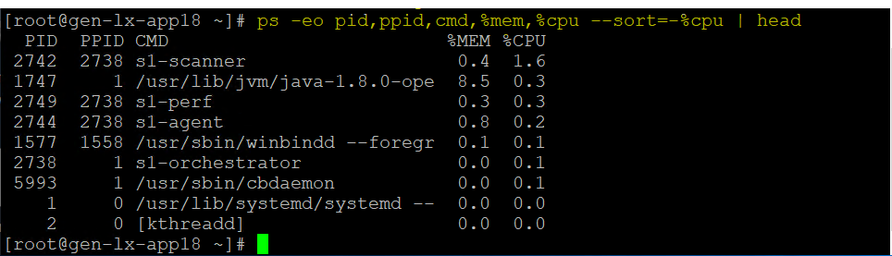

2. If the memory or CPU utilization is high, monitor for some time if still utilization is high, identify which is utilizing high memory and CPU

3. Once you found the particular process is consuming high we need to notify the respective team

**Example:** If applications like apache are consuming more need to intimate the Application team.

If a DB process like Oracle is consuming more need to intimate to the DB Team.

**Note:**

**CPU utilization** indicates the amount of load handled by individual processor cores to run various programs on a computer.

**Memory utilization** is the average utilization derived from the per cent of available memory in use at a given moment.