



**2017**

**2017**

**FRE-GY 5990**

**Capstone Project Report**

**Project Advisor: Prof. Edith Mandel**

**Project Member: Mengyang Liu, Xingyue Huang**

**Contents**

1. Introduction to SABR model 3

1.1 SABR model 3

1.2 SABR parameters 3

1.2.1 The level parameter *k* 3

1.2.2 The slope parameter *k* and *k* 3

1.2.3 The curvature parameter *k* 4

2. Hagan et al. Approximation 5

2.1 Lognormal approximation 5

2.2 Normal approximation 5

3. SABR calibration in practice 6

3.1 Over-specification test for Hagan et al. approximation 6

3.1.1 fixed *k* 6

3.1.2 fixed *k* 7

3.1.3 fixed *k* 7

3.1.4 fixed *k* and *k* 8

3.1.5 fixed *k* and *k* 9

3.1.6 fixed *k* and *k* 9

3.2 Collinearity test for Hagan et.al approximation 10

4. Monte Carlo simulation for SABR 11

4.1 Monte Carlo standard error 11

4.2 Monte Carlo schemes 11

4.2.1 Euler scheme 11

4.2.2 Milstein scheme 15

5. Validation of Hagan et al. approximation 17

5.1 Validation of c.d.f and p.d.f 17

5.1.1 Using lognormal Hagan 17

5.1.2 Using Monte Carlo simulation 17

5.2 Validation of lognormal implied volatility 17

5.2.1 Using lognormal Hagan 17

5.2.2 Using Monte Carlo simulation 17

5.3 Validation of normal implied volatility 19

5.3.1 Using lognormal Hagan 19

5.3.2 Using Monte Carlo simulation 19

6. The limits of Hagan et al. approximations 20

7. Alternative SABR approximations 21

7.1 Obloj SABR 21

7.1.1 Obloj calibration 21

7.1.2 Validation of c.d.f 22

7.1.3 Over-specification and collinearity test 22

8. Code structure 25

9. References 26

# 1. Introduction to SABR model

## 1.1 SABR model

The SABR model is defined by the two processes:

where is the forward interest rate, is the stochastic volatility, is the elasticity coefficient, is the volatility of volatility process and

.

## 1.2 SABR parameters

In this section we analyze how SABR parameters influence the level, slope and curvature of implied volatility smile.

### 1.2.1 The level parameter *k*

The parameter is the initial value of stochastic volatility process . It moves up and down the smile curve with almost no changes to the smile shape.

### 1.2.2 The slope parameter *k* and *k*

The parameter represents constant elasticity of variance (CEV) which takes value between 0 and 1. This is because that the SABR model is a martingale only if or as long as for It exerts effects on the smile slope. In particular, the slope will get more pronounced as moves from 1 to 0. An intuitive explanation of this change is the fact that the model will switch from lognormal to normal-like behavior when is lowered.

The parameter is the correlation between the two Brownian motions governing the forward rate process and the volatility process respectively. It can take any value within -1 and 1. Its effect on the implied volatility smile curve is similar to that of : the smile will get steeper when is more negative.

### 1.2.3 The curvature parameter *k*

The parameter is defined as the volatility of the stochastic volatility The effect of is to change the curvature of the smile curve. Specifically, higher increases the implied volatility for OTM and ITM options.

# 2. Hagan et al. Approximation

## 2.1 Lognormal approximation

## 2.2 Normal approximation

# 3. SABR calibration in practice

## 3.1 Over-specification test for Hagan et al. approximation

In this section we have conducted an over-specification test for Hagan et al. approximation. This test is aimed to examine the calibration quality of the Hagan approximation, and how the particular k will have an effect on it. Our tests are run with different sets of SABR parameters kept fixed and the remaining parameters calibrated based on the minimization algorithm and then ATM volatility recovered. Our subject data here is the data with expiry Tk-1=1Y.

### 3.1.1 fixed *k*

The calibration has been performed with k keeping fixed and calibrating the other two parameters k, k. We have repeated the calibration exercise using:

According to the plot below, all approximations provide excellent fit to market quotes except . Generally the smile slope gets more pronounced as moves closer to 1, which represents a switch from normal approximation to lognormal approximation.

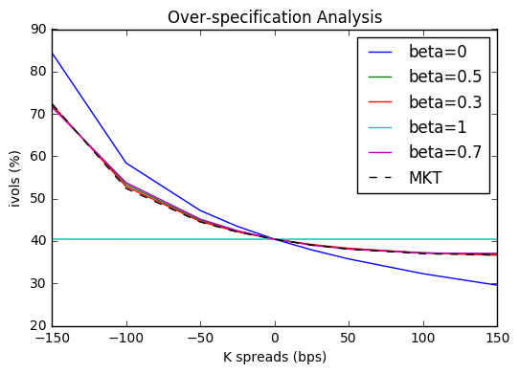

### 3.1.2 fixed *k*

We also present an assessment for the calibration where is kept fixed. We have repeated the calibration using:

We can see that =0, -0.3, -0.5 all give good approximations from the plot below while =-0.7, -0.9 do not fit well for out-of-the-money options. It’s also straightforward that has a similar effect on the smile shape as does: the smile slope becomes steeper as gets more negative.

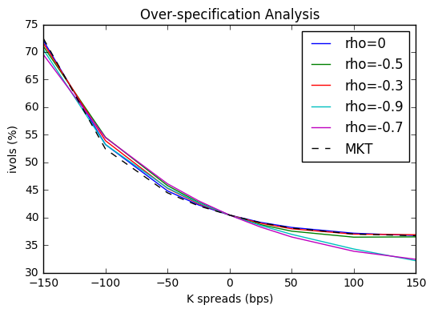

### 3.1.3 fixed *k*

The same calibration procedure is run for parameter k using:

And it can be seen from the plot below that the effect of is to increase or decrease its curvature: higher leads to increased volatility for out of the money (OTM) and in the money (ITM) options. Of these three values, the best performance is given by and also give good approximations.

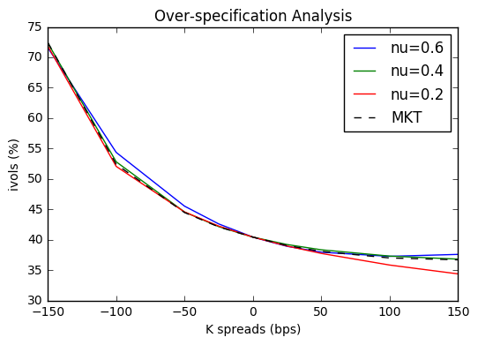

### 3.1.4 fixed *k* and *k*

We repeat the calibration procedure where parameter k and k kept fixed and k calibrated using:

All combinations of and yield good approximations except =0, =-0.8, as can be seen from the plot below. In other words, a sound approximation of Hagan et al. lognormal SABR model does not require all three parameters , and to be calibrated at once. Setting two of them fixed and calibrating the remaining one can be more computationally efficient without harming the quality of calibration.

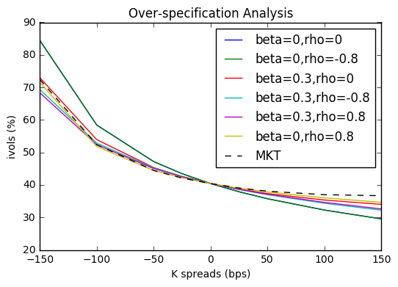

### 3.1.5 fixed *k* and *k*

Then again we repeat the calibration procedure where parameter k and kept fixed and k calibrated using:

When is fixed to 0.25, closer to 0 gives better performance while a high such as 0.7 and 1 do not fit well either for in-the-money options or for out-of-the-money options. For other values of , in general their ability to fit market data does not vary too much from each other.

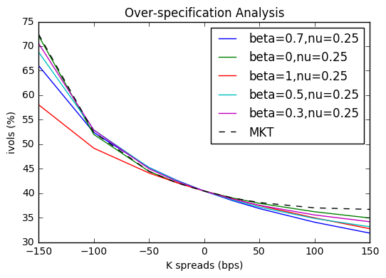

### 3.1.6 fixed *k* and *k*

We repeat the calibration procedure where parameter k and kept fixed and k calibrated using:

Of the three combinations given here, =0.8,=0.25 has the best performance for out-of-the-money options while =-0.8,=0.25 gives the worst.

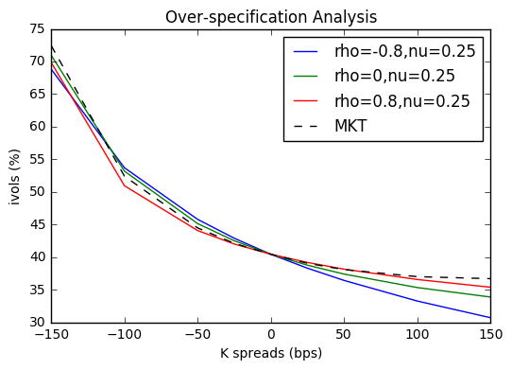

## 3.2 Collinearity test for Hagan et.al approximation

To further explore the quality of Hagan SABR approximation, we calculate the condition number of the calibration Jacobian matrix to detect collinearity.

Table: Collinearity test for Hagan et al. implementation

|  |  |
| --- | --- |
| Hagan et al. SABR | Condition number of Jacobian matrix |
| Calibrate , and | 1277 |
| Fix , calibrate and | 438 |
| Fix -0.5, calibrate and | 878 |
| Fix, calibrate and | 25969 |
| Fix =0 and =0.8, calibrate | 72 |
| Fix =0 and =0.25, calibrate | 1087 |
| Fix =0.8 and =0.25, calibrate | 29 |

We can see from the table above that 1) with one or two parameters fixed in calibration, SABR model has less collinearity as the condition number of the transposed Jacobian matrix of calibration has reduced from 1277 to around 1000 or even 100 below; 2) Of these different calibrations, fixing and one more factor or can reduce collinearity most. However, keeping aspecific parameters fixed to different values can give very different condition numbers. For example, the condition number rises to 14767 when we calibrate with fixed to 0.

# 4. Monte Carlo simulation for SABR

After having analyzed the fitting performances of Hagan et al. SABR model in terms of calibration fitting, we would like to use Monte Carlo simulation to investigate if they are able to correctly approximate the evolution of the SABR processes.

## 4.1 Monte Carlo standard error

Let’s denote Monte Carlo average estimator as

where is the total number of paths simulated and is the forward interest rate generated by the i-th simulation. The quantity

is used to determine the Monte Carlo standard error. The lower the standard error the better the accuracy of the tested Monte Carlo scheme.

## 4.2 Monte Carlo schemes

In this section we discuss two of most commonly used Monte Carlo schemes: Euler scheme and Milstein scheme and their simulations of Hagan et al. lognormal approximation.

### 4.2.1 Euler scheme

In Euler scheme, the SABR process can be rewritten as

where and are discrete versions of and respectively.

Here we implement a zero absorbing boundary for the forward process when as only in this case will SABR remain a martingale.

There is a risk that Euler scheme may fail to reach convergence in simulating the implied volatility. Therefore we have performed Monte Carlo simulations with different combinations of time step size and SABR parameters. The tests shown below are classified in three different groups based on :

For each of them we have tested five different values of :

and five different time step numbers:

for all cases: =100000, =10Y and =0.25. And time steps are chosen based on how long we want the discrete steps be. For example, if we choose we are dealing with discrete steps that are about 60 trading days long considering we have 252 trading days in a year. We put a cap at as we have not seen any considerable improvement in the convergence for higher values.

Table: Equivalence between the total and the actual per year

|  |  |
| --- | --- |
| Simulation time step | Equivalent time step per year |
| 1 | 0.1 |
| 40 | 4 |
| 240 | 24 |
| 480 | 48 |
| 960 | 96 |

Black implied volatilities (%)by Euler scheme for =0 and various combinations of . For all cases: =10Y, =0.25

|  |  |  |  |  |  |  |  |  |  |  |
| --- | --- | --- | --- | --- | --- | --- | --- | --- | --- | --- |
|  |  | Strike spreads (bps) | | | | | | | | |
|  | Steps | -150 | -100 | -50 | -25 | 0 | 25 | 50 | 100 | 150 |
| =0 | 1 | 30.11 | 26.70 | 24.14 | 23.10 | 22.18 | 21.35 | 20.59 | 19.28 | 18.17 |
| =0 | 40 | 32.31 | 28.10 | 25.15 | 24.01 | 23.03 | 22.20 | 21.49 | 20.38 | 19.60 |
| =0.25 | 240 | 32.72 | 28.43 | 25.43 | 24.27 | 23.28 | 22.44 | 21.73 | 20.62 | 19.83 |
|  | 480 | 32.67 | 28.38 | 25.37 | 14.19 | 23.20 | 22.35 | 21.64 | 20.53 | 19.74 |
|  | 960 | 33.18 | 28.75 | 25.65 | 24.46 | 23.45 | 22.59 | 21.87 | 20.72 | 19.93 |
|  |  |  |  |  |  |  |  |  |  |  |
| =0.3 | 1 | 29.83 | 26.52 | 24.05 | 23.04 | 22.13 | 21.31 | 20.56 | 19.26 | 18.15 |
| =0 | 40 | 28.67 | 26.00 | 24.06 | 23.30 | 22.67 | 22.13 | 21.67 | 20.97 | 20.48 |
| =0.25 | 240 | 28.54 | 23.86 | 23.95 | 23.21 | 22.60 | 22.08 | 21.64 | 20.97 | 20.52 |
|  | 480 | 28.41 | 25.76 | 23.85 | 23.12 | 22.50 | 21.98 | 21.55 | 20.90 | 20.45 |
|  | 960 | 28.30 | 25.68 | 23.78 | 23.04 | 22.41 | 21.89 | 21.45 | 20.78 | 20.33 |
|  |  |  |  |  |  |  |  |  |  |  |
| =0.5 | 1 | 29.76 | 26.51 | 24.08 | 23.08 | 22.18 | 21.37 | 20.63 | 19.33 | 18.22 |
| =0 | 40 | 27.78 | 25.50 | 23.92 | 23.32 | 22.94 | 22.44 | 22.10 | 21.64 | 21.34 |
| =0.25 | 240 | 26.84 | 24.84 | 23.41 | 22.86 | 22.41 | 22.05 | 21.77 | 21.36 | 21.13 |
|  | 480 | 27.08 | 24.97 | 23.51 | 22.96 | 22.50 | 22.14 | 21.84 | 21.42 | 21.16 |
|  | 960 | 26.68 | 24.69 | 23.32 | 22.80 | 22.37 | 22.02 | 21.73 | 21.32 | 21.06 |
|  |  |  |  |  |  |  |  |  |  |  |
| =0.7 | 1 | 30.31 | 26.91 | 24.41 | 23.36 | 22.43 | 21.59 | 20.82 | 19.51 | 18.39 |
| =0 | 40 | 25.96 | 24.34 | 23.27 | 22.89 | 22.59 | 22.36 | 22.19 | 21.97 | 21.88 |
| =0.25 | 240 | 25.91 | 24.30 | 23.26 | 22.89 | 22.61 | 22.39 | 22.23 | 22.05 | 21.99 |
|  | 480 | 25.76 | 24.19 | 23.18 | 22.82 | 22.55 | 22.35 | 22.20 | 22.05 | 22.02 |
|  | 960 | 25.88 | 24.29 | 23.26 | 22.91 | 22.64 | 22.44 | 22.29 | 22.11 | 22.06 |
|  |  |  |  |  |  |  |  |  |  |  |
| =1 | 1 | 30.60 | 27.11 | 24.53 | 23.47 | 22.52 | 21.67 | 20.90 | 19.56 | 18.43 |
| =0 | 40 | 24.62 | 23.66 | 23.16 | 23.04 | 22.98 | 23.00 | 23.00 | 23.16 | 23.41 |
| =0.25 | 240 | 23.82 | 22.97 | 22.55 | 22.45 | 22.42 | 22.49 | 22.49 | 22.67 | 22.93 |
|  | 480 | 22.57 | 22.11 | 21.90 | 21.86 | 21.87 | 21.99 | 21.99 | 22.21 | 22.48 |
|  | 960 | 22.58 | 22.15 | 21.93 | 21.90 | 21.91 | 22.05 | 22.05 | 22.27 | 22.54 |

Black implied volatilities (%)by Euler scheme for =0.8 and various combinations of *.* For all cases: =10Y, =0.25

|  |  |  |  |  |  |  |  |  |  |  |
| --- | --- | --- | --- | --- | --- | --- | --- | --- | --- | --- |
|  |  | Strike spreads (bps) | | | | | | | | |
|  | Steps | -150 | -100 | -50 | -25 | 0 | 25 | 50 | 100 | 150 |
| =0 | 1 | 30.72 | 27.35 | 24.86 | 23.83 | 22.90 | 22.06 | 21.30 | 19.96 | 18.81 |
| =0.8 | 40 | 25.87 | 24.53 | 23.75 | 23.49 | 23.28 | 23.12 | 22.99 | 22.81 | 22.69 |
| =0.25 | 240 | 25.31 | 24.16 | 23.52 | 23.31 | 23.15 | 23.03 | 22.94 | 22.81 | 22.73 |
|  | 480 | 25.77 | 24.45 | 23.72 | 23.49 | 23.31 | 23.16 | 23.05 | 22.91 | 22.83 |
|  | 960 | 24.89 | 23.84 | 23.25 | 23.05 | 23.05 | 22.79 | 22.71 | 22.59 | 22.51 |
|  |  |  |  |  |  |  |  |  |  |  |
| =0.3 | 1 | 30.52 | 27.08 | 24.53 | 23.48 | 22.54 | 21.70 | 20.94 | 19.59 | 18.45 |
| =0.8 | 40 | 23.55 | 23.26 | 23.29 | 23.36 | 22.45 | 23.56 | 23.66 | 23.87 | 20.08 |
| =0.25 | 240 | 22.27 | 22.33 | 22.56 | 22.69 | 22.83 | 22.98 | 23.12 | 23.39 | 23.63 |
|  | 480 | 23.25 | 23.00 | 23.08 | 23.18 | 23.29 | 23.41 | 23.53 | 23.78 | 24.02 |
|  | 960 | 23.10 | 22.94 | 23.08 | 23.19 | 23.31 | 23.44 | 23.57 | 23.82 | 24.06 |
|  |  |  |  |  |  |  |  |  |  |  |
| =0.5 | 1 | 29.68 | 26.43 | 24.02 | 23.03 | 22.14 | 21.33 | 20.59 | 19.31 | 18.22 |
| =0.8 | 40 | 22.30 | 22.56 | 23.06 | 23.33 | 23.60 | 23.85 | 24.10 | 24.56 | 24.96 |
| =0.25 | 240 | 21.30 | 21.83 | 22.49 | 22.81 | 23.12 | 23.41 | 23.71 | 24.24 | 24.73 |
|  | 480 | 22.86 | 22.88 | 23.32 | 23.59 | 23.85 | 24.12 | 24.37 | 24.84 | 25.29 |
|  | 960 | 22.76 | 22.77 | 23.18 | 23.44 | 23.70 | 23.96 | 24.21 | 24.70 | 25.15 |
|  |  |  |  |  |  |  |  |  |  |  |
| =0.7 | 1 | 29.62 | 26.28 | 23.82 | 22.80 | 21.90 | 21.08 | 20.33 | 19.03 | 17.94 |
| =0.8 | 40 | 22.05 | 22.57 | 23.43 | 23.88 | 24.31 | 24.73 | 25.13 | 25.86 | 26.53 |
| =0.25 | 240 | 20.08 | 21.16 | 22.29 | 22.81 | 23.31 | 23.78 | 24.41 | 25.00 | 25.73 |
|  | 480 | 20.46 | 21.40 | 22.48 | 23.01 | 23.51 | 23.99 | 24.44 | 25.26 | 25.29 |
|  | 960 | 21.53 | 22.12 | 23.06 | 23.54 | 24.00 | 24.44 | 24.86 | 25.65 | 25.15 |
|  |  |  |  |  |  |  |  |  |  |  |
| =1 | 1 | 28.74 | 25.50 | 23.11 | 22.13 | 21.24 | 20.45 | 19.73 | 18.47 | 17.40 |
| =0.8 | 40 | 31.95 | 30.36 | 30.66 | 31.07 | 31.55 | 32.08 | 32.61 | 33.67 | 34.68 |
| =0.25 | 240 | 13.97 | 17.89 | 20.25 | 21.22 | 22.09 | 22.89 | 23.62 | 24.93 | 26.07 |
|  | 480 | 12.10 | 17.14 | 19.65 | 20.66 | 21.56 | 22.38 | 22.13 | 24.46 | 25.62 |
|  | 960 | 10.00 | 15.45 | 18.36 | 19.44 | 20.38 | 21.22 | 21.98 | 23.30 | 24.45 |

Black implied volatilities (%) by Euler scheme for =-0.8 and various combinations of *.* For all cases: =10Y, =0.25

|  |  |  |  |  |  |  |  |  |  |  |
| --- | --- | --- | --- | --- | --- | --- | --- | --- | --- | --- |
|  |  | Strike spreads (bps) | | | | | | | | |
|  | Steps | -150 | -100 | -50 | -25 | 0 | 25 | 50 | 100 | 150 |
| =0 | 1 | 31.16 | 27.63 | 25.03 | 23.96 | 23.02 | 22.16 | 21.39 | 20.03 | 18.88 |
| =-0.8 | 40 | 37.46 | 31.32 | 26.73 | 24.82 | 23.10 | 21.54 | 20.13 | 17.66 | 15.61 |
| =0.25 | 240 | 37.68 | 31.45 | 26.79 | 24.86 | 23.12 | 21.55 | 20.12 | 17.63 | 15.57 |
|  | 480 | 37.86 | 31.58 | 26.88 | 24.93 | 23.17 | 21.57 | 20.12 | 17.60 | 15.50 |
|  | 960 | 37.89 | 31.59 | 26.89 | 24.94 | 23.19 | 21.60 | 20.16 | 17.64 | 15.57 |
|  |  |  |  |  |  |  |  |  |  |  |
| =0.3 | 1 | 32.89 | 29.14 | 26.38 | 25.24 | 24.23 | 23.33 | 22.51 | 21.07 | 18.85 |
| =-0.8 | 40 | 32.60 | 28.55 | 25.31 | 23.90 | 22.61 | 21.41 | 20.30 | 18.34 | 16.66 |
| =0.25 | 240 | 32.49 | 28.51 | 25.29 | 23.87 | 22.57 | 21.37 | 20.25 | 18.27 | 16.58 |
|  | 480 | 32.05 | 28.20 | 25.06 | 23.69 | 22.42 | 21.24 | 20.15 | 18.19 | 16.53 |
|  | 960 | 32.02 | 18.18 | 25.05 | 23.67 | 22.40 | 21.23 | 20.14 | 18.19 | 16.52 |
|  |  |  |  |  |  |  |  |  |  |  |
| =0.5 | 1 | 33.28 | 29.56 | 26.81 | 25.68 | 24.67 | 23.76 | 22.94 | 21.49 | 20.27 |
| =-0.8 | 40 | 30.81 | 27.55 | 24.89 | 23.72 | 22.64 | 21.64 | 20.71 | 19.02 | 17.57 |
| =0.25 | 240 | 30.77 | 27.46 | 24.78 | 23.62 | 22.53 | 21.53 | 20.60 | 18.93 | 17.51 |
|  | 480 | 31.02 | 27.64 | 24.91 | 23.72 | 22.62 | 21.61 | 20.68 | 19.00 | 17.54 |
|  | 960 | 30.92 | 27.59 | 24.87 | 23.68 | 22.58 | 21.57 | 20.63 | 18.93 | 17.47 |
|  |  |  |  |  |  |  |  |  |  |  |
| =0.7 | 1 | 34.73 | 30.86 | 28.00 | 26.81 | 25.75 | 24.80 | 23.92 | 22.39 | 21.08 |
| =-0.8 | 40 | 29.90 | 27.12 | 24.84 | 23.84 | 22.91 | 22.05 | 21.26 | 19.82 | 18.57 |
| =0.25 | 240 | 29.73 | 26.96 | 24.70 | 23.71 | 22.79 | 21.94 | 21.15 | 19.73 | 18.49 |
|  | 480 | 30.01 | 27.15 | 24.82 | 23.81 | 22.87 | 22.01 | 21.20 | 19.76 | 18.51 |
|  | 960 | 29.62 | 26.86 | 24.60 | 23.61 | 22.70 | 21.86 | 21.07 | 19.65 | 18.43 |
|  |  |  |  |  |  |  |  |  |  |  |
| =1 | 1 | 37.28 | 32.99 | 29.83 | 28.54 | 27.38 | 26.35 | 25.41 | 23.77 | 22.39 |
| =-0.8 | 40 | 28.56 | 26.50 | 24.83 | 24.10 | 23.43 | 22.80 | 22.22 | 21.18 | 20.28 |
| =0.25 | 240 | 28.49 | 26.41 | 24.73 | 24.00 | 23..32 | 22.70 | 22.13 | 21.10 | 20.22 |
|  | 480 | 27.86 | 25.98 | 24.42 | 23.73 | 23.09 | 22.50 | 21.95 | 20.96 | 20.11 |
|  | 960 | 27.72 | 25.88 | 24.35 | 23.68 | 23.05 | 22.46 | 21.91 | 20.91 | 20.04 |

It’s evident from the tables above that the case =-0.8 shows a generally good convergence of the Monte Carlo simulation under Euler scheme: the implied volatilities with different values of enjoy a low variance of 9.86%. The convergence is excellent especially for =0 and =0.5. For =0, the results are good for =0.7; we have the worst performance for =0.8, especially when =1.

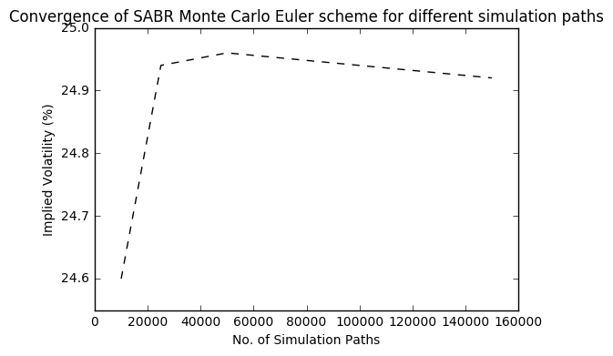

### 4.2.2 Milstein scheme

Compared with Euler scheme, Milstein scheme increases the accuracy of a stochastic process discrete approximation by adding higher order terms. The Milstein scheme for a stochastic differential equation of the type

is

where is the first derivative of the term b with respect to x. For the SABR forward process we take x= and we have

Its Milstein discretization is

For the SABR volatility process we take x= and we have

which leads to the following Milstein discretization equation:

For Milstein scheme, we don’t repeat the discussion of simulation results for different simulation time step sizes and sets of . Here we only provide simulation results for =40 and =-0.8.

Table: Black implied volatilities (%) by Milstein scheme for various combinations of . For all cases: =10Y, =0.25, =0.8, =40

|  |  |  |  |  |  |  |  |  |  |
| --- | --- | --- | --- | --- | --- | --- | --- | --- | --- |
|  | Strike Spreads (bps) | | | | | | | | |
|  | -150 | -100 | -50 | -25 | 0 | 25 | 50 | 100 | 150 |
| =0 | 37.69 | 31.50 | 26.86 | 24.93 | 23.20 | 21.63 | 20.21 | 17.75 | 15.71 |
| =0.3 | 32.35 | 28.42 | 25.24 | 23.86 | 22.59 | 21.42 | 20.33 | 18.39 | 16.73 |
| =0.5 | 30.88 | 27.61 | 24.95 | 23.78 | 22.71 | 21.72 | 20.80 | 19.16 | 17.75 |
| =0.7 | 29.44 | 26.80 | 24.63 | 23.68 | 22.80 | 21.99 | 21.23 | 19.85 | 18.66 |
| =1 | 28.12 | 26.20 | 24.63 | 23.94 | 23.31 | 22.72 | 22.17 | 21.19 | 20.35 |

Compared with Euler scheme, Milstein scheme enjoys a gain in accuracy of simulation and lower Monte Carlo standard error but it has much longer computation time. In general it doesn’t have much benefit over Euler scheme.

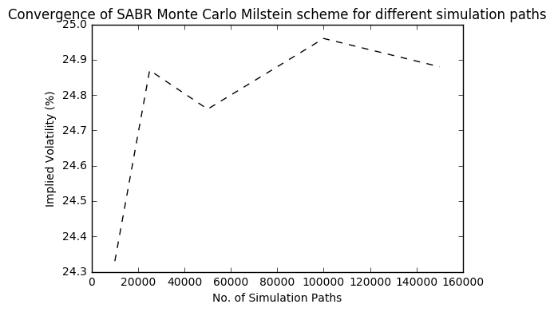

# 5. Validation of Hagan et al. approximation

## 5.1 Validation of c.d.f and p.d.f

### 5.1.1 Using lognormal Hagan

### 5.1.2 Using Monte Carlo simulation

## 5.2 Validation of lognormal implied volatility

### 5.2.1 Using lognormal Hagan

### 5.2.2 Using Monte Carlo simulation

We first investigate simulation results in =0 case with =10Y, ={0, 0.8, -0.8}. Then we explore more general cases with ={0, 0.3, 0.5, 0.7, 1}, ={0, 0.8, -0.8}, ={0.25, 0.5}.

Table: Black implied volatilities (%) by Euler scheme for various combinations of . For all cases: =10Y, =0, =0, =40，=100000

|  |  |  |  |  |  |  |  |  |  |
| --- | --- | --- | --- | --- | --- | --- | --- | --- | --- |
|  | Strike Spreads (bps) | | | | | | | | |
|  | -150 | -100 | -50 | -25 | 0 | 25 | 50 | 100 | 150 |
| =0 | 31.78 | 28.09 | 25.41 | 24.31 | 23.34 | 22.45 | 21.65 | 20.25 | 19.07 |
| =0.3 | 28.11 | 25.91 | 24.22 | 23.51 | 22.87 | 22.29 | 21.76 | 20.82 | 20.01 |
| =0.5 | 26.72 | 25.18 | 23.98 | 23.47 | 23.01 | 22.58 | 22.19 | 21.50 | 20.90 |
| =0.7 | 25.86 | 24.78 | 23.97 | 23.62 | 23.32 | 23.03 | 22.77 | 22.30 | 21.89 |
| =1 | 23.98 | 23.72 | 23.57 | 23.51 | 23.47 | 23.43 | 23.40 | 23.33 | 23.28 |

Table: Black implied volatilities (%) by Euler scheme for various combinations of . For all cases: =10Y, =0, =0.8, =40, =100000

|  |  |  |  |  |  |  |  |  |  |
| --- | --- | --- | --- | --- | --- | --- | --- | --- | --- |
|  | Strike Spreads (bps) | | | | | | | | |
|  | -150 | -100 | -50 | -25 | 0 | 25 | 50 | 100 | 150 |
| =0 | 31.30 | 27.58 | 25.04 | 23.99 | 23.04 | 22.19 | 21.42 | 20.07 | 18.92 |
| =0.3 | 28.49 | 26.21 | 24.46 | 23.72 | 23.06 | 22.45 | 21.90 | 20.92 | 20.07 |
| =0.5 | 27.37 | 25.65 | 24.36 | 23.81 | 23.32 | 22.87 | 22.46 | 21.73 | 21.09 |
| =0.7 | 25.17 | 24.28 | 23.57 | 23.26 | 22.98 | 22.71 | 22.47 | 22.04 | 21.65 |
| =1 | 23.07 | 23.09 | 23.07 | 23.05 | 23.04 | 23.02 | 23.00 | 22.99 | 22.97 |

Table: Black implied volatilities (%) by Euler scheme for various combinations of . For all cases: =10Y, =0, =-0.8, =40, =100000

|  |  |  |  |  |  |  |  |  |  |
| --- | --- | --- | --- | --- | --- | --- | --- | --- | --- |
|  | Strike Spreads (bps) | | | | | | | | |
|  | -150 | -100 | -50 | -25 | 0 | 25 | 50 | 100 | 150 |
| =0 | 31.26 | 27.73 | 25.12 | 24.04 | 23.08 | 22.21 | 21.43 | 20.07 | 18.91 |
| =0.3 | 28.59 | 26.27 | 24.49 | 23.75 | 23.09 | 22.48 | 21.93 | 20.94 | 20.10 |
| =0.5 | 26.56 | 25.08 | 23.92 | 23.43 | 22.98 | 22.56 | 22.18 | 21.50 | 20.90 |
| =0.7 | 25.57 | 24.56 | 23.80 | 23.48 | 23.18 | 22.91 | 22.66 | 22.20 | 21.80 |
| =1 | 22.58 | 22.76 | 22.82 | 22.83 | 22.83 | 22.83 | 22.83 | 22.82 | 22.81 |

Table: Black implied volatilities (%) by Euler scheme for various combinations of , , . For all cases: =40, =100000

|  |  |  |  |  |  |  |  |  |  |  |  |  |
| --- | --- | --- | --- | --- | --- | --- | --- | --- | --- | --- | --- | --- |
|  |  |  |  | -150 | -100 | -50 | -25 | 0 | 25 | 50 | 100 | 150 |
| 0.007 | 0 | 0 | 0.25 | 32.54 | 28.29 | 25.31 | 24.14 | 23.15 | 22.32 | 21.61 | 20.51 | 19.72 |
| 0.006 | 0 | 0 | 0.5 | 35.75 | 29.77 | 25.74 | 24.31 | 23.24 | 22.46 | 21.95 | 21.48 | 21.45 |
| 0.020 | 0.3 | 0 | 0.25 | 28.43 | 25.79 | 23.91 | 23.18 | 22.56 | 22.04 | 21.60 | 20.93 | 20.47 |
| 0.017 | 0.3 | 0 | 0.5 | 28.07 | 24.42 | 21.94 | 21.08 | 20.46 | 20.06 | 19.84 | 19.79 | 20.04 |
| 0.040 | 0.5 | 0 | 0.25 | 27.67 | 25.45 | 23.91 | 23.33 | 22.84 | 22.44 | 22.11 | 21.65 | 21.35 |
| 0.035 | 0.5 | 0 | 0.5 | 28.12 | 24.61 | 22.28 | 21.51 | 20.99 | 20.69 | 20.56 | 20.68 | 21.06 |
| 0.079 | 0.7 | 0 | 0.25 | 26.51 | 24.74 | 23.59 | 23.19 | 22.88 | 22.64 | 22.46 | 22.23 | 22.12 |
| 0.069 | 0.7 | 0 | 0.5 | 27.26 | 24.11 | 22.09 | 21.46 | 21.07 | 20.90 | 20.88 | 21.17 | 21.69 |
| 0.219 | 1 | 0 | 0.25 | 24.70 | 23.70 | 23.18 | 23.05 | 22.98 | 22.97 | 22.99 | 23.15 | 23.39 |
| 0.191 | 1 | 0 | 0.5 | NaN | NaN | NaN | NaN | NaN | NaN | NaN | NaN | NaN |
| 0.008 | 0 | 0.8 | 0.25 | 25.53 | 24.31 | 23.62 | 23.38 | 23.20 | 23.05 | 22.94 | 22.79 | 22.70 |
| 0.007 | 0 | 0.8 | 0.5 | 25.78 | 23.99 | 23.88 | 24.13 | 24.46 | 24.83 | 25.21 | 25.95 | 26.64 |
| 0.020 | 0.3 | 0.8 | 0.25 | 24.09 | 23.62 | 23.57 | 23.61 | 23.69 | 23.78 | 23.88 | 24.07 | 24.26 |
| 0.020 | 0.3 | 0.8 | 0.5 | 23.98 | 22.79 | 23.36 | 23.94 | 24.58 | 25.22 | 25.85 | 27.00 | 28.03 |
| 0.040 | 0.5 | 0.8 | 0.25 | 21.74 | 22.16 | 22.72 | 23.01 | 23.29 | 23.56 | 23.82 | 24.30 | 24.73 |
| 0.038 | 0.5 | 0.8 | 0.5 | 23.92 | 22.76 | 23.63 | 24.39 | 25.20 | 26.00 | 26.78 | 28.20 | 29.47 |
| 0.077 | 0.7 | 0.8 | 0.25 | 21.14 | 21.93 | 22.89 | 23.36 | 23.81 | 24.24 | 24.64 | 25.40 | 26.07 |
| 0.072 | 0.7 | 0.8 | 0.5 | 31.96 | 29.01 | 29.23 | 29.91 | 30.72 | 31.57 | 32.41 | 33.98 | 35.41 |
| 0.208 | 1 | 0.8 | 0.25 | 35.73 | 33.39 | 33.31 | 33.61 | 34.02 | 34.48 | 34.97 | 35.96 | 36.94 |
| 0.192 | 1 | 0.8 | 0.5 | NaN | NaN | NaN | NaN | NaN | NaN | NaN | NaN | NaN |
| 0.008 | 0 | -0.8 | 0.25 | 37.33 | 31.23 | 26.65 | 24.74 | 23.03 | 21.48 | 20.08 | 17.61 | 15.57 |
| 0.007 | 0 | -0.8 | 0.5 | 44.31 | 35.53 | 29.05 | 26.37 | 23.97 | 21.83 | 19.93 | 16.94 | 15.18 |
| 0.022 | 0.3 | -0.8 | 0.25 | 32.39 | 28.42 | 25.24 | 23.86 | 22.58 | 21.41 | 20.33 | 18.38 | 16.72 |
| 0.023 | 0.3 | -0.8 | 0.5 | 33.34 | 28.49 | 24.48 | 22.70 | 21.06 | 19.54 | 18.14 | 15.77 | 14.14 |
| 0.044 | 0.5 | -0.8 | 0.25 | 31.25 | 27.80 | 25.02 | 23.81 | 22.70 | 21.67 | 20.72 | 19.02 | 17.56 |
| 0.048 | 0.5 | -0.8 | 0.5 | 32.39 | 28.04 | 24.46 | 22.87 | 21.40 | 20.04 | 18.78 | 16.62 | 15.03 |
| 0.091 | 0.7 | -0.8 | 0.25 | 29.83 | 27.04 | 24.77 | 23.77 | 22.86 | 22.01 | 21.22 | 19.79 | 18.55 |
| 0.457 | 0.7 | -0.8 | 0.5 | NaN | 96.34 | 87.74 | 84.47 | 81.65 | 79.17 | 76.97 | 73.17 | 69.99 |
| 0.265 | 1 | -0.8 | 0.25 | 28.64 | 26.60 | 24.93 | 24.20 | 23.52 | 22.90 | 22.31 | 21.26 | 20.35 |
| 0.350 | 1 | -0.8 | 0.5 | NaN | NaN | NaN | NaN | NaN | NaN | NaN | NaN | NaN |

## 5.3 Validation of normal implied volatility

### 5.3.1 Using lognormal Hagan

### 5.3.2 Using Monte Carlo simulation

# 6. The limits of Hagan et al. approximations

# 7. Alternative SABR approximations

## 7.1 Obloj SABR

### 7.1.1 Obloj calibration

We have plotted implied volatility smile curves by Obloj lognormal SABR against Obloj SABR for expiry of 10Y, 5Y, 2Y, 1Y, 0.5Y and 0.25Y. We can see that for options with short maturities within one year, Obloj model provides a slightly lower approximation for deep in-the-money options that Hagan lognormal does while their estimation for at-the-money options and out-of-the-money options are extremely close; they have nearly the same smile curve for maturities over 1 year. Here Hagan lognormal SABR fits better to our market data sample.

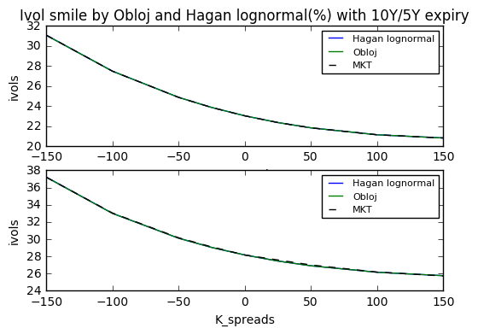

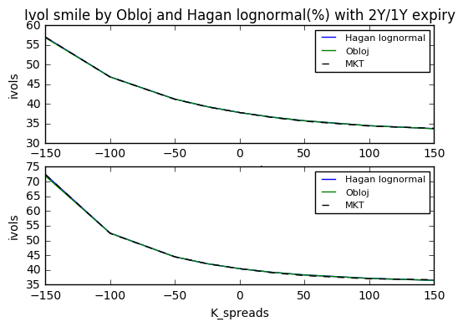

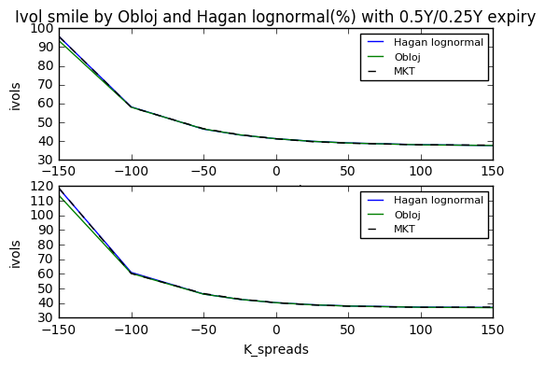

### 7.1.2 Validation of c.d.f

### 7.1.3 Over-specification and collinearity test

We repeat the same procedure for over-specification and collinearity test for Obloj SABR implementation and the results are listed below. Again our subject data here is the data with expiry Tk-1=1Y. It is straightforward that Obloj model and Hagan et al model give very close results for each calibration. What sets Obloj SABR apart from Hagan is that it gives much better approximation when is fixed to 1 than Hagan implementation. Moreover, Obloj model has more potential for collinearity reduction with one or two SABR parameters fixed in calibration.

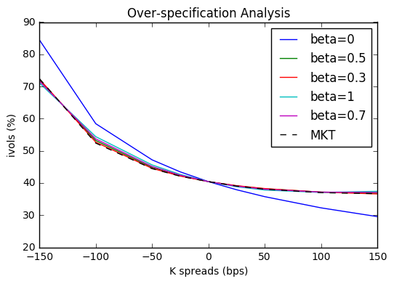

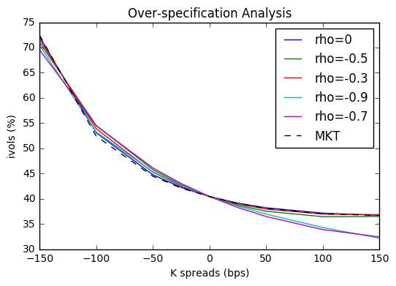

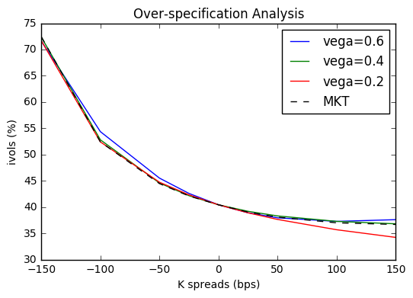

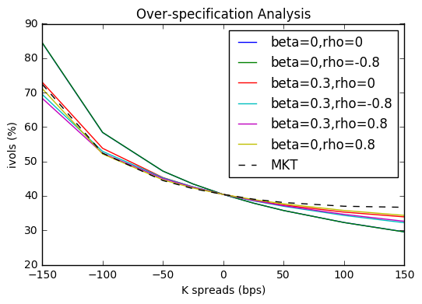

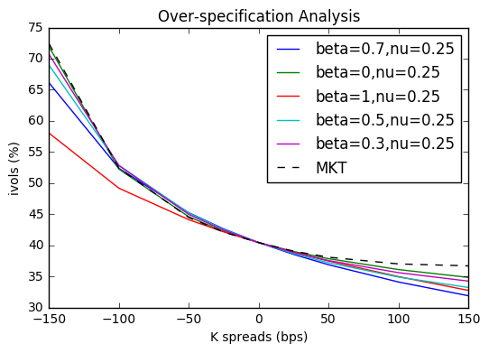

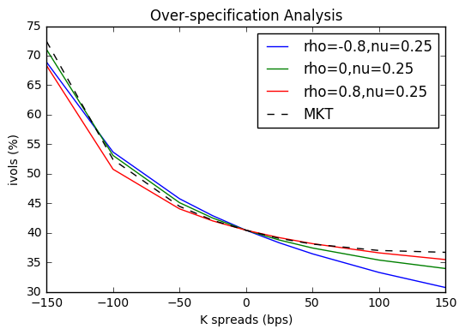

Table: Collinearity test for Obloj implementation

|  |  |
| --- | --- |
| Obloj SABR | Condition number of Jacobian matrix |
| Calibrate , and | 2711 |
| Fix , calibrate and | 1496 |
| Fix -0.9, calibrate and | 9 |
| Fix, calibrate and | 2140 |
| Fix =0 and =0.8, calibrate | 40 |
| Fix =0 and =0.25, calibrate | 878 |
| Fix =0.8 and =0.25, calibrate | 22 |

# 8. Code structure

We code in Python and manage version controls on Github platform. The full codes are available at <https://github.com/gsallc/CapstoneFall2017.git>.

For more efficient coding and review, we have structured our codes into six folders: Pricing, Fitter, Bin, Inputs Test and Documentation and below is a summary of them.

* Pricing: library codes for various SABR models including Hagan SABR model and Obloj SABR model, Black Scholes, Monte Carlo simulation
* Fitter: library codes for over-specification test and multi-collinearity test of SABR calibration
* Bin: driver codes for both pricing and fitter parts
* Inputs: market data of options
* Test: unit tests and doc tests
* Documentation: project plans and reports

# 9. References

[1] Hagan P, D Kumar, A Lesniewski and D Woodward, “Managing smile risk”, Wilmott Magazine, pages 84-108 (2002)

[2] Jan Obloj, “Fine-tune your smile: Correction to Hagan et al.”, Wilmott Magazine, pages 102-104 (2008)

[3] Antonov, A., Spector, M. “Free Boundary SABR”, RISK (2015)

[4] Giovanni Travaglini. “SABR Calibration in Python”, SSRN (2016)

[5] Joerg Kienitz, Daniel Wetterau. “Financial Modeling- Theory, Implementation and Practice with MATLAB Source” (2012)

[6] Christian Crispoldi, Gerald Wigger, Peter Larkin. “SABR and SABR LOBOR Market Models in Practice” (2015)