

USER GUIDE

Trinidad
Spanish. 03/2025. Rev.1.2.1

beinsen.com

Contents

Getting Started
- Device Design and Functions
- Safety warnings
- Unique features of your iron

Use your iron

- Meet the touchscreen
- Turning on and setting up your thermal iron
- Ironing process
- Interchangeable bottom plate
- Operation of the laser positioning system

Maintaining Your Iron

12 Maintenance operations

Troubleshooting

- How to change the resistance
- Most common problems

2

Getting Started

Device Design and Functions

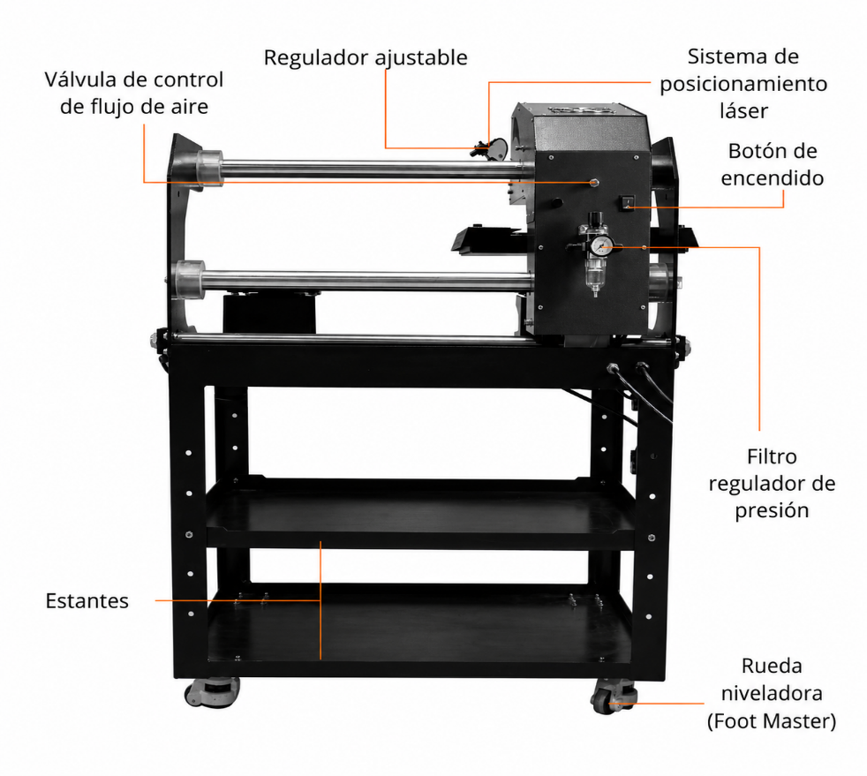
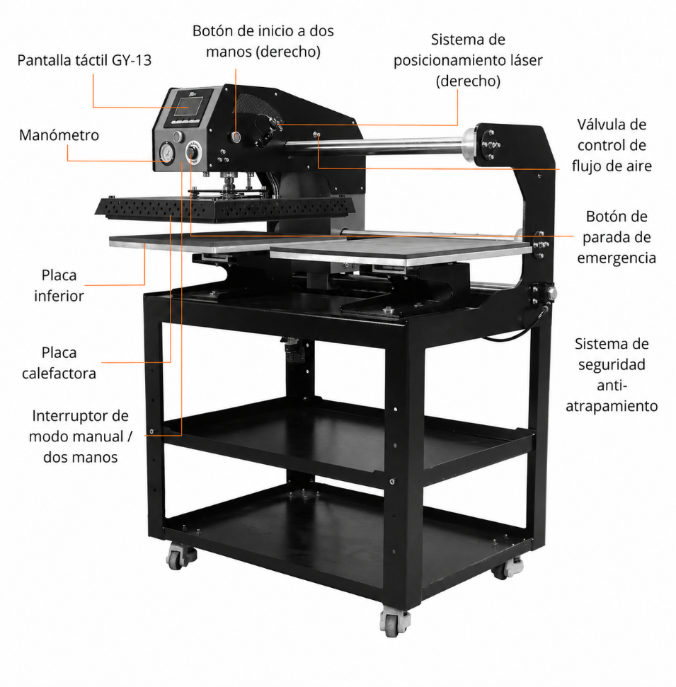
▶ Trinidad:


- Please read these instructions carefully before using your iron for the first time

- Use the heat press only for its intended purpose: pressing materials using heat.

- Avoid electric shocks by avoiding contact with water or liquids.

- Disconnect securely by holding the plug, not the cord, when disconnecting it from the electrical current.

- Keep cords away from hot surfaces and allow the machine to cool completely before storing.

- Do not use the machine if the cord is damaged or if it has been dropped or damaged. If repairs are necessary, take them to a qualified service technician to avoid risks of fire, electric shock, or injury.

- Always turn off the power before cleaning, repairing, or servicing the machine.

- Supervision is required for anyone using the heat press, especially children or those with reduced physical, sensory, or mental capabilities. Never leave the machine unattended while it is connected.

- Avoid burns by not touching hot metal parts or heated plate during use. Wear heat-resistant gloves.

- Do not overload electrical circuits. Avoid using other high-voltage equipment on the same circuit as the heat press.

- If an extension cord is needed, make sure it is rated at least 20 amps to prevent overheating. Position the cord so that it does not trip or pull on it.

- Keep your hands away from the top plate during locking to avoid injury caused by machine pressure.

- Place the heat press on a sturdy and suitable support to ensure stability during operation.

- Keep the work area clean and free of obstructions to avoid accidents.

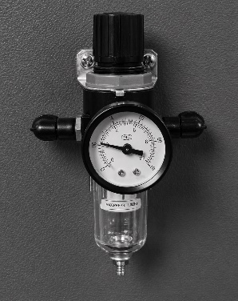
Pressure adjustment
1.

Connect the air supply: the pressure value will be displayed on the
Regulator filter pressure gauge. (Range: 0-1 MPa).

2.
Adjust air pressure: Pull up on the regulator filter knob to adjust the air pressure (turn it clockwise to increase the pressure and counterclockwise to decrease it). It is recommended to adjust the transfer pressure between 0.4 and 0.6 MPa. Once the desired pressure is reached, press down on the regulator filter knob again.

3.
Filter water from the air: The regulator filter will filter the water from the incoming air, which will be collected in the glass container located below the filter. Manually press the button on the bottom outlet to empty the water.

4.
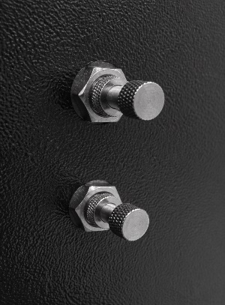
Adjusting the Heat Plate Rise Speed and Pressure: Adjust the two knobs on the right side of the machine. The upper airflow control valve adjusts the rate at which the heat plate rises, while the lower air flow control valve adjusts the rate at which the heat plate exerts downward pressure. You can adjust these parameters according to your needs (turn clockwise to slow down and counterclockwise to increase speed). After adjustments, tighten the screws located near the machine cover to secure the settings. (Note: The machine comes preset with appropriate speeds, so it is not recommended to modify these settings.)

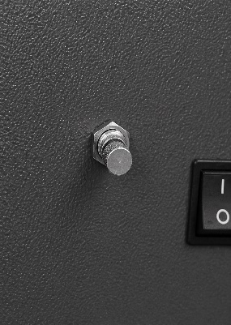
5.
Setting the left and right speed of the heating plate: Adjust the knob on the rear of the machine. This airflow control valve adjusts the speed of the hotplate's movement to the left and right (rotate clockwise to slow down and counterclockwise to increase speed). After making the adjustment, tighten the screw located near the machine cover to lock the setting. Note: The machine comes pre-set with an appropriate speed, so it is not recommended to change this setting.

Use your iron

Meet the touchscreen

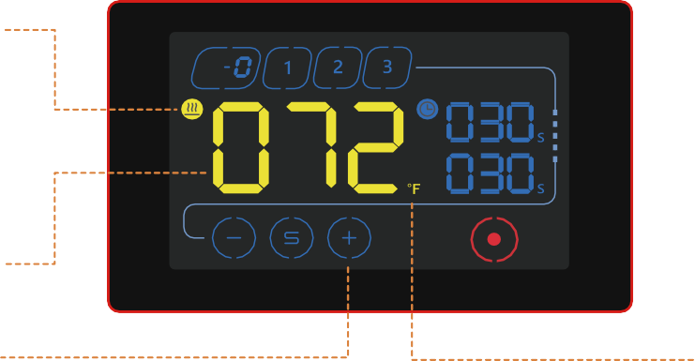
3 Programmable Memories
P

Pressure Level
Countdown indicator

Heat indicator

Timer 1

Timer 2

Power indicator
Configured Value

Adjustment buttons

Current temperature
Adjustable between 0 and 230 degrees Celsius

Memoirs
3 programmable memories
Fahrenheit or Celsius





Ignition
Power indicator

Pressure

Current pressure Between 0 and 8

Adjustment buttons
Use the  y to adjust the desired temperature and time. The  Change the purpose of the adjustment.





Dual timer
Its heat press has the possibility to set 2 timers that work sequentially. At the end of the countdown of the upper timer the iron opens, starting the countdown of the lower timer when the iron is closed again.
If you want to reset the timer, you must wait for the countdown of the lower timer to end.
You can set the timer above 0 to use only the lower timer.

Turning on and setting up your thermal iron

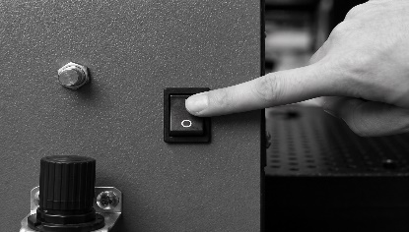
Turn on your heat iron
Press the power switch to the "I" position and start working.

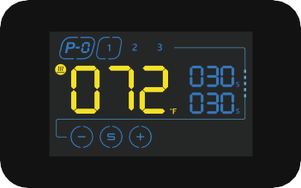
Memory Selection
The memory indicator flashes. Select one to begin your setup.

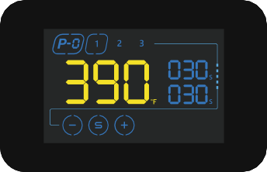
Adjusting the temperature


Tap the to begin setting the temperature. Use the y  to set the desired temperature in the display.
Tap to save the setting.

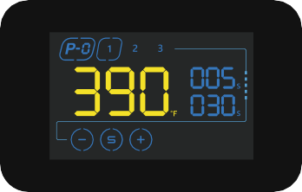
Setting the timers
Use the buttons again y to place the desired time and  to keep. The top timer is
Commonly used for garment pre-ironing and
for the transfer operation.
Always follow the recommendations indicated in the materials used.

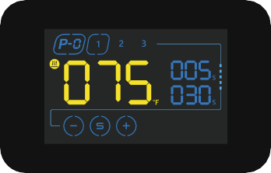
Heating the resistance
The indicator flashes to indicate that the machine is in warm-up mode. When the temperature reaches the set value, the bell emits an intermittent sound to indicate that the Beinsen Malvinas heat press is ready to press.

Automatic shutdown
After 150 minutes from the last operation, the press will automatically enter sleep mode and will display the message "OFF" on the screen.
You can turn it back on by tapping the control .



Turn off your heat iron
Press the power switch to return it to the "O" position and interrupt the power supply.

Ironing process

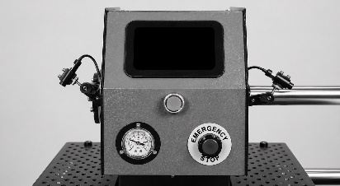
Preparation for Pressing
Connect it to the air source and turn on the machine. After 5 seconds, the controller's touch screen will appear and the machine will begin to heat up to the desired temperature you have set.

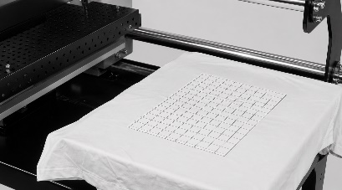
Preparation of materials
Adjust the pressure to the proper level. Place the garment (e.g., a T-shirt) on the bottom plate and place the transfer paper, foil, or other materials over the garment.

Start the transfer (one-handed modes)
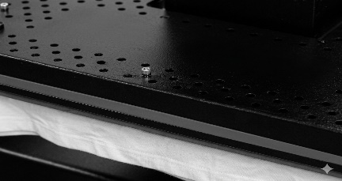
The machine reaches the set temperature, press the movement button to the left or right to move the hotplate to the desired position. Then press the "two-handed start button" and the heating plate will automatically press down; Timer 1 will start the countdown. Typically, "Timer 1" is used for preheating in order to remove moisture and wrinkles, while "Timer 2" is for the heat transfer process. If no preheating is required, set the same time value for both "Timer 1" and "Timer 2".

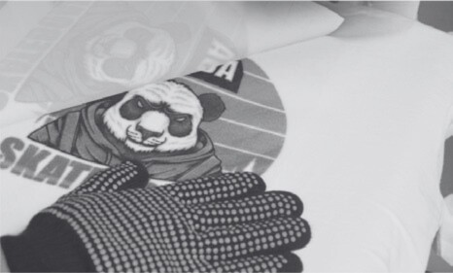
Finalize the transfer
When the timer countdown ends, the heating plate will automatically rise. Remove the bottom plate and peel off the transfer paper or film. The transfer is complete. (Note: Transfer papers may require cold or hot peeling; refer to the instructions on your transfer paper.)

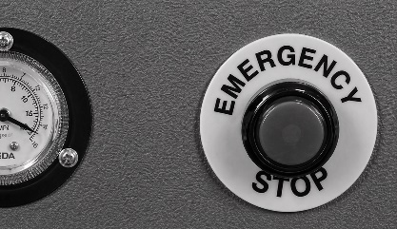

Emergency stop function
If you need to stop the machine immediately or in the event of
If you have a breakdown, press the emergency stop switch to stop operation and quickly raise the plate to prevent damage or injury.

Interchangeable bottom plate

How to change the bottom plate

1.

Remove the bottom plate. Pull the indexing pin and twist it to release it.

2.
Remove the bottom plate.
3.
Insert the new bottom plate

4.
Rotate the indexing pin, insert it, and lock it.
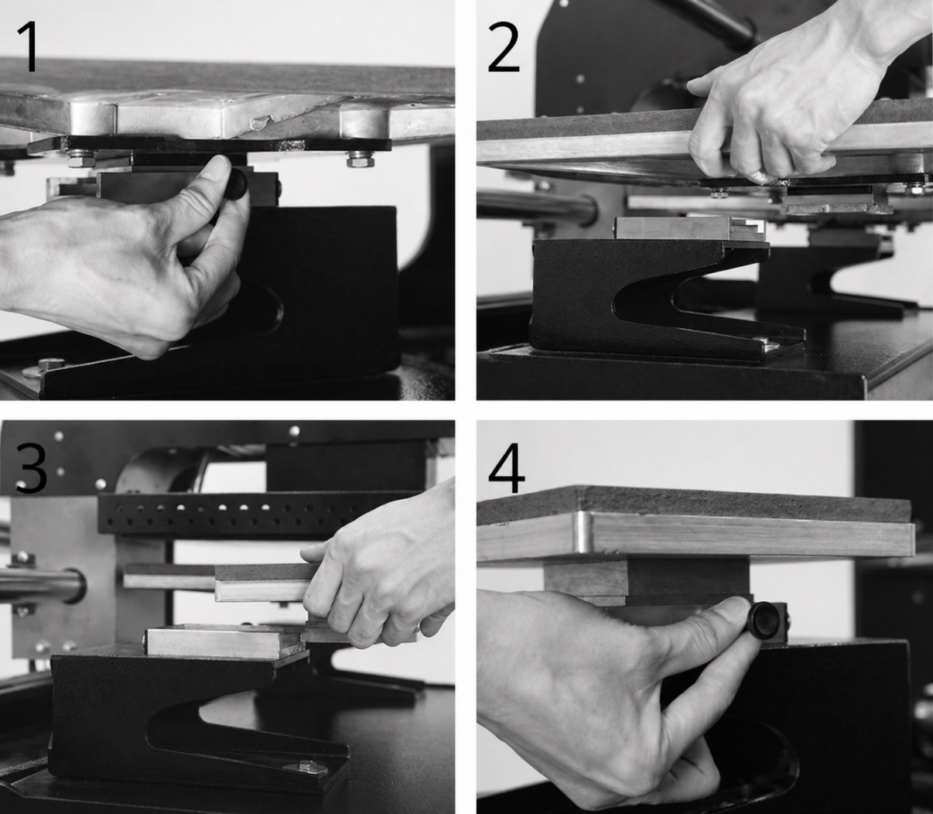

Lower chainrings available

Below we show you the different chainrings compatible with your Beinsen Trinidad heat press. Remember that only plates with a quick exchange system are compatible with your heat press.

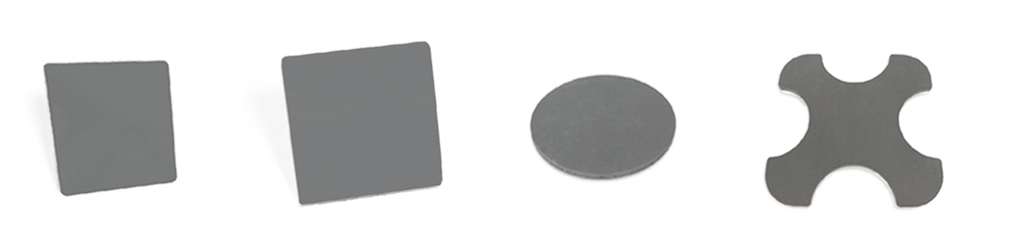

.

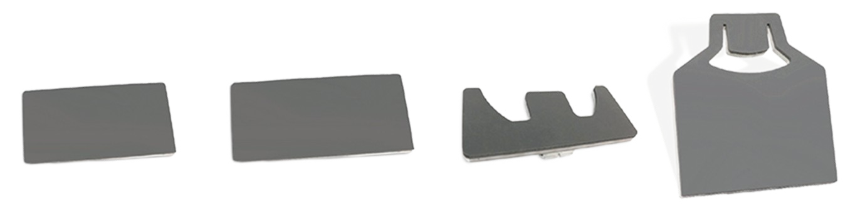

Operation of the laser positioning system
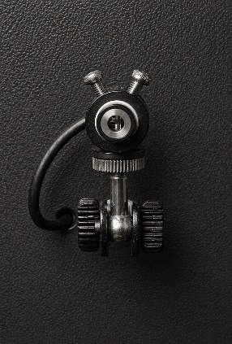
1.
The laser positioning system consists of a laser marker with a universal holder and an infrared laser. You can manually adjust the two universal joints to orient the infrared laser beam so that the intersection of the beams is located in the center of the bottom plate. Once the adjustment is complete, tighten the two adjustment screws on both sides. Rotate the infrared laser knob to ensure that the two intersecting beams are orthogonal to each other and parallel to the two orthogonal sides of the bottom plate. You can adjust the device according to actual needs.
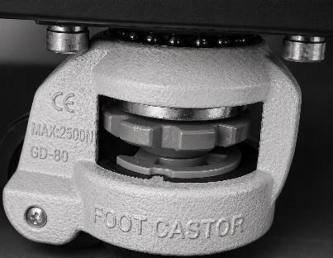
2.
Machine Travel: Turn the four adjustment wheels on the Foot Master swivel wheels clockwise to raise the support columns, allowing the machine to be moved.
Fixing the machine: Turn the four adjustment wheels of the Foot Master swivel wheels counterclockwise to lower the support columns, lifting the wheels off the ground and stabilizing the machine.

Introduction to the Pinch-Guard Security System
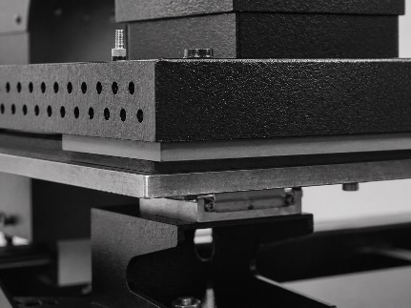
1.
The Pinch-Guard safety system is designed to prevent accidental injury or damage during heat press operations. Thanks to the incorporation of sensors in the heating plate, this system automatically detects any object or finger that is in the pressing area. If an obstacle is detected while the plate is lowered, it stops immediately and rises again, thus ensuring the protection of the user's hands and any material that is there unintentionally.

Instructions for switching between single-handed and two-handed modes
1.
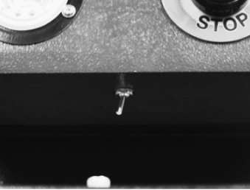
One-handed mode: After pressing the left or right scroll button to place the heat plate, press the start buttons on both sides to initiate downward pressing for transfer.
2.
Two-handed mode: Press the scroll button and the home button on the left (or right) side simultaneously. Once the position is reached, the machine will automatically press down for the transfer. The direction of movement is determined by the start button that is pressed. Make sure that "Timer 1" and "Timer 2" are set to the same time value.

Limit switch function
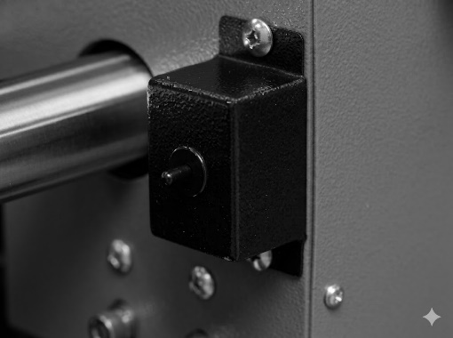
1.
The limit switch is used to check whether the hotplate has reached the desired position during the left or right movement. In two-handed mode, once the position is confirmed, the machine will press down automatically.

Maintaining Your Iron
To ensure optimal performance and extend the life of your thermal iron, proper and regular maintenance is essential. A clean and well-maintained equipment not only improves the quality of the prints, but also prevents damage and breakdowns that can affect their operation.

In this section you will find key recommendations for cleaning, caring for and inspecting the components of your iron, thus ensuring its efficiency and safety with each use.

Regular cleaning of sublimation plates or surfaces
- After each use, make sure that the sublimation plates or surfaces are clean and free of ink, paper, or any other material residue. Use a soft, clean cloth
slightly dampened with warm water or a specific cleaner recommended by the manufacturer to remove any residue. Avoid using abrasive products that can damage surfaces.

Replacement of protective films or coatings
- The vast majority of thermal plates incorporate protective films or coatings on the sublimation plates to prevent the ink from adhering directly to the plates. These coatings wear and lose properties over time, which affects the quality of the transfers. That's why you should replace them when they start to show signs of wear.

Inspection and cleaning of internal components
- Depending on the model of your heat iron, it may need to be disassembled to access internal components such as springs, cables, or electrical connections. Perform a regular visual inspection to ensure that there is no damage or wear to these components and clean them if necessary. Always disconnect the heat iron from the power source before performing any internal maintenance.

Maintaining Your Iron

Temperature Verification and Calibration
- Over time, it is possible that the temperature indicated on the screen of the heat plate may vary slightly from the actual temperature of the surface of the heating plate. To ensure accuracy, use a thermometer or similar tool to check if the heat plate reaches the correct temperature and make adjustments if not.

Lubricate joints and moving parts
- Thermal plate joints are friction points where moving parts interact with each other. Over time, a lack of lubrication can lead to wear, hinder movement, and generate unwanted noise. Applying lubricating oil on a regular basis helps reduce friction, prevent corrosion, and ensure smooth and efficient operation of the machine. It is
It is advisable to use a lubricant suitable for mechanical equipment and clean any excess to avoid accumulation of debris.

Protect the hot plate when not in use
- The heating plate is the key part of the griddle, as it distributes heat evenly to ensure effective transfer. If not properly protected, it can be damaged by residue buildup, scratches, or bumps, which would affect the quality of the prints.
To avoid this, it is recommended to clean it after each use, avoid contact with sharp or abrasive objects and, when not in use, cover it with a protective material to prevent the accumulation of dust and dirt.

Troubleshooting
Before contacting a Beinsen Service Center (SAT) or authorized service center, try the following solutions. Some situations may not apply to your device.

Most common problems

Nothing happens after you turn on the iron
- Check the condition of the plug. Make sure it doesn't connect well and isn't faulty.
- Check the status of the power button and touchscreen.
- Check the fuse. Make sure it is damaged or burned.
- If nothing appears on the screen but the power light is working, check the transformer's wire 5. If it has been loosened the problem is connection, otherwise it is possible that the transformer is defective.

The screen is working properly, but the heating plate is cold
- Check the connection of the thermal probe. In case of being incorrectly connected or loose, the screen will show "255" and the iron will beep continuously.

- Check if the solid-state relay light is on. Otherwise, check the status of the relay and the touchscreen.

- If you have replaced the relay but the heating plate still does not heat up, check the condition of the hob and the power cord.

The heating plate is working properly but the display shows "255ºC"

- Check the connection of the thermal probe.
- If the connection of the thermal probe is correct, it is possible that the fault is caused by the probe.

The heating plate works between 0 and 180ºC, but the digits on the screen jump above 200 or 300º suddenly or vary irregularly

- Check the connection of the thermal probe.
- If the thermal probe and probe connection are working properly, the digital controller (IC) program may be damaged and needs to be replaced.

Temperature out of control. It is set at 180º but the actual temperature is above 200ºC
  - Check the solid-state relay. It may be broken down and needs to be replaced.
  - The digital controller may be faulty and is still supplying electricity to the relay, in which case it needs to be replaced.

Time and temperature settings work abnormally after changing the hotplate

  - Reconfigure the time and temperature settings according to the instructions in this manual

The color transferred to the garment is too pale

  - Check the temperature of the iron, it may be too low.
  - Check the pressure, the pressure may be insufficient or the ironing time may be too short.

The transferred color is too brown or the transfer paper ends up burnt

  - Check the temperature of the iron, it may be excessively high.

The transferred print is blurry

  - Check the transfer time. Excessive ironing time can cause Ese or other effects.

The transferred image color or finish is not good enough

  - Check the pressure. It may be too low or the ironing time is too short.

  - Check the paper used in the transfer. Check the instructions for use provided by the manufacturer or try another paper.

The transfer paper adheres to the garment after transfer

  - Check the transfer temperature. It may be too high.
  - Check the ink used for printing. Review the instructions for use provided by the printer manufacturer or try different inks

Copyright
Copyright © 2025 Futura Teck de Murcia S.L.U.
This guide is protected by international copyright laws.
You may not reproduce, distribute, translate, or transmit any part of this guide in any way or by any means, whether electronic or mechanical, including photocopying, recording, or storing in any information storage and retrieval system.

Trademarks
- Beinsen and the Beinsen logo are registered trademarks of Futura Teck de Murcia S.L.U.
- All other trademarks and copyrights are the property of their respective owners.

