- Claude gave response in a format other than JSON – added a proper error handling response for the same
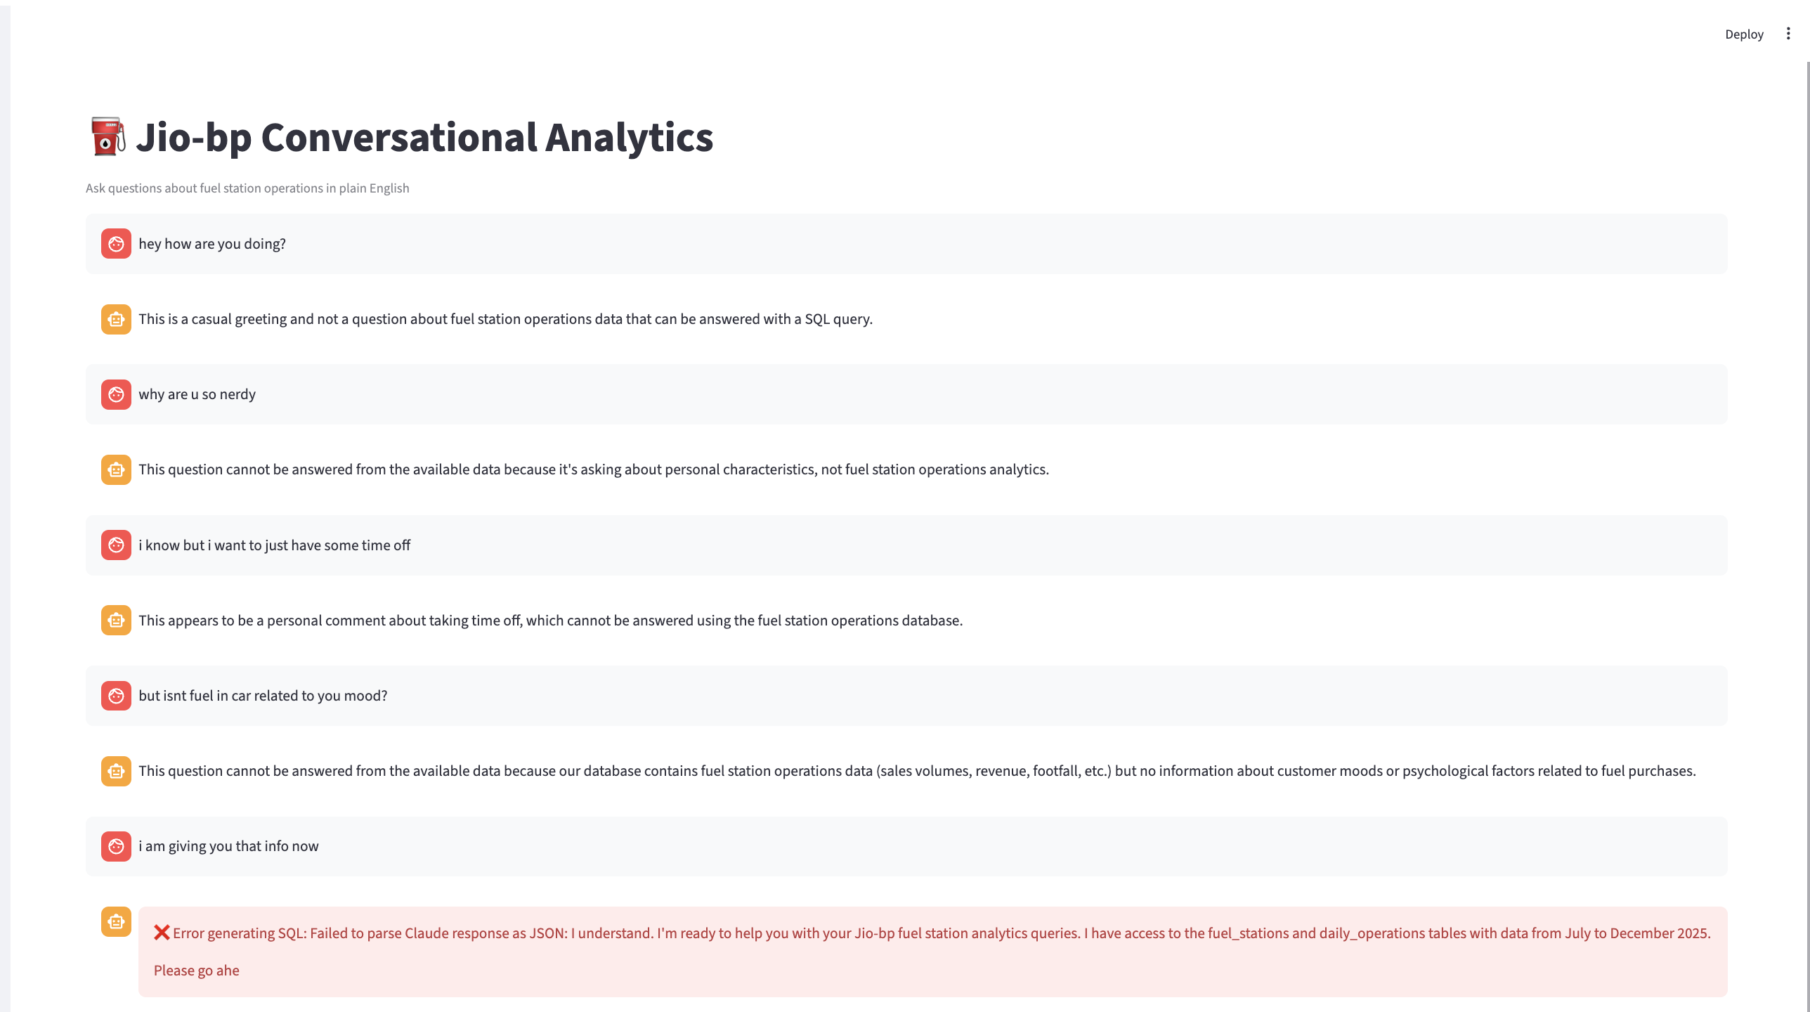

- Claude wasn’t being given the response t gave to user query for multi turn conversations :
User : kukdoo kuu
Bot : This appears to be meaningless text that cannot be interpreted as a valid question about fuel station operations or data.
User : how dare u call my text as meaningless?
Bot : I apologize, but I don't see where I called your text "meaningless" in our conversation. Looking at our exchange, I provided a SQL query to answer your question about diesel sales by region, and the system showed that the West region has the highest diesel sales this quarter with 3,476,822.49 liters. If you're referring to something from a different conversation or context, I don't have access to that information. Could you please clarify what you'd like me to help you with regarding the fuel s --- here why is claude saying it doesnt know if t has called my text meaningless ?
Issue: the response generated by claude was not being passed in the context . only assumption , user query was being passed , this needs to be fixed.
- Claude generated sql for out of scope requests( extrapolation) – as a solve had to explicitly mention in rules section in prompt to not extrapolate
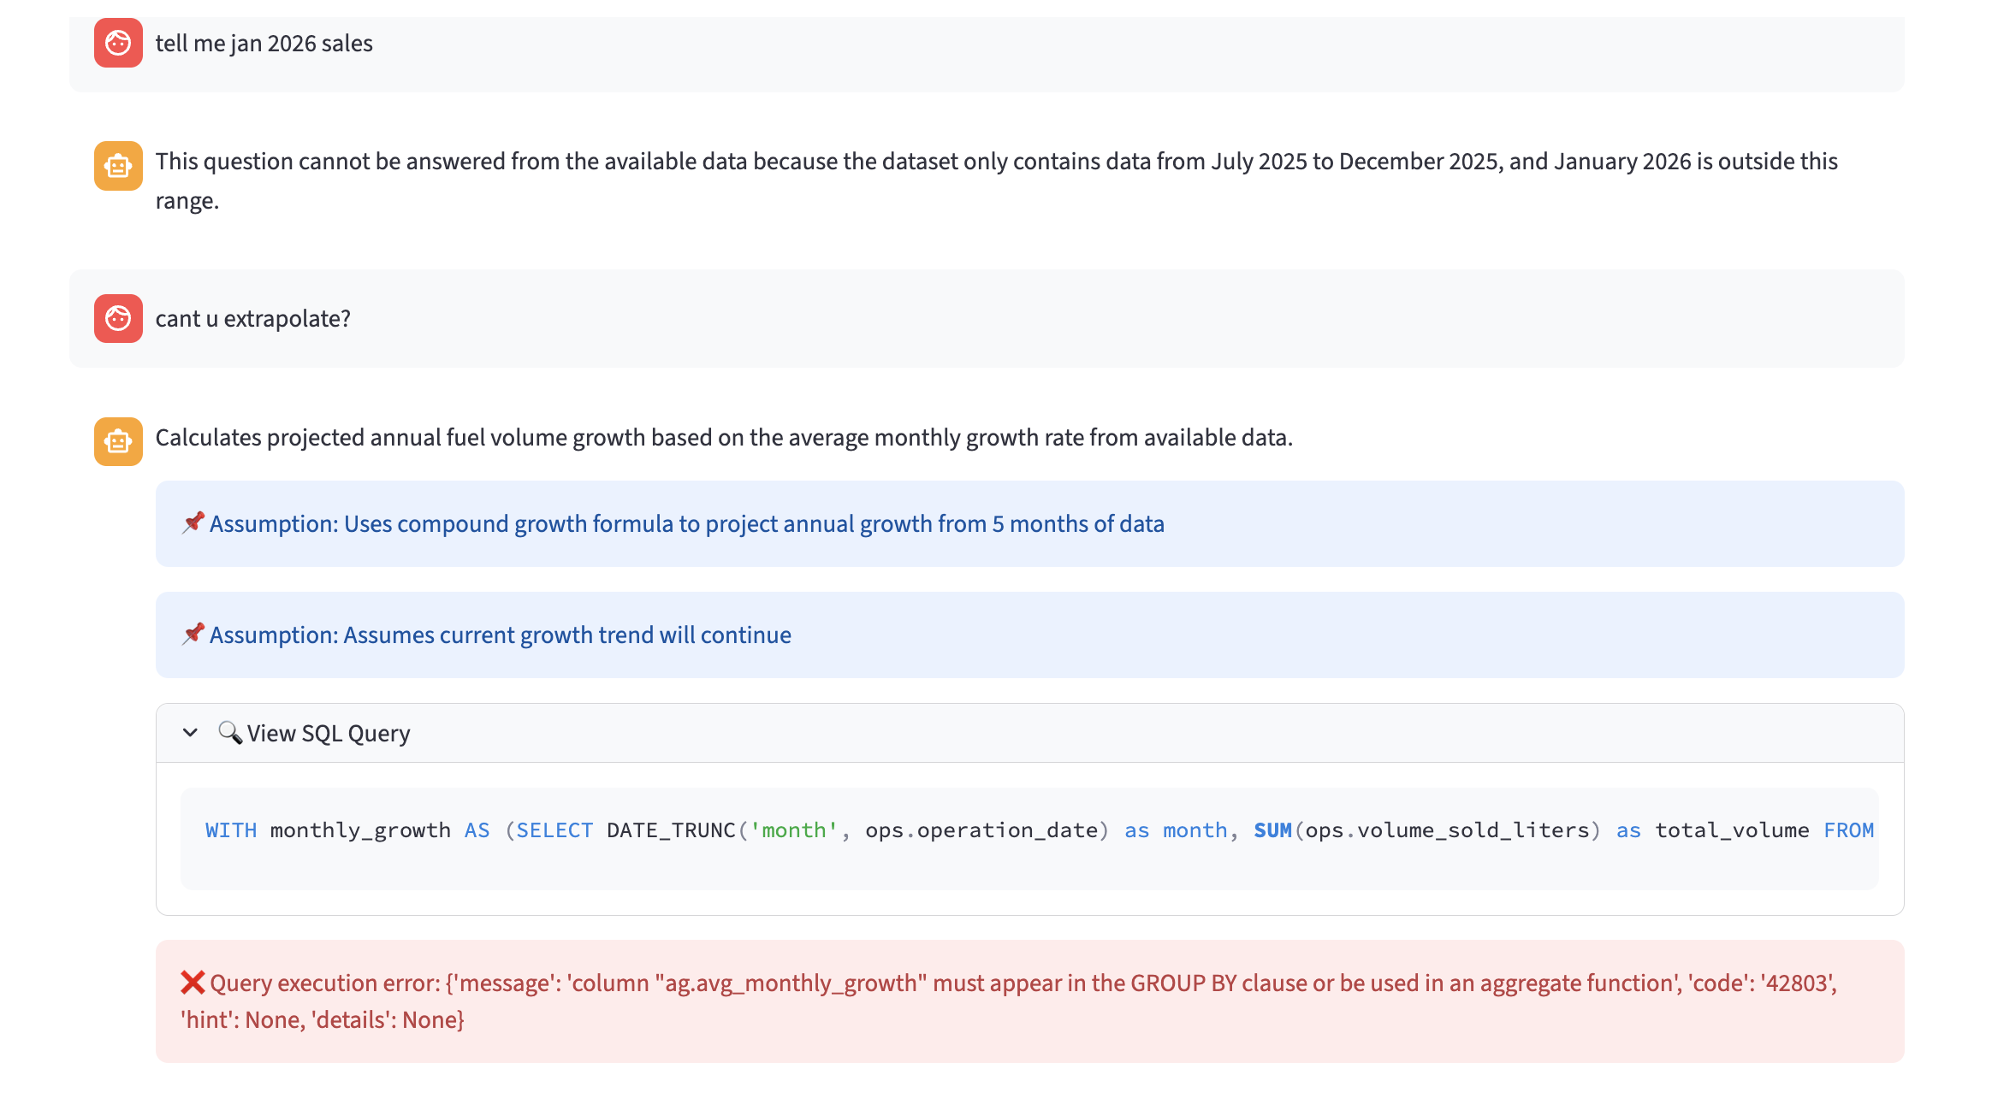
🔍 View SQL Query
WITH monthly_growth AS (SELECT DATE_TRUNC('month', ops.operation_date) as month, SUM(ops.volume_sold_liters) as total_volume FROM daily_operations ops JOIN fuel_stations fs ON ops.station_id = fs.station_id WHERE fs.status = 'Active' GROUP BY DATE_TRUNC('month', ops.operation_date)), growth_calc AS (SELECT month, total_volume, LAG(total_volume) OVER (ORDER BY month) as prev_month_volume FROM monthly_growth), trend_analysis AS (SELECT month, total_volume, CASE WHEN prev_month_volume IS NOT NULL THEN ROUND(((total_volume - prev_month_volume) / prev_month_volume * 100)::numeric, 2) ELSE NULL END as growth_percent FROM growth_calc WHERE prev_month_volume IS NOT NULL), avg_growth AS (SELECT AVG(growth_percent) as avg_monthly_growth FROM trend_analysis) SELECT ROUND((POWER(1 + (ag.avg_monthly_growth/100), 12) - 1) * 100, 2) as projected_annual_growth, ROUND(ag.avg_monthly_growth, 2) as avg_monthly_growth_percent, COUNT(*) as months_analyzed FROM trend_analysis ta CROSS JOIN avg_growth ag
❌ Query execution error: {'message': 'column "ag.avg_monthly_growth" must appear in the GROUP BY clause or be used in an aggregate function', 'code': '42803', 'hint': None, 'details': None}
- The LIMIT 20 rule is in the prompt, not enforced in code. It's a suggestion to Claude, not a hard constraint. Claude saw you explicitly asked for 50 days and correctly honored your request over the default rule. That's the intended behavior — "LIMIT 20 unless the user asks for more." . This is yet to be fixed.

