Practicum Final Exam – Even Semester Year 2021/2022
Subject |  |  | COMP6579 – Big Data Processing |  |  | 
Class | : | BE01 / BF01 / BK01 |  | Start Date | : 23 June 2021
Lecturer | : | D3803 - Dr. Ir. Yaya Heryadi, M.Sc.  D6414 - Kristien Margi Suryaningrum, S.Kom., M.Cs. |  | Start Time | : 11:20
Lecturer | : |  |  | End Date | : 23 June 2021
Lecturer | : |  |  | End Time | : 13:20

PERATURAN UJIAN:
Exam Regulations:
- Mahasiswa tidak diperbolehkan berdiskusi dan/atau bekerja sama dengan peserta ujian lainnya
Student is not allowed to discuss and/or work together with other exam participants
- Mahasiswa tidak diperbolehkan untuk membuka dan menyalin dari BUKU atau CATATAN, VIDEO dari pengajar (recording kelas, VBL, Youtube, dsb) dan REFERENSI lainnya
Student isn't allowed to open and copy from any resources such as notes, videos (class recording, VBL, Youtube, etc) and other references
- Mahasiswa tidak diperbolehkan membuka dan menyalin jawaban dari internet (google, stackoverflow, dsb)
Student isn't allowed to open and copy answer from the internet (google, stackoverflow, etc)
- Asisten BERHAK memberi nilai 0 (NOL) bagi peserta ujian yang melakukan segala bentuk kecurangan
Assistant is able to give 0 (ZERO) score for exam participant who does any cheating actions
- Kumpulkan jawaban tepat pada waktunya, apabila terlambat mengumpulkan maka jawaban tidak akan dikoreksi dan nilai mahasiswa adalah 0
Submit the answer on time, if not, then the answer will not be checked, and the students will receive 0 (ZERO)
- Bila Anda tidak membaca peraturan ini, maka Anda dianggap telah membaca dan menyetujuinya
If you have missed to read these regulations, so you are considered to have read and agreed on it



SOFTWARE YANG DIGUNAKAN:
Software will be used:
- Jupyter Notebook
- VM Cloudera
- VMWare Workstation 15

FILE YANG DIKUMPULKAN:
File must be collected:
- IPYNB

PERHATIAN!
Attention!
- Bagi yang mengerjakan tidak sesuai dengan soal, maka akan diberikan nilai NOL (0)
For those who do not work in accordance with the exam case will be marked as ZERO (0)
- Bagi yang mengerjakan tidak sesuai dengan software dan versi yang telah ditetapkan, maka akan tetap dikoreksi dengan software dan versi yang telah ditetapkan
For those who do not work in accordance with the software and specific version will be corrected by the predefined software and version
- Kompres semua jawaban yang akan diunggah. Pastikan format pengumpulan nama file dan ekstensi sesuai dengan format berikut: [NIM]-[NAMA].zip
Compress all file that will be uploaded. Make sure the format for collecting file name and extension according to the following format: [NIM]-[NAME].zip

Soal
Case
JrebFood
JrebFood is a company that provides food delivery service to restaurants. Recently, the manager of JrebFood informed you that an annual meeting will be held soon. As a business analyst, your job is to provide a visualization from the company’s transaction data. Below is the ERD JrebFood has provided:

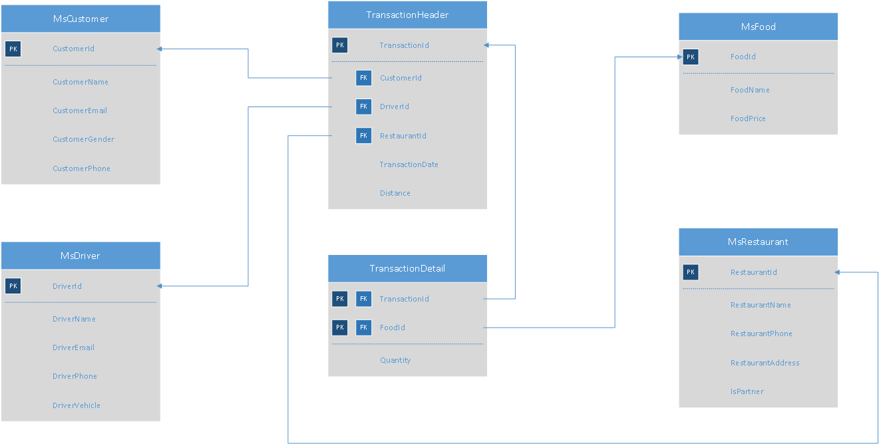
Figure 1. JrebFood ERD
Below is the task you must do to analyze the data:
- Load Data from CSV to Spark
Using SparkSession, read the following files (“MsCustomer.csv”, “MsDriver.csv”, “MsFood.csv”, “MsRestaurant.csv”, “TransactionHeader.csv”, “TransactionDetail.csv”).
- Query Analysis and Visualization
You are asked to gain some sales insight about the data. Below are some statements you need to answer. Use SparkSQL to answer the question and pyplot package to visualize the answer.

- Show how many orders JrebFood drivers who drived using Toyota have taken in February using barplot.
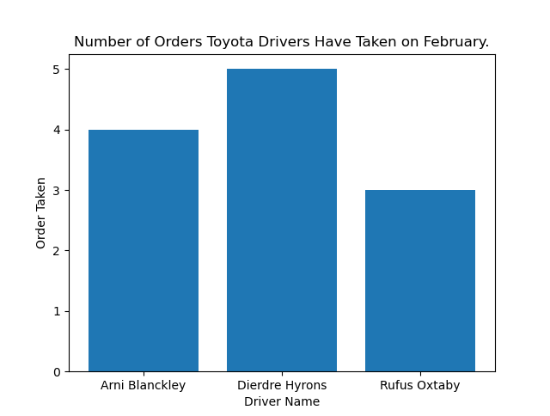
Figure 2. Number of Orders Taken Figure
- Show JrebFood partner restaurant revenue for every month in 2020 using line plot.
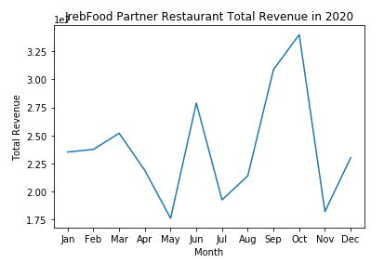
Figure 3. JrebFood Partner Restaurant Total Revenue in 2020 Figure
- Show the percentage of deliveries that JrebFood subsidize using pie plot. The delivery will be subsidized based on the distance of the delivery as follows:
Delivery Distance | Benefit
> Average Distance of All Deliveries in January | Subsidized Gasoline
<= Average Distance of All Deliveries in January | Unsubsidized Gasoline
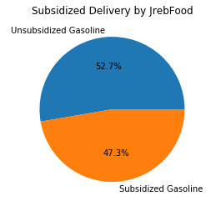
Figure 4. Subsidized Delivery by JrebFood Figure

S.S. Sail Safe
S.S. Sail Safe is school competition for A.I. enthusiast. The competition is held in Jakarta, where all participants must submit their predictive model that can predict whether or not a storm is coming. All participants will be given Storm_Training.csv and Storm_Testing.csv, your task is to create a classification model and test it to Storm_Testing.csv. Here are the descriptions for the columns in Storm_Training.csv and Storm_Testing.csv:

Column Name | Description
atmospheric_pressure | Pressure of the atmosphere in kPa.
visible_cloud | Visible nearby clouds on the sky (Cumulus, Stratus, Cumulonimbus, Cirrus).
wind_direction | The direction of the wind is blowing (East, North, West, South).
wind_speed | The speed of the wind in km/h.
sky_color | Color of the sky (Orange, Blue, Green, Gray).
ocean_wave_speed | The speed of ocean wave (Low, High, Medium)..
temperature | State of the temperature (Decline, Stable, Rise).
animal_activity | Nearby animals activity (Low, High, Medium).
storm_coming | Whether a storm is coming or not.
Figure 5. Storm_Training.csv and Storm_Testing.csv
Below are the steps you are required to do to generate the model:
- Load Data
Given the file “Storm_Training.csv” and “Storm_Testing.csv”, you are asked to load the data using SparkSession.
- Select Features
After you load the data, you need to select important features that will be used for training. Pick three important features.
- Data Preprocessing
In this step, please remove any missing values in the data.
- Transform Data
In this step, transform the raw data so that it is suitable for training. For example, recode the ‘Temperature’ column value to be either 0, 1, or 2.
- Normalization
After data preprocessing, you are required to normalize the data. Use the StandardScaler
package to normalize the data.
- Generate Model
Next, you are required to generate a model from the data. Use the LogisticRegression package to generate the model with ‘100’ as the max iteration.
- Model Testing and Evaluation
After the model is generated, you can test the model to predict whether the storm is coming or not. Use BinaryClassificationEvaluator package to print the accuracy of your model. Get the model with minimum accuracy 74% or higher.

Good Luck 😊

