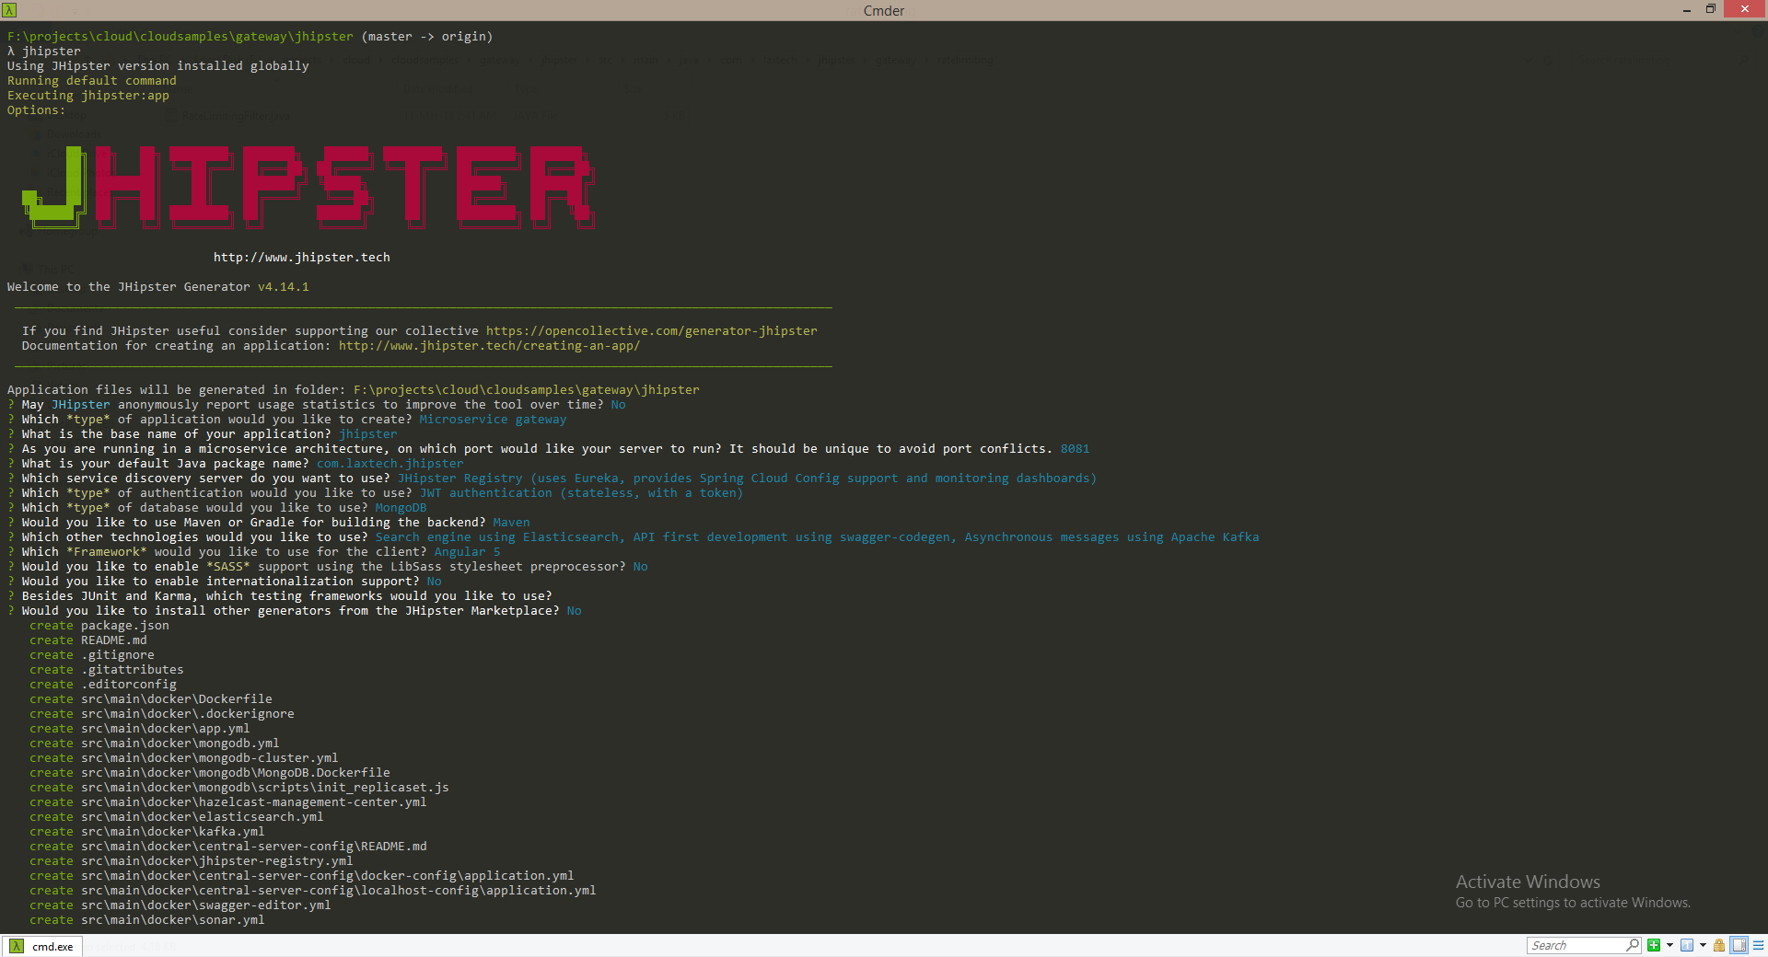

Start:

Welcome to the JHipster Generator v4.14.1

_______________________________________________________________________________________________________________

If you find JHipster useful consider supporting our collective https://opencollective.com/generator-jhipster

Documentation for creating an application: http://www.jhipster.tech/creating-an-app/

_______________________________________________________________________________________________________________

Application files will be generated in folder: F:\projects\cloud\cloudsamples\gateway\jhipster

? May JHipster anonymously report usage statistics to improve the tool over time? No

? Which *type* of application would you like to create? Microservice gateway

? What is the base name of your application? jhipster

? As you are running in a microservice architecture, on which port would like your server to run? It should be unique to avoid port conflicts. 8081

? What is your default Java package name? com.laxtech.jhipster

? Which service discovery server do you want to use? JHipster Registry (uses Eureka, provides Spring Cloud Config support and monitoring dashboards)

? Which *type* of authentication would you like to use? JWT authentication (stateless, with a token)

? Which *type* of database would you like to use? MongoDB

? Would you like to use Maven or Gradle for building the backend? Maven

? Which other technologies would you like to use? Search engine using Elasticsearch, API first development using swagger-codegen, Asynchronous messages using Apache Kafka

? Which *Framework* would you like to use for the client? Angular 5

? Would you like to enable *SASS* support using the LibSass stylesheet preprocessor? No

? Would you like to enable internationalization support? No

? Besides JUnit and Karma, which testing frameworks would you like to use?

? Would you like to install other generators from the JHipster Marketplace? No

End:

If you find JHipster useful consider supporting our collective https://opencollective.com/generator-jhipster

Server application generated successfully.

Run your Spring Boot application:

./mvnw (mvnw if using Windows Command Prompt)

Client application generated successfully.

Start your Webpack development server with:

yarn start

Congratulations, JHipster execution is complete!

Start : jhipster1

Application files will be generated in folder: F:\projects\cloud\cloudsamples\gateway\jhipster1

? Which *type* of application would you like to create? Microservice gateway

? What is the base name of your application? JhipsterMicroSrv

? As you are running in a microservice architecture, on which port would like your server to run? It should be unique to avoid port conflicts. 8080

? What is your default Java package name? com.laxtech.jhipster

? Which service discovery server do you want to use? JHipster Registry (uses Eureka, provides Spring Cloud Config support and monitoring dashboards)

? Which *type* of authentication would you like to use? JWT authentication (stateless, with a token)

? Which *type* of database would you like to use? SQL (H2, MySQL, MariaDB, PostgreSQL, Oracle, MSSQL)

? Which *production* database would you like to use? MySQL

? Which *development* database would you like to use? H2 with in-memory persistence

? Do you want to use Hibernate 2nd level cache? No

? Would you like to use Maven or Gradle for building the backend? Maven

? Which other technologies would you like to use?

? Which *Framework* would you like to use for the client? Angular 5

? Would you like to enable *SASS* support using the LibSass stylesheet preprocessor? No

? Would you like to enable internationalization support? No

? Besides JUnit and Karma, which testing frameworks would you like to use?

? Would you like to install other generators from the JHipster Marketplace? No