**Custom Policy**

Setup:

1. Create settings.xml in user_home/.m2 direcoty.
2. Run arch-type.bat under newly created project directory. This will create project using archetype template. Set -DgroupId to your org id (use parent organization or chield business group id) and artifactId to project name say “custom-demo-response-policy” ie -DartifactId=custom-demo-response-policy.

Configure:

1. Configure policy in custom-demo-response-policy.yaml file.

Implement:

1. Implement policy in template.xml file
2. Add following in pom.xml

*<http.policy.transform.extension>3.1.0</http.policy.transform.extension>*

and

*<dependency>*

*<groupId>com.mulesoft.anypoint</groupId>*

*<artifactId>mule-http-policy-transform-extension</artifactId>*

*<version>${http.policy.transform.extension}</version>*

*<classifier>mule-plugin</classifier>*

*<!-- HTTP Connector is excluded to avoid packaging it with the policy, since the application's HTTP connector is used -->*

*<exclusions>*

*<exclusion>*

*<groupId>org.mule.connectors</groupId>*

*<artifactId>mule-http-connector</artifactId>*

*</exclusion>*

*</exclusions>*

*</dependency>*

And

*<distributionManagement>*

*<repository>*

*<id>exchange-server</id>*

*<name>Corporate Repository</name>*

*<url>${exchange.url}</url>*

*<layout>default</layout>*

*</repository>*

*</distributionManagement>*

1. Settings.xml

*<servers>*

*<server>*

*<id>exchange-server</id>*

*<username>sanjeev20</username>*

*<password>********</password>*

*</server>*

*<server>*

*<id>releases-ee</id>*

*<username>muletraining.nexus</username>*

*<password>**************</password>*

*</server>*

*</servers>*

And

*<repositories>*

*<repository>*

*<id>releases-ee</id>*

*<name>Mule EE Repository</name>*

*<url>https://repository.mulesoft.org/nexus-ee/content/repositories/releases-ee/</url>*

*<layout>default</layout>*

*</repository>*

*…*

*<repositories>*

Upload to Exchange:

1. mvn deploy

Client APP:

1. Create api and publish
2. Create implementation app and deploy. This need to be done in same BG where we have API in API Manager.
   1. To deploy application, add client_id and client_secret of org/ BG in anypoint studio

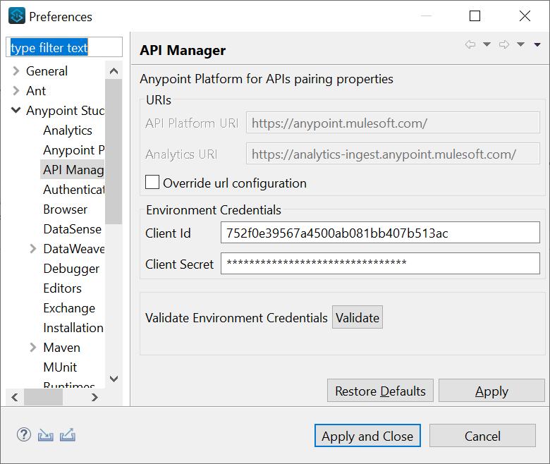

* 1. Above will set following properties in runtime settings

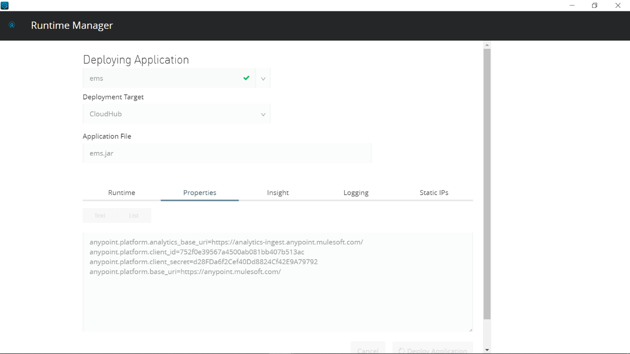

1. Create app using raml api and deploy client app to exchange

Apply Policy:

1. In api manager configure policy.

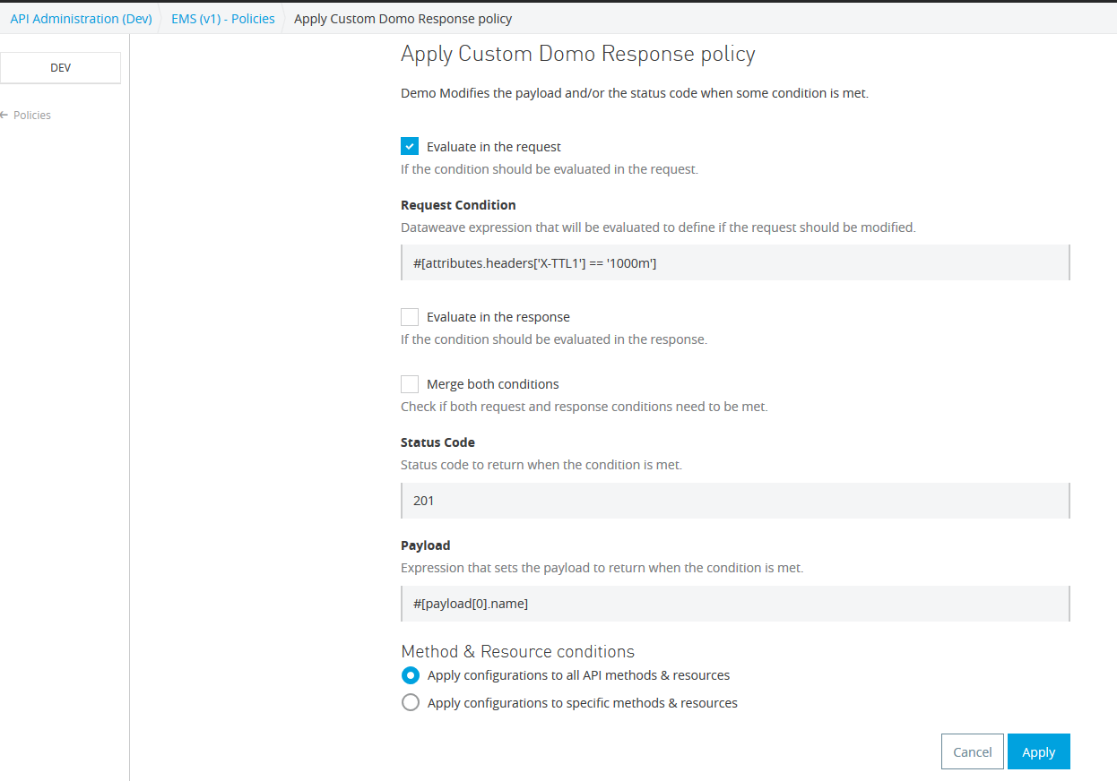

Invoke client api:

1. With header X-TTL1 = 1000m

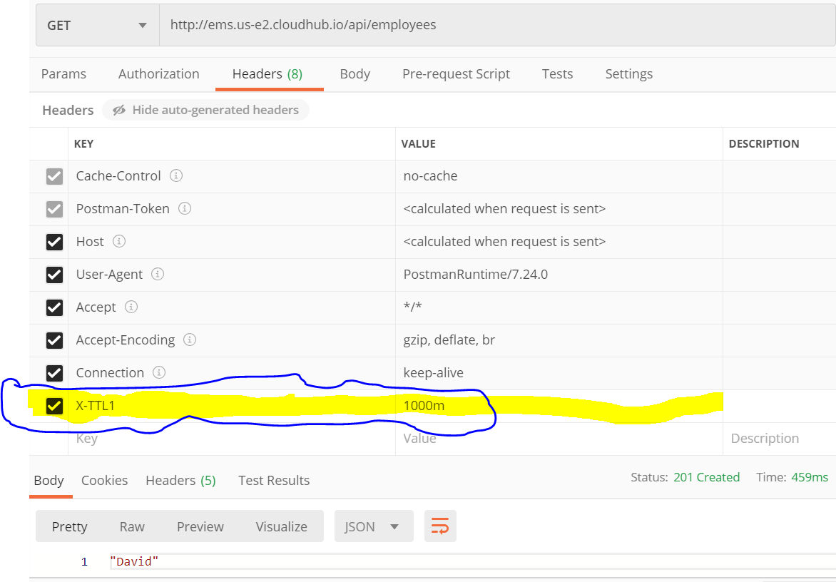

1. Without header X-TTL1

