

**Data Technician**

|  |
| --- |
|  |

|  |
| --- |
| Name: Lee Nock |
| Course Date: |
|  |

**Table of contents**

Day 1: Task 1 3

Day 1: Task 2 4

Day 1: Task 3 5

Day 1: Task 4 6

Day 2: Task 1 7

Day 3: Task 1 11

Day 3: Task 2 12

Day 3: Task 3 14

Day 4: Task 1 15

Day 4: Task 2 16

Day 4: Task 2 (Optional) 17

**1. Scenario Background** 17

**2. Data Laws and Regulations** 17

**3. Azure Service Recommendations** 17

**4. Data Types and Data Modelling** 17

**5. Data Storage Formats and Structures in Azure** 18

**6. Additional Considerations** 18

**Submission Guidelines:** 18

**Course Notes** 21

**Additional Information** 22

# Day 1: Task 1

Please research and complete the below questions relating to key concepts of cloud.

Be prepared to discuss the below in the group following this task.

|  |  |
| --- | --- |
| What can cloud computing do for us in the real-world? | Scale resources instantly.  Access apps/data from anywhere.  Speed up service deployment.  Improve disaster recovery.  Provide AI, analytics, and other advanced tools. |
| How can it benefit a business? | Lower costs (pay-as-you-go).  Adapt quickly to change.  Enable team collaboration.  Strong security & compliance.  Reliable business continuity.  Support sustainability goals. |
| What’s the alternative to cloud computing? | On-premises servers (fully in-house).  Private or hybrid clouds.  Cloud repatriation (moving workloads back in-house). |
| What cloud providers can we use, what are their features and functions? | AWS – Largest provider, huge service range, global reach.  Azure – Strong Microsoft integration, hybrid-friendly.  Google Cloud – Leader in analytics & AI.  Oracle Cloud – Strong for Oracle workloads & hybrid options.  IBM Cloud – Enterprise-focused, flexible hybrid setups.  Specialist providers – Niche services (AI compute, regional data control). |

# Day 1: Task 2

Please research the below cloud offerings, explain what they are and examples of use cases.

|  |  |  |
| --- | --- | --- |
| Cloud Offerings | Explain what it is | When / how might you use this service in the real-world? |
| IaaS (Infrastructure as a service) | Cloud provider supplies virtual servers, storage, and networking; you install and manage your own OS, software, and configurations. | Host websites or applications with full control over the environment.  Set up temporary testing or development systems.  Create backup and disaster recovery solutions in another region. |
| PaaS (Platform as a service) | Provider offers a complete platform—servers, storage, databases, middleware—so you can focus on writing and running code without worrying about infrastructure. | Rapidly develop and deploy apps.  Handle high-demand services without manual scaling.  Enable teams to collaborate on coding projects from anywhere. |
| SaaS (Software as a service) | Fully managed applications you access via a web browser; provider handles all updates, security, and infrastructure. | Email, file sharing, and team collaboration tools.  Business software like customer relationship management (CRM) or accounting platforms.  Video conferencing and project management. |

# Day 1: Task 3

Pricing Calculator: **In this exercise, you use the Pricing calculator to estimate the cost of running a basic web application on Azure.**

|  |  |
| --- | --- |
| Cost of a basic web application | Completed |

TCO Calculator: **In this exercise, you use the Total Cost of Ownership (TCO) Calculator to compare the cost of running a sample workload in your datacentre versus on Azure.**

|  |  |
| --- | --- |
| Datacentre vs Azure | Completed |

# Day 1: Task 4

Please research the below terms and explain what they are, when they would be appropriate and a real-world example of where it could be implemented (i.e. what type of organisation).

|  |  |
| --- | --- |
| Public Cloud | **What it is:** A public cloud is a cloud environment where services and infrastructure are owned and operated by third-party cloud service providers and shared across multiple organizations (tenants). Resources like servers and storage are available to the public over the internet.  **When appropriate:**   * For startups, small to medium businesses, or any organization that wants scalable, cost-effective IT resources without investing in physical hardware. * When you need rapid provisioning of resources and pay-as-you-go pricing. * For applications that don’t require strict regulatory compliance or sensitive data handling.   **Example:**   * **Example provider:** Amazon Web Services (AWS), Microsoft Azure, Google Cloud Platform (GCP). * **Organization:** An e-commerce startup using AWS to host its website and manage traffic spikes during sales events. |
| Private Cloud | **What it is:** A private cloud is a cloud environment dedicated solely to one organization. It can be hosted on-premises or by a third-party provider but is isolated and not shared with others.  **When appropriate:**   * For organizations requiring strict control over their data and infrastructure due to regulatory compliance, security, or performance reasons. * When you want the benefits of cloud computing (automation, scalability) but need dedicated resources. * In industries like finance, government, or healthcare where data privacy is critical.   **Example:**   * **Example provider:** VMware private cloud, OpenStack private cloud solutions. * **Organization:** A bank using a private cloud to run sensitive financial applications and ensure regulatory compliance. |
| Hybrid Cloud | **What it is:** A hybrid cloud combines public and private clouds, allowing data and applications to be shared between them. Organizations can keep sensitive workloads on a private cloud while using the public cloud for less critical resources or to handle peak loads.  **When appropriate:**   * When you need to balance security and flexibility. * For organizations with existing on-premises infrastructure wanting to extend capacity or enable disaster recovery using public cloud resources. * When applications or data need to move between private and public environments for cost or compliance reasons.   **Example:**   * **Example provider:** Microsoft Azure Stack, AWS Outposts, Google Anthos. * **Organization:** A retail chain with sensitive customer data on a private cloud but uses the public cloud for big data analytics and seasonal traffic surges. |
| Community Cloud | **What it is:** A community cloud is a shared cloud environment built for a specific community of users with common concerns such as security, compliance, or jurisdiction. Multiple organizations collaborate to share the infrastructure and costs.  **When appropriate:**   * When multiple organizations in the same industry or with similar requirements want to share resources while maintaining privacy and compliance. * For government agencies or healthcare providers sharing infrastructure while adhering to specific regulations.   **Example:**   * **Example:** A consortium of hospitals sharing a community cloud to securely share patient data and collaborate on research. * **Organization:** Multiple universities collaborating on research using a community cloud hosted by a trusted provider. |

# Day 2: Task 1

Describe, with examples, the **three** major areas that the Computer Misuse Act deals with.

|  |  |  |
| --- | --- | --- |
| Area | Description | Example |
| Unauthorised Access to Computer Material (Section 1) | This occurs when someone intentionally accesses a computer or data without permission and knows the access is unauthorised. The individual doesn’t need to have a specific target in mind—just accessing without authorization is enough. | Hacking into someone’s email account or internal work files by guessing or stealing credentials, even if you do not end up doing anything further. |
| Unauthorised Access with Intent to Commit or Facilitate Further Offences (Section 2) | This is when unauthorised access (covered under Section 1) is made with the purpose of committing another crime—like fraud, theft, or blackmail—even if the secondary crime itself isn’t completed. | Logging into a company’s payroll system without permission to steal salary funds or personal info for blackmail. |
| Unauthorised Acts with Intent to Impair, or Recklessness as to Impairing, Computer Operations (Section 3) | This targets any unauthorised action that either intentionally or recklessly impairs a computer’s operation, disrupts access to data, or hinders reliability—even without accessing data directly. This includes actions like deploying malware or carrying out DDoS attacks | Launching a Distributed Denial of Service (DDoS) attack to overwhelm and crash a website, or introducing a virus that damages or deletes files. |

The computer misuse act 1990 is an act where an individual can be criminalised because of computer related offense. Describe three extra powers that the Police and Justice Act 2006 (Computer Misuse) has added.

|  |
| --- |
| Description |
| Increased Maximum Penalties for Offences  The Act raised the maximum penalties for existing offences:   * Unauthorised access to computer material (formerly Section 1) now carries up to 2 years' imprisonment, a significant increase from the earlier limit. * Unauthorised acts with intent to impair the operation of a computer (formerly Section 3) can now result in up to 10 years' imprisonment. This change acknowledges the growing severity of cyber-related offences in modern contexts. |
| Explicit Criminalisation of Denial-of-Service (DoS) Attacks  Before this amendment, DoS attacks existed in a legal grey area—since they may not involve direct unauthorised access or modification of data, it wasn’t always clear they were offences. The 2006 Act corrected that by specifically including DoS attacks under the remit of the Computer Misuse Act, eliminating ambiguity and making them explicitly illegal. |
| Offence of “Making, Supplying, or Obtaining Articles for Use in Offences”  The Act introduced a new offence (Section 3A), targeting the creation, distribution, or possession of tools used to facilitate computer misuse—for instance, hacking toolkits or malware designed to enable unauthorised access or damage. This means that even if someone doesn’t commit the hacking offence itself, they can be prosecuted for providing the means to do so. |

Look at the below website to answer the questions:

<https://www.gov.uk/personal-data-my-employer-can-keep-about-me>

|  |
| --- |
| Write down three items of data which a company can store about an employee. |
| Name, address, date of birth – Basic identity details. |
| National Insurance number – For tax and employment record purposes. |
| Employment details – Includes education and qualifications, work experience, employment terms (pay, hours, holidays, benefits), emergency contact details, and employment history within the organisation. |

|  |
| --- |
| Give three more examples of data that an employer can only store if they first get the employee’s permission. |
| Race and ethnicity |
| Religion or political opinions |
| Health and medical conditions, including biometrics (like fingerprints), sexual orientation or history, and trade union membership |

Conduct further research to answer the below questions.

|  |  |
| --- | --- |
| Question | Answer |
| Provide one example of: Copyright infringement | Downloading and distributing copyrighted songs without permission, such as using file-sharing networks to share music illegally. |
| Provide one example of: Plagiarism | Copying text from a website or book and presenting it as your own, for instance copying passages into an assignment without quotation marks or citation. |
| What are two consequences of copyright infringement and software piracy? | **Civil and criminal penalties**, including fines up to $250,000 and prison sentences.  **Damages in lawsuits**, such as statutory damages ranging from $750–$150,000 per work infringed. |
| Give three possible consequences for individuals when using pirated software | **Security risks**, such as malware or spyware hidden in cracked software.  **Inability to receive updates or patches**, leaving systems vulnerable to bugs.  **Legal exposure**, facing lawsuits or fines even if the infringement was unintentional. |

Listed below are some laws which we have covered today:

1. Computer Misuse Act 1990

2. Police and Justice Act 2006 (Computer Misuse)

3. Copyright, Designs and Patents Act 1988

4. Copyright (Computer Programs) Regulations 1992

5. The Health and Safety (Display Screen Equipment) Regulations 1992

6. Data Protection Act 2018

7. Consumer Rights Act 2015

* Insert a number in the first column of each row to match each of the statements with one of the above Acts.
* One of statements is incorrect and not illegal. For this statement, write ‘Not illegal’.

|  |  |
| --- | --- |
| **Act number** | **Clause** |
| 1 | With some exceptions, it is illegal to use unlicensed software |
| 7 | Any product, digital or otherwise, must be fit for the purpose it is supplied for |
| 1 | Unauthorised modification of computer material is illegal |
| N/A | It is illegal to create or use a hacking tool for penetration testing |
| 6 | Personal data may only be used for specified, explicit purposes |
| 5 | Employers must provide their computer users with adequate health and safety training for any workstation they work at |
| 1 | It is illegal to distribute hacking tools for criminal purposes |
| 3 | It is illegal to distribute an illicit recording |
| 6 | Personal data may not be kept longer than necessary |
| 1 | Gaining unauthorised access to a computer system is illegal |
| 5 | Employers must ensure that employees take regular and adequate breaks from looking at their screens |
| 1 | It is illegal to prevent or hinder access (e.g. by a denial-of-service attack) to any program or data held in any computer |
| 6 | Personal data must be accurate and where necessary kept up to date |

# Day 3: Task 1

Please complete the below lab (3) *‘Explore relational data in Azure’* and paste evidence of the completed lab in the box provided.

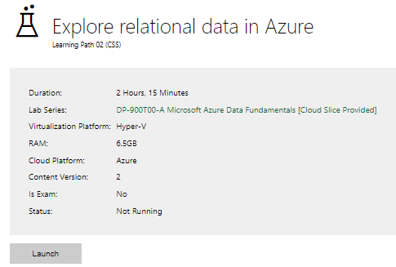

|  |  |
| --- | --- |
| Completed lab |  |

# Day 3: Task 2: Skillable

Complete below exercises in lab environment using AdventureWorks DB.

**-- 1. Customers with last names starting with 'A'**

-- Scenario: The marketing department is preparing a campaign targeting customers whose last names begin with the letter 'A'. They need a list of these customers to personalize outreach messages.

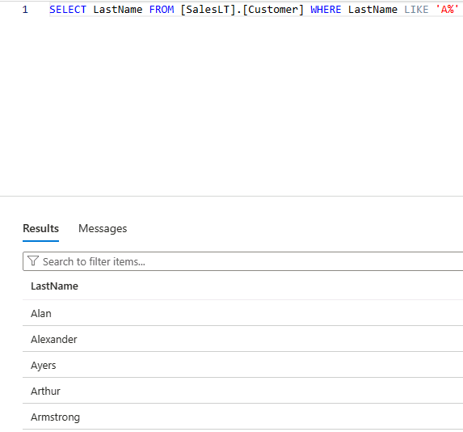

**-- 2. Customers with first name starting with 'A' and last name ending with 'a'**

-- Scenario: The CRM team is analyzing customer name patterns for personalization strategies. They're particularly interested in users with a first name starting with 'A' and a last name ending in 'a'.

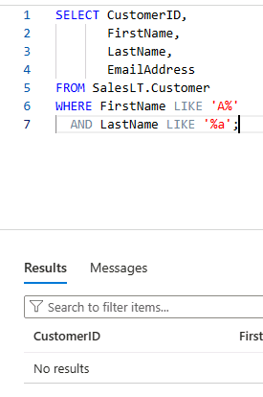

**-- 3. Count of customers with first name starting with 'A' and last name including 'o'**

-- Scenario: A data analyst is generating statistics for a name segmentation report and needs to count how many customers meet both criteria: first name starts with 'A' and last name contains the letter 'o'.

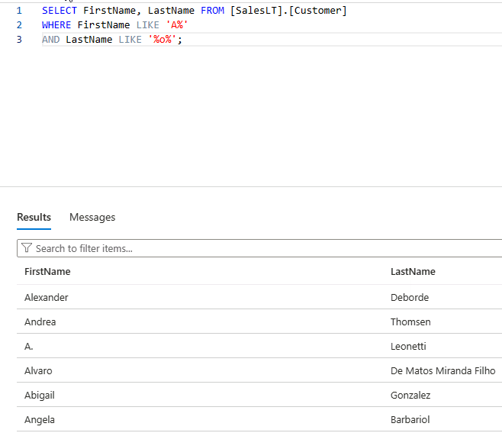

**-- 4. Top 3 black products of size 'S' ordered by list price**

-- Scenario: The merchandising team is curating a list of 'Black' colored products in size 'S' for a limited-time promotion. They want to showcase the top 3 most affordable options first.

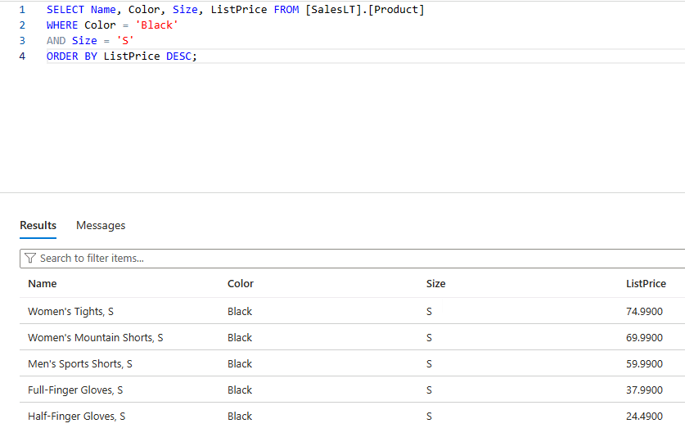

**-- 5. Average standard cost of products**

-- Scenario: The finance team is calculating the average standard cost across all products to assess baseline production expenses.

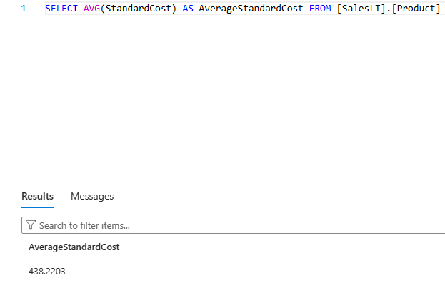

**-- 6. Difference between average standard cost and average list price**

-- Scenario: The pricing strategy team is examining the average markup between the standard cost and the list price to evaluate profitability trends.

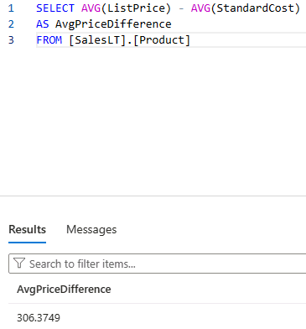

**-- 7. Product with highest profit margin**

-- Scenario: Management wants to identify the most profitable product by finding the item with the highest difference between list price and standard cost.

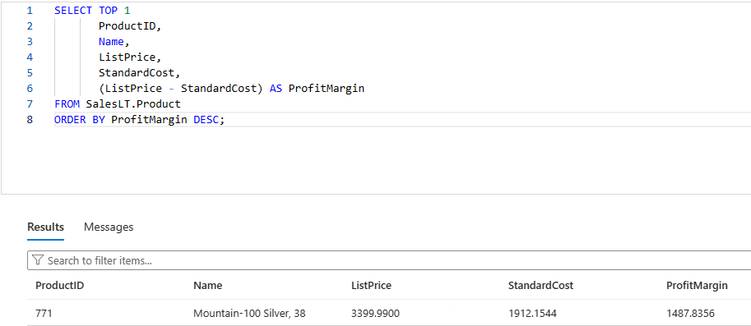

**-- 8. Number of products per category**

-- Scenario: Inventory control needs a summary of how many products exist in each product category to manage stock levels effectively.

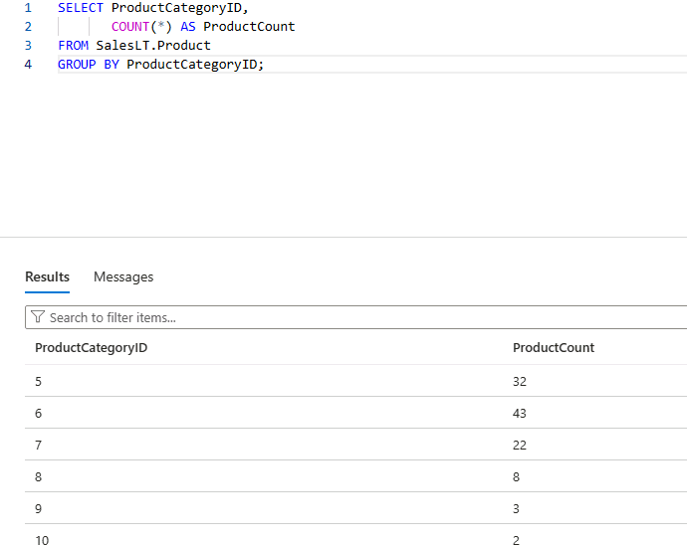

**-- 9. Average list price by category**

-- Scenario: The product pricing team is reviewing average list prices by category to adjust pricing strategies and identify outliers.

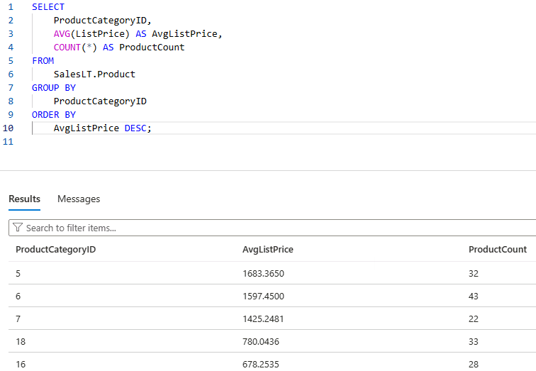

**-- 10. Orders with customer information**

-- Scenario: The operations team needs a comprehensive report of customer orders, including order details and basic customer info, to review sales performance.

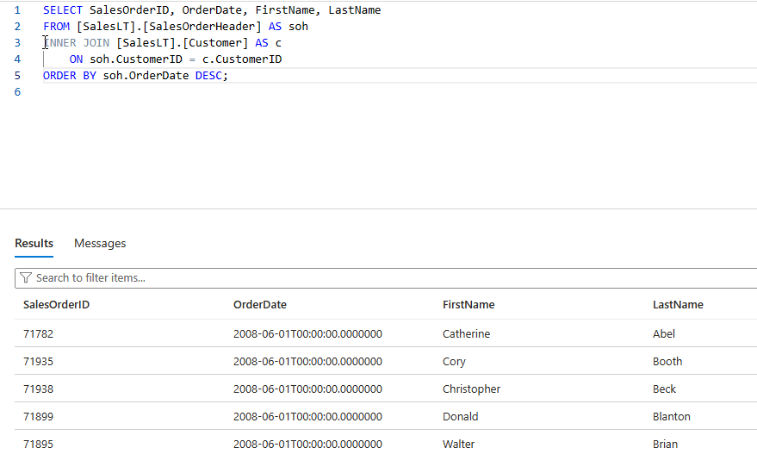

**-- 11. Products priced above average list price**

-- Scenario: The sales team wants to identify premium products that are priced above the average list price for highlighting in high-end marketing campaigns.

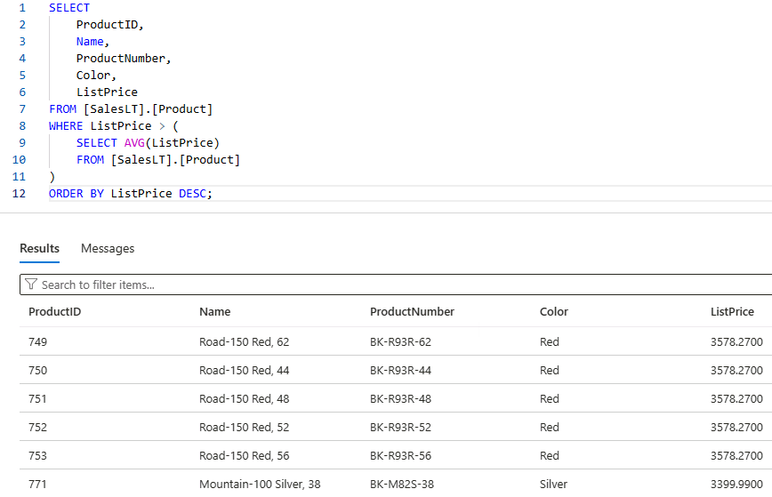

**-- 12. Total quantity sold per product**

-- Scenario: The business intelligence team is evaluating product performance by analyzing the total quantity sold for each product across all orders.

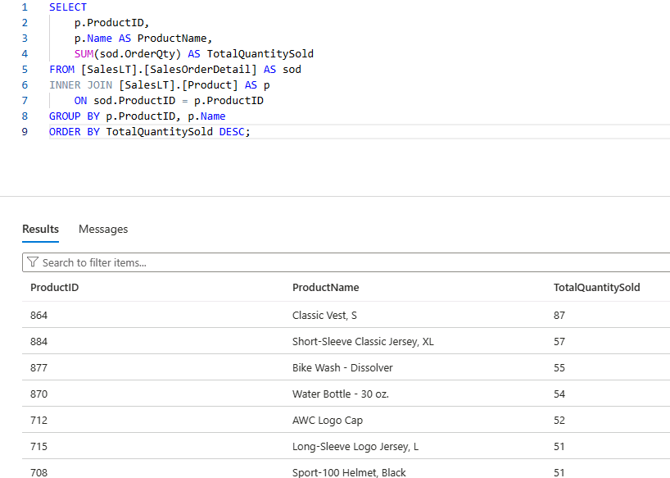

**-- 13. Total sales per customer**

-- Scenario: The customer success team wants to calculate the total value of orders placed by each customer to identify high-value clients for loyalty programs.

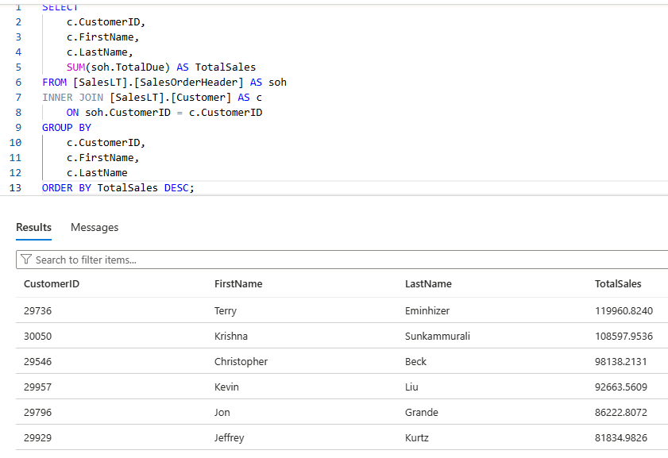

# Day 3: Task 3: Skillable

Please complete the below lab (4) *‘Explore non-relational data in Azure’* and paste evidence of the completed lab in the box provided.

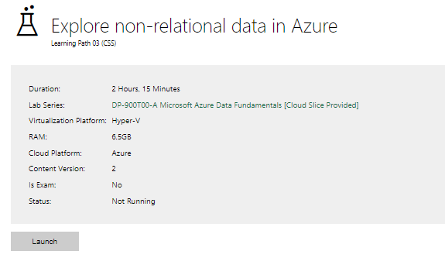

|  |  |
| --- | --- |
| Completed lab |  |

# Day 4: Task 1: MS Fabric using Just IT

Please follow the link below to complete the lab using your Just IT account in MS Fabric.

There are 3 modules to complete.

[Data Factory end-to-end tutorial introduction and architecture - Microsoft Fabric | Microsoft Learn](https://learn.microsoft.com/en-us/fabric/data-factory/tutorial-end-to-end-introduction)

# Day 4: Task 2: Skillable

In your teams, complete the Azure DP-900 practice exam and paste your result below – this is open book and please research and discuss your answers as a team.

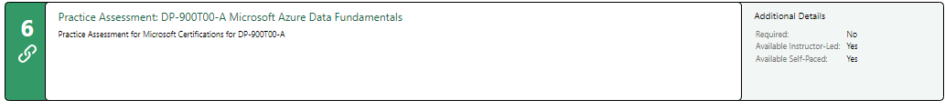

|  |  |
| --- | --- |
| Result |  |

# Day 4: Task 2 (Optional)

#### **1. Scenario Background**

"Paws & Whiskers" is a growing pet shop that aims to improve its business by analysing sales, customer information, and inventory data. Currently, the data is collected manually or stored in spreadsheets. Management is interested in transitioning to Microsoft Azure to streamline data storage, analysis, and reporting, enabling them to make data-driven decisions.

#### **2. Data Laws and Regulations**

Identify and explain the data laws and regulations relevant to handling customer data within the proposal. Ensure you cover the following points:

* **GDPR Compliance**: Highlight the importance of adhering to the General Data Protection Regulation (GDPR), particularly as it relates to storing and processing customer information.
* **Data Protection Act (DPA) 2018**: Outline how the DPA 2018 may affect the way "Paws & Whiskers" collects and stores data, ensuring compliance with UK laws on data privacy.
* **Other Industry Standards**: Research any additional data protection standards or regulations that may apply to pet shop data, particularly if they involve sensitive or payment information.

#### **3. Azure Service Recommendations**

Recommend Microsoft Azure services that would suit the company’s data analysis needs and explain why these services are suitable. Your recommendations should include:

* **Data Storage**: Identify suitable storage options, such as **Azure Blob Storage** or **Azure SQL Database**, and discuss the benefits of each for storing large datasets, including inventory, sales transactions, and customer details.
* **Data Analysis Tools**: Recommend tools such as **Azure Machine Learning** for customer behaviour analysis or **Azure Synapse Analytics** for analysing sales trends.
* **Data Integration and Automation**: Explain how services like **Azure Data Factory** could automate data collection and integration processes, improving efficiency.

#### **4. Data Types and Data Modelling**

Define the types of data "Paws & Whiskers" will need to work with and describe your approach to data modelling:

* **Data Categories**: Identify key data types, such as customer demographics, transaction history, pet inventory, and product categories.
* **Data Modelling Approach**: Outline how you would structure this data using a relational model or a data warehouse approach, considering factors like tables, entities, relationships, and primary keys.

#### **5. Data Storage Formats and Structures in Azure**

Discuss how you would store data within Azure and the formats you would recommend:

* **Data Formats**: Specify recommended formats (e.g., CSV for raw data imports, JSON for structured data, Parquet for analytics) and explain why these formats are suitable for specific data types.
* **Data Security and Encryption**: Include recommendations for securing data using Azure’s built-in encryption features and access controls to ensure compliance with data privacy regulations.

#### **6. Additional Considerations**

Provide any other considerations that might enhance data handling and efficiency in Azure, such as:

* **Backup and Disaster Recovery**: Outline a backup plan using **Azure Backup** or **Azure Site Recovery** to safeguard against data loss.
* **Data Visualisation**: Discuss potential use of **Power BI** within Azure for creating dashboards that provide management with real-time insights into sales and customer trends.
* **Future Scalability**: Comment on how Azure services can scale as the business grows, accommodating larger datasets and more complex analyses.

### **Submission Guidelines:**

1. **Structure**: Ensure your report is well-organised, with sections for each task (e.g., Data Laws, Azure Services, Data Types, etc.).
2. **Formatting**: Include headings, bullet points where appropriate, and any visuals or diagrams that support your explanations.
3. **References**: Cite any resources or regulations referenced in the report.
4. **Length**: Aim for 1500-2000 words.

|  |
| --- |
|  |

|  |
| --- |
| **Course Notes** |

It is recommended to take notes from the course, use the space below to do so, or use the revision guide shared with the class:

|  |
| --- |
| **Additional Information** |

We have included a range of additional links to further resources and information that you may find useful, these can be found within your revision guide.

**END OF WORKBOOK**

**Please check through your work thoroughly before submitting and update the table of contents if required.**

**Please send your completed work booklet to your trainer.**