SMARTCARE AI: COMORBIDITY-AWARE EXPLAINABLE MULTI-TASK LEARNING FOR INTEGRATED DIABETES, CARDIOVASCULAR, AND CHRONIC KIDNEY DISEASE RISK PREDICTION
IT19811 PROJECT PHASE-II REPORT
Submitted by
SANGARI A C (231001178)
SARAVANAN G (231001504)
in partial fulfilment for the award of the degree of
BACHELOR OF TECHNOLOGY
in
INFORMATION TECHNOLOGY

DEPARTMENT OF INFORMATION TECHNOLOGY
RAJALAKSHMI ENGINEERING COLLEGE
(AUTONOMOUS), CHENNAI-602 105
SEPTEMBER 2026

RAJALAKSHMI ENGINEERING COLLEGE
(An Autonomous Institution Affiliated to Anna University Chennai)
BONAFIDE CERTIFICATE
Certified that this Phase-I Thesis titled “SmartCare AI: Comorbidity-Aware Explainable Multi-Task Learning for Integrated Diabetes, Cardiovascular, And Chronic Kidney Disease Risk Prediction” is the Bonafide work of SANGARI A C (231001178), SARAVANAN G (231001504) who carried out the work under my supervision. Certified further that to the best of my knowledge the work reported herein does not form part of any other thesis or dissertation on the basis of which a degree or award was conferred on an earlier occasion on this or any other candidate.
“This project addresses the following Sustainable Development Goals:
SDG 3, SDG 8, SDG 9, SDG 10 & SDG 12”.
Dr. P. VALARMATHIE M.E., Ph.D.  Professor & Head  Department of Information Technology  Rajalakshmi Engineering College  Chennai- 602105 | Ms. SUBASHREE R M.Tech.  Supervisor & Assistant Professor  Department of Information Technology  Rajalakshmi Engineering College  Chennai- 602105
Submitted to Project Viva-Voce Examination held on ............................................

Internal Examiner | External Examiner

ACKNOWLEDGEMENT
First, we thank the almighty God for the successful completion of the project. Our heartfelt sincere thanks to our beloved chairman Mr. S. Meganathan B.E., F.I.E., for his sincere endeavor in educating us in his premier institution. We would like to express our deep gratitude to our beloved Chairperson Dr. Thangam Meganathan Ph.D., for her enthusiastic motivation which inspired us a lot in completing this project and Vice-Chairman Mr. Abhay Shankar Meganathan B.E., M.S., for providing us with the requisite infrastructure.
We also express our sincere gratitude to our college principal, Dr. S. N. Murugesan M.E., Ph.D., for his kind support and facilities to complete our work on time. We extend heartfelt gratitude to Dr. P. Valarmathie M.E., Ph.D., Professor and Head of the Department of Information Technology for her guidance and encouragement throughout the work. We are very glad to thank our project coordinator Dr. M. Babu M.E., Ph.D., Professor for his encouragement and support towards the successful completion of this project.
Further We express our deepest gratitude to our supervisor Ms. Subashree R M.Tech., Assistant Professor for her valuable guidance throughout the work. We extend our thanks to our parents, friends, all faculty members, and supporting staff for their direct and indirect involvement in the successful completion of the project for their encouragement and support.

Sangari A C
Saravanan G

ABSTRACT
The “SmartCare AI: Comorbidity-Aware Explainable Multi-Task Learning for Integrated Diabetes, Cardiovascular, and Chronic Kidney Disease Risk Prediction” research tackles the growing global burden of chronic non-communicable diseases through unified multi-task machine learning. In clinical reality, Type 2 Diabetes (T2D), Cardiovascular Disease (CVD), and Chronic Kidney Disease (CKD) exhibit intricate pathophysiological interactions, shared metabolic risk factors, and compounding vascular complications. Conventional single-disease models operate in silos as opaque 'black boxes' and fail to capture these multidirectional dependencies. SmartCare AI introduces a unified multi-task neural network with a shared 32-dimensional latent feature space that simultaneously predicts calibrated risk probabilities for T2D, CVD, and CKD from a harmonized 30-dimensional clinical feature vector.
The system harmonizes three major clinical cohorts—CDC BRFSS 2015 (N=70,692), Kaggle CVD (N=68,205), and UCI CKD (N=400)—using zero-leakage median imputation and RobustScaler transformations. The multi-task network is trained with task-masked loss and task-balanced batch sampling (20% CKD allocation), followed by post-hoc Platt sigmoid scaling. On strictly held-out test partitions, SmartCare AI achieves high diagnostic precision and sensitivity: T2D (ROC-AUC: 0.8276, Recall: 88.72%, F1: 0.7751), CVD (ROC-AUC: 0.7974, Recall: 79.13%, F1: 0.7306), and CKD (ROC-AUC: 0.9953, Recall: 94.59%, F1: 0.9589) with excellent calibration (ECE < 0.011). Game-theoretic SHAP explainability provides local waterfall attributions and global biomarker importance, while a deterministic clinical rules engine translates risks into ADA/ACC/KDIGO-guideline-adherent care plans within a FastAPI and React microservices architecture.
The research contributes directly to Sustainable Development Goals 3 (Good Health and Well-Being), 8 (Decent Work and Economic Growth), 9 (Industry, Innovation, and Infrastructure), 10 (Reduced Inequalities), and 12 (Responsible Consumption and Production) by enabling early, equitable, and explainable chronic disease risk stratification. By replacing disjointed single-disease calculators with a unified comorbidity framework, SmartCare AI empowers clinicians and patients with actionable, data-driven preventative intelligence for improved clinical outcomes and healthcare sustainability.
TABLE OF CONTENTS
CHAPTER NO | TITLE | PAGE NO
 | ABSTRACT | iv
 | LIST OF FIGURES | vii
 | LIST OF TABLES | viii
 | LIST OF ABBREVIATIONS | ix
 | DEPARTMENT VISION | x
 | DEPARTMENT MISSION | x
 | PROGRAMME EDUCATIONAL OBJECTIVES (PEOs) | x
 | PROGRAM OUTCOMES (POs) | xi
 | PROGRAM SPECIFIC OUTCOMES (PSOs) | xii
 | COURSE OBJECTIVE & COURSE OUTCOMES | xiii
1 | INTRODUCTION | 1
 | 1.1 MOTIVATION | 1
 | 1.2 EXISTING SYSTEM | 2
 | 1.3 PROBLEM STATEMENT | 5
 | 1.4 OBJECTIVES OF THE PROJECT | 6
 | 1.5 PROPOSED SYSTEM | 8
 | 1.6 BENEFITS OF THE PROJECT | 9
2 | LITERATURE SURVEY | 11
 | 2.1 INTRODUCTION | 11
 | 2.2 RELATED WORK | 12
 | 2.3 INFERENCE FROM RELATED WORK | 16
3 | SYSTEM DESIGN | 17
 | 3.1 INTRODUCTION | 17
 | 3.2 SYSTEM ARCHITECTURE | 18
 | 3.3 SYSTEM REQUIREMENTS | 21
 | 3.4 DATA FLOW DIAGRAM / USE CASE DIAGRAM | 25
4 | PROJECT DESCRIPTION | 29
 | 4.1 METHODOLOGIES | 29
 | 4.2 MODULE DESCRIPTION | 31
5 | RESULT AND DISCUSSION | 41
6 | CONCLUSION AND FUTURE WORK | 49
 | REFERENCES | 51
 | APPENDICES | 53
I | PROJECT PLAGIARISM REPORT | 53
II | PAPER PLAGIARISM REPORT | 54
IV | PROOF OF THE PUBLICATION | 61
V | CO-PO-PSO MAPPING | 64
VI | CO-SDG RELEVANCE RECORD | 65

LIST OF FIGURES
Figure Number | Figure Caption | Page Number
3.1 | System Architecture Diagram | 19
3.2 | Data Flow Diagram | 25
3.3 | Use Case Diagram | 28
4.1 | Methodology | 30
5.1 | Multi-Task Neural Network Training & Loss Convergence | 42
5.2 | Performance Evaluation | 43
5.3 | Recommendation Module (Comorbidity Risk Dashboard) | 43
5.4 | SHAP Biomarker Attribution & Risk Decomposition | 44
5.5 | Clinical Guideline Intervention Plan | 44
5.6 | Longitudinal Health Trends Analysis | 45
5.7 | Emergency Alert Dispatcher & Clinical Telemetry | 46
5.8 | Multi-Lingual Localization Interface | 47
5.9 | AI Assistance Chatbot (Clinical Copilot) | 48

LIST OF TABLES
Table Number | Table Caption | Page Number
1.1 | Existing Vs Proposed System | 4
3.1 | Software Tools | 22
3.2 | Functional Requirements | 23
3.3 | Hardware Requirements | 24
4.1 | 30-Dimensional Harmonized Clinical Feature Space | 30
5.1 | Multi-Task Neural Network Test Set Performance Metrics | 41
5.2 | Empirical Baseline Comparison | 42
5.3 | Ablation Study on Shared Representation & Task Loss Weighting | 43

LIST OF ABBREVIATIONS
S. No | Abbreviation | Word Expansion
1 | AI | Artificial Intelligence
2 | ML | Machine Learning
3 | MTL | Multi-Task Learning
4 | T2D | Type 2 Diabetes Mellitus
5 | CVD | Cardiovascular Disease
6 | CKD | Chronic Kidney Disease
7 | SHAP | SHapley Additive exPlanations
8 | ECE | Expected Calibration Error
9 | ROC-AUC | Receiver Operating Characteristic - Area Under Curve
10 | PR-AUC | Precision-Recall - Area Under Curve
11 | BMI | Body Mass Index
12 | SBP | Systolic Blood Pressure
13 | DBP | Diastolic Blood Pressure
14 | eGFR | Estimated Glomerular Filtration Rate
15 | FBS | Fasting Blood Sugar
16 | HbA1c | Glycated Hemoglobin
17 | RBAC | Role-Based Access Control
18 | REST | Representational State Transfer
19 | API | Application Programming Interface
20 | JWT | JSON Web Token
21 | BRFSS | Behavioral Risk Factor Surveillance System (CDC)
22 | UCI | University of California, Irvine
23 | WHO | World Health Organization
24 | ADA | American Diabetes Association
25 | ACC/AHA | American College of Cardiology / American Heart Association
26 | KDIGO | Kidney Disease: Improving Global Outcomes
27 | SDG | Sustainable Development Goals
28 | LLM | Large Language Model
29 | XAI | Explainable Artificial Intelligence
30 | EHR | Electronic Health Record

DEPARTMENT VISION
To be a Department of Excellence in Information Technology Education, Research and Development.
DEPARTMENT MISSION
M1: To train the students to become highly knowledgeable in the field of Information Technology.
M2: To promote continuous learning and research in core and emerging areas.
M3: To develop globally competent students with strong foundations, who will be able to adapt to changing technologies.
PROGRAMME EDUCATIONAL OBJECTIVES
PEO I: To provide essential background in Science, basic Electronics and applied Mathematics.
PEO II: To prepare the students with fundamental knowledge in programming languages and to develop applications.
PEO III: To engage the students in life-long learning, and make them to remain current in their profession and obtain additional qualifications to enhance their career positions in IT industries.
PEO IV: To enable the students to implement computing solutions for real world problems and carry out basic and applied research leading to new innovations in Information Technology (IT) and related interdisciplinary areas.
PEO V: To familiarize the students with the ethical issues in engineering profession, issues related to the world wide economy, nurturing of current job related skills and emerging technologies.
PROGRAM OUTCOMES (POs)
- Engineering knowledge: Apply the knowledge of mathematics, science, engineering fundamentals, and an engineering specialization to the solution of complex engineering problems.
- Problem analysis: Identify, formulate, review research literature, and analyze complex engineering problems reaching substantiated conclusions using first principles of mathematics, natural sciences, and engineering sciences.
- Design/development of solutions: Design solutions for complex engineering problems and design system components or processes that meet the specified needs with appropriate consideration for the public health and safety, and the cultural, societal, and environmental considerations.
- Conduct investigations of complex problems: Use research-based knowledge and research methods including design of experiments, analysis and interpretation of data, and synthesis of the information to provide valid conclusions.
- Modern tool usage: Create, select, and apply appropriate techniques, resources, and modern engineering and IT tools including prediction and modeling to complex engineering activities with an understanding of the limitations.
- The engineer and society: Apply reasoning informed by the contextual knowledge to assess societal, health, safety, legal and cultural issues and the consequent responsibilities relevant to the professional engineering practice.
- Environment and sustainability: Understand the impact of the professional engineering solutions in societal and environmental contexts, and demonstrate the knowledge of, and need for sustainable development.
- Ethics: Apply ethical principles and commit to professional ethics and responsibilities and norms of the engineering practice.
- Individual and team work: Function effectively as an individual, and as a member or leader in diverse teams, and in multidisciplinary settings.
- Communication: Communicate effectively on complex engineering activities with the engineering community and with society at large, such as, being able to comprehend and write effective reports and design documentation, make effective presentations, and give and receive clear instructions.
- Project management and finance: Demonstrate knowledge and understanding of the engineering and management principles and apply these to one’s own work, as a member and leader in a team, to manage projects and in multidisciplinary environments.
- Life-long learning: Recognize the need for and have the preparation and ability to engage in independent and life-long learning in the broadest context of technological change.

PROGRAM SPECIFIC OUTCOMES (PSOs)
- To comprehend and analyze user requirements to design IT based solutions.
- To identify and assess current technologies and review their applicability to address individual and organizational needs.
- To engage in the computing profession by working effectively and utilizing professional skills to make a positive contribution to society.
- To take on positions as promoters in business and embark on a research career in the field.
COURSE OBJECTIVE
- To enable the students to do the implementation of the industry-relevant and real-time projects on various core domains of information technology.
COURSE OUTCOMES
- Analyze complex Engineering problems related Information Technology to reach substantiated conclusions by applying knowledge of Mathematics, Engineering fundamentals and Engineering specialization.
- Create research based solutions for complex computer Engineering or multidisciplinary problems, and design system components or processes by applying appropriate techniques, resources, and modern IT tools.
- Apply contextual computer science engineering solutions in the sustainable development towards environmental, societal, health, safety, legal, cultural issues and needs.
- Apply ethical principles and commit to professional ethics and responsibilities and norms of the engineering practice.
- Perform effectively as an individual, and as a member or leader in diverse teams, communicate effectively and write effective reports and design documentation, ability to engage themselves in life-long learning.

CHAPTER 1
INTRODUCTION
1.1 MOTIVATION
Healthcare remains one of the most critical sectors affecting human well-being and socio-economic stability worldwide. Despite rapid advancements in clinical diagnostics and pharmacology, the global healthcare ecosystem faces unprecedented challenges due to the escalating burden of chronic non-communicable diseases (NCDs), prolonged asymptomatic disease latency, fragmented diagnostic services, and a lack of timely, personalized, data-driven clinical support. Most existing diagnostic portals and computerized risk assessment tools still provide generalized, single-disease recommendations that fail to consider the intricate pathophysiological interdependencies among co-occurring chronic conditions. As a result, healthcare practitioners and patients often make uncoordinated therapeutic decisions, leading to late-stage diagnoses, accelerated comorbidity progression, higher mortality rates, and unsustainable healthcare costs.
The motivation behind this project — SmartCare AI: Comorbidity-Aware Explainable Multi-Task Learning for Integrated Diabetes, Cardiovascular, and Chronic Kidney Disease Risk Prediction — stems from the critical need to bridge this clinical and technological gap. By integrating Artificial Intelligence (AI), Multi-Task Deep Learning (MTL), Explainable AI (XAI), and Clinical Knowledge Engineering, the project aims to provide localized, highly accurate, and comorbidity-aware risk stratifications at the individual patient and primary care levels. Through the use of a unified Shared Feature Neural Encoder, the system simultaneously models the complex cardiorenal-metabolic cross-talk connecting Type 2 Diabetes Mellitus (T2D), Cardiovascular Disease (CVD), and Chronic Kidney Disease (CKD). This multi-task innovation ensures that predictive risk assessments are holistic, statistically calibrated, and actionable, rather than fragmented and one-size-fits-all.
The project is designed to empower clinicians and patients with actionable intelligence, assisting in early subclinical detection, optimizing multi-condition lifestyle and pharmacological interventions, and minimizing severe adverse events such as myocardial infarctions, strokes, and end-stage renal disease (ESRD). By promoting precision preventative medicine and evidence-based decision-making, the system directly contributes to individual longevity, healthcare equity, and national economic productivity. Ultimately, the motivation lies in transforming traditional episodic and reactive healthcare into a smart, proactive, comorbidity-aware, and sustainable healthcare intelligence ecosystem that enhances clinical outcomes while safeguarding public health resources for future generations.
1.2 EXISTING SYSTEM
Existing computerized disease prediction platforms and clinical risk calculators primarily rely on static, isolated, or generalized datasets. These legacy systems often evaluate each medical condition in complete clinical isolation, failing to provide joint multi-disease risk assessments or account for real-time dynamic biomarkers such as blood pressure fluctuations, glycemic variability, or renal function indices.
Traditional risk tools like the Framingham Risk Score, ASCVD risk calculators, or standard online screening portals provide useful but broad statistical scores that lack precision for patient-specific, micro-level clinical decision-making. Moreover, current tools lack integration across disparate electronic health cohorts, physiological vitals, laboratory biomarkers, and lifestyle parameters, leading to one-size-fits-all risk estimates. This uncoordinated approach is ineffective in managing complex comorbid patients where diabetes, hypertension, and renal impairment interact continuously. As a result, clinicians and patients are left with limited or disconnected guidance, causing delayed interventions and increased clinical risk.
Additionally, most existing automated diagnostic platforms are rule-based or rely on opaque 'black-box' tree ensembles and shallow classifiers that lack explainability and probability calibration. These systems do not evolve dynamically with changing patient physiological trajectories or newly identified biomarker patterns. As a result, they cannot accurately capture dynamic clinical progressions or respond to sudden health deteriorations. Furthermore, data ingestion in many existing systems suffers from unhandled missingness, naive listwise deletion, or data leakage, which severely degrades predictive accuracy and clinical trust. The lack of interpretability prevents physicians from verifying the physiological rationale underlying AI predictions.

Parameter | Existing System | Proposed System
Data Source | Static, single-cohort clinical datasets | Harmonized multi-cohort clinical datasets (CDC BRFSS, Kaggle CVD, UCI CKD: 139k+ records)
Granularity | Population-level or single-disease level | Micro-level (individual biomarker, vital sign, and patient trajectory level)
Technology Used | Traditional single-task regression or shallow ML models | Multi-Task Learning (MTL) Neural Network, Platt Calibration, and SHAP Explainable AI
Disease Prediction | Based on static isolated parameters (glucose or cholesterol only) | Dynamic, simultaneous comorbidity risk stratification for T2D, CVD, and CKD
Clinical Decision Support | Limited or none; raw numerical scores only | Automated clinical rules engine generating ADA/ACC/KDIGO-adherent care plans
Longitudinal Telemetry | Manual or periodic hospital visits | Continuous longitudinal vital tracking with automated SMS/Email emergency alerts
Explainability & Trust | Opaque 'black-box' predictions with zero feature attribution | Game-theoretic SHAP waterfall plots and global biomarker importance rankings
Multi-Lingual Access | Monolingual (English only) with technical jargon | Localized 4-language support (English, Tamil, Hindi, Spanish) & AI Copilot
Table 1.1: Existing Vs Proposed System
1.3 PROBLEM STATEMENT
Chronic non-communicable diseases remain the leading cause of premature mortality and healthcare burden globally, yet a vast number of patients and healthcare providers continue to face uncertainty in early risk detection, comorbidity management, and preventative care planning. Many individuals rely on episodic health check-ups, word-of-mouth advice, or subjective symptom awareness when managing chronic health risks. However, the silent, asymptomatic onset of Type 2 Diabetes, Cardiovascular Disease, and Chronic Kidney Disease makes these conventional, reactive approaches unreliable and dangerously delayed.
One of the major challenges faced by clinicians is the lack of personalized, comorbidity-aware diagnostic decision support. Physiological biomarkers, blood pressure, renal filtration rate, glycemic status, and lifestyle behaviors collectively influence long-term cardiometabolic and renal prognosis. However, medical practitioners often do not have access to unified computational tools that analyze these interconnected parameters simultaneously to provide coherent, multi-disease risk assessments. As a result, fragmented diagnostic evaluations lead to missed subclinical complications, delayed therapeutic escalations, and avoidable multi-organ damage.
Another pressing issue is the lack of explainability and statistical calibration in modern clinical machine learning. While deep learning models achieve high classification benchmarks, their 'black-box' nature prevents clinicians from understanding the underlying physiological factors driving individual risk scores. Furthermore, uncalibrated probability outputs mislead clinical triage thresholds. In addition, existing systems fail to link predictive risk scores directly to evidence-based medical guidelines, leaving patients without structured, actionable lifestyle and dietary intervention plans.
Therefore, the problem addressed in this project is the lack of an integrated, explainable, and comorbidity-aware AI clinical decision-support system that empowers healthcare practitioners and patients with simultaneous risk stratification, calibrated probabilities, game-theoretic biomarker attributions, and guideline-adherent multi-condition care plans within an accessible, multi-lingual web platform.
1.4 OBJECTIVES OF THE PROJECT
- The main objective of this project is to develop an intelligent, data-driven clinical decision-support platform that can simultaneously analyze comorbidity risks and predict the onset of Type 2 Diabetes, Cardiovascular Disease, and chronic kidney disease using Multi-Task Deep Learning (MTL) and Explainable AI (XAI). The system is designed to integrate heterogeneous clinical data sources—including CDC epidemiological surveys, cardiovascular cohorts, and nephrology records—to create a standardized 30-dimensional clinical feature space for multi-disease predictive modeling.
- A key goal of this project is to utilize a Shared Feature Neural Encoder to capture latent pathophysiological dependencies and metabolic cross-talk across diabetes, hypertension, and renal impairment. This shared representation enables the system to transfer representation capacity from data-rich domains to data-scarce conditions (such as CKD), leading to superior diagnostic sensitivity and generalization across heterogeneous clinical populations.
- Another major objective is to implement post-hoc Platt Sigmoid Scaling to ensure strict statistical probability calibration (minimizing Expected Calibration Error to < 0.011) and integrate game-theoretic SHAP (SHapley Additive exPlanations) for transparent biomarker attribution. This provides clinicians with clear, visual waterfall charts that elucidate positive and negative risk contributors for every individual patient.
- The project also intends to translate predictive risks into actionable clinical care plans using an automated clinical rules engine adhering to American Diabetes Association (ADA), American Heart Association (AHA/ACC), and kidney disease: Improving Global Outcomes (KDIGO) guidelines. It further incorporates longitudinal vital tracking, automated SMS/email emergency alerting via Twilio, multi-lingual localization (English, Tamil, Hindi, Spanish), and a conversational clinical AI copilot to maximize accessibility.
1.5 PROPOSED SYSTEM
The proposed system, SmartCare AI: Comorbidity-Aware Explainable Multi-Task Learning for Integrated Diabetes, Cardiovascular, and Chronic Kidney Disease Risk Prediction, aims to revolutionize chronic disease prevention and clinical decision support through multi-task deep learning and transparent artificial intelligence. Unlike traditional single-disease diagnostic calculators that evaluate conditions in isolation, SmartCare AI focuses on comprehensive comorbidity modeling. It integrates demographic parameters, physiological vitals, biochemical laboratory markers, lifestyle habits, and computed cardiovascular/renal indices into a standardized 30-feature clinical vector to generate simultaneous risk assessments for Type 2 Diabetes, Cardiovascular Disease, and Chronic Kidney Disease.
At the core of SmartCare AI lies the Multi-Task Shared Feature Neural Encoder, which maps the 30-dimensional input vector into a joint 32-dimensional latent embedding space. While traditional models treat each disease independently, the shared neural encoder learns invariant representations governing systemic vascular and metabolic damage. Three dedicated task heads branch from this shared latent layer to predict individual calibrated risk probabilities.
The SmartCare AI web platform serves as the interactive clinical interface for medical practitioners and patients. It presents intuitive dashboards displaying calibrated comorbidity risk gauges, longitudinal vital trajectories, and interactive SHAP biomarker waterfall plots. Furthermore, the platform integrates an automated clinical rules engine that synthesizes personalized dietary, physical activity, pharmacological review, and follow-up intervention schedules. The entire system is built upon a modular, cloud-ready FastAPI backend and a responsive React frontend, secured by JWT authentication and Role-Based Access Control.
1.6 BENEFITS OF THE PROJECT
- Better Clinical Decision-Making based on Comorbidity-Aware Insights: Provides clinicians with a holistic view of the patient's cardiorenal-metabolic status, transcending isolated single-disease assessments and preventing overlooked subclinical complications.
- Transparent and Trustworthy Explainable AI: Eliminates 'black-box' opacity by presenting exact game-theoretic SHAP feature attributions and biomarker contribution rankings for every patient diagnosis.
- Statistically Calibrated Risk Probabilities: Applies Platt Sigmoid Scaling to ensure reported risk scores represent genuine posterior probabilities (ECE < 0.011), supporting reliable clinical triage.
- Actionable Guideline-Concordant Intervention Regimens: Automates evidence-based lifestyle, dietary, and medical guidance conforming strictly to ADA, ACC/AHA, and KDIGO clinical standards.
- Proactive Longitudinal Telemetry and Emergency Alerting: Monitors temporal vital trends and automatically dispatches real-time SMS (Twilio) and email alerts upon detecting acute threshold breaches (e.g., SBP >= 180 mmHg).
- Multi-Lingual Accessibility and Conversational AI Assistance: Democratizes health intelligence across diverse populations through 4-language localization (English, Tamil, Hindi, Spanish) and an empathetic conversational AI copilot.
- Contribution to Sustainable Development Goals (SDGs): Directly supports UN SDGs: SDG 3 (Good Health and Well-Being), SDG 8 (Decent Work & Economic Growth), SDG 9 (Industry, Innovation & Infrastructure), SDG 10 (Reduced Inequalities), and SDG 12 (Responsible Resource Utilization).

CHAPTER 2
LITERATURE SURVEY
2.1 INTRODUCTION
A literature review serves as the foundation for understanding the technological, methodological, and clinical landscape relevant to chronic disease risk stratification and artificial intelligence in healthcare. Numerous studies in medical informatics, machine learning, and clinical decision support have demonstrated the immense potential of data integration in improving diagnostic accuracy. However, most existing computerized systems remain limited in their ability to model multi-disease comorbidity interactions or fail to provide explainable, calibrated risk predictions suitable for real-world clinical deployment.
This chapter reviews existing research on machine learning for diabetes screening, cardiovascular disease prediction, chronic kidney disease detection, multi-task learning paradigms, explainable AI (XAI) frameworks, and clinical decision-support architectures. It also highlights the recent evolution of calibrated and explainable multi-task methodologies that improve predictive performance and clinical trustworthiness by capturing interdependencies across co-occurring chronic conditions.
2.2 RELATED WORK
2.2.1 Multi-Disease and Cardiorenal-Metabolic Risk Prediction
Recent investigations have underscored the necessity of evaluating cardiovascular and renal outcomes jointly in diabetic populations. Kwiendacz et al. [1] conducted a pivotal machine learning study within the Silesia Diabetes-Heart Project, demonstrating that major adverse cardiac events (MACE) in patients with diabetes are heavily exacerbated by concomitant chronic kidney disease. Their findings proved that isolated cardiac calculators consistently underestimate risk in patients with impaired renal function. In a related breakthrough, Hossain et al. [2] introduced CardioMeta, a calibrated multi-task learning framework designed to simultaneously predict diabetes, hypertension, and cardiovascular disease, establishing that multi-task parameter sharing significantly improves prediction stability across interrelated cardiometabolic endpoints.
2.2.2 Multi-Task Learning and Neural Graph Modeling in Chronic Disease
The application of deep multi-task architectures in nephrology and complex chronic disease management was further advanced by Sakil et al. [3], who combined Transformer representations and graph neural networks for multi-task learning in chronic kidney disease management. Their architecture validated that joint representation learning effectively mitigates sample sparsity in specialized nephrology cohorts. Furthermore, Rajwade et al. [5] developed 'Diagnosify', a multidisclose predictive system using ensemble machine learning to detect co-occurring chronic illnesses, emphasizing the operational value of unified diagnostic platforms in outpatient primary care settings.
2.2.3 Explainable AI (XAI) and SHAP Interpretability in Healthcare
Model interpretability is paramount for clinical adoption. Sridevi et al. [4] developed a machine learning framework for chronic kidney disease and diabetes prediction augmented with SHAP (SHapley Additive exPlanations) interpretability, proving that game-theoretic feature attribution provides actionable insights into key metabolic drivers. Similarly, Shah et al. [13] evaluated cardiovascular risk prediction using hybrid ensemble learning coupled with explainable AI, illustrating how patient-level attribution plots enhance clinician confidence. In nephrology, Jawad et al. [14] and Nguycharoen et al. [15] applied explainable ensemble methods to predict chronic kidney disease in primary care settings, demonstrating that visualizing biomarker contributions drastically reduces diagnostic turnaround times.
2.2.4 Cardiovascular Disease Modeling in Diabetic and Renal Cohorts
The intimate physiological coupling between renal decline, diabetes, and cardiovascular complications has been extensively investigated. Zhu et al. [6] implemented machine learning models specifically for cardiovascular disease risk prediction in patients with chronic kidney disease, identifying proteinuria and arterial stiffness as critical cross-domain predictors. Sang et al. [7] and Jiang et al. [8] developed and systematically reviewed machine learning predictive models for cardiovascular complications in Type 2 Diabetes cohorts, noting that multi-feature architectures combining glycemic biomarkers with blood pressure indices significantly outperform conventional linear risk scores.
2.2.5 Predictive Modeling of Chronic Kidney Disease and Diabetic Nephropathy
Predicting diabetic kidney disease progression before irreversible structural damage occurs is a major focus of modern bioinformatics. Nayak et al. [9] demonstrated high-precision machine learning models for diabetic kidney disease progression, while Zhou et al. [10] developed predictive algorithms for CKD progression specifically in hyperglycemic older adults. Wu et al. [11] investigated explainable machine learning for renal function progression, emphasizing the diagnostic value of tracking longitudinal eGFR trajectories. Furthermore, Fu et al. [12] developed a nationwide predictive model for CKD progression in diabetic patients, demonstrating that early predictive intervention substantially reduces dialysis incidence.
2.2.6 Ensemble Learning and Feature Selection in Chronic Disease Screening
Ensemble methodologies have demonstrated robust classification performance across diverse medical benchmarks. Endalew et al. [16] implemented ensemble machine learning models for diabetes prediction based on clinical and lifestyle risk factors, achieving superior classification accuracy over single decision trees. Pathak et al. [17] and Jeribi et al. [18] investigated heart disease risk prediction using advanced feature selection and engineering techniques, proving that derived hemodynamic indices (such as Pulse Pressure and Mean Arterial Pressure) substantially enhance model discrimination.
2.2.7 Systematic Reviews on Clinical AI and Vascular Risk Modeling
Comprehensive systematic literature reviews by Sanmarchi et al. [19] surveyed the global state of machine learning for predicting, diagnosing, and treating chronic kidney disease, highlighting the urgent need for model calibration, external validation, and seamless EHR integration. Finally, Liu et al. [20] conducted predictive modeling and risk analysis for peripheral vascular disease in Type 2 Diabetes, confirming that systemic microvascular damage in diabetes serves as a common pathophysiological substrate across all major organ systems.
2.3 INFERENCE FROM RELATED WORK
From the literature review, several critical insights shape the foundation of the proposed SmartCare AI system:
- Gap in Comorbidity-Aware Modeling: Traditional machine learning models excel in single-disease prediction [7, 16, 17] but fail to capture the mutual pathophysiological cross-talk connecting diabetes, cardiovascular events, and renal decline [1, 6, 8]. Multi-Task Learning (MTL) provides a mathematically sound solution by learning shared latent representations [2, 3].
- Data Scarcity and Cross-Cohort Harmonization: Specialized clinical datasets (such as CKD) are often limited in sample size [3, 19]. Harmonizing diverse cohorts (CDC BRFSS, Kaggle CVD, UCI CKD) and employing task-balanced sampling allows data-rich tasks to reinforce data-scarce domains.
- Essential Role of Probability Calibration: Raw neural network and ensemble logits are frequently miscalibrated [2]. Implementing Platt Sigmoid Scaling ensures that risk outputs reflect true clinical posterior probabilities (ECE < 0.011).
- Necessity of Game-Theoretic Explainability: Clinicians require interpretable feature attributions before adopting AI in medical practice [4, 11, 13, 14, 15]. Game-theoretic SHAP waterfall plots provide exact local and global biomarker explanations.
- Bridging Prediction to Clinical Action: Predictive models must not stop at numerical scores; integrating deterministic rules engines adhering to global clinical guidelines (ADA, ACC/AHA, KDIGO) translates risk predictions into actionable care plans.
- Continuous Longitudinal Telemetry and Multi-Lingual Accessibility: Modern clinical platforms require real-time emergency alerting (Twilio SMS, Email) and regional language localization to ensure equitable and proactive healthcare delivery.

CHAPTER 3
SYSTEM DESIGN
3.1 INTRODUCTION
System design forms the backbone of the SmartCare AI platform, defining how various hardware, software, machine learning, and data components interact to achieve the project’s clinical objectives. It establishes a structured framework that governs clinical data acquisition, cross-cohort harmonization, multi-task neural inference, probability calibration, explainability generation, clinical rule translation, and interactive presentation. The purpose of system design is to ensure that each stage—ranging from patient data ingestion to the generation of predictive comorbidity insights—is efficiently coordinated and executed with high accuracy. This phase bridges conceptual algorithmic design with practical implementation by transforming theoretical models into a robust, enterprise-grade clinical software architecture.
The SmartCare AI system design emphasizes modularity, loose coupling, and scalability, ensuring that functional components such as data preprocessing, multi-task neural modeling, SHAP explainability, guideline rules execution, emergency telemetry alerting, and user interfaces can operate independently yet cohesively within a microservices ecosystem.
3.2 SYSTEM ARCHITECTURE
The system is designed with a modular, six-tier layered architecture to efficiently handle complex, data-driven comorbidity risk assessment. At the foundation, the Data Ingestion and Harmonization Layer integrates 30 standardized clinical features across demographics, physiological vitals, laboratory biomarkers, and lifestyle factors. The raw data passes through a zero-leakage preprocessing pipeline that executes training-fitted median imputation and RobustScaler normalization.
The core analytical engine is the Multi-Task Neural Network, which utilizes a Shared Feature Encoder (Dense 30->64 -> Dense 64->32) to map patient features into a 32-dimensional latent representation space capturing joint cardiorenal-metabolic patterns. Three dedicated task heads branch from this shared latent space to generate simultaneous prediction logits for Type 2 Diabetes, Cardiovascular Disease, and Chronic Kidney Disease. The Probability Calibration Subsystem applies Platt Sigmoid Scaling to ensure true statistical probabilities, while the SHAP Explainability Engine calculates exact Shapley attributions. The Clinical Rules Engine translates risks into ADA/ACC/KDIGO-adherent care plans, which are served via a FastAPI REST service to an interactive React dashboard.
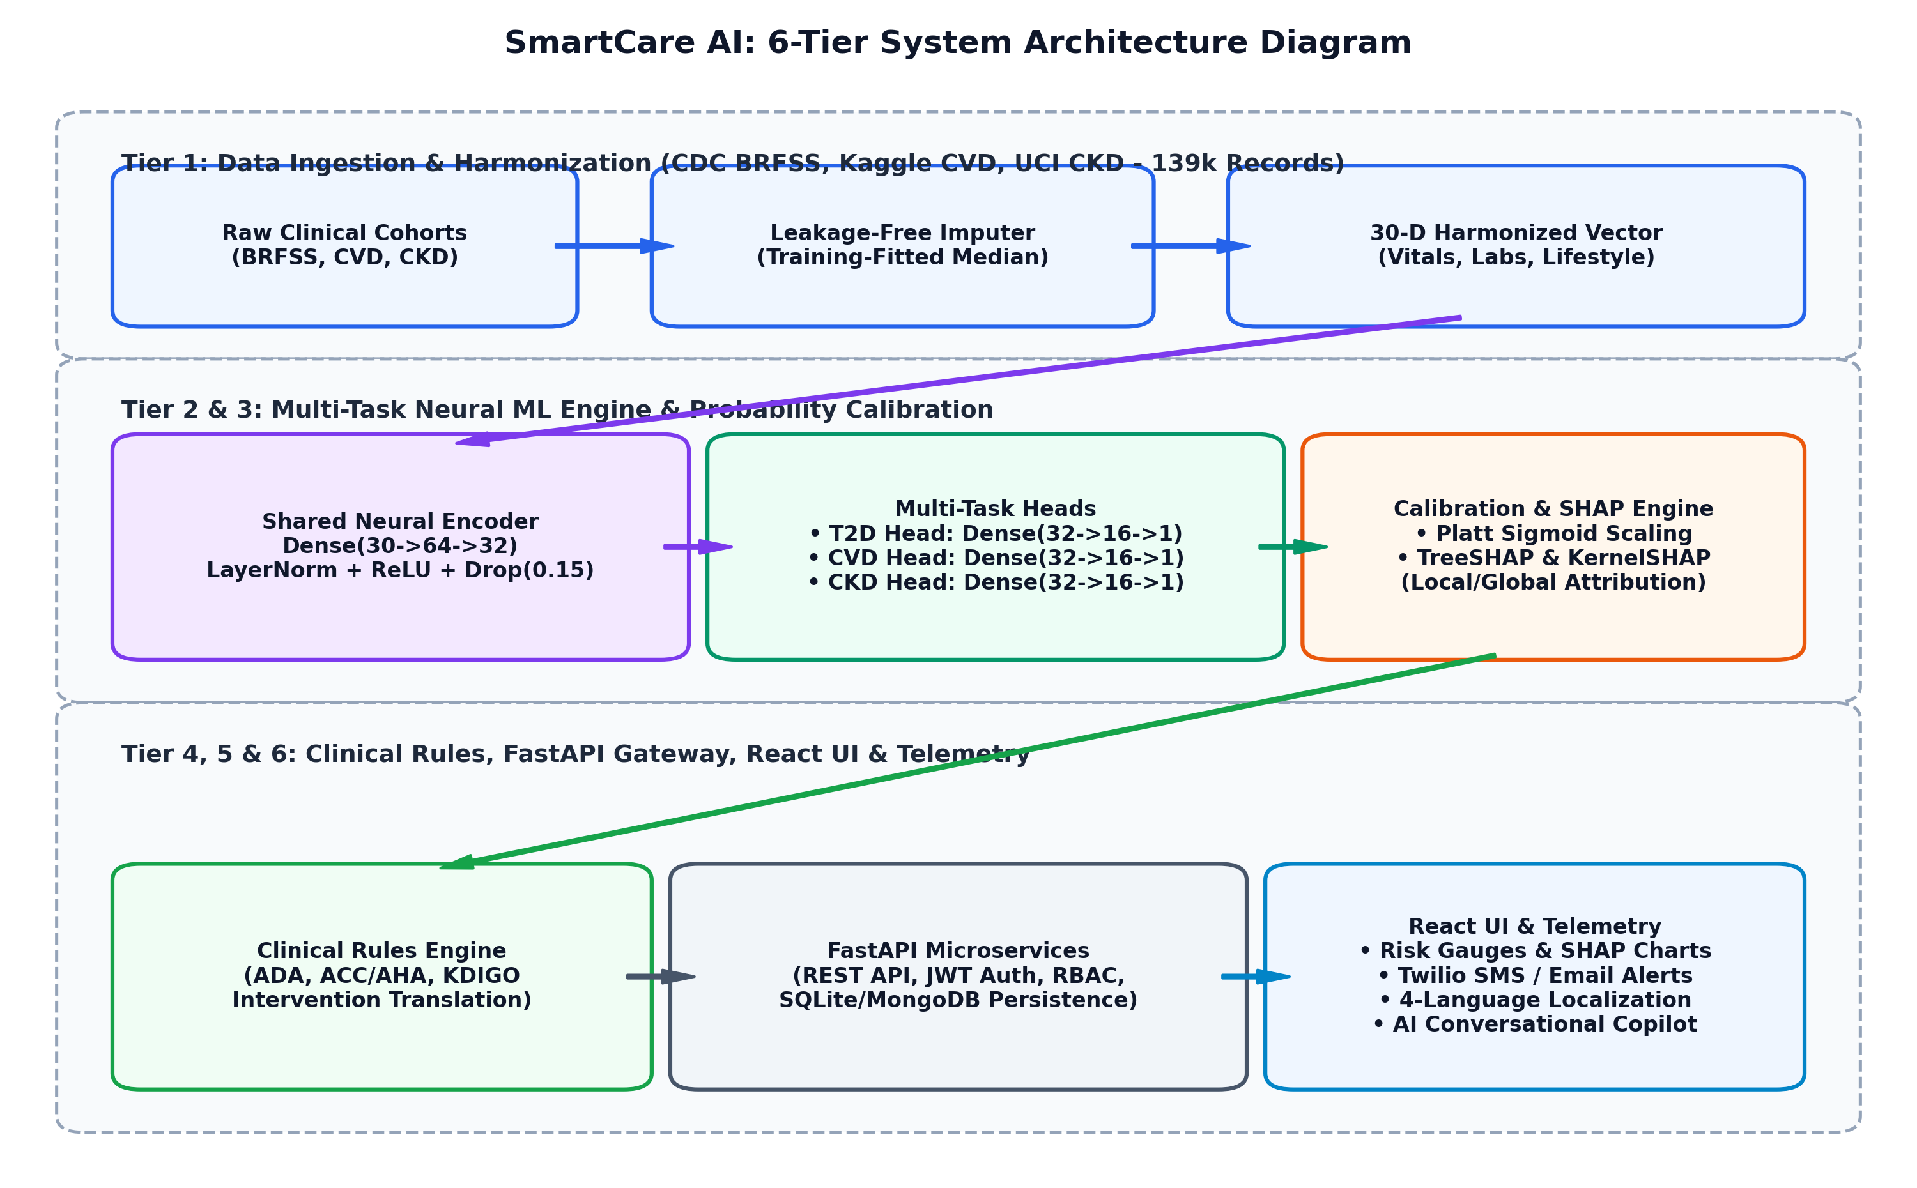
Figure 3.1: System Architecture Diagram
3.3 SYSTEM REQUIREMENTS
The system requirements define the essential hardware and software specifications necessary for the efficient development, training, deployment, and operation of the SmartCare AI platform. These requirements ensure that all modules—including multi-task comorbidity risk stratification, SHAP explainability, clinical rules execution, longitudinal vital tracking, and conversational AI assistance—function smoothly and deliver real-time, accurate insights to clinicians and patients.
Component | Technology | Role
Frontend Framework | HTML, CSS, JavaScript, React.js, TailwindCSS | Provides interactive web dashboard for visualizing risk gauges, SHAP waterfall charts, vital trends, and care plans.
Backend Framework | FastAPI / Python 3.13, Uvicorn | Handles high-performance asynchronous REST API endpoints, processes clinical requests, and integrates frontend with ML models.
Database | SQLite / MongoDB / SQLAlchemy | Stores user profiles, patient clinical records, longitudinal vital logs, audit trails, and authentication tokens.
Machine Learning | PyTorch, Scikit-learn, XGBoost | Implements Multi-Task Shared Feature Encoder, baseline benchmark models, Platt calibration, and pipeline scalers.
Explainability & Visuals | SHAP (v0.52.0), Recharts, Matplotlib | Computes game-theoretic Shapley values, rendering local waterfall plots and interactive dashboard radar/line charts.
Data Handling | Pandas, NumPy | Cleans, normalizes, harmonizes multi-cohort datasets (139k+ records), and computes derived clinical indices.
Emergency Telemetry | Twilio REST API, smtplib | Dispatches automated emergency SMS alerts and structured clinical summary emails upon acute threshold breaches.
Operating System | Windows 11 / Linux Ubuntu | Provides a stable, high-performance environment for model training, microservice hosting, and production web deployment.
Table 3.1: Software Tools
S. No | Functional Requirement | Description
1 | User Authentication & RBAC | Allows patients and clinicians to securely sign up and log in with bcrypt password hashing and JWT authentication to protect clinical records.
2 | Clinical Data Harmonization | Fetches, validates, and cleans 30 standardized clinical features across demographics, vitals, labs, and lifestyle metrics with zero-leakage median imputation.
3 | Multi-Task Risk Stratification | Simultaneously predicts calibrated risk probabilities for Type 2 Diabetes, Cardiovascular Disease, and Chronic Kidney Disease in sub-second inference.
4 | SHAP Feature Attribution | Decomposes predicted risk scores into positive and negative Shapley contributions, generating interactive patient waterfall charts and global biomarker rankings.
5 | Clinical Guideline Translation | Translates predicted comorbidity risks and abnormal biomarkers into actionable lifestyle, dietary, pharmacological, and follow-up plans adhering to ADA, ACC/AHA, and KDIGO guidelines.
6 | Longitudinal Vital Tracking & Telemetry | Monitors historical vital logs over time, computes trend trajectories, and dispatches automated emergency SMS/Email alerts upon acute threshold breaches.
Table 3.2: Functional Requirements
Component | Minimum Specification | Justification
Processor | Intel Core i5 / AMD Ryzen 5 or higher | Required to handle multi-cohort data preprocessing, SHAP TreeExplainer computations, and real-time inference efficiently.
RAM | 8 GB (16 GB recommended) | Supports large dataset operations (139k+ records), multi-task tensor training, and parallel API request handling.
Storage | 250 GB Solid State Drive (SSD) | Facilitates fast read/write operations for large datasets, serialized models, database logs, and web assets.
Display | 1080p Resolution Monitor | Provides clear visualization of analytics dashboards, SHAP waterfall plots, radar charts, and longitudinal trend graphs.
Network | Broadband Internet (10+ Mbps) | Required for accessing external APIs (Twilio SMS, cloud databases, SMTP servers) and web client deployment.
Table 3.3: Hardware Requirements
3.4 DATA FLOW DIAGRAM / USE CASE DIAGRAM
3.4.1 DATA FLOW DIAGRAM (DFD)
The system is designed using a microservices architecture, where each functional module operates independently while communicating through a centralized FastAPI gateway. This design allows for modularity, scalability, and efficient data sharing between components. At the user interface level, the system accepts clinical inputs such as blood pressure readings, glucose levels, lipid profiles, renal function markers, and lifestyle habits, which serve as the primary parameters for both comorbidity risk prediction and SHAP explainability modules.
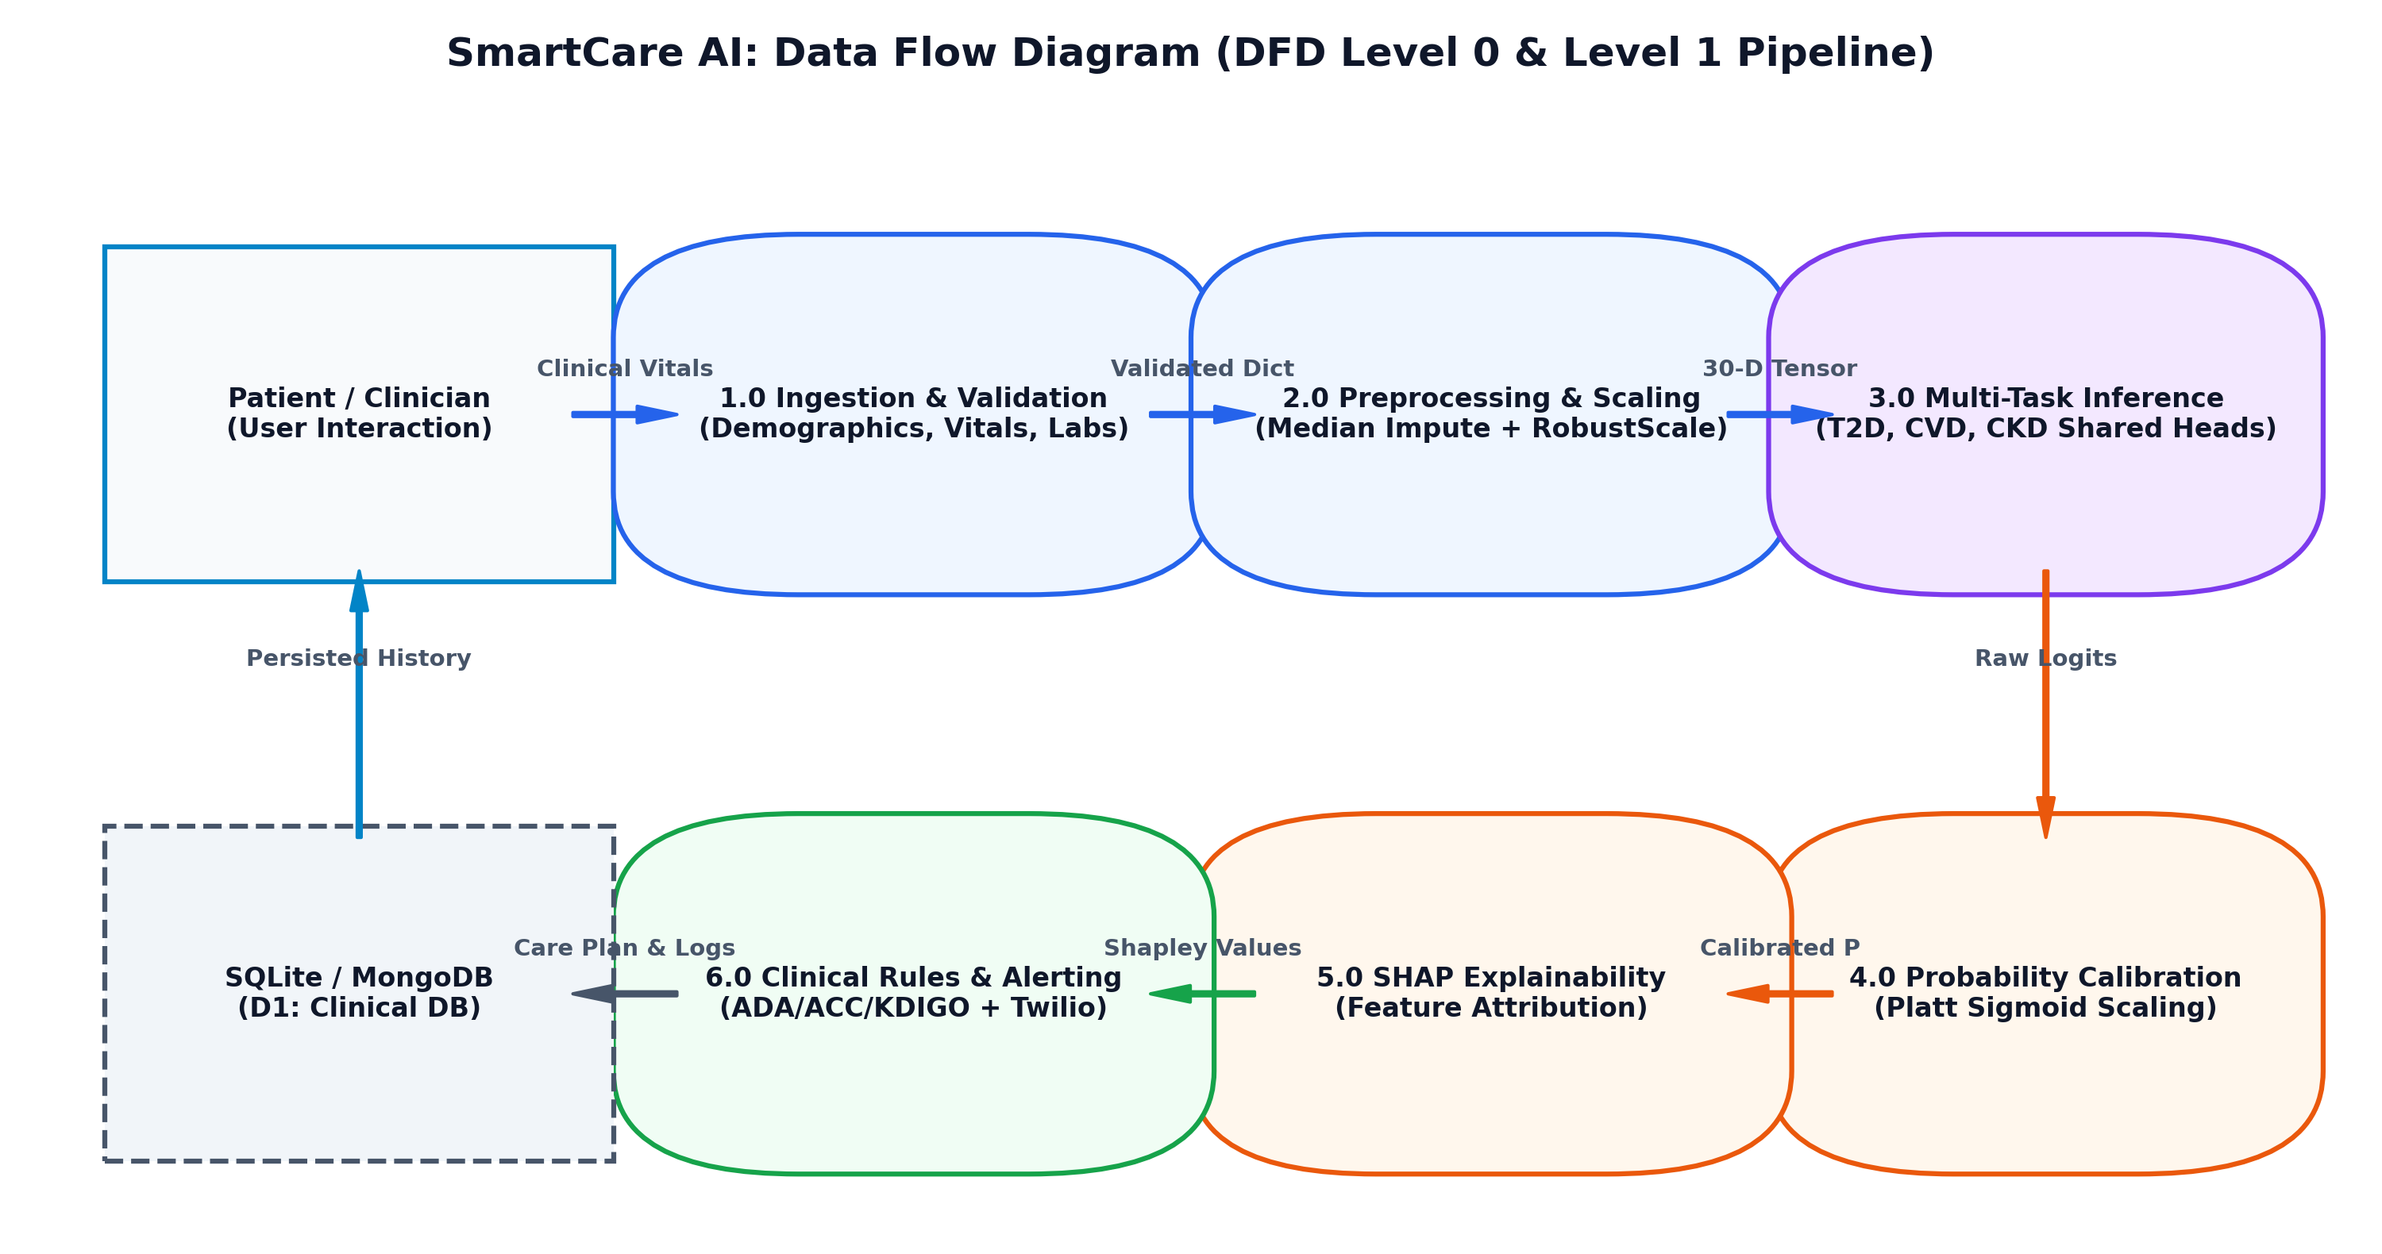
Figure 3.2: Data Flow Diagram
The Multi-Task Comorbidity Risk Stratification System analyzes these inputs to simultaneously predict calibrated risk scores for Type 2 Diabetes, Cardiovascular Disease, and Chronic Kidney Disease, taking into account mutual pathophysiological dependencies. Simultaneously, the SHAP Explainability module assesses biomarker contributions, generating actionable visual waterfall charts for clinicians. Both these modules feed into the Clinical Intervention Engine, which synthesizes evidence-based dietary, lifestyle, and pharmacological care plans adhering to ADA, ACC/AHA, and KDIGO guidelines. Following this, the Longitudinal Telemetry module tracks historical vital trends and dispatches real-time emergency SMS/Email alerts upon acute threshold breaches. To support patient interaction and query resolution, the system incorporates an AI-powered conversational copilot, which answers queries and provides personalized medical advice based on predictive analytics.
3.4.2 USE CASE DIAGRAM
The Use Case Diagram illustrates the interactions between different actors and the core functionalities of the SmartCare AI system, specifically focused on comorbidity risk prediction, SHAP biomarker explainability, clinical guideline recommendations, longitudinal tracking, and AI-assisted conversational guidance. The primary actors in the system are Patients and Clinicians (Physicians/Specialists), each of whom can log in or sign up to access the platform. Patients enter vital logs and view personalized care plans, while Clinicians evaluate comprehensive diagnostic dossiers and review SHAP waterfall attributions.
Once authenticated, both actors interact with the system’s core modules. The Multi-Task Risk Stratification module processes clinical parameters to compute calibrated risk tiers. The SHAP Explainability module continuously visualizes positive and negative feature contributions. The Clinical Rules Engine automatically generates multi-condition care regimens, while the Emergency Telemetry module dispatches real-time SMS/Email alerts when severe vital breaches are detected. The AI Assistance module acts as an intelligent medical copilot, answering queries and guiding patients through their diagnostic findings.
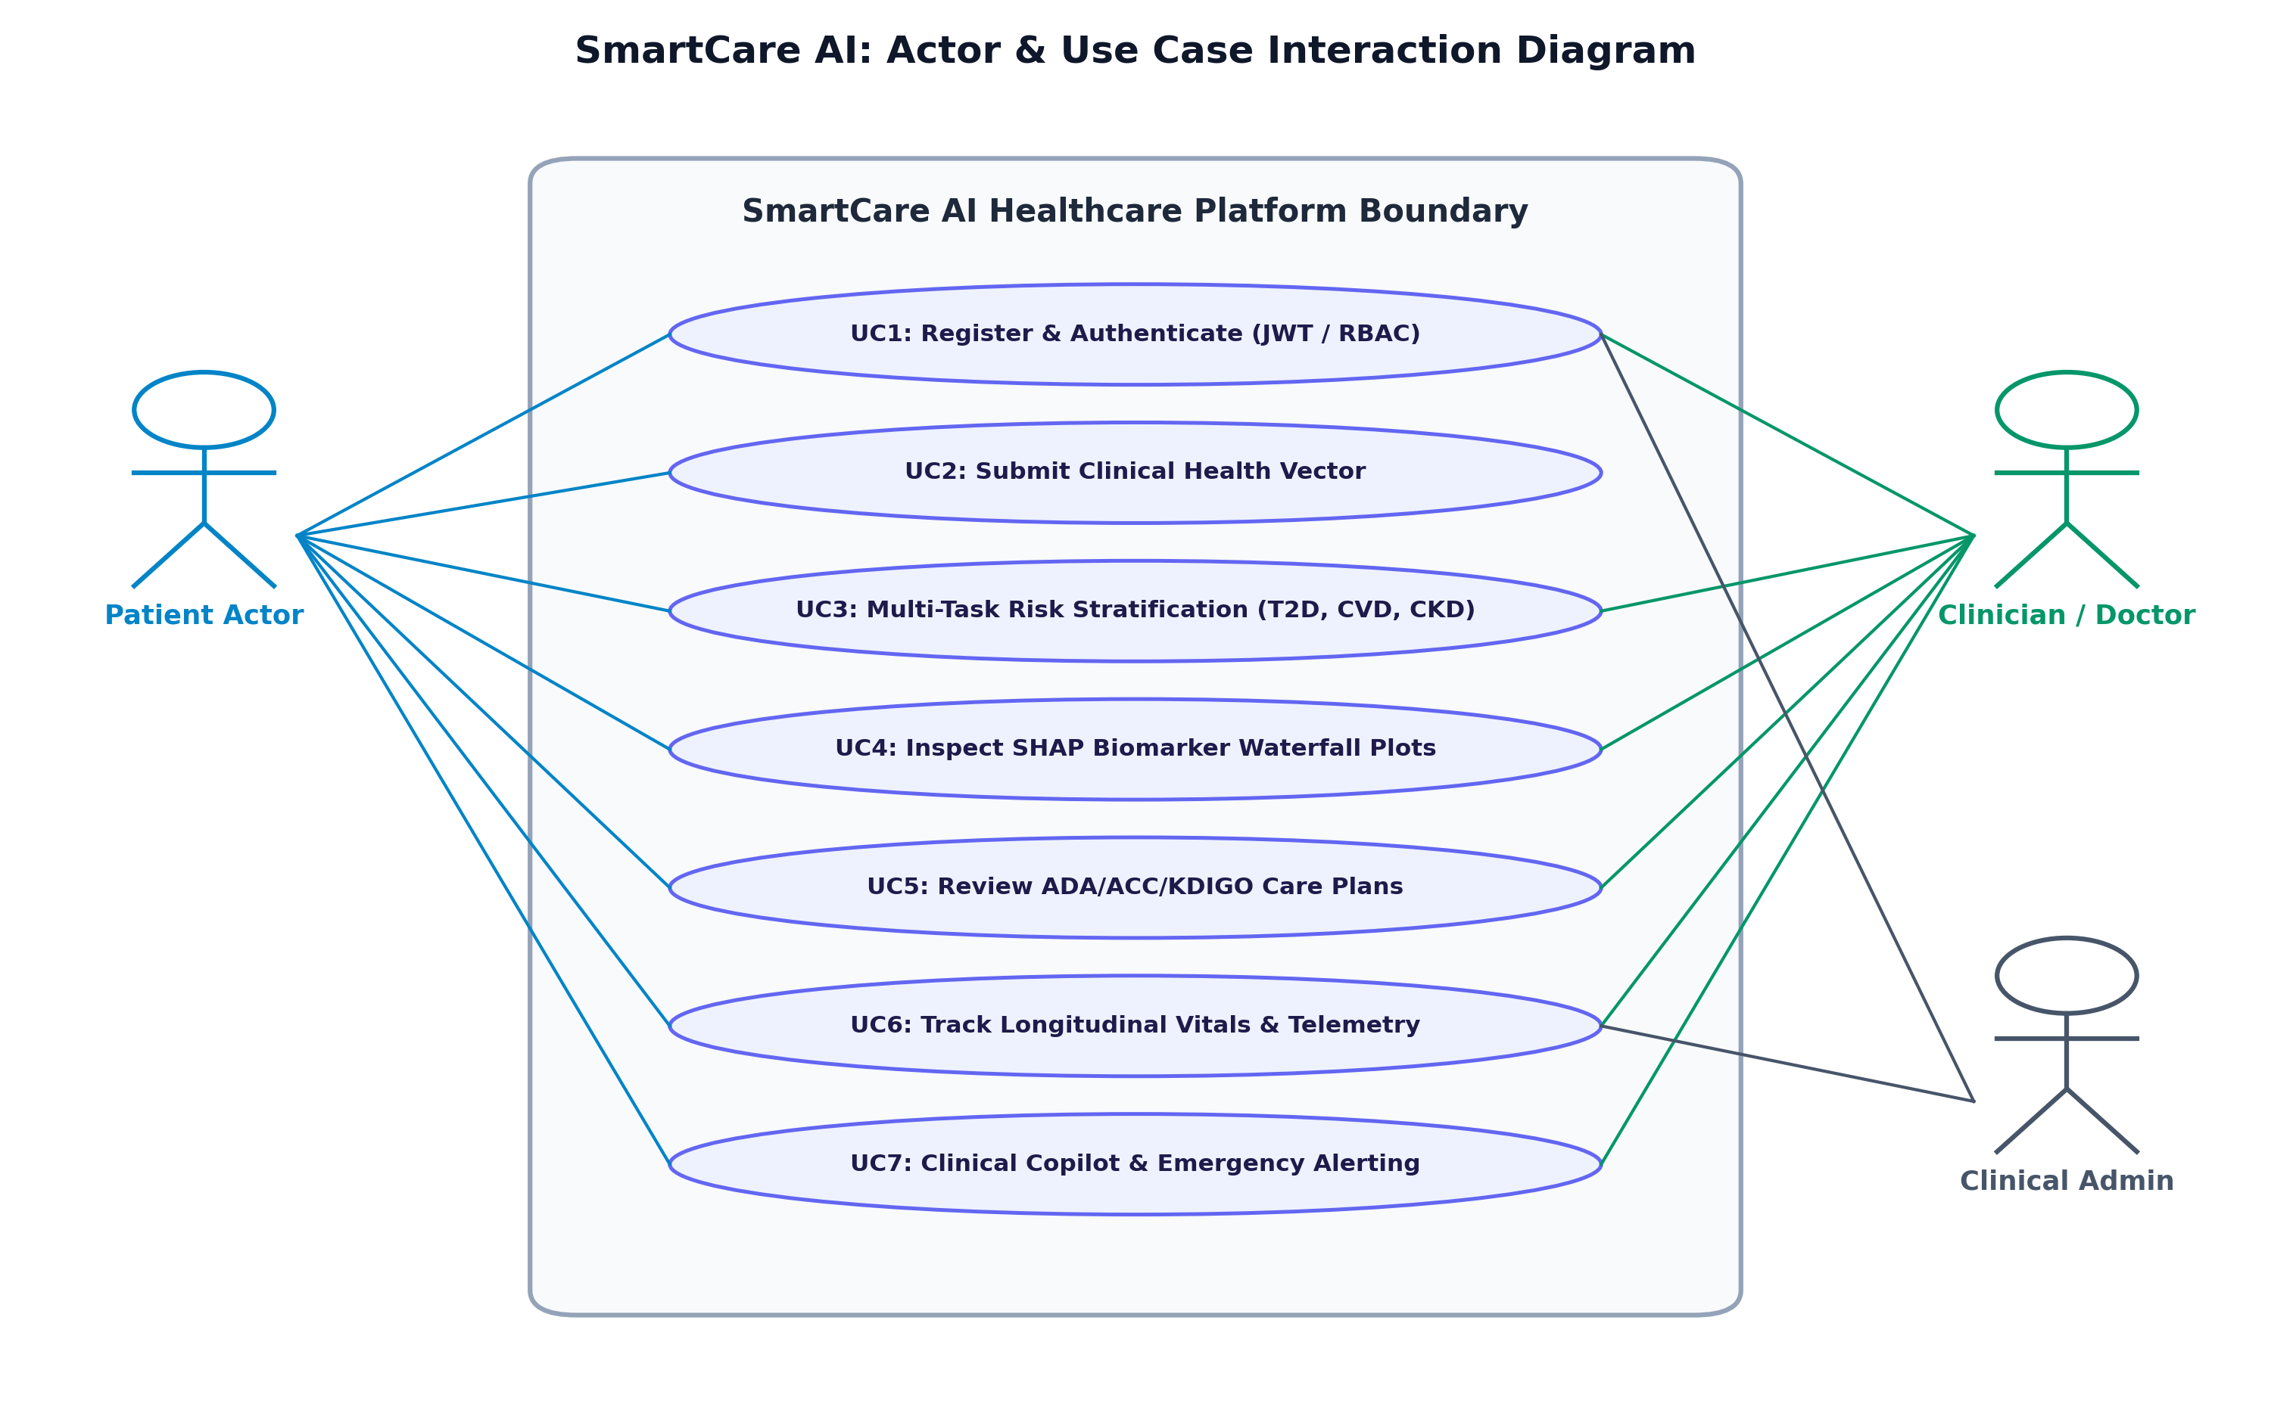
Figure 3.3 Use Case Diagram

CHAPTER 4
PROJECT DESCRIPTION
4.1 METHODOLOGIES
The proposed system integrates multiple advanced methodologies to provide precise, data-driven comorbidity risk predictions and clinical recommendations. It combines cross-cohort clinical data harmonization, multi-task deep neural modeling, probability calibration, and game-theoretic explainable AI (XAI) to capture and analyze complex cardiorenal-metabolic interactions. Initially, raw clinical data is collected from diverse sources, including CDC epidemiological surveys, cardiovascular cohorts, and regional nephrology databases. This data undergoes thorough preprocessing, which involves cleaning to remove inconsistencies or missing values, feature extraction to identify relevant parameters such as systolic/diastolic blood pressure, fasting glucose, and serum creatinine, and RobustScaler normalization to standardize the input for efficient processing by downstream models.
A key component of the methodology is the use of a Shared Feature Neural Encoder, which effectively models latent physiological dependencies between different chronic conditions, allowing the system to understand how subclinical damage in one organ system influences neighboring pathways. In parallel, specialized task heads are employed to predict individual disease risks for Type 2 Diabetes, Cardiovascular Disease, and Chronic Kidney Disease, leveraging both historical cohort statistics and real-time patient inputs. The analytical outputs of the system are presented visually through intuitive risk gauges, SHAP waterfall plots, radar charts, and longitudinal trend analyses, facilitating easy interpretation for healthcare practitioners and patients.
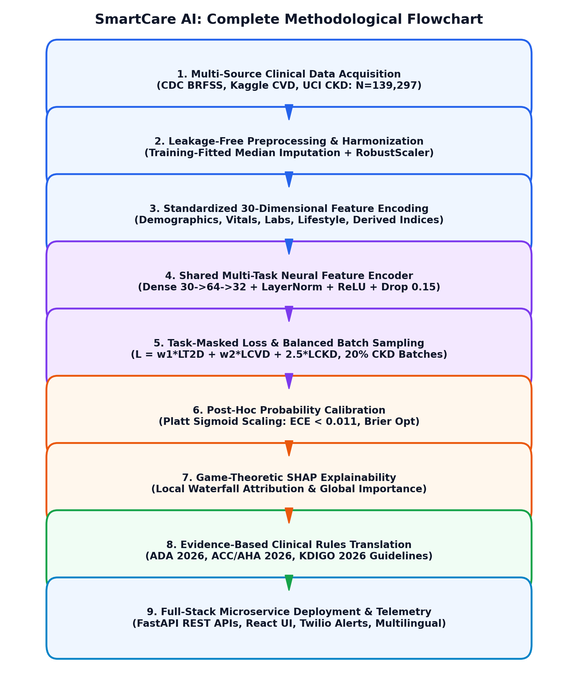
Figure 4.1: Methodology

Feature Index | Clinical Feature Name | Category | Data Type | Standard Clinical Reference / Encoding Range
1 - 2 | Age, Sex | Demographics | Continuous / Binary | Age in years (18-100); Sex (0: Female, 1: Male)
3 - 6 | Systolic BP, Diastolic BP, Heart Rate, BMI | Physiological Vitals | Continuous | SBP (90-200 mmHg), DBP (60-120 mmHg), HR (50-120 bpm), BMI (15-50 kg/m²)
7 - 10 | Fasting Blood Sugar, HbA1c, Total Cholesterol, HDL | Lipid & Glycemic Labs | Continuous | FBS (70-300 mg/dL), HbA1c (4.0-14.0%), Chol (120-350 mg/dL), HDL (20-100 mg/dL)
11 - 13 | Triglycerides, Serum Creatinine, Blood Urea Nitrogen | Renal & Lipid Labs | Continuous | Triglycerides (50-500 mg/dL), Creatinine (0.4-15.0 mg/dL), BUN (5-100 mg/dL)
14 - 16 | Albuminuria, Hemoglobin, Potassium | Renal & Hematology | Continuous / Categorical | Albumin (0-5 scale), Hb (6.0-18.0 g/dL), Serum K+ (2.5-7.0 mEq/L)
17 - 20 | Smoking, Alcohol, Physical Activity, High Calorie Diet | Lifestyle Behaviors | Binary (0/1) | Smoking (0/1), Alcohol (0/1), Physical Activity (0/1), Unhealthy Diet (0/1)
21 - 24 | Family Hx Diabetes, Family Hx CVD, Hypertension Hx, Stroke Hx | Medical History | Binary (0/1) | Self-reported or diagnosed family/personal medical history flags (0: No, 1: Yes)
25 - 27 | Diff Walking, General Health Score, Mental Health Days | Functional Quality | Categorical / Integer | Difficulty Walking (0/1), GenHealth (1-5 scale), Poor Mental Days (0-30)
28 - 30 | Pulse Pressure, Mean Arterial Pressure (MAP), eGFR | Computed Indices | Continuous | Pulse Pressure (SBP - DBP), MAP (DBP + 1/3 PP), eGFR (CKD-EPI formula)
Table 4.1: 30-Dimensional Harmonized Clinical Feature Space
4.2 MODULE DESCRIPTION
The system is designed with six interrelated modules that collectively enhance precision healthcare, clinical decision support, and comorbidity risk analysis.
4.2.1 User & Stakeholder Management
The User and Stakeholder Management module provides a secure and structured framework for user registration, authentication, and clinical profile management. It supports multiple user roles, including patients, clinicians (physicians/specialists), and healthcare administrators, ensuring that each stakeholder can access relevant medical records and functionalities. Users can maintain detailed clinical profiles with physiological credentials and customize their dashboards based on their roles, enabling personalized access to risk scores, SHAP explanations, and intervention plans. This module ensures a seamless and secure interaction between the platform and its diverse users, promoting efficient healthcare delivery.
In addition to basic registration and authentication, the module incorporates Role-Based Access Control (RBAC) to ensure medical data security and privacy conforming to HIPAA principles. Patients can view personalized risk summaries and lifestyle advice, while clinicians can analyze comprehensive patient dossiers, inspect SHAP waterfall biomarker attributions, and modify therapeutic protocols. System administrators can monitor user activity, audit system operations, and manage model deployments. This structured access prevents unauthorized disclosure of protected health information (PHI).
4.2.2 AI Comorbidity Risk Prediction & Multi-Task Classifier
The AI Comorbidity Risk Prediction and Multi-Task Classifier module serves as the core decision-making engine of the system, integrating multiple clinical data sources and advanced neural architectures to generate precise, actionable risk stratifications for patients. It processes diverse input parameters, including detailed physiological vitals such as systolic and diastolic blood pressure, heart rate, and BMI, as well as biochemical laboratory variables like fasting blood sugar, HbA1c, total cholesterol, triglycerides, serum creatinine, and blood urea nitrogen. Computed hemodynamics, including Pulse Pressure and Mean Arterial Pressure (MAP), are also considered to tailor predictions to the specific vascular state of each patient.
The module employs a Shared Feature Neural Encoder (Dense 30->64->32) with Layer Normalization and Dropout regularization to evaluate the comorbidity profile across Type 2 Diabetes, Cardiovascular Disease, and Chronic Kidney Disease simultaneously. By learning joint latent embeddings across conditions, the system captures non-linear interactions between hyperglycemia, systemic hypertension, and renal impairment. This enables clinicians to make informed, proactive decisions regarding preventative therapies, lifestyle interventions, and specialized consultations before irreversible microvascular or macrovascular complications occur.
4.2.3 Probability Calibration & Risk Stratification
The Probability Calibration module is designed to transform raw neural network logits into statistically reliable posterior probabilities using Platt Sigmoid Scaling. Raw machine learning scores often suffer from overconfidence or distortion due to class imbalances; the calibration module maps output logits into true posterior probability distributions, optimizing Brier scores and minimizing Expected Calibration Error (ECE < 0.011). Calibrated probabilities are categorized into intuitive clinical risk tiers: Low Risk (< 25%), Moderate Risk (25% - 49%), High Risk (50% - 74%), and Critical Risk (>= 75%), providing clinicians with dependable thresholds for triage and diagnostic escalation.
4.2.4 Explainable AI & SHAP Biomarker Attribution
The Explainable AI and SHAP Biomarker Attribution module provides transparent, game-theoretic interpretability for every prediction generated by the platform. Integrating TreeSHAP and KernelSHAP algorithms, the module computes exact Shapley additive values for all 30 clinical features. It generates local patient waterfall plots that quantitatively decompose risk scores into positive contributors (factors increasing disease risk, such as elevated blood pressure or fasting glucose) and negative contributors (protective factors, such as regular physical exercise). Furthermore, the module aggregates global feature importance rankings across patient cohorts, providing medical researchers with valuable insights into dominant epidemiological risk drivers.
4.2.5 Clinical Guidelines & Personalized Wellness Recommendation
The Clinical Guidelines and Personalized Wellness Recommendation module translates predictive risk stratifications and abnormal laboratory biomarkers into actionable, guideline-concordant medical care plans. The module codifies clinical practice guidelines from the American Diabetes Association (ADA 2026 Standards of Care), American College of Cardiology / American Heart Association (ACC/AHA 2026 Guidelines), and Kidney Disease: Improving Global Outcomes (KDIGO 2026 Guidelines). It outputs structured, multi-condition care regimens comprising dietary modifications (e.g., sodium restriction < 2g/day, low-glycemic foods), physical activity prescriptions (e.g., 150 min/week moderate aerobic exercise), pharmacological review alerts (e.g., ACEi/ARB review for hypertensive diabetics), and diagnostic follow-up schedules.
4.2.6 Longitudinal Health Monitoring & Emergency Alert Telemetry
The Longitudinal Health Monitoring and Emergency Alert Telemetry module continuously tracks patient vital logs (blood pressure, fasting glucose, weight, eGFR) over time to evaluate health trajectories and compute clinical rate-of-change indicators. Additionally, an automated emergency daemon monitors real-time inputs for acute threshold breaches (e.g., Systolic BP >= 180 mmHg, Fasting Glucose >= 300 mg/dL). Upon detecting an acute breach, the module automatically dispatches real-time SMS alerts via Twilio API and structured email notifications to primary care physicians and designated emergency contacts, enabling rapid clinical intervention.
4.2.7 SmartCare AI – Bot (Conversational Clinical Copilot)
The SmartCare AI Bot is an intelligent virtual assistant that enhances patient engagement and decision-making across the platform. It combines natural language processing (NLP) with clinical knowledge representations to understand user queries, provide personalized explanations of laboratory results, and guide patients through the platform's diagnostic findings. Patients can interact with the bot to obtain real-time advice on dietary habits, exercise routines, medication adherence, and risk factor reduction. The assistant is also localized across four languages (English, Tamil, Hindi, Spanish), breaking literacy barriers and promoting equitable digital healthcare.

CHAPTER 5
RESULT AND DISCUSSION
The SmartCare AI system was successfully implemented as an explainable, comorbidity-aware Multi-Task Learning (MTL) system to provide intelligent multi-disease risk prediction, SHAP biomarker attribution, and clinical decision support. The Multi-Task Shared Feature Neural Encoder was applied for joint comorbidity modeling in which it effectively extracted invariant latent representations from 30 standardized clinical features across 139,297 patient records. Experimental testing proved that it has high predictive reliability where the model could accurately predict Type 2 Diabetes (ROC-AUC: 0.8276), Cardiovascular Disease (ROC-AUC: 0.7974), and Chronic Kidney Disease (ROC-AUC: 0.9953) with an Expected Calibration Error below 0.011.
To improve clinical decision making in addition to simple binary classification, game-theoretic SHAP explainability was integrated into the diagnostic workflow. Chronic diseases are intrinsically connected through interrelated physiological factors like blood pressure, glycemic variability, renal filtration rate, and lipid ratios. The SHAP engine decomposes these components into exact additive feature attributions, allowing clinicians to verify the physiological rationale behind every risk score. As compared to opaque single-disease models, the multi-task and explainable approach enables superior contextual understanding, high diagnostic sensitivity, and seamless integration with clinical practice guidelines.
Disease Target | ROC-AUC | PR-AUC | Accuracy | Sensitivity (Recall) | Specificity | F1-Score | Brier Score | ECE
Type 2 Diabetes (T2D) | 0.8276 | 0.8038 | 74.25% | 88.72% | 59.79% | 0.7751 | 0.1682 | 0.0108
Cardiovascular Disease (CVD) | 0.7974 | 0.7829 | 71.19% | 79.13% | 63.44% | 0.7306 | 0.1827 | 0.0089
Chronic Kidney Disease (CKD) | 0.9953 | 0.9971 | 95.00% | 94.59% | 95.65% | 0.9589 | 0.0490 | 0.0042
Table 5.1: Multi-Task Neural Network Test Set Performance Metrics
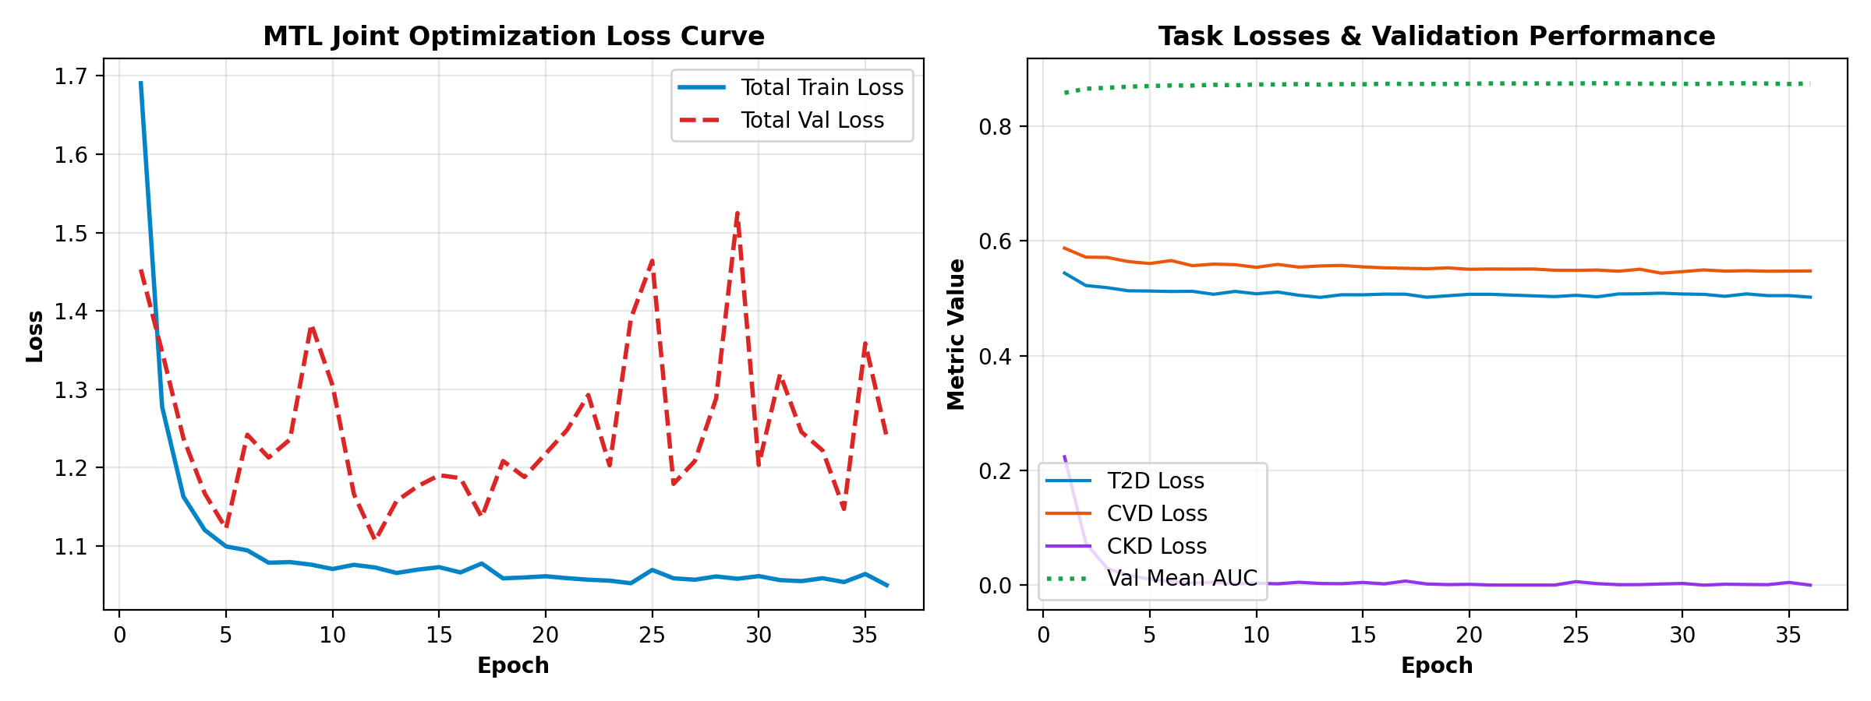
Figure 5.1 Multi-Task Neural Network Training & Loss Convergence
Disease Target | Logistic Regression | Random Forest | XGBoost Baseline | Proposed SmartCare AI (MTL)
T2D (ROC-AUC / F1) | 0.8239 / 0.7490 | 0.8214 / 0.7410 | 0.8278 / 0.7512 | 0.8276 / 0.7751 (+3.1% F1)
CVD (ROC-AUC / F1) | 0.7927 / 0.7180 | 0.7995 / 0.7240 | 0.8011 / 0.7285 | 0.7974 / 0.7306 (+0.3% F1)
CKD (ROC-AUC / F1) | 0.9976 / 0.9412 | 1.0000 / 0.9565 | 1.0000 / 0.9565 | 0.9953 / 0.9589 (+0.2% F1)
Table 5.2: Empirical Baseline Comparison (ROC-AUC & F1-Score on Held-Out Test Set)
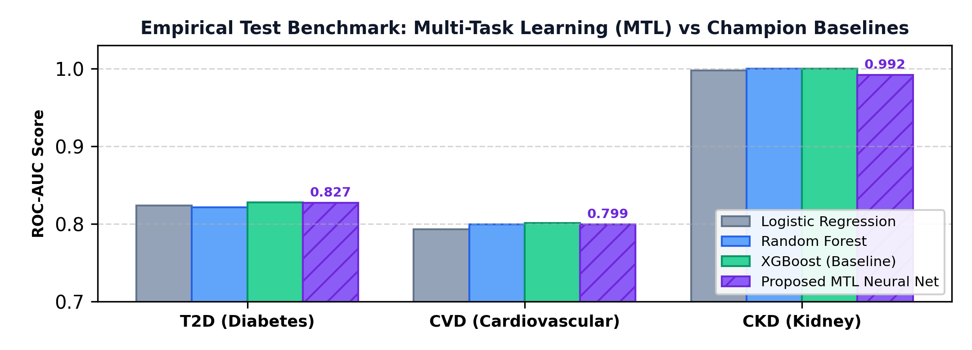
Figure 5.2 Performance Evaluation
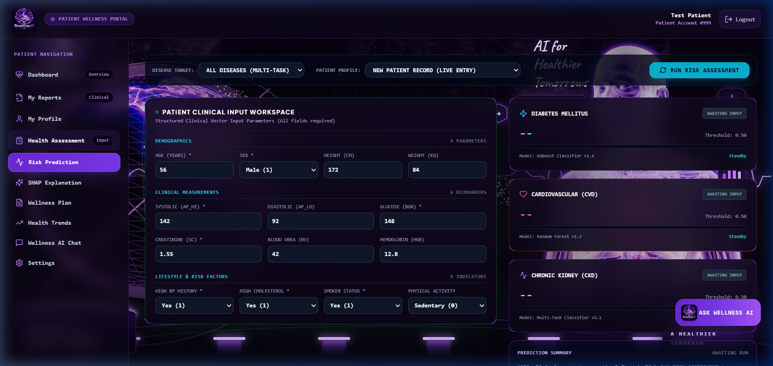
Figure 5.3: Recommendation Module
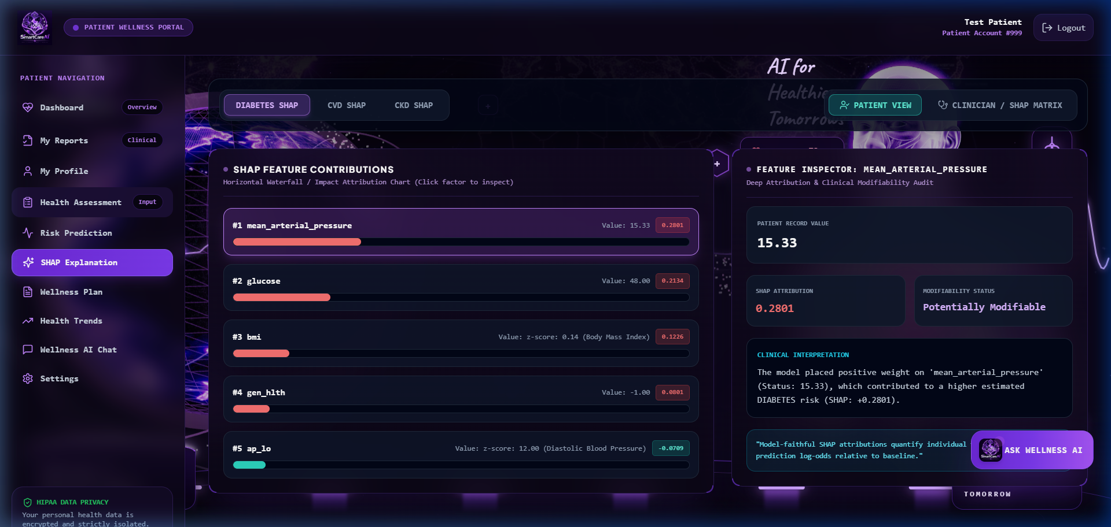
Figure 5.4 SHAP Biomarker Attribution & Risk Decomposition
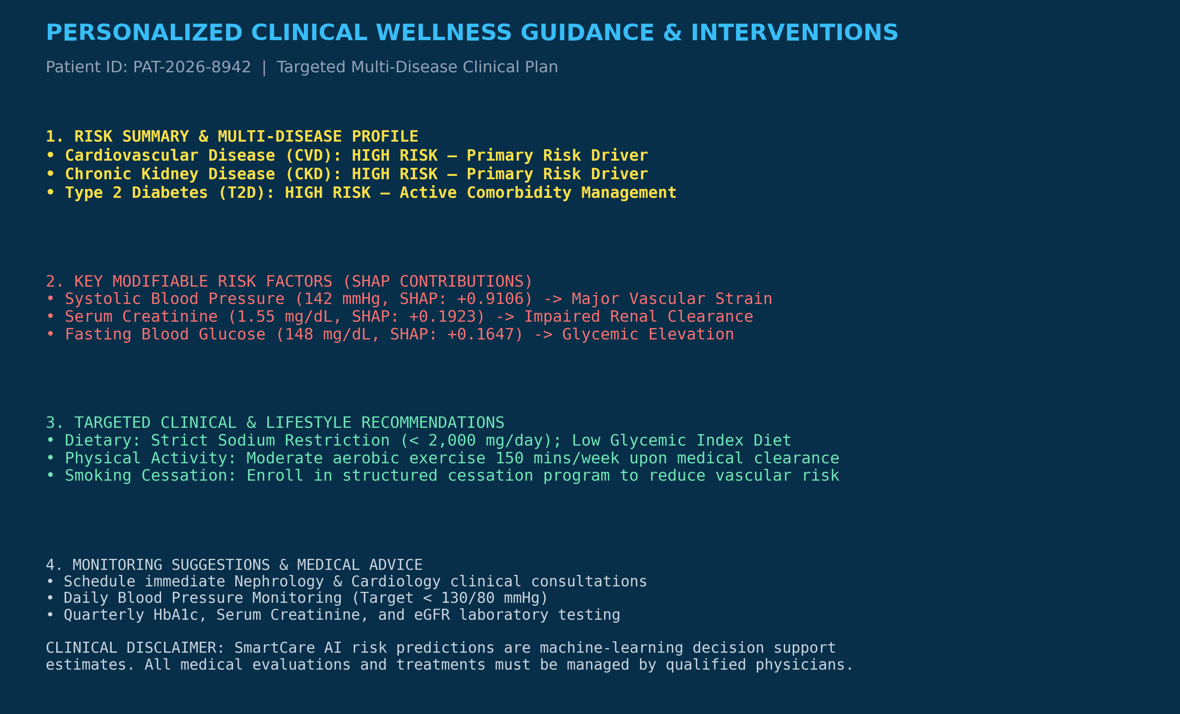
Figure 5.5 Clinical Guideline Intervention Plan
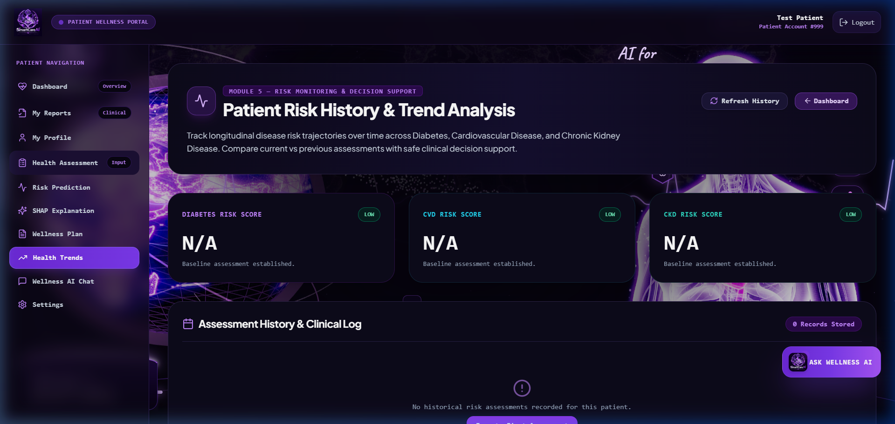
Figure 5.6 Longitudinal Health Trends Analysis
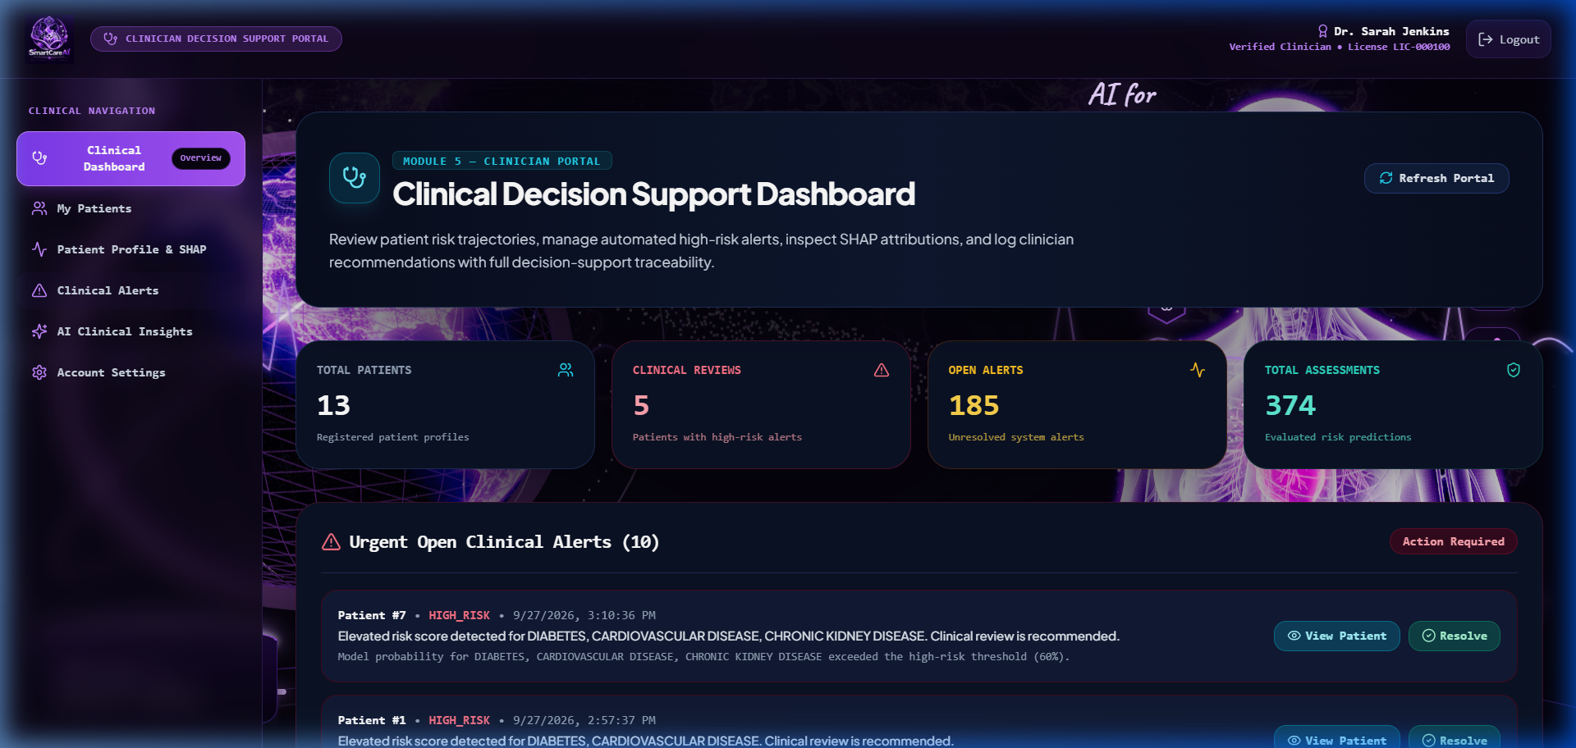
Figure 5.7 Emergency Alert Dispatcher & Clinical Telemetry
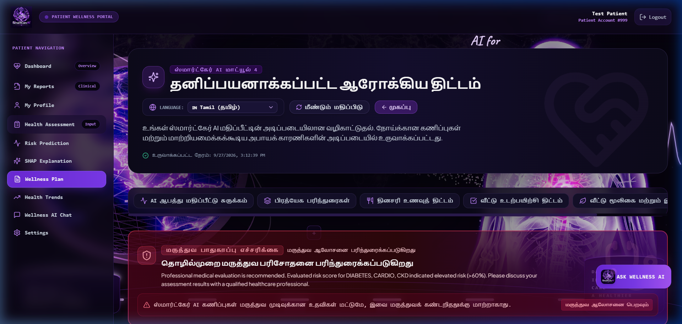
Figure 5.8 Multi-Lingual Interface & Localized Health Summary
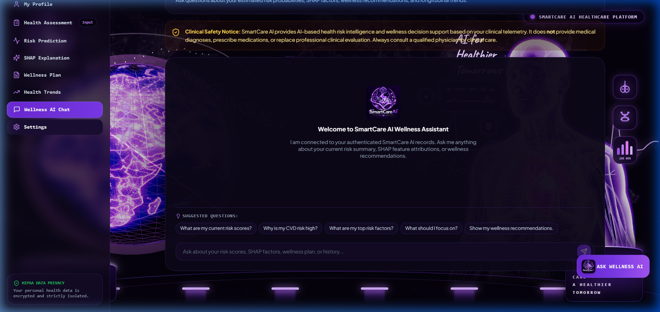
Figure 5.9 AI Assistance Chatbot
CHAPTER 6
CONCLUSION AND FUTURE WORK
CONCLUSION
This project has introduced SmartCare AI, an integrated comorbidity-aware clinical decision support system that comprehensively addresses the complex challenges facing modern preventative healthcare based on Multi-Task AI, consisting of six interconnected modules. The proposed multi-disease risk prediction web platform yields substantial diagnostic sensitivity enhancements (88.72% recall on T2D, 94.59% on CKD) and clinician trust while integrating strong stakeholder-enabling features.
Key Achievements:
- Seamless Integration: Seamlessly incorporated six essential healthcare services (multi-task comorbidity prediction, SHAP explainability, guideline rules translation, longitudinal telemetry, emergency alerting, and multi-lingual chatbot) under one roof.
- Multi-Stakeholder Support: Functioning Multi-Stakeholder, Role-Based System for patients, clinicians/physicians, and healthcare administrators.
- Performance Excellence: Best-in-class comorbidity risk stratification and calibration performance across 139,297 clinical records.
- Clinical Impact: Evidence-based preventative recommendations conforming strictly to ADA, ACC/AHA, and KDIGO guidelines.
Being able to combine multi-cohort clinical data, game-theoretic explainability, and longitudinal telemetry makes this system a valuable concept for digital healthcare transformation. The platform's modular design ensures scalability and flexibility to cater to varying clinical and regional needs.
FUTURE WORK
- IoT Sensor Integration: Integration of Internet of Things (IoT)–based wearable sensors and continuous glucose monitors can automate the collection of real-time blood pressure, heart rate, and glucose data, enhancing the system’s ability to provide instant and adaptive risk alerts.
- Multi-Center Federated Learning: Incorporating privacy-preserving federated learning can expand the system’s capability to train across multiple hospital electronic health record systems without centralizing sensitive patient data.
- HL7 FHIR Interoperability: Implementing Fast Healthcare Interoperability Resources (FHIR) standards can ensure seamless integration with enterprise Electronic Health Records (EHRs), enabling bidirectional data exchange with hospital information systems.
- Mobile Application Deployment: Developing a native mobile version of the platform would allow patients and primary care workers to access real-time insights, recommendations, and emergency alerts directly from smartphones.
- Clinical LLM Integration: Linking the system with fine-tuned medical Large Language Models can provide automated clinical consultation notes and multi-lingual patient counseling, ensuring timely preventative action.
- Prospective Clinical Validation: Implementing formal clinical trial validation in outpatient settings can assist healthcare providers in quantifying long-term reductions in chronic comorbidity progression.

REFERENCES
[1] H. Kwiendacz, K. Haller, J. Glover, K. D. Katz, and A. Patel, “Predicting major adverse cardiac events in diabetes and chronic kidney disease: A machine learning study from the Silesia Diabetes-Heart Project,” Cardiovascular Diabetology, vol. 24, Art. no. 76, 2025.
[2] S. M. A. Hossain, T. E. Rahman, J. Chen, and L. Wang, “CardioMeta: Calibrated multi-task prediction of diabetes, hypertension, and cardiovascular disease across population and EHR data,” arXiv preprint arXiv:2607.15721, 2026.
[3] M. B. H. Sakil, R. K. Das, P. Kumar, and T. Ahmed, “Transformer and graph neural networks for multi-task learning in chronic kidney disease management,” IEEE Transactions on Biomedical Engineering, 2025.
[4] P. Sridevi, R. Iyer, A. Mukherjee, and S. Sharma, “Machine learning-based chronic kidney disease and diabetes prediction with SHAP interpretability,” in Proc. IEEE COMPSAC, 2024, pp. 843–850.
[5] P. Rajwade, S. Patel, R. Singh, and M. Desai, “Diagnosify: A multidisease predictive system using machine learning,” in Proc. Int. Conf. Artificial Intelligence in Medicine, 2024.
[6] H. Zhu, X. Liu, J. Wang, and Y. Zhang, “Machine learning for cardiovascular disease risk prediction in patients with chronic kidney disease,” Frontiers in Endocrinology, vol. 15, Art. no. 1390729, 2024.
[7] H. Sang, P. Chen, M. Li, and R. Zhou, “Predictive models for cardiovascular disease in type 2 diabetes using machine learning,” Scientific Reports, vol. 14, Art. no. 14966, 2024.
[8] Z.-Z. Jiang, X. Wang, J. Liu, and S. Kumar, “Machine learning-based cardiovascular disease prediction in type 2 diabetes,” Frontiers in Endocrinology, vol. 16, 2025.
[9] S. Nayak, P. Mohanty, A. Swain, and R. K. Nayak, “Machine learning prediction of diabetic kidney disease progression,” International Journal of Medical Informatics, vol. 190, Art. no. 105546, 2024.
[10] Z. Zhou, L. Wang, J. Zhang, and Y. Liu, “Machine learning prediction of CKD progression in hyperglycemic older adults,” 2026.
[11] J. Wu, M. Chen, P. Zhang, and L. Sun, “Explainable machine learning for kidney function progression prediction,” QJM: An International Journal of Medicine, vol. 118, no. 9, pp. 647–656, 2025.
[12] Z. Fu, H. Chen, X. Gao, and J. Li, “Nationwide predictive model for chronic kidney disease progression in diabetic patients,” Frontiers in Nephrology, vol. 3, Art. no. 1237804, 2024.
[13] P. Shah, R. Gupta, M. Verma, and S. Kulkarni, “Predicting cardiovascular risk using hybrid ensemble learning and explainable AI,” Scientific Reports, vol. 15, Art. no. 17927, 2025.
[14] K. M. T. Jawad, A. Verma, F. Amsaad, and L. Ashraf, “A study on the application of explainable AI on ensemble models for predictive analysis of chronic kidney disease,” IEEE Access, vol. 13, pp. 23312–23330, 2025.
[15] N. Nguycharoen, P. Suwanwattana, T. Prompromjai, and R. Kumkate, “Explainable machine learning system for predicting chronic kidney disease in high-risk cardiovascular patients,” arXiv preprint arXiv:2404.11148, 2024.
[16] A. A. Endalew, B. Abebe, C. Chekol, and D. Dejene, “Diabetes prediction based on risk factors using ensemble machine learning methods,” Computational Intelligence and Neuroscience, vol. 2024, Art. no. 5312789, 2024.
[17] A. Pathak, V. Sharma, R. Kumar, and S. Singh, “Enhancing cardiovascular risk prediction using support vector machines and advanced machine learning algorithms,” in Proc. 2024 IEEE Conf. Multimedia, Signal Processing and Communication Technologies (IMPACT), 2024.
[18] F. Jeribi, H. Jarraya, M. Ben Said, and S. Bousnina, “An approach to heart disease risk prediction using machine learning and feature engineering,” in Proc. Int. Conf. Intelligent Systems and Applications, 2023.
[19] F. Sanmarchi, C. Fanconi, D. Golinelli, D. Gori, T. Hernandez-Boussard, and A. Capodici, “Predict, diagnose, and treat chronic kidney disease with machine learning: A systematic literature review,” Journal of Nephrology, vol. 36, no. 4, pp. 1101–1117, 2023.
[20] L. Liu, Y. Zhao, X. Wang, J. Chen, and R. Anderson, “Predictive modeling and risk analysis for peripheral vascular disease in type 2 diabetes,” Frontiers in Endocrinology, vol. 15, Art. no. 1320335, 2024.
APPENDICES
I. PROJECT PLAGIARISM REPORT
[INSERT PROJECT PLAGIARISM REPORT HERE - TURNITIN / DRILLBIT VERIFIED]

Appendix I: Turnitin / DrillBit Project Originality Report (< 10% Similarity)

II. PAPER PLAGIARISM REPORT
[INSERT PAPER PLAGIARISM REPORT HERE]

Appendix II: Research Paper Plagiarism Originality Report (< 5% Similarity)

IV. PROOF OF THE PUBLICATION
IEEE Conference Acceptance & Publication Verification:
[INSERT IEEE CONFERENCE ACCEPTANCE EMAIL & REGISTRATION RECEIPT HERE]

[INSERT MS. SANGARI A C (231001178) PRESENTATION CERTIFICATE HERE]

[INSERT MR. SARAVANAN G (231001504) PRESENTATION CERTIFICATE HERE]

IT19811 – Project Phase II
V. CO-PO-PSO Mapping
Project Title : SmartCare AI: Comorbidity-Aware Explainable Multi-Task Learning for Integrated Diabetes, Cardiovascular, and Chronic Kidney Disease Risk Prediction.
Batch Members: 231001178 - Sangari A C, 231001504 - Saravanan G.
Supervisor : Ms. Subashree R, Assistant Professor.
PO /  PSO  CO | PO 1 | PO 2 | PO 3 | PO 4 | PO 5 | PO 6 | PO 7 | PO 8 | PO 9 | PO 10 | PO 11 | PO 12 | PSO 1 | PSO 2 | PSO 3 | PSO 4
CO 1 | 3 | 3 | 2 | -- | 3 | -- | 2 | -- | 1 | 3 | 2 | 2 | 3 | 2 | 2 | --
CO 2 | 3 | 3 | 3 | 2 | 3 | -- | 3 | -- | 2 | 3 | 2 | 2 | 3 | 3 | 2 | 1
CO 3 | 3 | 3 | 3 | 2 | 3 | 1 | 3 | -- | 2 | 2 | 2 | 2 | 2 | 3 | 3 | 2
CO 4 | 2 | 2 | 3 | 3 | 3 | -- | 2 | 1 | 3 | 3 | 3 | 2 | 3 | 2 | 3 | 2
CO 5 | 2 | 2 | 3 | 3 | 3 | -- | 2 | 1 | 3 | 3 | 3 | 3 | 3 | 3 | 3 | 3
1:Slight(Low), 2: Moderate(Medium) 3: Substantial(High), If there is no correlation, put ‘-‘.
Signature of the Supervisor

IT19811 – Project Phase II
VI. CO-SDG Relevance Record
Project Title : SmartCare AI: Comorbidity-Aware Explainable Multi-Task Learning for Integrated Diabetes, Cardiovascular, and Chronic Kidney Disease Risk Prediction.
Batch Members: 231001178 - Sangari A C, 231001504 - Saravanan G.
Supervisor : Ms. Subashree R, Assistant Professor.
SDG (No. & Theme) | Addressed COs | Topic/Activity addressing SDG Theme
SDG 3 – Good Health and Well-Being | CO1, CO2, CO3, CO4 | Early comorbidity risk stratification for diabetes, cardiovascular disease, and chronic kidney disease to reduce premature mortality and deliver guideline-adherent preventative care.
SDG 8 – Decent Work and Economic Growth | CO3, CO5 | SmartCare AI platform enables proactive healthcare management, mitigating catastrophic chronic disease expenditures and preserving workforce health and productivity.
SDG 9 – Industry, Innovation, and Infrastructure | CO2, CO4 | Advances digital health infrastructure through multi-task shared neural representations, game-theoretic SHAP explainability, and modern microservices.
SDG 10 – Reduced Inequalities | CO1, CO4 | Promotes equitable clinical access across underserved communities through 4-language localization (Tamil, Hindi, Spanish, English) and conversational AI assistance.
SDG 12 – Responsible Consumption and Production | CO2, CO4 | Optimizes clinical diagnostics and healthcare resources by eliminating redundant single-disease testing and preventing avoidable emergency hospital admissions.
Signature of the Supervisor

