ONE MEANINGFUL GAME
CONSOLE OPERATIONS

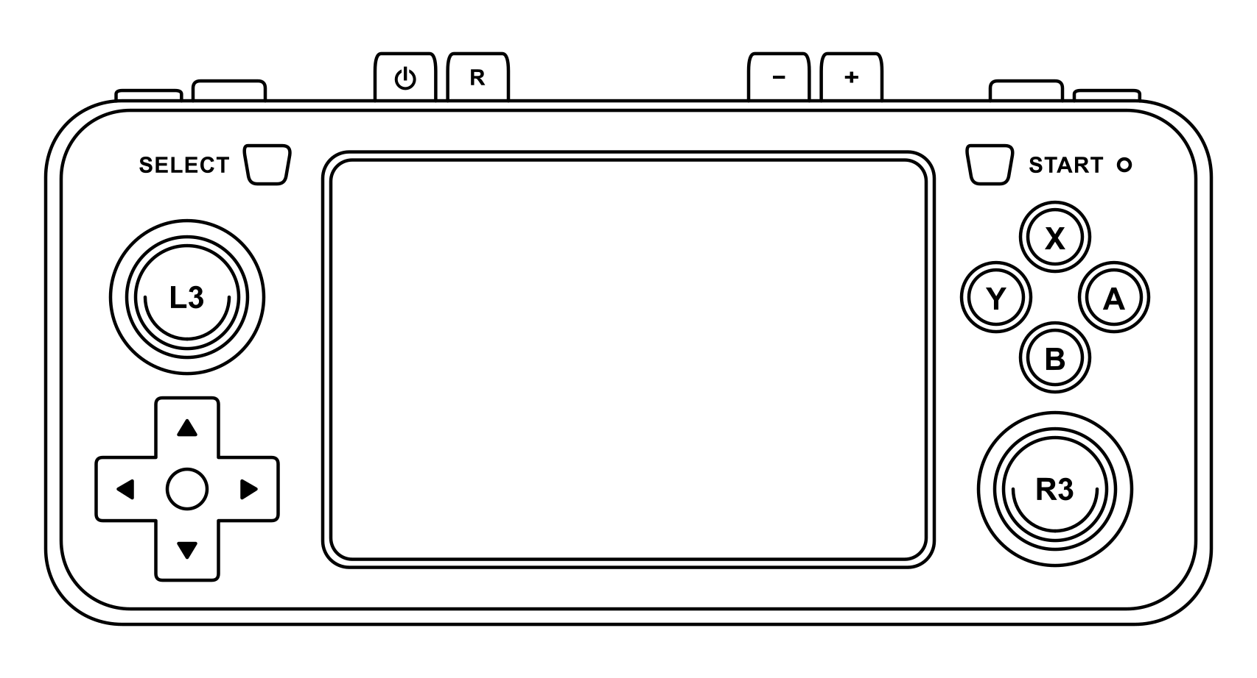

POWER ON | Hold the POWER button until the LED light turns green.
POWER OFF | Press the POWER button and wait until the LED light turns off.
RESET | Press the RESET button to start the next game (the console will reboot).
BATTERY | When the LED light turns red the battery charge is under 30%.  Press SELECT + START to enter the Retroarch Quick Menu, the battery level will be on the top right.  Press SELECT + START to return to the game.
VOLUME | Press the - / + buttons to decrease or increase the volume.  Press and hold the R3 analog stick then press the L3 analog stick to mute the audio.
BRIGHTNESS | Press and hold the R3 analog stick then press UP to increase brightness or DOWN to decrease brightness.
INSERT COIN | Press SELECT to insert a virtual coin.
START | Press START to join the game as Player 1.
PAUSE | Press SELECT + START to pause the game.  Press SELECT + START to resume the game.

