Discount VS Profitability

Abstract
This project focuses on analyzing the relationship between discount levels and profitability using interactive data visualization techniques. In many businesses, discounts are used to increase sales and attract customers, but excessive discounting can negatively impact profit margins and overall financial performance. The objective of this project is to identify how discounts influence profit across different categories, regions, and customer segments. The dataset contains important variables such as sales, profit, discount percentage, category, region, and order date. Using Tableau, the data is analyzed and transformed into meaningful visual insights through charts, KPI cards, and interactive dashboards. The dashboard helps identify high-risk transactions, loss-making discount ranges, and regions with poor margin performance. The project supports data-driven pricing decisions and helps management understand the balance between sales growth and profitability.
Objective
The main objective of this project is to analyze how discount strategies affect business profitability using a data-driven visualization approach. The project aims to identify the discount levels at which profit margins begin to decline and detect high-risk transactions that generate losses despite high sales. Another important objective is to compare profit performance across different product categories, regions, and customer segments to understand where margin leakage is occurring. The project also focuses on developing an interactive Tableau dashboard that allows users to explore profit patterns dynamically using filters and visual analytics. Ultimately, the goal is to help management make better pricing and discounting decisions that improve profitability while maintaining sustainable sales growth.
Problem Statement
The company is experiencing a significant business issue where revenue continues to grow, but profit margins are steadily decreasing. Initial analysis suggests that excessive and uncontrolled discounting is one of the primary reasons for this margin erosion. Sales teams often provide aggressive discounts to achieve sales targets without considering the long-term impact on profitability. The company currently lacks a proper analytical system to monitor how discounts affect profits across different regions, categories, and customer segments. Existing reports are static and delayed, making it difficult for management to identify risky discounting patterns in real time. As a result, many transactions generate low or even negative profits, creating financial inefficiencies. This project addresses the problem by developing a Profit vs Discount Visualization Dashboard that provides clear insights into discount behavior and profitability trends, enabling better strategic decision-making.
Proposed System
The proposed system is an interactive Tableau dashboard developed to analyze the impact of discount strategies on business profitability. The dashboard integrates important business metrics such as Total Sales, Total Profit, Profit Margin Percentage, Average Discount Percentage, High-Risk Orders, and Loss-Making Orders into a unified analytical framework. Multiple visualizations including quadrant-based scatter analysis, bar charts, heat maps, line charts, and category profitability analysis are used to identify margin leakage and profit-risk relationships. The quadrant chart helps classify discount-risk zones by comparing average discount levels with profit margins, enabling clear identification of high-risk and low-risk business areas. Calculated fields such as Discount Band, Profit Margin Percentage, Loss-Making Orders, and High-Risk Transactions are created to support deeper analytical insights. Interactive filters allow users to dynamically analyze performance based on category, region, segment, discount band, and order year. The dashboard also includes an insights section that highlights critical discount thresholds, regional margin leakage, and category-level profitability risks. Overall, the system transforms raw transactional data into actionable business intelligence that supports effective pricing strategy, margin control, and data-driven decision-making.
Advantages
The proposed system offers several advantages for business analysis and decision-making. It provides a clear understanding of how discounts influence profitability across different business dimensions. The dashboard helps management quickly identify high-risk transactions and loss-making discount ranges, enabling faster corrective actions. Interactive visualizations improve data interpretation and allow users to explore patterns dynamically without relying on complex reports. The system also improves pricing strategy by identifying the discount levels that negatively impact profit margins. By highlighting category-level and regional performance differences, the dashboard supports better operational planning and margin control. The visual format of the dashboard makes complex financial relationships easier to understand for both technical and non-technical users. Overall, the system improves business visibility, supports data-driven decision-making, and contributes to sustainable profitability growth.
Existing System
The existing system mainly depends on basic sales and financial reports that provide limited visibility into discount-related profitability issues. Discount approval decisions are often based on assumptions or sales pressure rather than detailed analytical insights. The system lacks interactive visualizations and does not provide transaction-level analysis of discount impact. Reports are usually generated after significant delays, making it difficult to identify and correct harmful discounting behavior in real time. There is also no proper mechanism to classify high-risk transactions or monitor profit leakage across categories and regions. As a result, management struggles to balance sales growth with profitability, and many loss-making transactions remain unnoticed.
Disadvantages
The proposed system has certain limitations that should be considered during implementation and analysis. The accuracy of the dashboard depends heavily on the quality and completeness of the dataset, so missing or incorrect data may affect the reliability of insights. The analysis is based on historical transactional data and may not fully capture external business factors such as market competition, seasonal demand, or customer behavior changes. The classification of high-risk transactions is based on predefined rules and thresholds, which may require adjustments depending on business requirements. Since the system is developed using Tableau and sample datasets, scalability may become a challenge when handling extremely large real-time datasets. Additionally, the dashboard supports analytical decision-making but should not completely replace managerial judgment and business experience.
Modules Used
- Datasets From Kaggle(Superstore Dataset)
- Key Columns: Sales, Profit, Discount, Category, Region
- Tool Used: Tableau
- Data Cleaning: Data preprocessing and validation
- Data Processing: Calculated fields and transformation
- Analysis: KPI analysis and profit-risk evaluation
- Visualization: Scatter Plot(Quadrant Analysis), Heat Map, Bar Chart, Line Chart, KPI Cards, Insight Section
- Features: Interactive Filters, Dashboard Actions, Discount Band Analysis, High-Risk Transaction Detection
Methodology
The project follows a structured analytical methodology to ensure meaningful and accurate business insights. Initially, the dataset is imported and cleaned to remove inconsistencies, handle missing values, and prepare the data for analysis. Important calculated fields such as Profit Margin Percentage, Discount Band, and High-Risk Transactions are created to support profitability analysis. Key performance indicators including Total Sales, Total Profit, Average Discount Percentage, and Loss Orders Count are developed to measure business performance. Multiple visualizations are then created in Tableau to analyze relationships between discount levels and profit outcomes. Quadrant-based scatter analysis is used to identify the relationship between average discount levels and profit margins, helping classify high-risk and low-risk profitability zones, while heat maps and category analysis identify regional and product-level margin risks. Trend analysis is performed using time-series charts to understand changes in profitability over time. Finally, an interactive dashboard is developed with filters and insight sections to support dynamic exploration and business decision-making.
Conclusion
The project successfully demonstrates the importance of analyzing discount strategies from a profitability perspective rather than focusing only on revenue growth. The dashboard clearly identifies that excessive discounting can significantly reduce profit margins and even create loss-making transactions. The analysis highlights that certain discount bands, regions, and product categories are more vulnerable to profit leakage than others. The use of interactive visualizations and calculated risk indicators improves business understanding and supports more effective pricing decisions. Overall, the project transforms raw sales data into actionable insights that help organizations maintain a balance between competitive pricing and sustainable profitability.
Result
The project successfully achieves its objective of identifying the relationship between discounts and profitability using Tableau visualization techniques. The dashboard effectively highlights high-risk discount ranges and detects transactions that generate negative profits despite high sales volume. It provides clear visibility into regional and category-level margin performance, enabling management to identify areas that require corrective action. The analysis shows that higher discounts do not always lead to higher profitability and, in many cases, contribute to financial losses. The interactive dashboard allows users to quickly filter and analyze business performance from multiple perspectives. Overall, the project improves pricing analysis, enhances business intelligence capabilities, and supports better strategic decision-making.
Future Improvement
The project can be further improved by integrating real-time business data to support live profitability monitoring and faster decision-making. Advanced analytical techniques such as predictive analytics and machine learning can be implemented to forecast the impact of future discount strategies on profit margins. Additional business variables such as customer behavior, competitor pricing, shipping cost, and inventory levels can also be included for deeper analysis. The dashboard can be integrated with enterprise systems such as ERP or CRM platforms to automate data updates and improve operational efficiency. Future versions of the system can also include AI-driven recommendations for optimal discount ranges and risk alerts for potentially loss-making transactions. These enhancements will make the system more intelligent, scalable, and valuable for long-term business planning.
Output
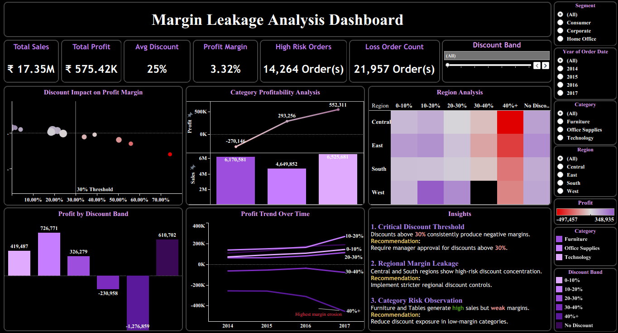

Reference
PRICING & DISCOUNT STRATEGY ANALYSIS: IMPACT ON SALES VOLUME AND PROFITABILITY - by Ibrahimmobolaji

