Vendor Performance & Procurement Optimization Report

Abstract
This project focuses on analyzing vendor performance to improve procurement decisions in a business environment. The company works with multiple vendors who differ in cost, delivery reliability, and profit contribution. However, existing decision-making relies heavily on experience rather than structured analysis, leading to inefficiencies.The main goal of this project is to evaluate vendors using a data-driven approach. The dataset includes key variables such as cost, delivery performance, and profit margins. Using MS Excel, the data is cleaned, processed, and analyzed to create meaningful insights. A dynamic dashboard is developed to visually represent vendor performance.The analysis introduces a vendor performance score that combines multiple factors into a single metric. This helps identify the best-performing vendors and highlights underperforming ones. The project supports better procurement strategies and improves overall business efficiency.
Objective
The main objective of this project is to analyze vendor performance using a data-driven approach to support better procurement decisions. Instead of relying on a single factor like cost, the project aims to evaluate vendors based on multiple key parameters such as cost efficiency, delivery reliability, and profit contribution. It focuses on identifying the best-performing vendors who provide a balanced combination of these factors. Another important objective is to understand the trade-offs between cost and reliability, ensuring that decisions are not made based on price alone. The project also aims to highlight underperforming vendors and provide actionable insights to improve overall procurement efficiency. Ultimately, the goal is to help management make informed, accurate, and optimized vendor selection decisions that improve business performance and profitability.
Problem Statement
The company currently faces challenges in selecting the right vendors for procurement. Vendor decisions are often based on past relationships or assumptions rather than structured analysis.One major issue is that focusing only on low-cost vendors can lead to poor delivery performance and reduced reliability. Similarly, vendors with high reliability may come at a higher cost, affecting overall profitability. There is no clear method to balance these trade-offs.The existing system lacks a proper evaluation framework that considers multiple factors simultaneously. As a result, management cannot clearly identify which vendors provide the best overall value.This project addresses the problem by introducing a data-driven vendor evaluation model that combines cost, reliability, and profit into a unified decision-making approach.
Proposed System
The proposed system is an interactive Vendor Performance Dashboard developed using MS Excel to provide a structured and data-driven approach to procurement analysis. This system integrates key vendor-related factors such as cost, delivery reliability, and profit contribution into a single analytical framework. The data is first cleaned and transformed using Power Query, and then analyzed using pivot tables and calculated metrics. A key feature of the system is the Vendor Performance Score, which combines multiple parameters into a unified index for easy comparison and decision-making. The dashboard includes visual elements such as charts, KPI cards, and a cost vs reliability trade-off analysis to clearly represent vendor performance. It also provides interactive slicers that allow users to filter data based on categories, regions, and shipping modes. Additionally, an insights section highlights the best-performing vendor and flags underperforming vendors for attention. Overall, the system transforms raw procurement data into meaningful insights, enabling faster, more accurate, and data-driven vendor selection decisions.
Advantages
The proposed system offers several practical advantages that significantly improve procurement analysis and decision-making. It provides a clear and structured view of vendor performance by combining multiple factors such as cost, delivery reliability, and profit contribution into a single framework. This helps management move away from assumption-based decisions and rely on accurate data insights. The interactive dashboard allows users to quickly filter and explore data, saving time compared to manual analysis. It makes it easier to identify the best-performing vendors as well as underperforming ones that require attention. The system also improves cost control by highlighting inefficiencies and supports better negotiation strategies with suppliers. By presenting insights in a simple and visual format, it enhances understanding even for non-technical users. Overall, the system increases operational efficiency, supports faster decision-making, and contributes to improved profitability and long-term business growth.
Existing System
The existing system focuses mainly on basic procurement data without detailed analysis. Vendor selection is often based on experience or past relationships.There is no structured method to compare vendors using multiple performance metrics. The system lacks visibility into delivery reliability and profit contribution. Reports are static and do not provide interactive insights.As a result, management struggles to make informed decisions, and inefficiencies in procurement remain unnoticed.
Disadvantages
The proposed system, while effective, has certain limitations that should be considered. The accuracy of the analysis depends heavily on the quality and completeness of the input data, so any errors or missing values can affect the results. The vendor performance score is based on predefined weights, which may not perfectly reflect real business priorities and could require adjustment over time. The model simplifies complex vendor behavior into a single score, which may overlook certain qualitative factors such as supplier relationships or market conditions. Since the system is built in Excel, it may face performance limitations with very large datasets. Additionally, it requires basic user understanding to interpret charts and insights correctly. The dashboard is also dependent on manual updates unless integrated with automated data sources. Despite these limitations, the system still provides valuable insights when used carefully alongside business judgment.
Modules Used
- Datasets From Kaggle(Vendor procurement dataset , Supply Chain Datasets)
- Key Columns: Vendor, Cost, Delivery Reliability, Profit Margin
- Tool Used: MS Excel
- Data Cleaning: Power Query
- Data Processing: Transformation and validation
- Analysis: Pivot Tables
- Visualization: Charts ,Graphs and Insight Box
- Features: Slicers, KPI Cards
Methodology
The project follows a structured and systematic methodology to ensure accurate and meaningful analysis. Initially, the dataset is collected from Kaggle, which provides a reliable source of procurement and vendor-related data. The data is then imported into MS Excel, where data cleaning is performed using Power Query to handle missing values, remove inconsistencies, and ensure proper formatting. After cleaning, the data is transformed and prepared for analysis by creating necessary calculated fields such as cost, delivery delay, reliability metrics, and profit margin. A vendor performance score is then developed using a weighted combination of key factors like cost efficiency, delivery reliability, and profit contribution. Pivot tables are used to summarize and analyze the data from different perspectives. Various charts and visualizations are created to represent insights clearly. An interactive dashboard is then designed, incorporating KPI cards, slicers, and multiple charts for better user interaction. Finally, the results are analyzed and validated to ensure that the insights are accurate and useful for decision-making.
Conclusion
The project successfully demonstrates the importance of data-driven vendor selection. It highlights that cost alone is not sufficient for decision-making. The dashboard identifies Nova the best vendor because it offers a balanced combination of cost efficiency, delivery reliability, and profit contribution. The use of a composite performance score helps in making objective and informed decisions. The trade-off analysis further strengthens the understanding of vendor performance. Overall, the project improves procurement efficiency and supports better business outcomes.
Result
The project successfully achieves its objective of providing a clear and data-driven evaluation of vendor performance. The dashboard effectively identifies the best-performing vendor based on a balanced assessment of cost, delivery reliability, and profit contribution. It highlights that relying on a single factor, such as cost, can lead to inefficient decisions, while a combined performance score offers a more accurate evaluation. The analysis also brings attention to underperforming vendors, allowing management to take corrective actions. The interactive dashboard enables quick filtering and comparison, making it easier to understand vendor behavior and performance trends. Overall, the project improves procurement decision-making, enhances operational efficiency, and supports better resource allocation, ultimately contributing to improved business performance.
Future Improvement
The project can be further enhanced by incorporating advanced features and technologies to improve its efficiency and scalability. One key improvement would be integrating the dashboard with tools like Power BI or Tableau for more advanced and interactive visualizations. Real-time data integration can be implemented to ensure that the dashboard reflects up-to-date information without manual updates. The model can also be extended by including additional factors such as vendor risk analysis, supplier ratings, and market conditions. Machine learning techniques can be applied to predict vendor performance and support proactive decision-making. Automation can be introduced to reduce manual effort in data cleaning and updating. Additionally, developing a mobile-friendly version of the dashboard can improve accessibility for management. Expanding the dataset and incorporating predictive analytics will make the system more robust, accurate, and valuable for long-term business planning.
Output
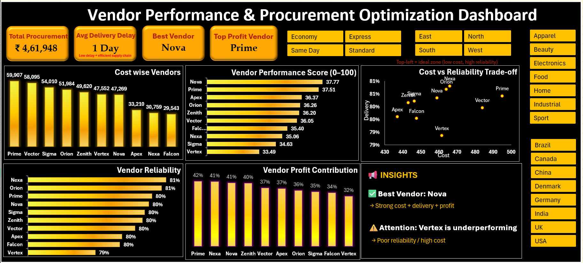
Reference
NIL

