Software Development Project

Functional Requirements Document

Team Members
Jaswanth Bandlamudi
Sasikiran Gaddipati.

Version | Description of Change | Author | Date
1,0 | Adding requirements | Jaswanth Bandlamudi | 20/10/2019

INTRODUCTION
This system monitors activation during the inference phase and judges whether the decision is reliable or not.

Purpose
The Purpose of this system is to judge the reliability of the Neural Network trained to classify an image out of the training set.

Scope
The scope of the system is to visualize the activations during training and inference and make a decision

Background
For using neural networks in safety critical domains, it is important to know if a decision made by a neural network is supported by prior similarities in training. After the standard training process, one creates a monitor by feeding the training data to the network again in order to store the neuron activation patterns in abstract form. In operation, a classification decision over an input is further improved by examining if a pattern similar to the generated pattern is contained in the monitor. If the monitor does not contain any pattern similar to the generated pattern, it raises a warning that the decision is not based on the training data.

References

Runtime Monitoring Neuron Activation Patterns

FUNCTIONAL REQUIREMENTS

Context diagram

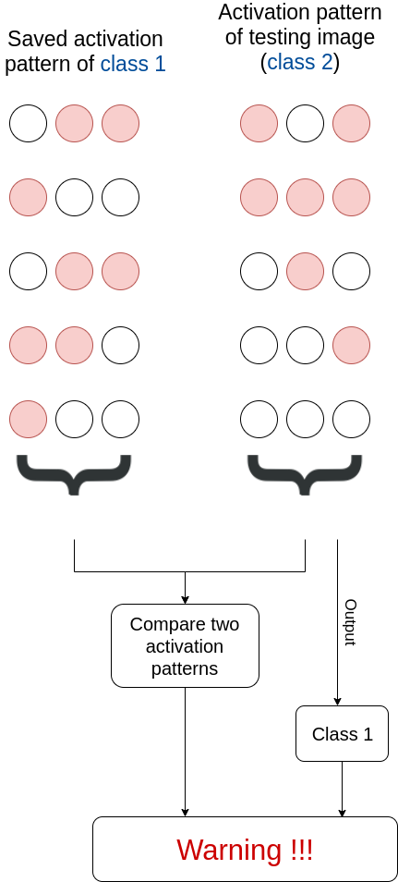
Exhibit 2 - Generic Context Diagram

User Requirements
- The system shall have a Neural network for classification purpose
- The system shall be trainable.
- The system shall take images as its inputs
- The system shall have a data structure which stores the activation patterns during training.
- The data structure chose shall be useful in calculating the norm/distance with another such data structure
- The system shall have a subsystem which is able to visualize the activation patterns during both training and inference phase.
- The system shall have a decision making ability to decide whether the classification is reliable or not.

Data Flow Diagrams

During Training:

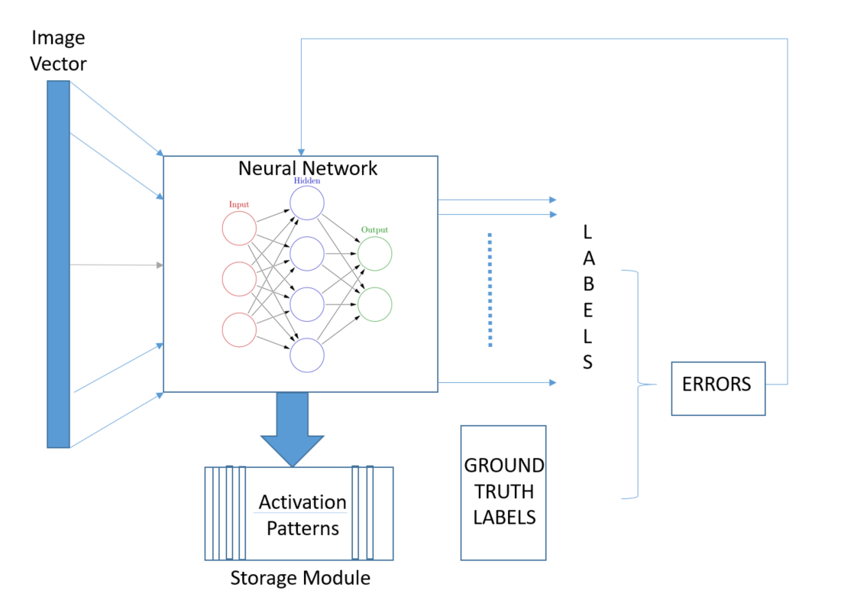

During Inference

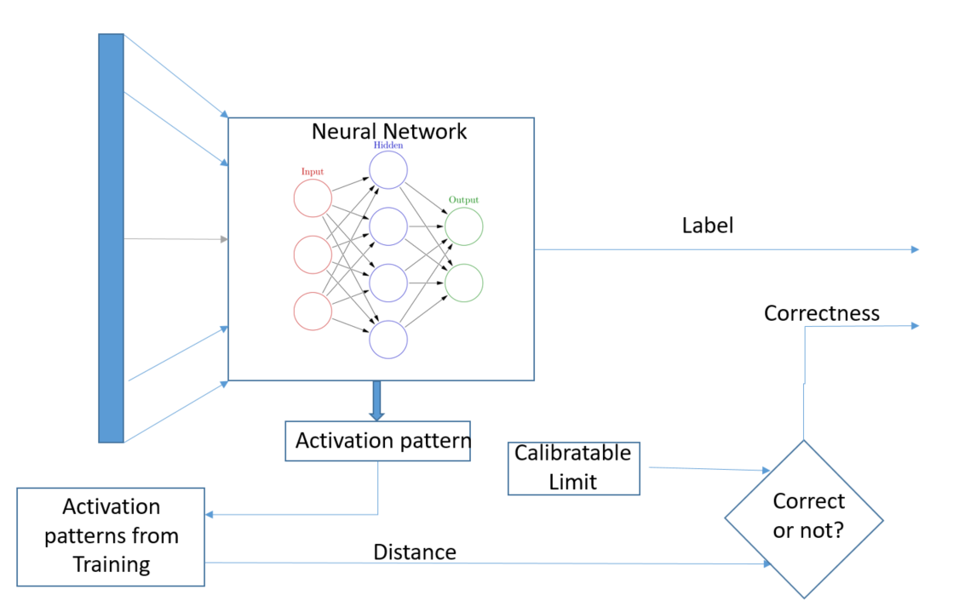

APPENDIX A - GLOSSARY
[Define terms, acronyms, and abbreviations used in the FRD.]

