**UI Testing**

**User Story:**

**MOS-18117** : **Stub - As a Registration Officer, I should be able to facilitate retrieving a lost UIN**

An individual has a UIN allocated but has lost it and is not aware of his/her RID and UIN number, then it creates Lost UIN request.

The Home Page contains Lost UIN option as follows:

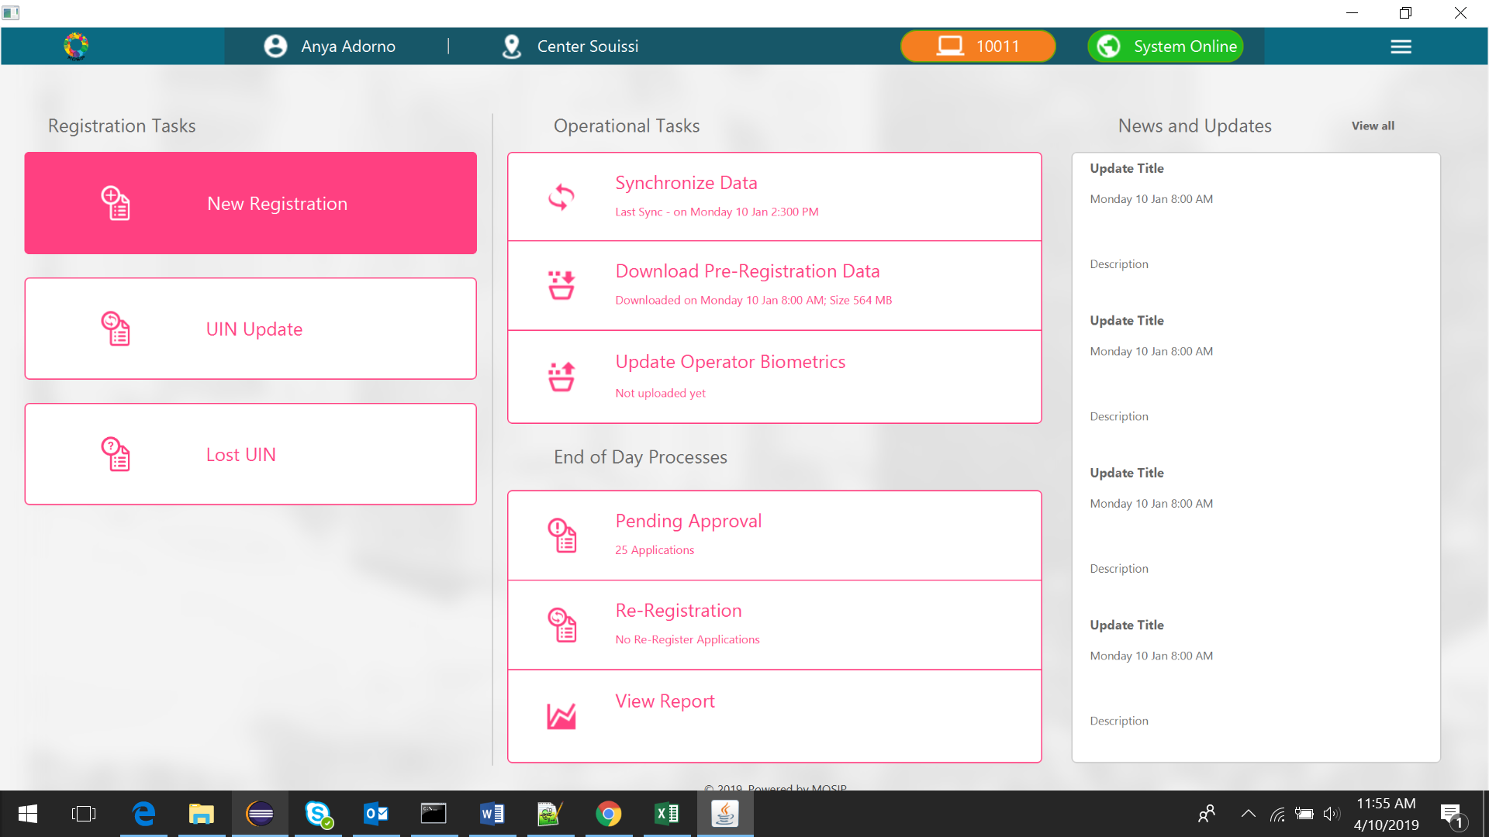

In case of Lost UIN, all the Demographic fields are not mandatory. The operator enters as much demographic details as the individual provides. All fields are optional - Name, Age or Date of Birth, Gender, Foreigner/National, Address, Email, Phone, CNIE/PIN/Residence Card, Parent/Guardian RID/UIN, and Parent/Guardian Name.

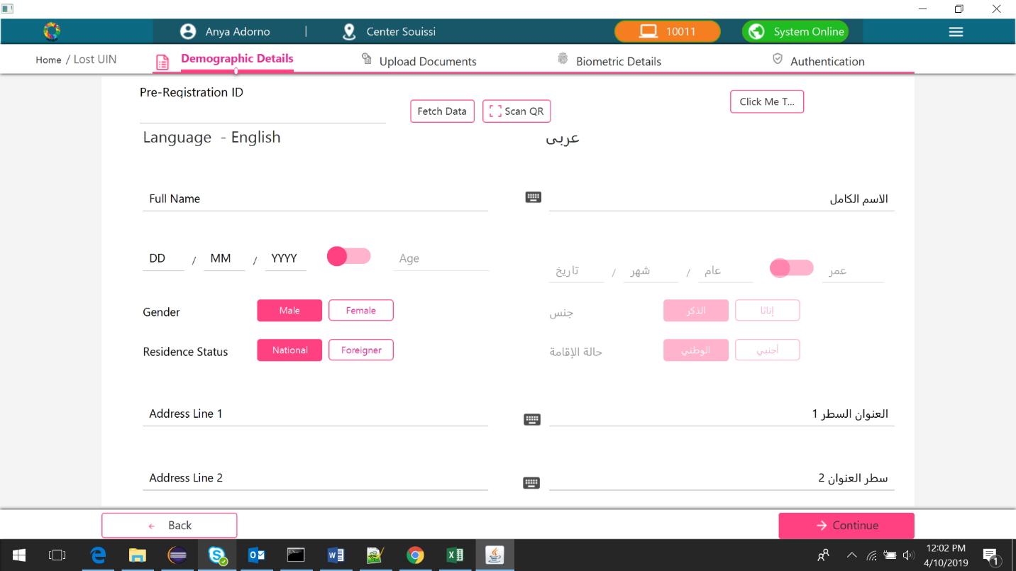

Documents should NOT be uploaded.

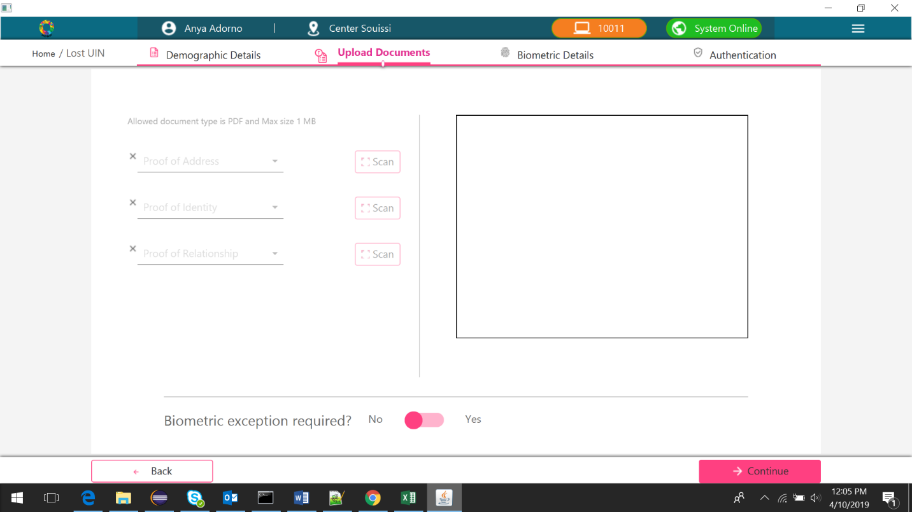

Capture all fingerprints and irises minus any exceptions.

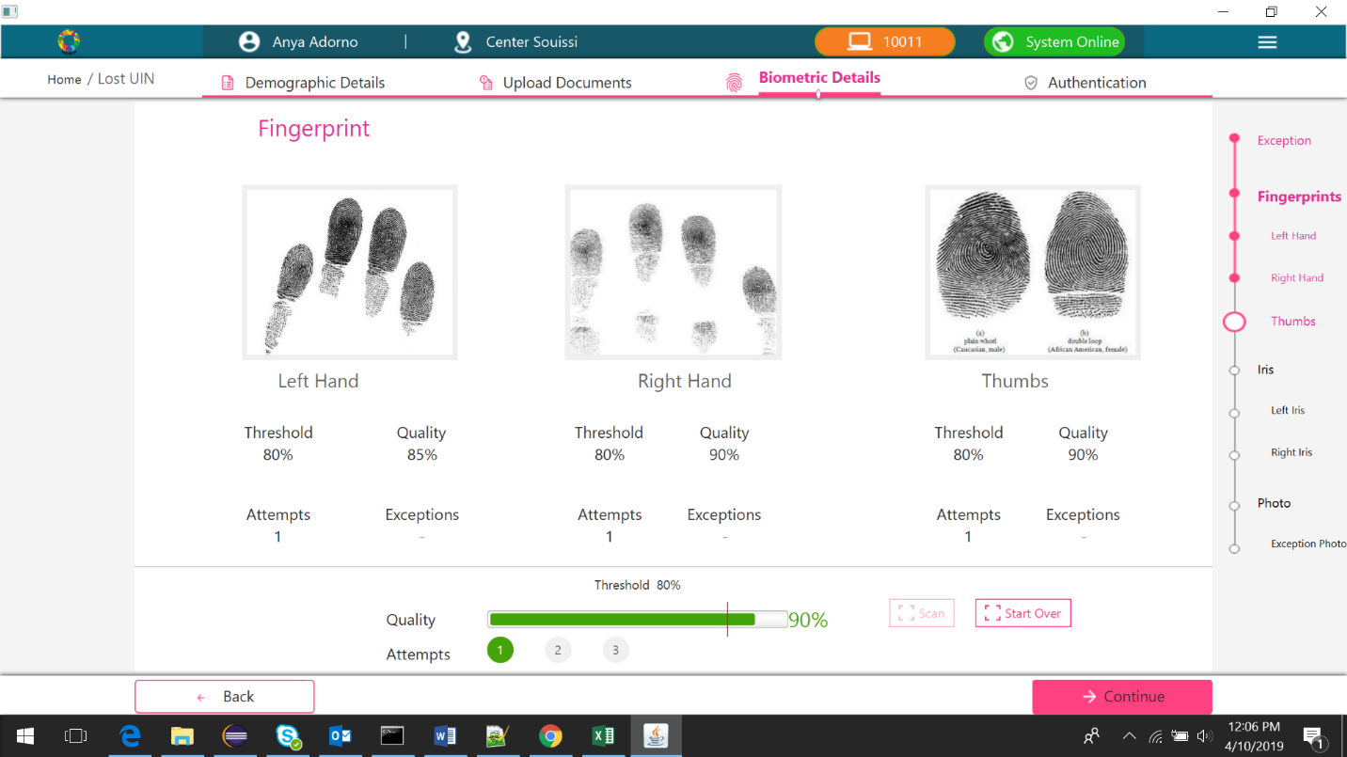

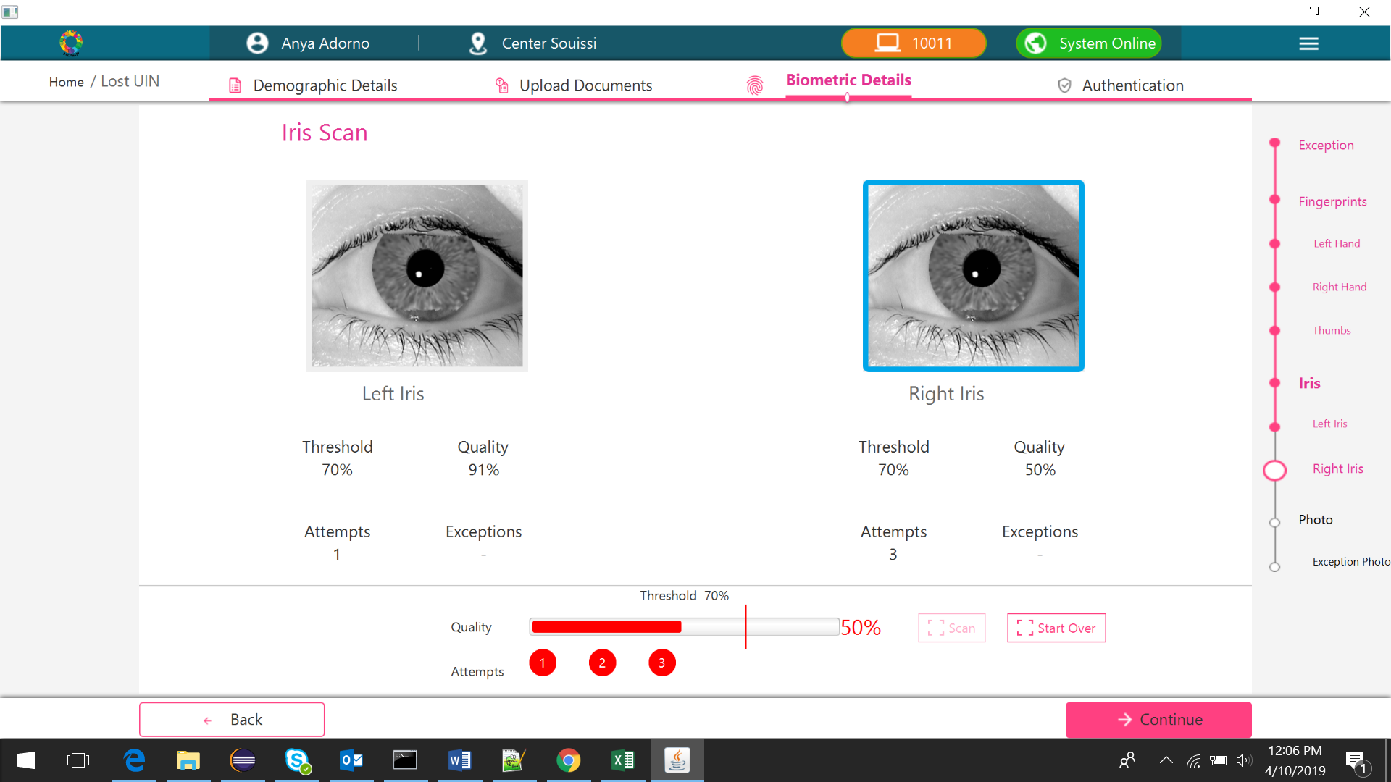

Registration Preview page will be as follow:

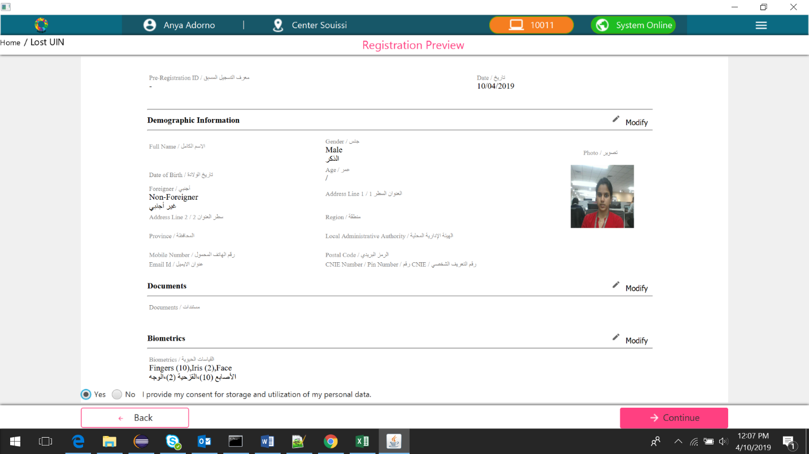

Authentication works same as for New Registration.

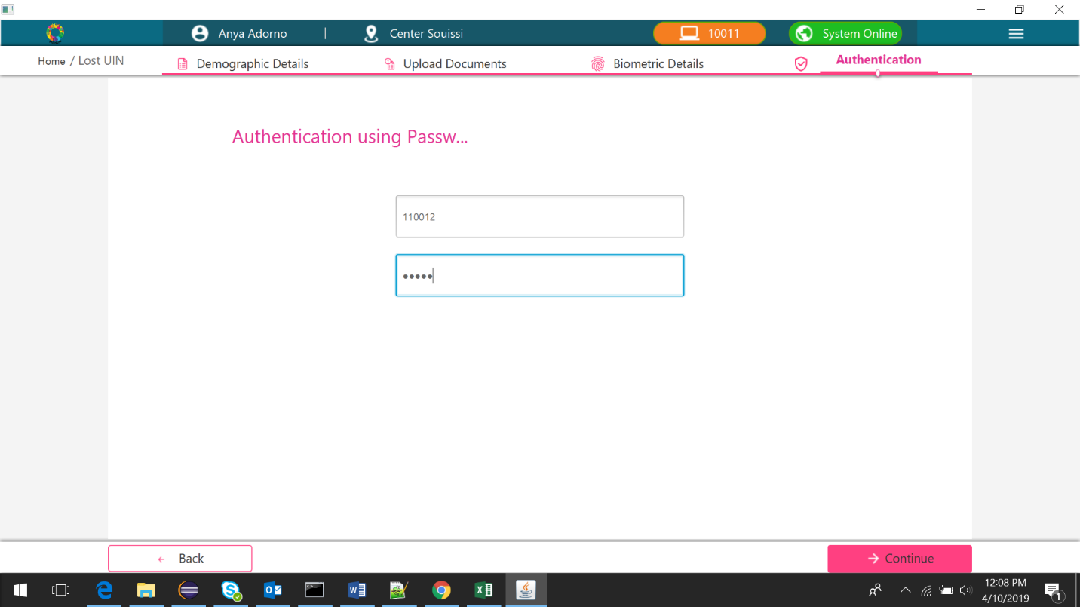

Acknowledgement page will also be same as New Registration.

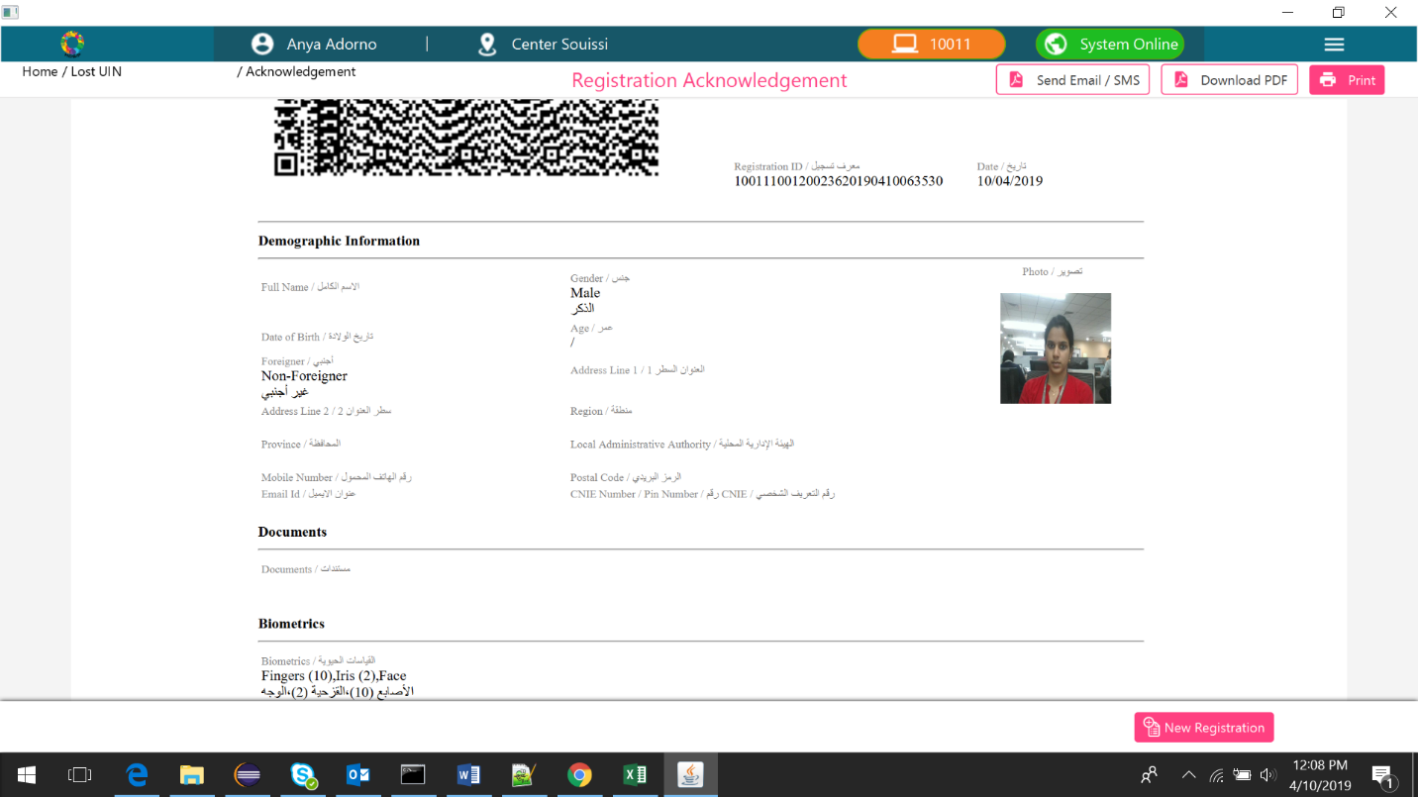

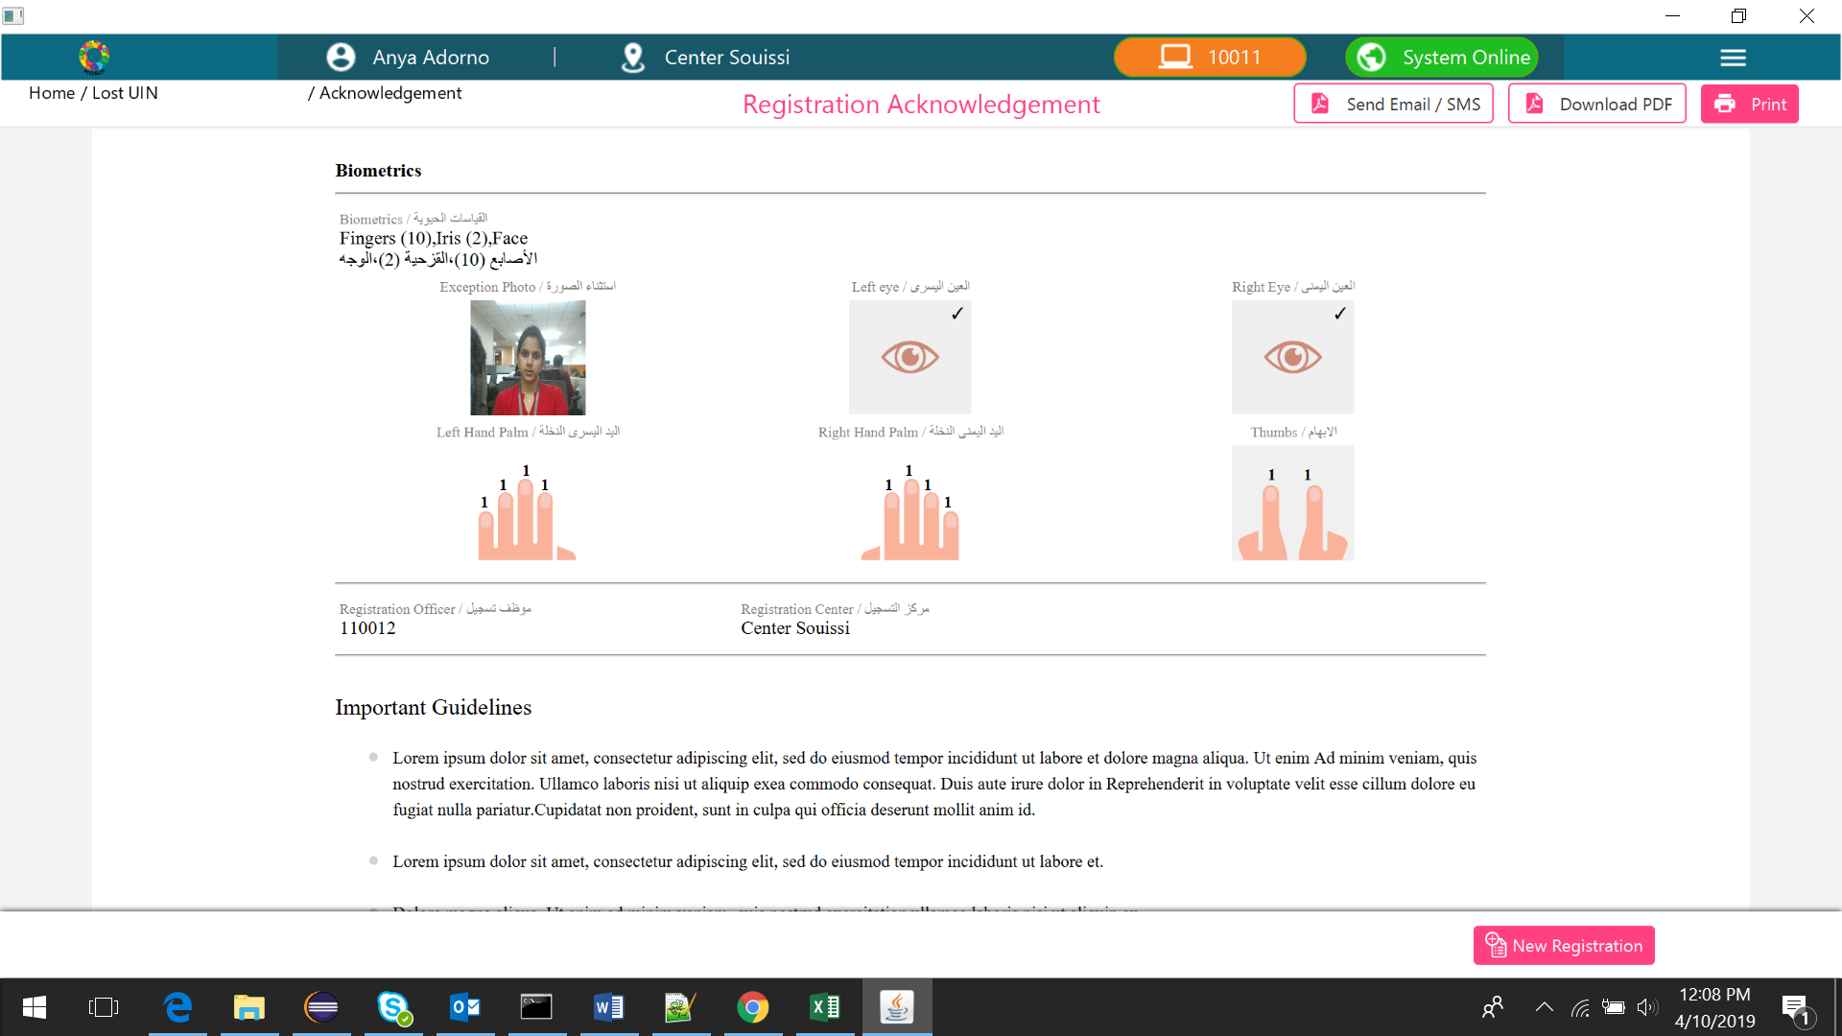

If no biometrics can be captured (due to country disabling fingerprint + iris + face), then it is not permitted to create a Lost UIN request. Display an error message when the user clicks on ‘Lost UIN’ - “Unable to create a Lost UIN request as biometric capture has been turned off”.

