CASE STUDY REPORT
A Project Work Synopsis
Project Title: ATTENDANCE MANAGEMENT SYSTEM
Object Oriented Programming using Java (Course Code: 25CSH-235 / 25CSH-238)
Submitted in the partial fulfillment for the award of the degree of
BACHELOR OF ENGINEERING
IN
COMPUTER SCIENCE WITH SPECIALIZATION IN
ARTIFICIAL INTELLIGENCE AND MACHINE LEARNING
Submitted by:
25BAI70907 Tanmay Mazumdar
Semester: 3
Submitted to:
Mrs. Reshma
Under the Supervision of:
Department of Social Internship [BE (CSE - AML)]

CHANDIGARH UNIVERSITY, GHARUAN, MOHALI - 140413,
PUNJAB
November, 2026

Abstract
The Attendance Management System is a text-based Java application designed to maintain student and teacher records, record daily attendance, calculate attendance percentages and identify students whose attendance is below a defined 75% threshold. The application uses object-oriented design and local UTF-8 text files for persistent storage. It is intended as an academic case study demonstrating how Java can be used to solve a practical institutional problem without requiring an external database.

1. Introduction
Educational institutions need a consistent method to record attendance and review student participation. Manual registers can be time-consuming to search, difficult to summarize and vulnerable to calculation mistakes. This project proposes a menu-driven console application that organizes student profiles, teacher profiles and attendance entries in separate files.

2. Problem Statement
A manual attendance process can make it difficult to retrieve a student's attendance history, calculate attendance percentages accurately and quickly identify students below the required attendance threshold. The proposed system provides a simple computerized workflow with persistent records and report-generation features.

3. Objectives
- Register and maintain student details.
- Register teachers who are authorized to mark attendance.
- Record Present, Absent or Late status for a student on a date.
- Prevent duplicate attendance entries for the same student and date.
- Retrieve attendance history and calculate attendance percentage.
- Generate class reports and identify students below 75%.
- Demonstrate Java OOP concepts, exception handling and file handling.

4. Scope and Assumptions
- The application is a single-user, console-based prototype.
- Data is stored locally in UTF-8 text files in the data folder.
- A teacher must be registered before their ID can be used to mark attendance.
- One attendance record is allowed per student per date.
- PRESENT and LATE count as attended; ABSENT does not.
- The shortage report lists students with at least one attendance record and a percentage below 75%.

5. Functional Requirements
ID | Requirement | Description
FR-01 | Student registration | Store student ID, name, email, programme and semester.
FR-02 | Teacher registration | Store teacher ID, name and department.
FR-03 | Attendance marking | Record date, status, student ID and teacher ID.
FR-04 | Duplicate prevention | Reject a second record for the same student and date.
FR-05 | History lookup | Display all attendance records for a selected student.
FR-06 | Percentage calculation | Calculate attended sessions divided by total marked sessions.
FR-07 | Shortage report | List students below 75% attendance.
FR-08 | Persistence | Retain records between application runs.
FR-09 | Student update | Update a registered student's name, email, programme and semester.
FR-10 | Student deletion | Delete a student and remove their associated attendance history.
FR-11 | Teacher update and deletion | Update a teacher's name and department; delete a teacher who has not marked any attendance.
FR-12 | Student search | Find students by part of their name (case-insensitive).
FR-13 | CSV export | Export the class attendance report to data/class_report.csv.

6. Non-Functional Requirements
- Usability: menu options and prompts should be clear.
- Reliability: invalid input should not terminate the application.
- Maintainability: entities, service logic and storage are separated into classes.
- Portability: the program uses standard Java APIs and can run on systems with JDK 8 or later.
- Data persistence: records remain available after the program exits.

7. System Design

7.1 Architecture
The application follows a simple layered structure. Main handles the menu; InputHelper reads and validates console input; AttendanceManager contains business rules and keeps the data in memory; AttendanceService defines the service contract; Student, Teacher and AttendanceRecord represent domain entities; FileStorage performs text-file input and output.

7.2 Class Responsibilities
Class / Interface | Responsibility
User | Abstract parent class containing common ID and name fields.
Student | Stores student profile details and serializes its record.
Teacher | Stores teacher profile details and serializes its record.
AttendanceStatus | Defines PRESENT, ABSENT and LATE values.
AttendanceRecord | Represents one student's attendance on one date.
AttendanceService | Declares core attendance service operations.
FileStorage | Reads, appends and overwrites UTF-8 text files.
AttendanceManager | Implements validation, attendance and reporting logic. Loads all records into memory at start-up and saves them after every change.
Main | Displays the menu and accepts user input.
InputHelper | Reads console input and re-prompts until names, emails, numbers, dates and statuses are valid.
AttendanceException | Represents business-rule validation failures.

7.3 OOP Concepts Used
Concept | Implementation | Purpose
Encapsulation | Private fields with getters/setters | Protects object state.
Inheritance | Student and Teacher extend User | Reuses common identity fields.
Abstraction | Abstract User class | Defines a common user contract.
Polymorphism | Student and Teacher override getRole() and displayInfo(); Main stores both as User references and calls displayInfo(), so each object prints itself in its own way. | Demonstrates runtime method dispatch for different User objects.
Interface | AttendanceManager implements AttendanceService | Separates service contract from implementation.
Constructors | Entity constructors initialize fields | Creates valid objects.
Exception handling | Validation and try/catch in Main | Handles invalid input and I/O failures.
Packages | com.cu.attendance | Organizes related classes.
Custom exception | AttendanceException extends RuntimeException | Provides a domain-specific exception for business-rule violations.

8. File Handling and Data Format
The system uses Java NIO file operations through the FileStorage class. Files are stored under the data directory and use UTF-8 text encoding. Each record occupies one line and uses the vertical bar (|) as a field separator.
- students.txt: studentId|name|email|programme|semester
- teachers.txt: teacherId|name|department
- attendance.txt: studentId|yyyy-MM-dd|status|teacherId
The files are created when records are first written. When the application starts it loads the three data files into memory once; after every add, update or delete it writes the changes back, so the saved data is available on the next run. A corrupt line in a data file is reported with a clear message instead of crashing the program. The CSV report option writes data/class_report.csv. This prototype is designed for a local academic demonstration, not concurrent multi-user deployment.

9. Attendance Calculation
Attendance percentage = (Number of PRESENT records + Number of LATE records) / Total attendance records × 100. ABSENT records contribute to the denominator but not the numerator. If no attendance has been recorded, the application displays 0.00%.
Example: if a student has 16 PRESENT, 2 LATE and 2 ABSENT records, attended sessions = 18, total sessions = 20, and attendance percentage = 90%.

10. Algorithms

10.1 Mark Attendance
- Accept student ID, date, status and teacher ID.
- Check that the student exists.
- Check that the teacher exists.
- Search existing records for the same student ID and date.
- If a duplicate exists, reject the entry.
- Otherwise append the new attendance record to attendance.txt.

10.2 Generate Shortage List
- Read all registered students.
- For each student, retrieve attendance records.
- Skip students with no attendance records.
- Calculate attendance percentage.
- Add the student to the report if percentage is below 75%.

11. Testing and Expected Results
Test | Input / Action | Expected result | Status
TC-01 | Register a new student | Student saved to students.txt | Pass (local scripted run)
TC-02 | Register duplicate student ID | Duplicate rejected | Pass (local scripted run)
TC-03 | Mark attendance with valid IDs | Record saved | Pass (local scripted run)
TC-04 | Mark same student/date again | Duplicate rejected | Pass (local scripted run)
TC-05 | Use unknown student ID | Operation rejected | Pass (local scripted run)
TC-06 | Enter invalid date | Prompt repeats until valid date | Pass (local scripted run)
TC-07 | Calculate 18 attended of 20 | 90.00% displayed | Pass (local scripted run)
TC-08 | Restart application | Previously saved records remain | Pass (local scripted run)
TC-09 | Register Student and Teacher, then choose View all users and roles | Both appear with STUDENT and TEACHER roles | Pass (local scripted run)
TC-10 | Update a student, view the list, then delete the student | Updated details appear; deleted student no longer appears | Pass (local scripted run)
TC-11 | Search for a student by part of the name | Matching students listed; unknown text shows "No matching students" | Pass (local scripted run)
TC-12 | Update a teacher; try to delete a teacher who has marked attendance; delete one who has not | Update saved; first deletion rejected; second deletion succeeds | Pass (local scripted run)
TC-13 | Export the class report to CSV | data/class_report.csv created with one row per student | Pass (local scripted run)
TC-14 | Enter a future date, an invalid email, a name with digits and an invalid status | Each invalid entry is rejected and the prompt repeats | Pass (local scripted run)
Testing note: these are planned test cases and expected results. Execute them on the target computer and record actual outcomes before final submission.

12. Limitations
- No graphical user interface or web access is included.
- Text files are not encrypted and should not contain sensitive production data.
- The prototype is intended for one local operator; simultaneous writes are not coordinated.
- The design supports student and teacher update and deletion. Deleting a student also removes that student's attendance history; a teacher who has marked attendance cannot be deleted. Data is loaded into memory at start-up, so edits made to the text files while the program is running are not noticed.
- Authentication and role-based login are outside the current scope.

13. Future Enhancements
- Add secure login and role-based permissions.
- Add an audit history of who changed which record.
- Add printable PDF reports.
- Add a graphical interface using Java Swing or JavaFX.
- Move to a database for multi-user deployment.
- Add course/subject-wise attendance and configurable shortage thresholds.

14. Conclusion
The Attendance Management System demonstrates how Java can be applied to a practical academic problem using object-oriented programming and file handling. It provides student and teacher registration, attendance recording, duplicate prevention, attendance calculations and shortage reporting. The project directly supports the course outcome of developing a text-based Java application incorporating file-handling concepts.

Appendix A: How to Compile and Run
1. Install JDK 8 or later and verify `java -version` and `javac -version`.
2. Open a terminal in the project root folder.
3. Compile: `javac -d out src/com/cu/attendance/*.java`
4. Run: `java -cp out com.cu.attendance.Main`
5. Register a teacher and students before marking attendance.

Appendix B: Source Code
The complete Java source code is supplied separately in the project ZIP archive. The source files are organized in the package com.cu.attendance.

Appendix C: Program Output (Console Screenshots)
The figures below are terminal-style renderings of real runs of the program (compiled with javac -Xlint:all) on the supplied sample data. Repeated menu text is collapsed to "[... menu displayed ...]" to save space. Inputs typed by the user are shown after each prompt.
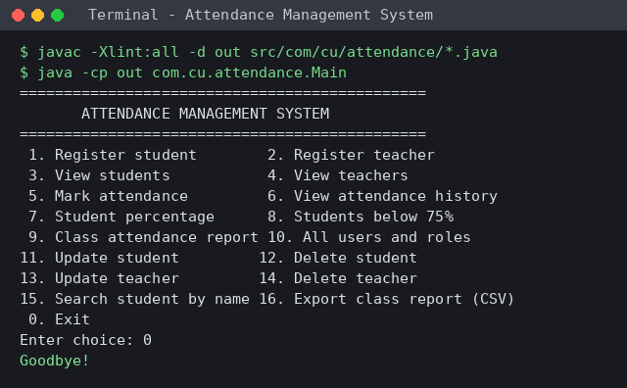
Figure 1: Compiling (no warnings) and starting the application
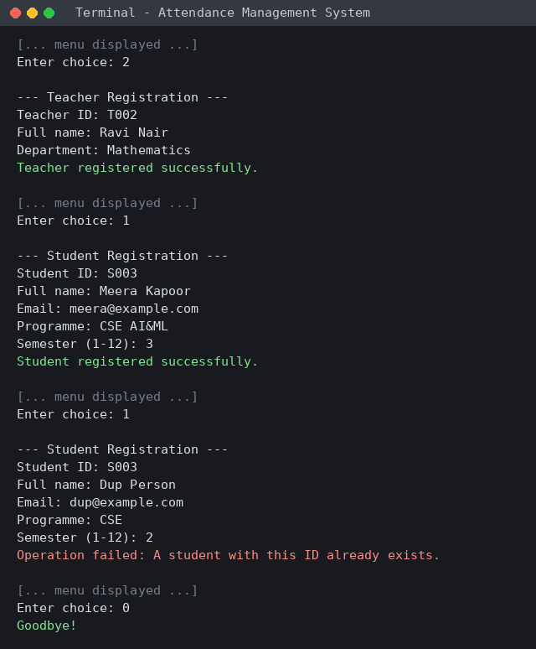
Figure 2: Registering a teacher and students, and rejecting a duplicate student ID
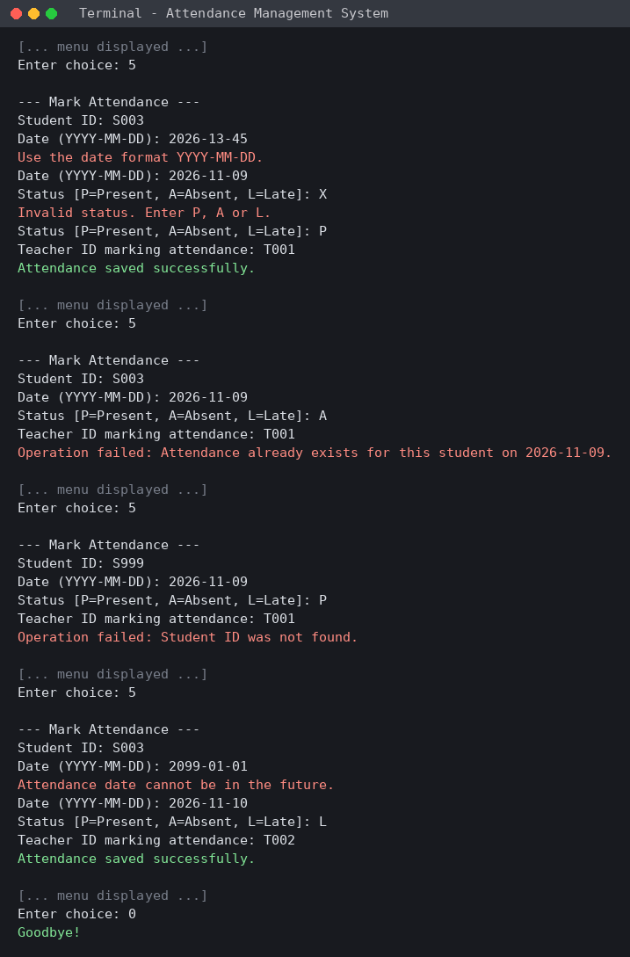
Figure 3: Marking attendance with input validation and duplicate / unknown-ID checks
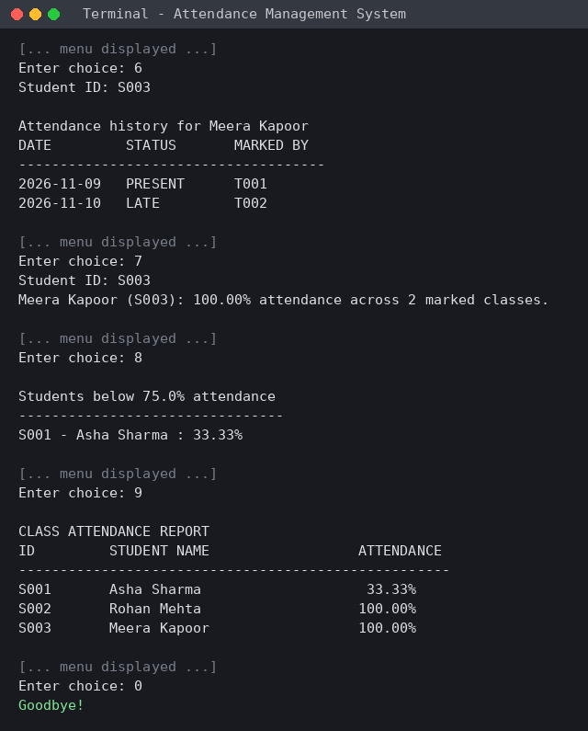
Figure 4: Attendance history, percentage, shortage list and class report
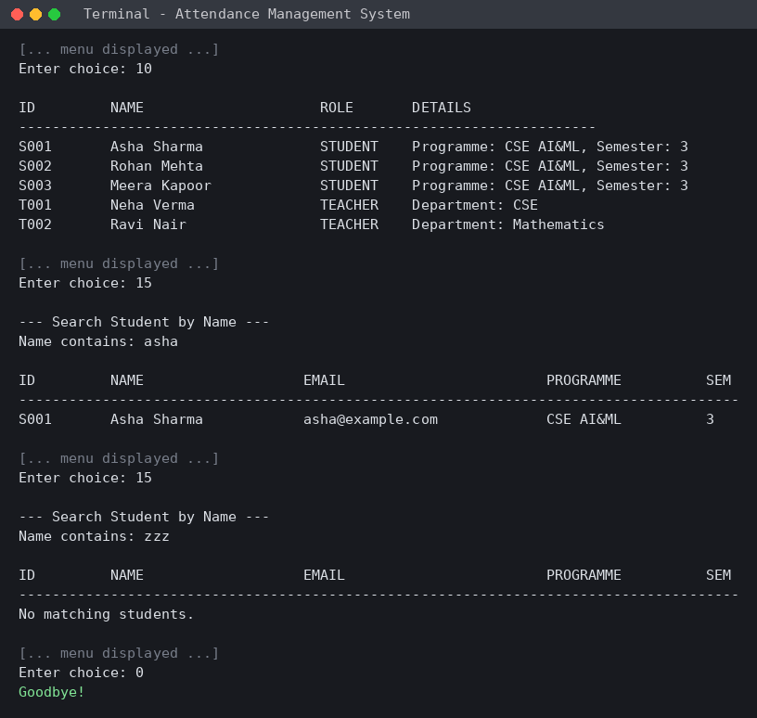
Figure 5: All users and roles (polymorphism) and search by name
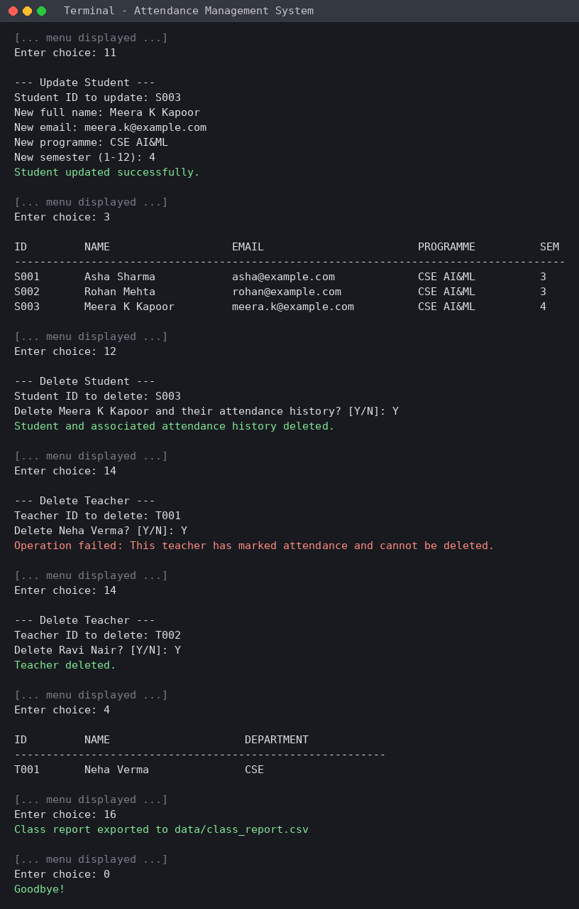
Figure 6: Update / delete student, teacher deletion rules and CSV export
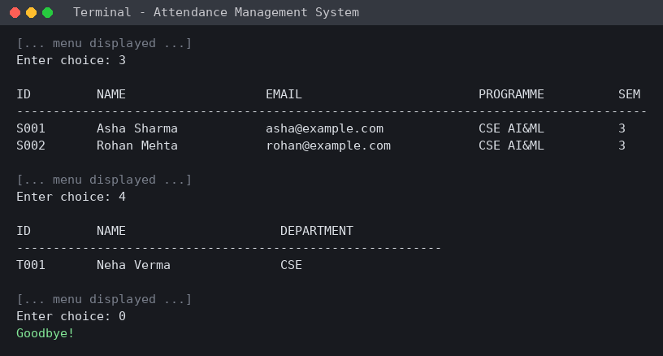
Figure 7: After restarting the application the saved data is still available

References
- Chandigarh University, Object Oriented Programming using Java (25CSH-235/238), uploaded course lecture material: Java Fundamentals, Constructors, Inheritance, Polymorphism, Packages and Interfaces.
- Herbert Schildt, Java: The Complete Reference, 11th Edition, McGraw-Hill, 2019.
- R. Nageswara Rao, Core Java: An Integrated Approach.
Execution update (11 November 2026): TC-01 to TC-14 were executed as scripted console sessions against the revised source (compiled with javac -Xlint:all, zero warnings) using a local JDK. All fourteen checks passed. Console output from these runs is shown in Appendix C.

