Dockerfile:

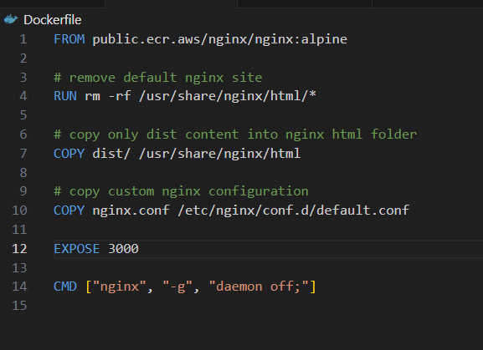

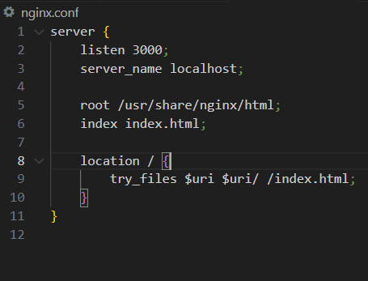
Build image and test locally:

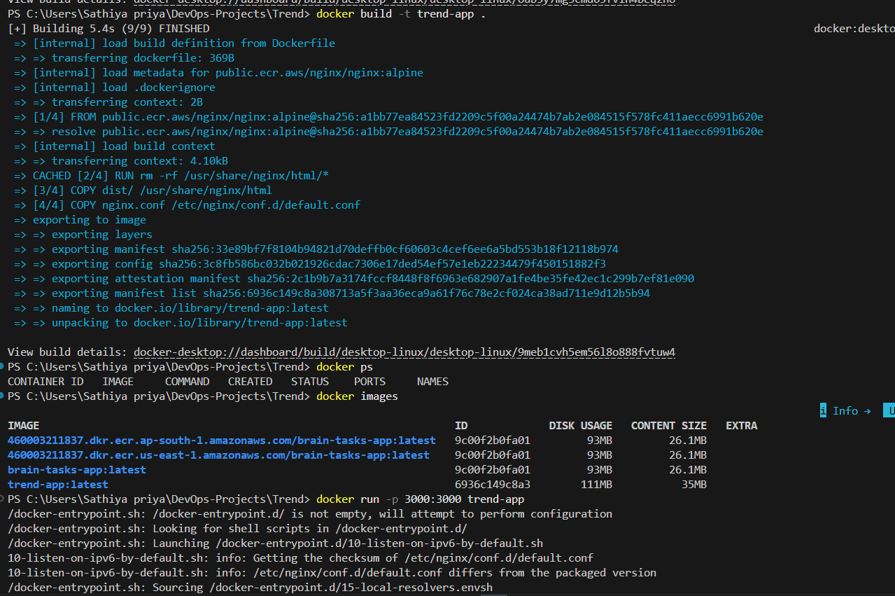



Push to dockerhub:

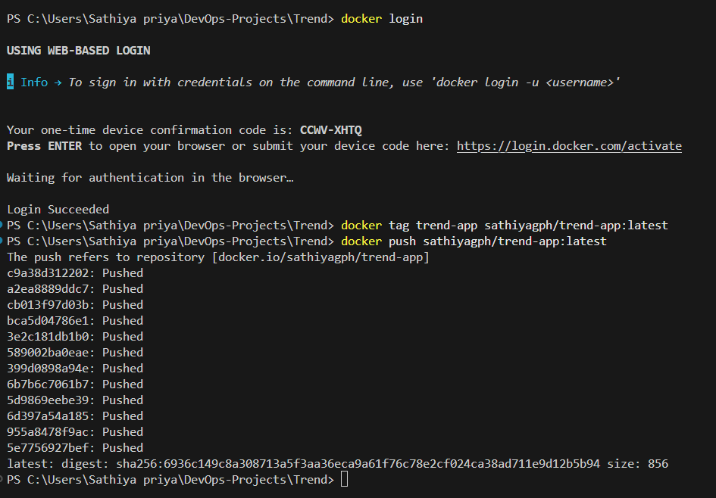

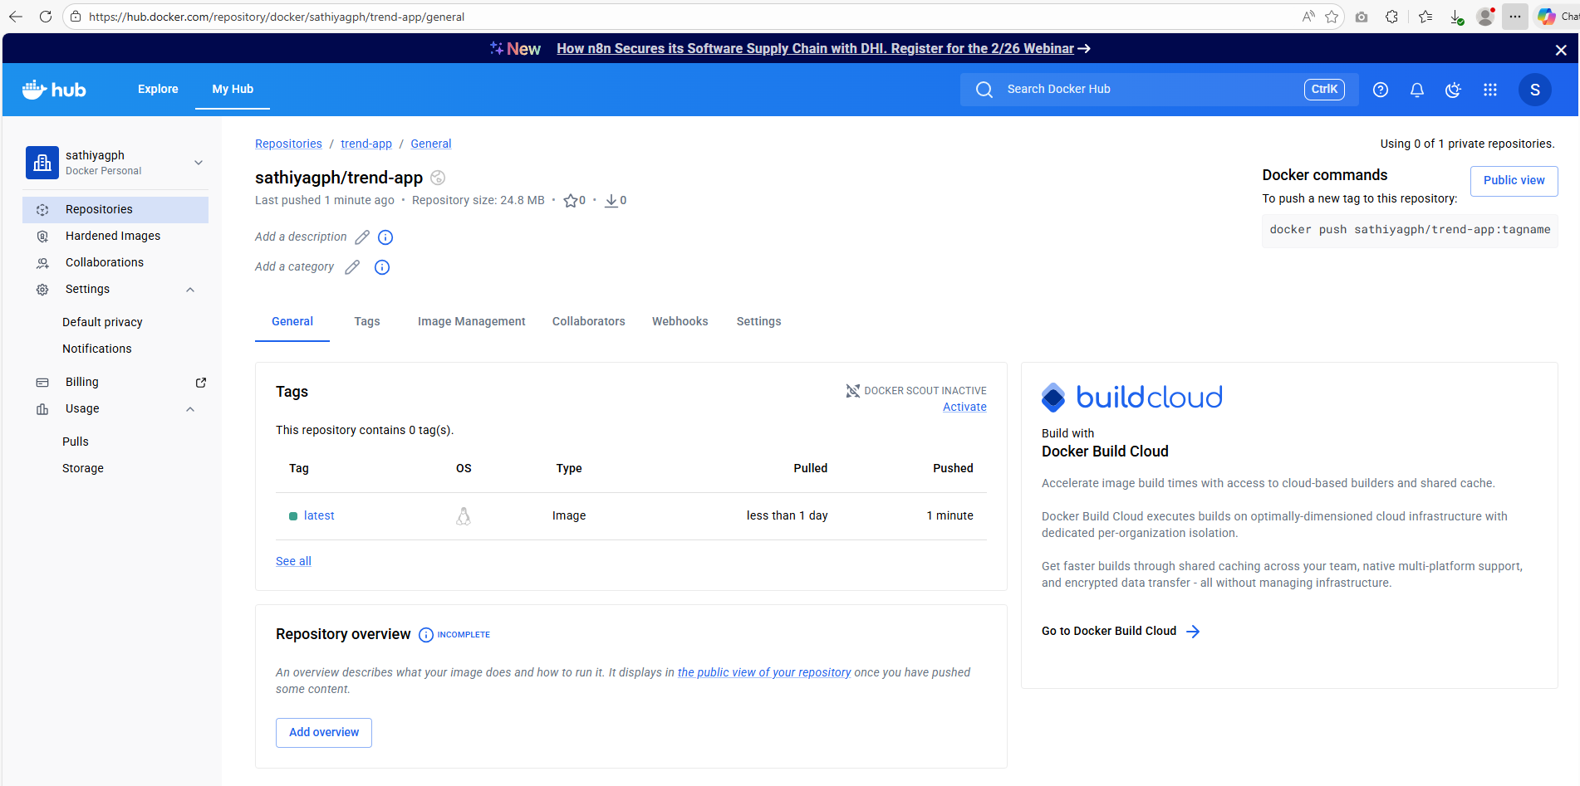

Terraform:

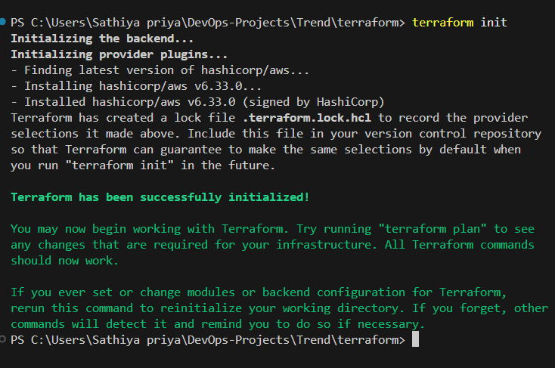

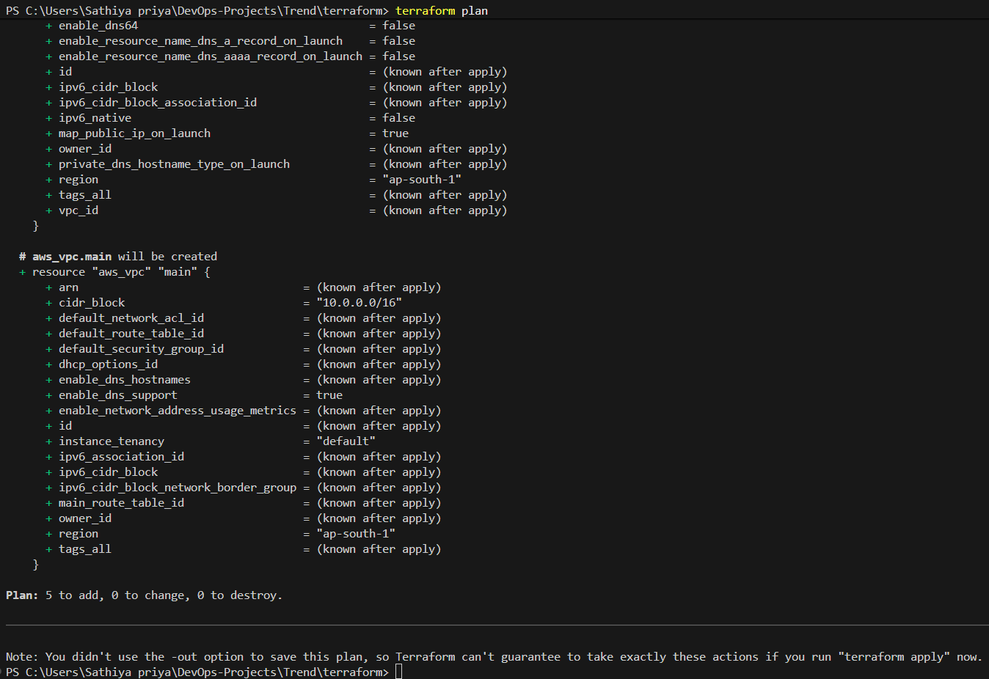

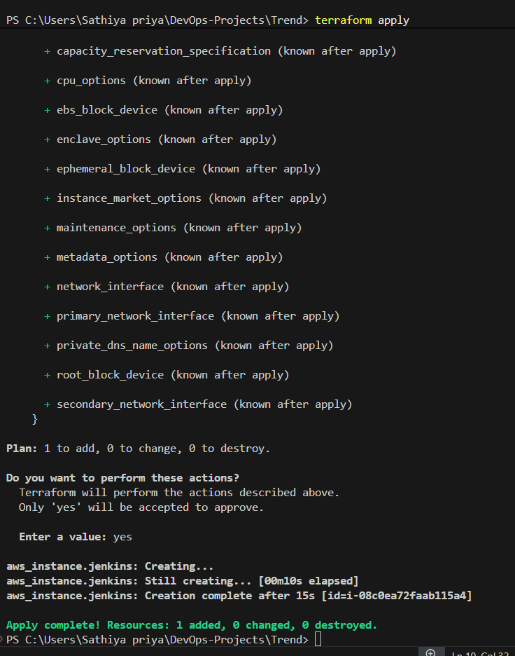

EC2:

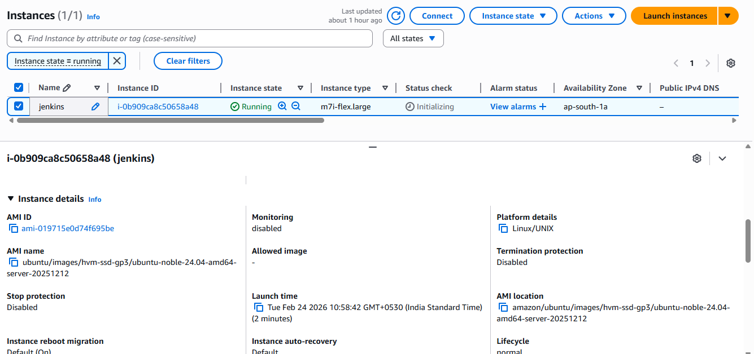

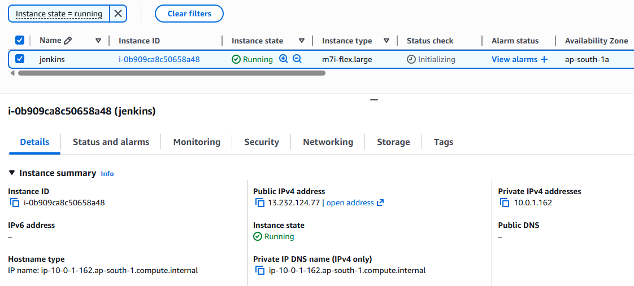

Jenkins:

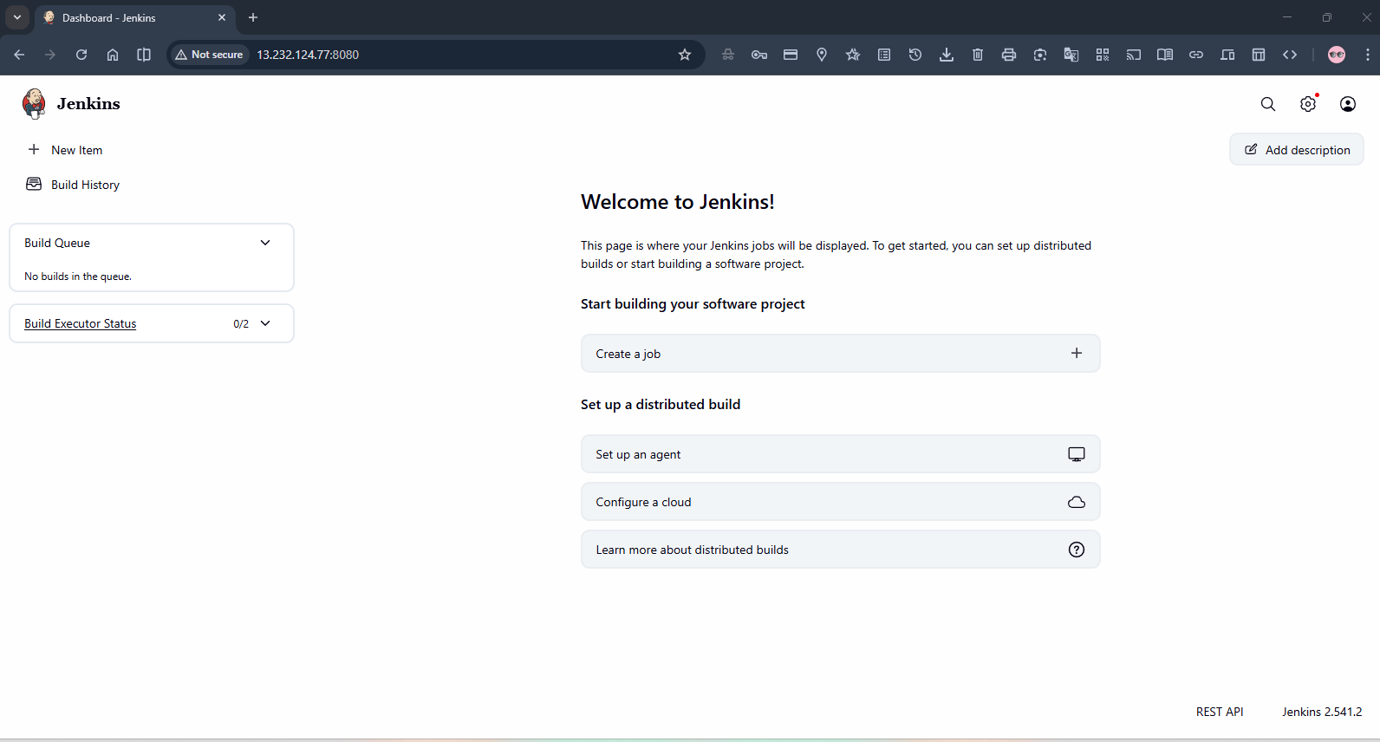

Cluster creation & deploy to EC2:

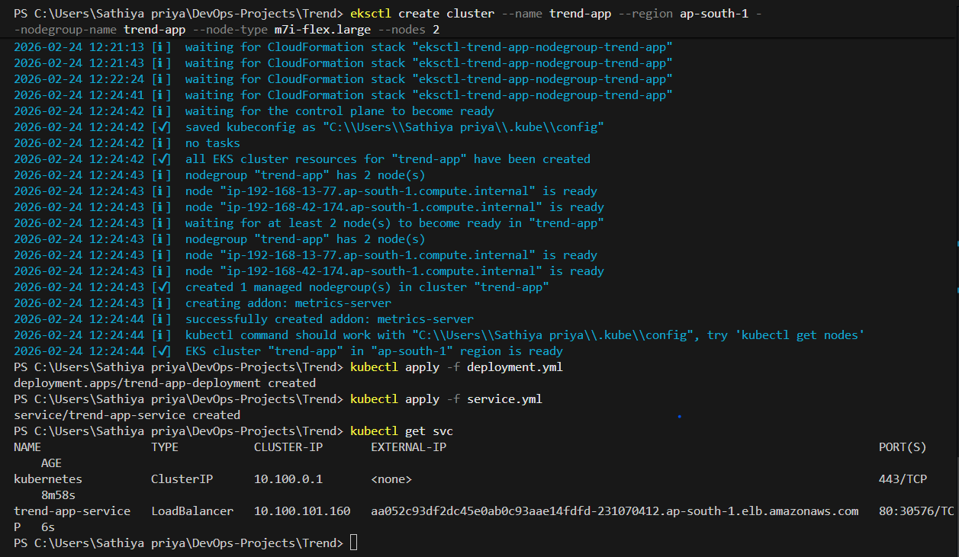



Jenkins CI/CD:

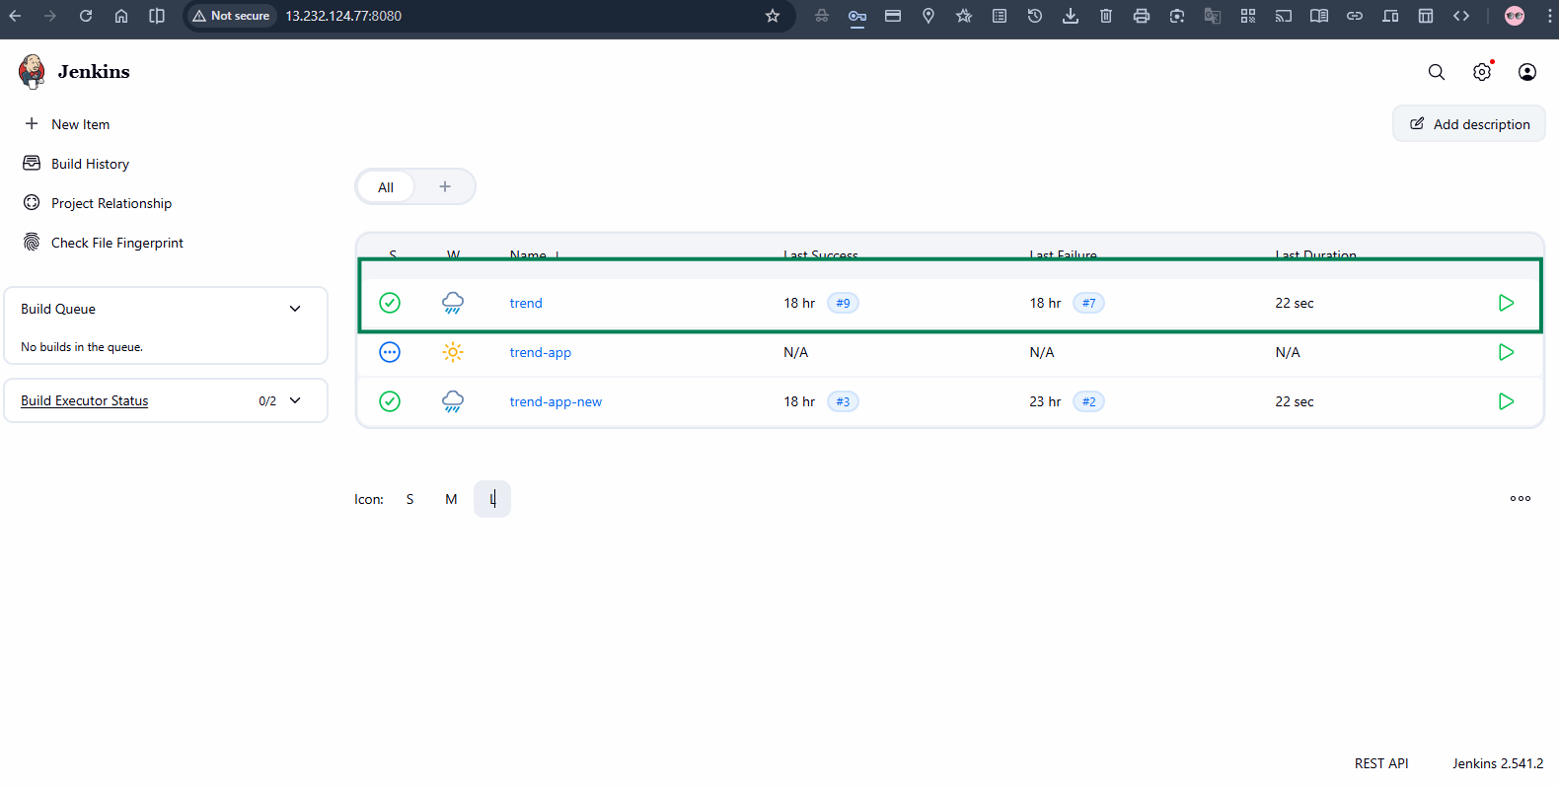

Github webhook for integration:

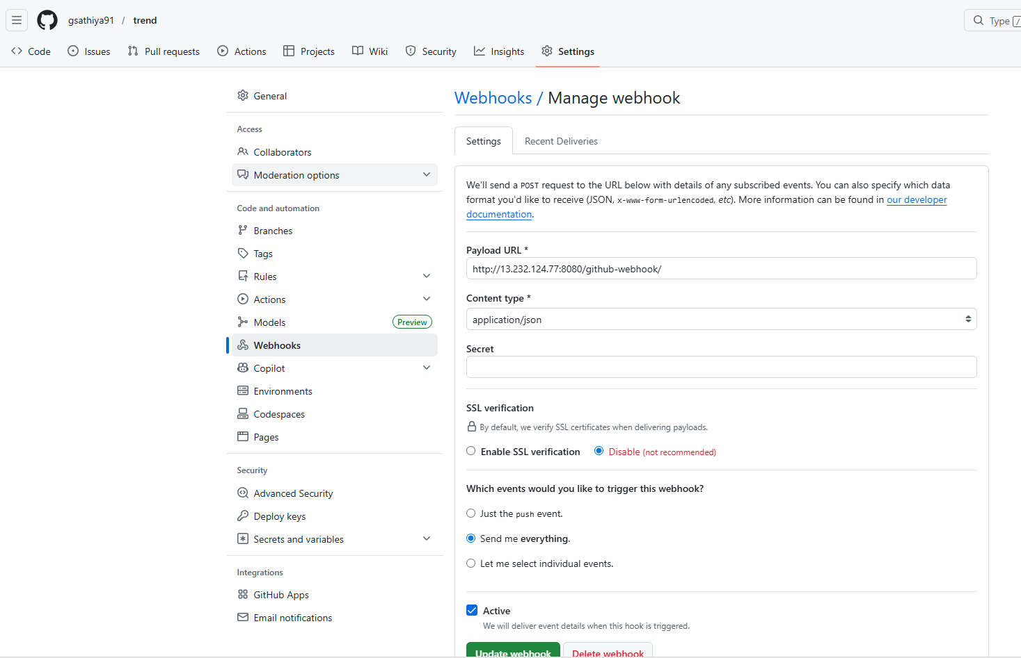

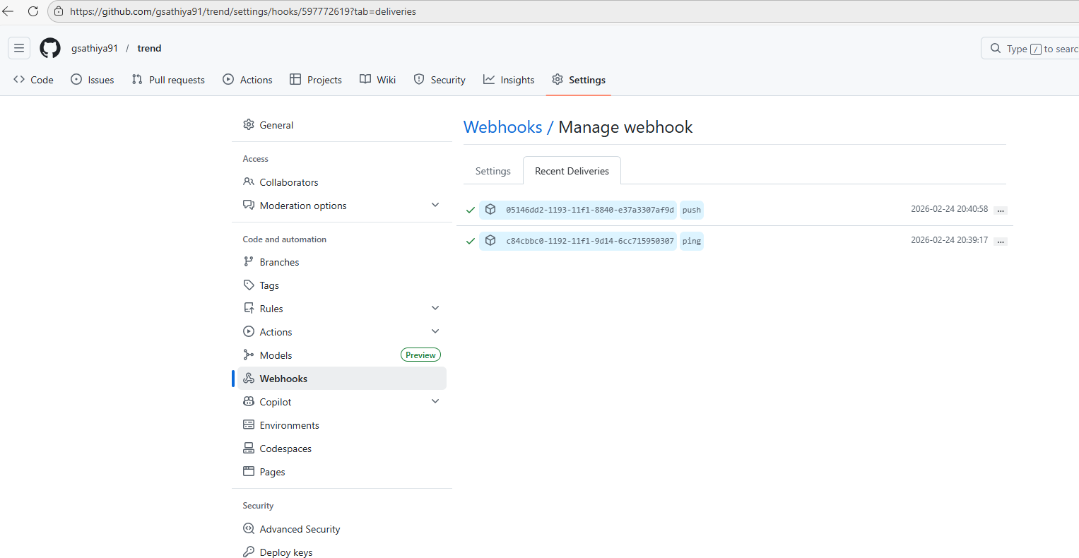

Deployment success in jenkins:

Started by user Sathiya priya

Obtained jenkinsfile from git https://github.com/gsathiya91/trend
[Pipeline] Start of Pipeline
[Pipeline] node
Running on Jenkins
in /var/lib/jenkins/workspace/trend
[Pipeline] {
[Pipeline] stage
[Pipeline] { (Declarative: Checkout SCM)
[Pipeline] checkout
The recommended git tool is: git
using credential github-trend-app
> git rev-parse --resolve-git-dir /var/lib/jenkins/workspace/trend/.git # timeout=10
Fetching changes from the remote Git repository
> git config remote.origin.url https://github.com/gsathiya91/trend # timeout=10
Fetching upstream changes from https://github.com/gsathiya91/trend
> git --version # timeout=10
> git --version # 'git version 2.43.0'
using GIT_ASKPASS to set credentials github-trend-app-key
> git fetch --tags --force --progress -- https://github.com/gsathiya91/trend +refs/heads/*:refs/remotes/origin/* # timeout=10
> git rev-parse refs/remotes/origin/main^{commit} # timeout=10
Checking out Revision aea38d8d7cfc9324fd0b50ece7f98ee8400d949d (refs/remotes/origin/main)
> git config core.sparsecheckout # timeout=10
> git checkout -f aea38d8d7cfc9324fd0b50ece7f98ee8400d949d # timeout=10
Commit message: "fixed dockerhub credential id"
> git rev-list --no-walk d3864be54b21d543ab57dac97f2899284e3e3a40 # timeout=10
[Pipeline] }
[Pipeline] // stage
[Pipeline] withEnv
[Pipeline] {
[Pipeline] withEnv
[Pipeline] {
[Pipeline] stage
[Pipeline] { (Clone Code)
[Pipeline] git
The recommended git tool is: git
No credentials specified
> git rev-parse --resolve-git-dir /var/lib/jenkins/workspace/trend/.git # timeout=10
Fetching changes from the remote Git repository
> git config remote.origin.url https://github.com/gsathiya91/trend.git # timeout=10
Fetching upstream changes from https://github.com/gsathiya91/trend.git
> git --version # timeout=10
> git --version # 'git version 2.43.0'
> git fetch --tags --force --progress -- https://github.com/gsathiya91/trend.git +refs/heads/*:refs/remotes/origin/* # timeout=10

> git rev-parse refs/remotes/origin/main^{commit} # timeout=10
Checking out Revision aea38d8d7cfc9324fd0b50ece7f98ee8400d949d (refs/remotes/origin/main)
> git config core.sparsecheckout # timeout=10
> git checkout -f aea38d8d7cfc9324fd0b50ece7f98ee8400d949d # timeout=10
> git branch -a -v --no-abbrev # timeout=10
> git branch -D main # timeout=10
> git checkout -b main aea38d8d7cfc9324fd0b50ece7f98ee8400d949d # timeout=10
Commit message: "fixed dockerhub credential id"
[Pipeline] }
[Pipeline] // stage
[Pipeline] stage
[Pipeline] { (Build Docker Image)
[Pipeline] sh
+ docker build -t sathiyagph/trend-app:latest .
DEPRECATED: The legacy builder is deprecated and will be removed in a future release.
Install the buildx component to build images with BuildKit:
https://docs.docker.com/go/buildx/

Sending build context to Docker daemon 18.51MB

Step 1/6 : FROM public.ecr.aws/nginx/nginx:alpine
---> b76de378d572
Step 2/6 : RUN rm -rf /usr/share/nginx/html/*
---> Using cache
---> 57224f4fda0e
Step 3/6 : COPY dist/ /usr/share/nginx/html
---> Using cache
---> 6609d6bc9321
Step 4/6 : COPY nginx.conf /etc/nginx/conf.d/default.conf
---> Using cache
---> bc0cd5e18f0a
Step 5/6 : EXPOSE 3000
---> Using cache
---> b735d3bf3c20
Step 6/6 : CMD ["nginx", "-g", "daemon off;"]
---> Using cache
---> 8c9be87481f1
Successfully built 8c9be87481f1
Successfully tagged sathiyagph/trend-app:latest
[Pipeline] }
[Pipeline] // stage
[Pipeline] stage
[Pipeline] { (Login to DockerHub)
[Pipeline] withCredentials
Masking supported pattern matches of $DOCKER_PASS
[Pipeline] {
[Pipeline] sh
+ echo ****
+ docker login -u sathiyagph --password-stdin

WARNING! Your credentials are stored unencrypted in '/var/lib/jenkins/.docker/config.json'.
Configure a credential helper to remove this warning. See
https://docs.docker.com/go/credential-store/

Login Succeeded
[Pipeline] }
[Pipeline] // withCredentials
[Pipeline] }
[Pipeline] // stage
[Pipeline] stage
[Pipeline] { (Push Image to DockerHub)
[Pipeline] sh
+ docker push sathiyagph/trend-app:latest
The push refers to repository [docker.io/sathiyagph/trend-app]

2d63bbd27f75: Preparing
3aa3677bd52c: Preparing
cd4f11f74c36: Preparing
da3ac26fdf0f: Preparing
7b2903554e63: Preparing
6c0e59fd138a: Preparing
aa0fc249df10: Preparing
f35bcec50d8c: Preparing
660f9a93104f: Preparing
53998a5033c3: Preparing
989e799e6349: Preparing
6c0e59fd138a: Waiting
aa0fc249df10: Waiting
f35bcec50d8c: Waiting
660f9a93104f: Waiting
53998a5033c3: Waiting
989e799e6349: Waiting

7b2903554e63: Layer already exists
cd4f11f74c36: Layer already exists
3aa3677bd52c: Layer already exists
da3ac26fdf0f: Layer already exists
2d63bbd27f75: Layer already exists
6c0e59fd138a: Layer already exists
aa0fc249df10: Layer already exists
53998a5033c3: Layer already exists
660f9a93104f: Layer already exists
f35bcec50d8c: Layer already exists

989e799e6349: Layer already exists

latest: digest: sha256:7c68eaf084ece58dd24bfac32c5e81e51c6aba9d69a24c35a0bb65a8c826ec41 size: 2614
[Pipeline] }
[Pipeline] // stage
[Pipeline] stage
[Pipeline] { (Deploy to EKS)
[Pipeline] sh
+ aws eks --region ap-south-1 update-kubeconfig --name trend-app

Updated context arn:aws:eks:ap-south-1:442067950974:cluster/trend-app in /var/lib/jenkins/.kube/config
+ kubectl apply -f deployment.yml

deployment.apps/trend-app-deployment unchanged
+ kubectl apply -f service.yml

service/trend-app-service unchanged
[Pipeline] }
[Pipeline] // stage
[Pipeline] stage
[Pipeline] { (Declarative: Post Actions)
[Pipeline] echo
Application successfully deployed to EKS 🚀
[Pipeline] }
[Pipeline] // stage
[Pipeline] }
[Pipeline] // withEnv
[Pipeline] }
[Pipeline] // withEnv
[Pipeline] }
[Pipeline] // node
[Pipeline] End of Pipeline
Finished: SUCCESS



