Software Requirements Specification (SRS)
Smart Expense & Budget Management Application
Field | Detail
Project | Smart Expense & Budget Management Application
Course | Software Engineering – Mini Project (Section 5G)
Team | Team 14
Version / Date | 1.0 | 06-09-2026
Status | Draft for review

Team members
Sl. No | SRN | Name
1 | PES2UG24CS427 | Sahana Shivakumar Badiger
2 | PES2UG24CS428 | Sai Arjun M
3 | PES2UG24CS429 | Sai Arya A L
4 | PES2UG24CS430 | Sai Sathvik Gullipalli

Revision history
Version | Date | Author | Change summary | Approval
1.0 | 06-09-2026 | Team 14 | Initial SRS — requirements, use cases and RTM

Approvals
Role | Name | Signature / Email | Date
Course Coordinator
Team Lead

Table of Contents
1. Introduction 2. Overall description 3. External interfaces 4. System features 5. Non-functional requirements 6. Quality attributes & acceptance tests 7. UML use-case diagrams 8. Requirements Traceability Matrix

1. Introduction

1.1 Purpose
This document specifies the requirements for the Smart Expense & Budget Management Application, built by Team 14 for the Software Engineering mini project. It states what the application must do, how well it must do it, and how each requirement is verified. Readers: the project team, the course coordinator and the evaluators.

1.2 Scope
A web application in which one user records daily expenses and income, groups them into categories, sets a monthly budget, and sees where the money went through a dashboard with charts. In scope: user accounts, transaction entry and editing, categories, budgets with threshold alerts, dashboard and CSV export.
Out of scope: bank / UPI / card integration and statement import, shared or family budgets, native mobile apps, multi-currency and tax handling, and email or push notifications (alerts are shown in-app).

1.3 Audience
Team 14 developers, the course coordinator and the evaluation panel.

1.4 Definitions
Term | Meaning
SRS / RTM | Software Requirements Specification / Requirements Traceability Matrix
FR / NFR | Functional Requirement / Non-Functional Requirement
Transaction | A single expense or income record entered by the user
Category / Budget | A label grouping expenses / a spending limit set for a month
CSV / ORM | Comma-Separated Values file / Object-Relational Mapper
TLS / XSS | Transport Layer Security / Cross-Site Scripting

2. Overall description

2.1 Product perspective
A new, self-contained product with no external financial integrations. It uses a standard three-layer web architecture: a browser UI, a server-side application layer holding the business rules, and a relational database storing users, transactions, categories and budgets. All data comes from what the user types in.

2.2 Major product functions
- Register, log in and log out of a personal account
- Record, edit and delete expense and income entries under categories
- Set monthly and per-category budgets; get alerts at 80% and above 100%
- View monthly totals, a category breakdown chart and a six-month trend
- Filter and sort transactions and export the result as CSV

2.3 User roles
Role | Description and expectations
Registered User | Primary actor. Owns an account and all data in it. Basic web literacy; expects expense entry to take seconds and the dashboard to be self-explanatory.
Guest | Unauthenticated visitor. Can reach only the landing, registration and login pages.
Administrator | Team member who maintains the deployment, seeds default categories and takes backups, using server tooling rather than an admin screen.

2.4 Operating environment
Client: a modern browser (Chrome, Firefox or Edge) with JavaScript. Server: a web application server on Linux or Windows, deployed locally or on free-tier hosting. Data: a relational database (SQLite, or MySQL/PostgreSQL when deployed). Network: internet or campus LAN.

2.5 Constraints and assumptions
- Four students, one semester — the feature set is capped at the scope in 1.2
- Server-side web framework with a relational database; requirements are written to be framework-independent
- Only free and open-source libraries and free-tier hosting; a single currency (INR)
- No real bank, card or UPI credentials are handled anywhere in the system
- Users enter their own data honestly; the system verifies nothing against an external source

3. External interface requirements

3.1 User interfaces
A responsive web UI with a consistent header and navigation. Screens: Registration / Login; Dashboard (income, expense and balance cards, budget usage bar, category pie chart, six-month trend, alert banner); Transactions (table with filter, sort, edit and delete); Add / Edit Transaction form; Budget; Categories. Error messages appear next to the field they concern.

3.2 Hardware interfaces
None specific. The application runs on any desktop, laptop, tablet or phone that can run a supported browser; no peripherals are used.

3.3 Software interfaces
- Browser ↔ application server — HTTP over TLS; form posts and/or JSON endpoints
- Application server ↔ database — SQL through an ORM or parameterised queries
- Client charting library — renders the category and trend charts from aggregated JSON
- CSV export — server streams a CSV file with the correct content-type header

3.4 Communications interfaces
HTTPS (TLS 1.2+) in the deployed environment, with plain HTTP redirected. Session state in an HttpOnly, Secure cookie. Data exchanged as UTF-8 JSON. Failed requests offer a retry rather than discarding user input.

4. System features
Each requirement carries an acceptance criterion and a test case reference. IDs follow SEB-F-###.

4.1 User account and authentication
Req ID | Requirement (shall...) | Type | Priority | Source | Acceptance criteria / Test case
SEB-F-001 | Allow a new user to register with a unique email, name and password. | Functional | High | End User | Unused email creates an account. TC-AUTH-01
SEB-F-002 | Authenticate a user with email and password and start a session. | Functional | High | End User | Correct credentials open the dashboard; wrong ones show an error. TC-AUTH-02
SEB-F-003 | Allow logout, after which protected pages are not reachable. | Functional | High | End User | After logout, /dashboard redirects to login. TC-AUTH-03
SEB-F-004 | Restrict every user to their own records only. | Functional | High | Security | Requesting another user’s record ID returns 403/404. TC-AUTH-04

4.2 Transaction and category management
Req ID | Requirement (shall...) | Type | Priority | Source | Acceptance criteria / Test case
SEB-F-005 | Allow a user to add an expense with amount, date, category, payment mode and optional note. | Functional | High | End User | Saved expense appears in the list with the entered values. TC-EXP-01
SEB-F-006 | Allow a user to record income with amount, date and source. | Functional | Medium | End User | Income is saved and counted in the monthly balance. TC-EXP-02
SEB-F-007 | Validate that amount is a positive number and date is not in the future. | Functional | High | QA | Invalid input rejected with a field-level message. TC-EXP-03
SEB-F-008 | Allow a user to edit an existing transaction. | Functional | High | End User | Edited values persist and totals recalculate. TC-EXP-04
SEB-F-009 | Allow a user to delete a transaction after a confirmation prompt. | Functional | Medium | End User | Confirm deletes; cancel leaves the record. TC-EXP-05
SEB-F-010 | Allow filtering and sorting of the transaction list by date range, category and amount. | Functional | Medium | End User | Only matching rows shown; total updates. TC-EXP-06
SEB-F-011 | Provide default categories (Food, Travel, Rent, Utilities, Shopping, Health, Education, Other) and allow the user to add or rename their own. | Functional | Medium | End User | A user-created category is selectable on the expense form. TC-CAT-01

4.3 Budget management and alerts
Req ID | Requirement (shall...) | Type | Priority | Source | Acceptance criteria / Test case
SEB-F-012 | Allow a user to set a monthly budget for the month and, optionally, per category. | Functional | High | End User | Saved budget is shown on the dashboard for that month. TC-BUD-01
SEB-F-013 | Compute and display amount spent, amount remaining and percentage of budget used. | Functional | High | End User | Figures match the month’s expense total within ₹1. TC-BUD-02
SEB-F-014 | Show a warning alert at 80% of a budget and a distinct over-budget alert above 100%, without blocking new entries. | Functional | Medium | End User | Both alerts appear at the right thresholds; entry still allowed. TC-BUD-03

4.4 Dashboard, analytics and reports
Req ID | Requirement (shall...) | Type | Priority | Source | Acceptance criteria / Test case
SEB-F-015 | Present a dashboard with total income, total expense and net balance for the selected month. | Functional | High | End User | Dashboard totals match the transaction list. TC-DSH-01
SEB-F-016 | Display a category-wise pie chart and a six-month spending trend chart. | Functional | High | End User | Chart values match the underlying data; empty months show zero. TC-DSH-02
SEB-F-017 | Allow export of the filtered transaction list for a date range as a CSV file. | Functional | Medium | End User | CSV downloads and row count matches the on-screen list. TC-RPT-01

5. Non-functional requirements
Req ID | Requirement | Category | Priority | Acceptance criteria / Measurement
SEB-NF-001 | Dashboard and transaction-list pages shall load within 3 seconds for an account holding up to 5,000 transactions. | Performance | High | Load time ≤ 3 s for 90% of requests on a 5,000-row seeded database. TC-PERF-01
SEB-NF-002 | The application shall support at least 20 concurrent logged-in users without functional errors. | Scalability | Medium | 20 simulated sessions complete with no 5xx errors. TC-PERF-02
SEB-NF-003 | Committed data shall survive a server restart, and a failed save shall leave no partial record. | Reliability | High | Data consistent after restart; interrupted save rolls back. TC-REL-01
SEB-NF-004 | A first-time user shall be able to record an expense within 3 clicks of the dashboard, with actionable error messages. | Usability | Medium | Walkthrough with 5 users; click count ≤ 3. TC-UX-01
SEB-NF-005 | The UI shall render correctly on the latest Chrome, Firefox and Edge, and be usable on a 360 px wide screen. | Portability | Medium | Manual check on 3 browsers and one mobile viewport; no clipping. TC-PORT-01

5.1 Security

5.1.1 Security objectives
SO-1 — Confidentiality: a user’s transactions, budgets and account details must be readable only by that user, in transit and at rest.
SO-2 — Integrity and controlled access: records may be created or changed only by their owner through the application’s validated paths, so stored balances always reflect what the owner entered.

5.1.2 Security requirements
Req ID | Requirement (shall...) | Priority | Acceptance criteria / Test case
SEB-SR-001 | Carry all browser–server traffic over HTTPS (TLS 1.2+) in the deployed environment. | High | HTTP redirects to HTTPS; valid certificate. TC-SEC-01
SEB-SR-002 | Store passwords only as salted one-way hashes (bcrypt / PBKDF2); never in reversible form or in logs. | High | Database holds only hashes with per-user salt. TC-SEC-02
SEB-SR-003 | Authorise every request to a protected resource against the logged-in user’s ID. | High | Tampering with a record ID returns 403/404. TC-SEC-03
SEB-SR-004 | Use parameterised queries or an ORM and escape user text on output, to prevent SQL injection and stored XSS. | High | Injection payloads are stored and rendered as inert text. TC-SEC-04
SEB-SR-005 | Enforce a minimum password length of 8 characters and lock login for 5 minutes after 5 consecutive failures. | Medium | Weak password rejected; 6th failed login blocked. TC-SEC-05

6. Quality attributes & acceptance tests
- Correctness — every total and chart value is recomputed from stored transactions and reconciled against the list during testing
- Usability — short forms, three-click expense entry, field-level errors, readable on a phone
- Security — hashed passwords, per-user authorisation, parameterised queries, HTTPS
- Performance and reliability — indexed queries on user and date; database transactions for multi-step writes
- Maintainability — modular code, README with setup steps, Git history with meaningful commits

6.1 Acceptance test suites
- TS-1 Authentication — TC-AUTH-01 to 04 TS-2 Transactions — TC-EXP-01 to 06, TC-CAT-01
- TS-3 Budgets — TC-BUD-01 to 03 TS-4 Dashboard and reports — TC-DSH-01, TC-DSH-02, TC-RPT-01
- TS-5 Non-functional — TC-PERF-01, TC-PERF-02, TC-REL-01, TC-UX-01, TC-PORT-01 TS-6 Security — TC-SEC-01 to 05

6.2 Exit criteria
All High-priority functional, non-functional and security requirements pass their acceptance criteria; every requirement in the RTM is mapped to an executed test case; no open Critical or Major defect at the final review.

7. UML use-case diagrams

7.1 Diagram 1 — Account, transactions and categories
Actors: Registered User (primary), Guest (limited), Database (supporting).
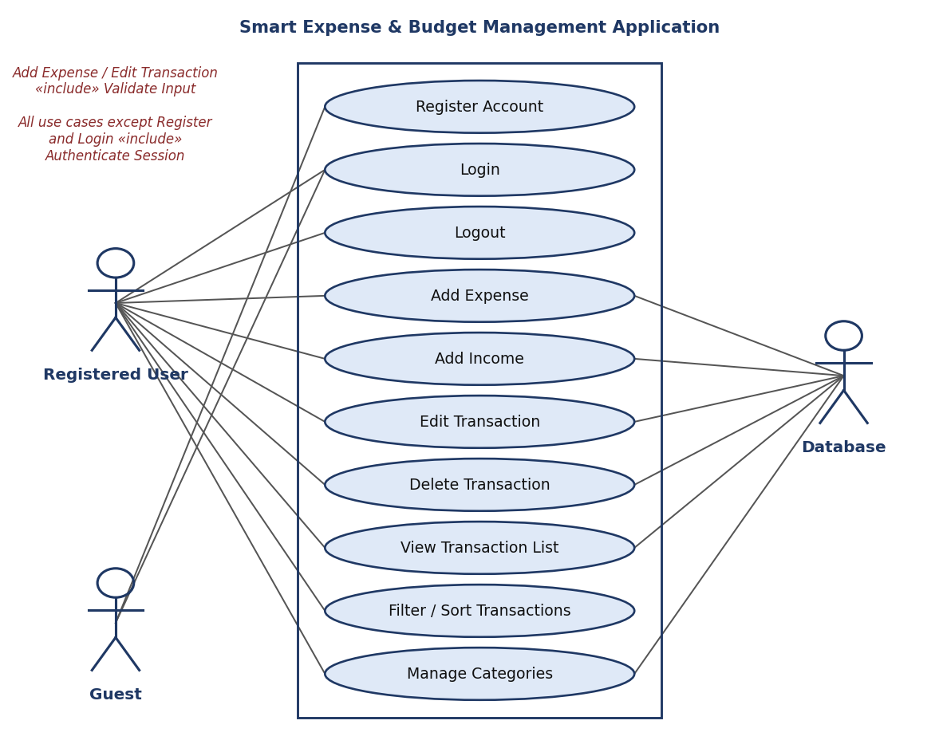
Figure 1 — Use-case diagram: account, transactions and categories

7.2 Diagram 2 — Budgets, dashboard and reports
Actors: Registered User (primary), Administrator (supporting), Database (supporting).
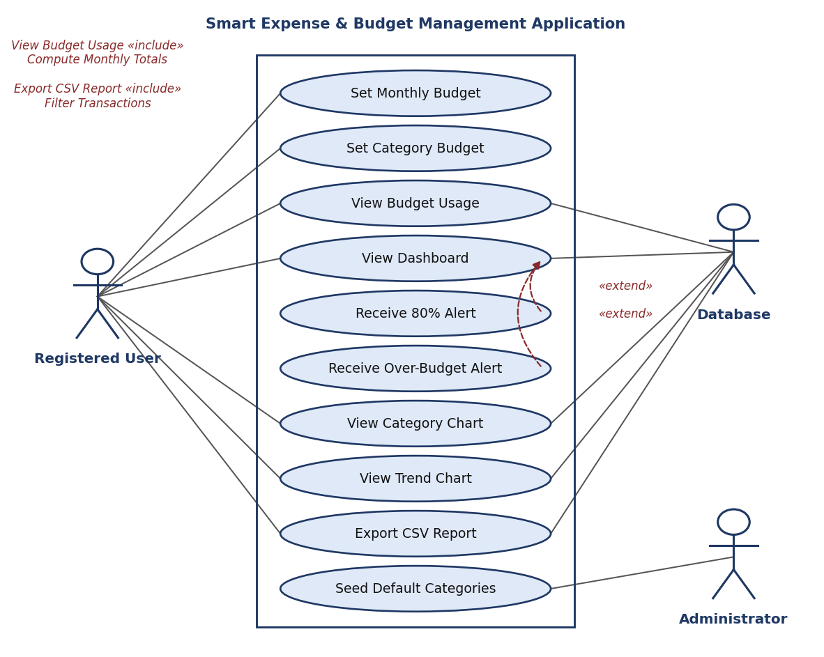
Figure 2 — Use-case diagram: budgets, dashboard and reports

8. Requirements Traceability Matrix (RTM)
Status: N = Not started, P = Partially implemented, A = Approved / verified.
Req ID | Requirement (short) | Section / Design spec | Module | Test case | Status
SEB-F-001 | User registration | 4.1 / DS-Auth-01 | AuthModule | TC-AUTH-01 | N
SEB-F-002 | User login | 4.1 / DS-Auth-02 | AuthModule | TC-AUTH-02 | N
SEB-F-003 | Logout and session guard | 4.1 / DS-Auth-03 | AuthModule | TC-AUTH-03 | N
SEB-F-004 | Per-user data isolation | 4.1 / DS-Auth-04 | AuthModule | TC-AUTH-04 | N
SEB-F-005 | Add expense | 4.2 / DS-Txn-01 | TransactionModule | TC-EXP-01 | N
SEB-F-006 | Add income | 4.2 / DS-Txn-02 | TransactionModule | TC-EXP-02 | N
SEB-F-007 | Input validation | 4.2 / DS-Txn-03 | TransactionModule | TC-EXP-03 | N
SEB-F-008 | Edit transaction | 4.2 / DS-Txn-04 | TransactionModule | TC-EXP-04 | N
SEB-F-009 | Delete transaction | 4.2 / DS-Txn-05 | TransactionModule | TC-EXP-05 | N
SEB-F-010 | Filter and sort list | 4.2 / DS-Txn-06 | TransactionModule | TC-EXP-06 | N
SEB-F-011 | Manage categories | 4.2 / DS-Cat-01 | CategoryModule | TC-CAT-01 | N
SEB-F-012 | Set monthly budget | 4.3 / DS-Bud-01 | BudgetModule | TC-BUD-01 | N
SEB-F-013 | Budget usage figures | 4.3 / DS-Bud-02 | BudgetModule | TC-BUD-02 | N
SEB-F-014 | Budget alerts | 4.3 / DS-Bud-03 | BudgetModule | TC-BUD-03 | N
SEB-F-015 | Dashboard totals | 4.4 / DS-Dsh-01 | ReportModule | TC-DSH-01 | N
SEB-F-016 | Charts | 4.4 / DS-Dsh-02 | ReportModule | TC-DSH-02 | N
SEB-F-017 | CSV export | 4.4 / DS-Rpt-01 | ReportModule | TC-RPT-01 | N
SEB-NF-001 | Page load ≤ 3 s | 5 / DS-Perf-01 | WebUI / API | TC-PERF-01 | N
SEB-NF-002 | 20 concurrent users | 5 / DS-Perf-02 | Server | TC-PERF-02 | N
SEB-NF-003 | Data durability | 5 / DS-Rel-01 | Database | TC-REL-01 | N
SEB-NF-004 | Ease of use | 5 / DS-UX-01 | WebUI | TC-UX-01 | N
SEB-NF-005 | Browser / mobile support | 5 / DS-Port-01 | WebUI | TC-PORT-01 | N
SEB-SR-001 | HTTPS everywhere | 5.1.2 / DS-Sec-01 | Deployment | TC-SEC-01 | N
SEB-SR-002 | Hashed passwords | 5.1.2 / DS-Sec-02 | AuthModule | TC-SEC-02 | N
SEB-SR-003 | Authorisation checks | 5.1.2 / DS-Sec-03 | AuthModule | TC-SEC-03 | N
SEB-SR-004 | Injection / XSS defence | 5.1.2 / DS-Sec-04 | All | TC-SEC-04 | N
SEB-SR-005 | Password policy, lockout | 5.1.2 / DS-Sec-05 | AuthModule | TC-SEC-05 | N

