|  |
| --- |
| SavgunKo GAmes |
| Game Design Document |
| **Flatland-Radness Game**  https://scontent-yyz1-1.xx.fbcdn.net/hphotos-xfl1/v/wl/t34.0-12/12825097_10207542846902595_425257518_n.jpg?oh=d491141292f44f35af175ba6308f6930&oe=56E59997 |
| Version #01  All work Copyright © 2012 by SavgunKo Games.  All rights reserved. |
| **George Savchenko & Jason Gunter** |
|  |

|  |
| --- |
| March 31, 2016 |

**Table of Contents**

Contents

**I.** **Game Overview** 5

**II.** **Game Play Mechanics** 5

**III.** **Camera** 5

**IV.** **Controls** 5

**V.** **Menu and Screen Descriptions** 5

**VI.** **Game World** 6

**VII.** **Levels** 6

**VIII.** **Game Progression** 6

**IX.** **Items** 6

**X.** **Scoring** 6

**XI.** **Bonuses** 6

**XII.** **Cheat Codes** 6

**XIII.** **Sound Index** 6

**XIV.** **Art / Multimedia Index** 7

**XV.** **Future Features** 7

**Version History**

<https://github.com/gsavchenko/Flatland-Radness-FullGame>

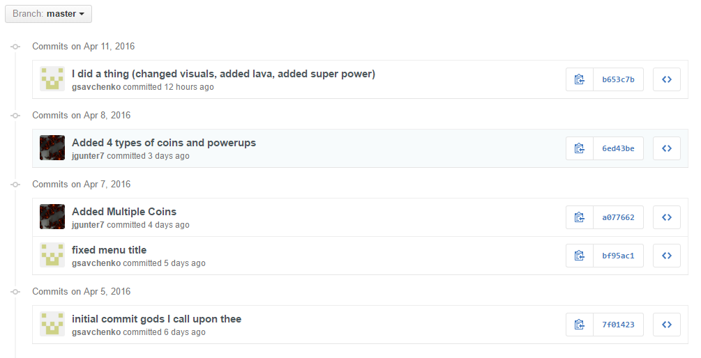

1. **Game Overview**

The player must avoid the angry bears that have escaped the local zoo! By pure circumstance a wizard has put a curse on the park the bears have gone to. It is up to the player to collect the mana balls for power ups and the escape the park (when the score is 30). The player was also cursed with the ability to make all objects levitate. The park’s ground now turns to lava periodically and will kill the player if they touch it.

1. **Game Play Mechanics**

The player will collect mana balls and use the keyboard and mouse keys to move their player to the goal.

The player must avoid the bears following them or the will lose health.

The player must manage their power charge level to be able to avoid touching the lava.

The floor will periodically change to lava which will instantly kill the player.

The player can collect special mana balls that will allow them to have special abilities.

The player can hide on top of platforms to avoid enemies and lava.

1. **Camera**

A first person camera will be used, as it is a requirement for this assignment.

1. **Controls**

The user will be able to use the up, down, left and right arrow keys to move the player forwards, backwards, left and right. In addition to this, the E key will allow the user to use their player’s levitation ability.

1. **Menu and Screen Descriptions**

**Menu:**

The menu will allow the user to start the game, read through the instruction screens, or exit the browser.

**Instructions:**

The instructions screen will allow the user to navigate the instruction pages with “Next” and “Back”, and will include a “Play” and “Menu” button for easy navigation for the user.

**Play:**

This option will play the main game.

**Game Over:**

This will be the game over screen, which will allow the player to go back to the main menu, or restart the game.

1. **Game World**

The player is in a square arena; the bears will follow the player throughout the arena for the player to avoid. Mana balls will also spawn to provide score and game changes to the player. Additional levels will increase difficulty and bring different power ups or changes to the game play. Collecting a certain number of mana balls will progress the player to the next levels. Level progression will include an increase amount of obstacles.

1. **Levels**

As mentioned above, each level will show different obstacles and power ups. This will be defined later as part 2 and 3 of this project.

1. **Game Progression**

The player will collect a certain amount of mana balls to proceed to the next level. Level 1 is for coins < 10, level 2 is for coins >= 10 but < 20, and level three will be for any player that has more than 20 coins collected.

1. **Items**

**Bear Object:**

This object is spherical in shape, and will slide around the arena area. If it collides with the player, it will make a sound, and decrease the player health for the period of contact.

**Mana Balls:**

This item will increase the player score and will respawn when the player collides with it. Different colour coins will provide different power ups or game play changes.

* Yellow
  + The yellow mana balls will simply increment the players score by 1
* Blue
  + The blue mana balls give the power up of “Boulders are Coins”, this allows the player score to increment by 1 when they hit a boulder
* Green
  + The green mana balls give the power up of “Immune”, this makes the player immune to the bears attacks
* Red
  + The red mana balls give the power up of “Enhanced Movement”, this makes the bears slower and the player much faster, allowing them to quickly navigate the arena

1. **Scoring**

The player score will be tracked by the net number of coins the player has lost or gained during game play.

1. **Bonuses**

Bonuses have not yet been determined.

1. **Cheat Codes**

Some cheats will be available from the console in the browser. This may be defined during the final stages of the project.

1. **Sound Index**
   1. Bling Sound (bling.wav)
   2. Collect Coin Sound (coin.mp3)
   3. Take Damage Sound (damage.mp3)
   4. Lose Game Sound (gamelost.wav)
   5. Win Game Sound (gameover.mp3)
   6. Player Hit Sound (hit.wav)
   7. Player Jump Sound (Land.wav)
   8. Chord Sound (yaychord.wav)
   9. Yeah Sound (yeah.mp3)
2. **Art / Multimedia Index**
   1. Bear texture (bear.png)

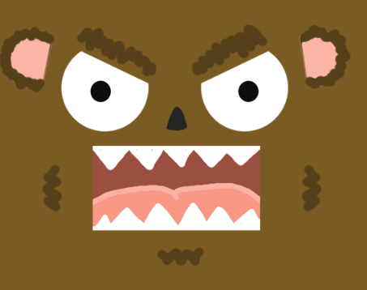

* 1. Wall texture (forest.png)

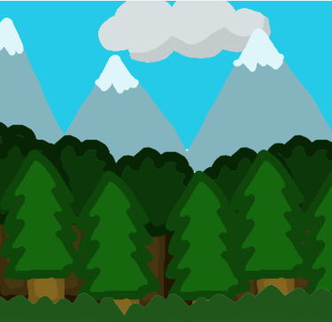

* 1. Mana Ball texture (yellow_t.png)



* 1. Mana ball texture (blue_t.png)



* 1. Mana ball texture (red_t.png)

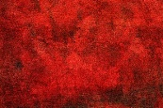

* 1. Mana ball texture (green_t.png)

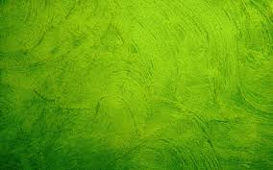

* 1. Exit Button (ExitButton.png)

C:\Users\Jason\Desktop\GIT\Flatland-Radness-FullGame\Assets\images\ExitButton.png

* 1. Rules Button (InstructionsButton.png)

C:\Users\Jason\Desktop\GIT\Flatland-Radness-FullGame\Assets\images\InstructionsButton.png

* 1. Start Button (StartButton.png)

C:\Users\Jason\Desktop\GIT\Flatland-Radness-FullGame\Assets\images\StartButton.png

* 1. Restart Button (RestartButton.png)

C:\Users\Jason\Desktop\GIT\Flatland-Radness-FullGame\Assets\images\RestartButton.png

1. **Future Features**

These will be updated once further progress has been made on the game.

1. **Wireframes**

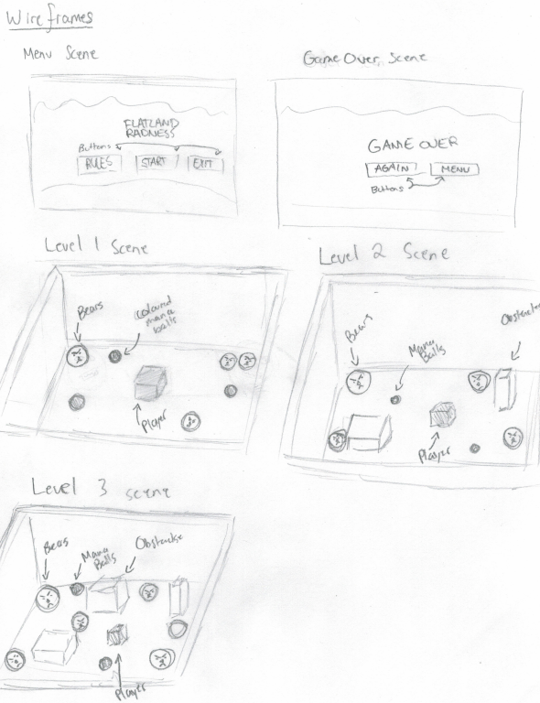

1. **Screenshots**

