|  |
| --- |
| SavgunKo GAmes |
| Game Design Document |
| **Uphill Madness Game**  https://scontent-yyz1-1.xx.fbcdn.net/hphotos-xfl1/v/wl/t34.0-12/12825097_10207542846902595_425257518_n.jpg?oh=d491141292f44f35af175ba6308f6930&oe=56E59997 |
| Version #01  All work Copyright © 2012 by SavgunKo Games.  All rights reserved. |
| **George Savchenko & Jason Gunter** |
|  |

|  |
| --- |
| March 11, 2016 |

**Table of Contents**

Contents

**I.** **Game Overview** 4

**II.** **Game Play Mechanics** 4

**III.** **Camera** 4

**IV.** **Controls** 4

**V.** **Menu and Screen Descriptions** 4

**VI.** **Game World** 5

**VII.** **Levels** 5

**VIII.** **Game Progression** 5

**IX.** **Items** 5

**X.** **Scoring** 5

**XI.** **Bonuses** 5

**XII.** **Cheat Codes** 6

**XIII.** **Sound Index** 6

**XIV.** **Art / Multimedia Index** 6

**XV.** **Future Features** 6

**Version History**

<https://github.com/gsavchenko/Uphill-Madness>

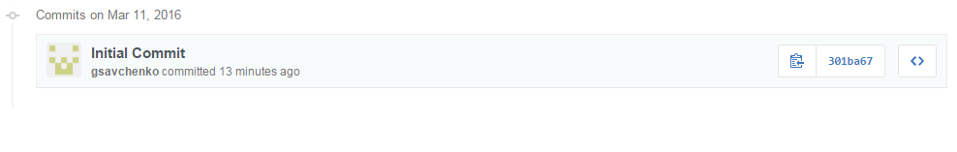

1. **Game Overview**

The player must avoid spherical objects that they encounter in the game to reach the top of the level. The player can move side-to-side and jump over the spheres to avoid them. The objective is to continue climbing up the hill and reach the top without losing all the player’s coins. Lastly, the player can collect coins to get a high score in the game.

1. **Game Play Mechanics**

The player will collect coins and use the arrow keys and keyboard to move their player to the goal.

1. **Camera**

A first person camera will be used, as it is a requirement for this assignment.

1. **Controls**

The user will be able to use the left and right arrow keys to move the player left and right. In addition to this, the user can use the space bar to jump.

1. **Menu and Screen Descriptions**

**Menu:**

The menu will allow the user to start the game.

**Main Game:**

This option will play the main game

1. **Game World**

The player is climbing up a spiral hill; the spherical objects are rolling down the hill, which the player has to avoid in order to complete the level. If we include additional levels, the difficulty will increase, but the spiral hill will likely remain the same.

1. **Levels**

If the game contains several levels, the difficulty and frequency of the obstacles should increase.

1. **Game Progression**

The player must reach the top of the hill to progress to different levels, they can also collect coins to attempt to beat the high score.

1. **Items**

**Spherical Object:**

This may take the form of a boulder, or sphere. If these objects collide with the player, the player will lose coins.

**Coins:**

This item will add addition coins when the player collides with it.

1. **Scoring**

The player score will be tracked by the net number of coins the player has lost or gained during game play.

1. **Bonuses**

Possible bonuses that may be added to this project:

* Soundtrack
* Textures

1. **Cheat Codes**

Some cheats will be available from the console in the browser. This may be defined during the final stages of the project.

1. **Sound Index**
   1. Background Music (background.wav)
   2. Collision (collide.wav)
   3. Coin Collection (coin.wav)
2. **Art / Multimedia Index**
   1. Sphere textures (textures.png)
   2. Plane texture (ground.png)
   3. Side-Hill texture (hill.png)
   4. Coin texture (coin.png)
3. **Future Features**

These will be updated once further progress has been made on the game.