COS 397: Computer Science Capstone I

**System Requirements Specification**

UMaine Athletic Department Inventory Management System



Version 0.3

Collin Rodrigue, Brennan Poitras, Graham Bridges, Gabe Poulin, Sean Radel

1 November 2023

#### Table of Contents

1. Introduction 1

1.1 Purpose of This Document 1

1.2. References 1

1.3. Purpose of the Product 1

1.4. Product Scope 2

2. Functional Requirements 4

2.1 Use Case Descriptions 19

3. Non-Functional Requirements 19

3.1 Non-Functional Requirements List 19

4. User Interface 22

5. Deliverables 22

5.1 List of Deliverables and Dates 22

6. Open Issues 23

Appendix A – Agreement Between Customer and Contractor 23

Appendix B – Team Review Sign-off 23

Appendix C – Document Contributions 23

# Introduction

This is a capstone project for the University of Maine Athletics Department, in partial fulfillment of the Computer Science BS degree for the University of Maine. The goal of this project is to build a solution for managing and tracking sports equipment and apparel. The key stakeholders for our project are Jude Killy, Nick Fox, and Kevin Ritz. Jude Killy submitted the project on behalf of the athletic department to combat the issue of an inefficient inventory management process. Currently, Nick Fox and Kevin Ritz are tasked with managing inventory orders and distribution of items to players and teams. This process is only documented on a spreadsheet, which can be found in section 1.2 References. The group aims to develop a solution that can increase the efficiency of entering data items, storing inventory data, and tracking the distribution to athletes and teams.

## 1.1 Purpose of This Document

The purpose of this document is to describe the core requirements of our inventory management system. After introducing our project, we describe our functional requirements using a UML diagram and further our explanation with use case specification tables. Next, we document our non-functional requirements, which describe aspects of the system like performance, reliability, scalability, compliance, security, etc. Functional requirements describe what the system should do, while non-functional requirements describe how the system should perform. Following our requirements, we describe our deliverables and preliminary schedule for those documents.

## 1.2. References

1. Athletic Department managed Google Drive containing all inventory tracking spreadsheets:<https://drive.google.com/drive/folders/1dclEKCke2CdXU3GNA5ee5VpROfOWX25w>
2. MITRE ATT&CK Matrix: <https://attack.mitre.org/>

## 1.3. Purpose of the Product

The purpose of the product is to fulfill the customer needs of an inventory management solution. Our system will replace the customer's previous solutions for managing their equipment. The customer previously used Front Rush and currently uses a combination of Excel spreadsheets and word of mouth to track inventory. Our product will allow the customer to organize their inventory by associating equipment with teams and players. The system will be designed with simplicity in mind so that they do not need experienced developers to maintain their product following the delivery date. Equipment, player accounts, and teams will be able to be made on the fly to allow the system to scale to the customer's needs.

## 1.4. Product Scope

The top level use case diagrams define the scope of our product. All product features are abstractly defined.

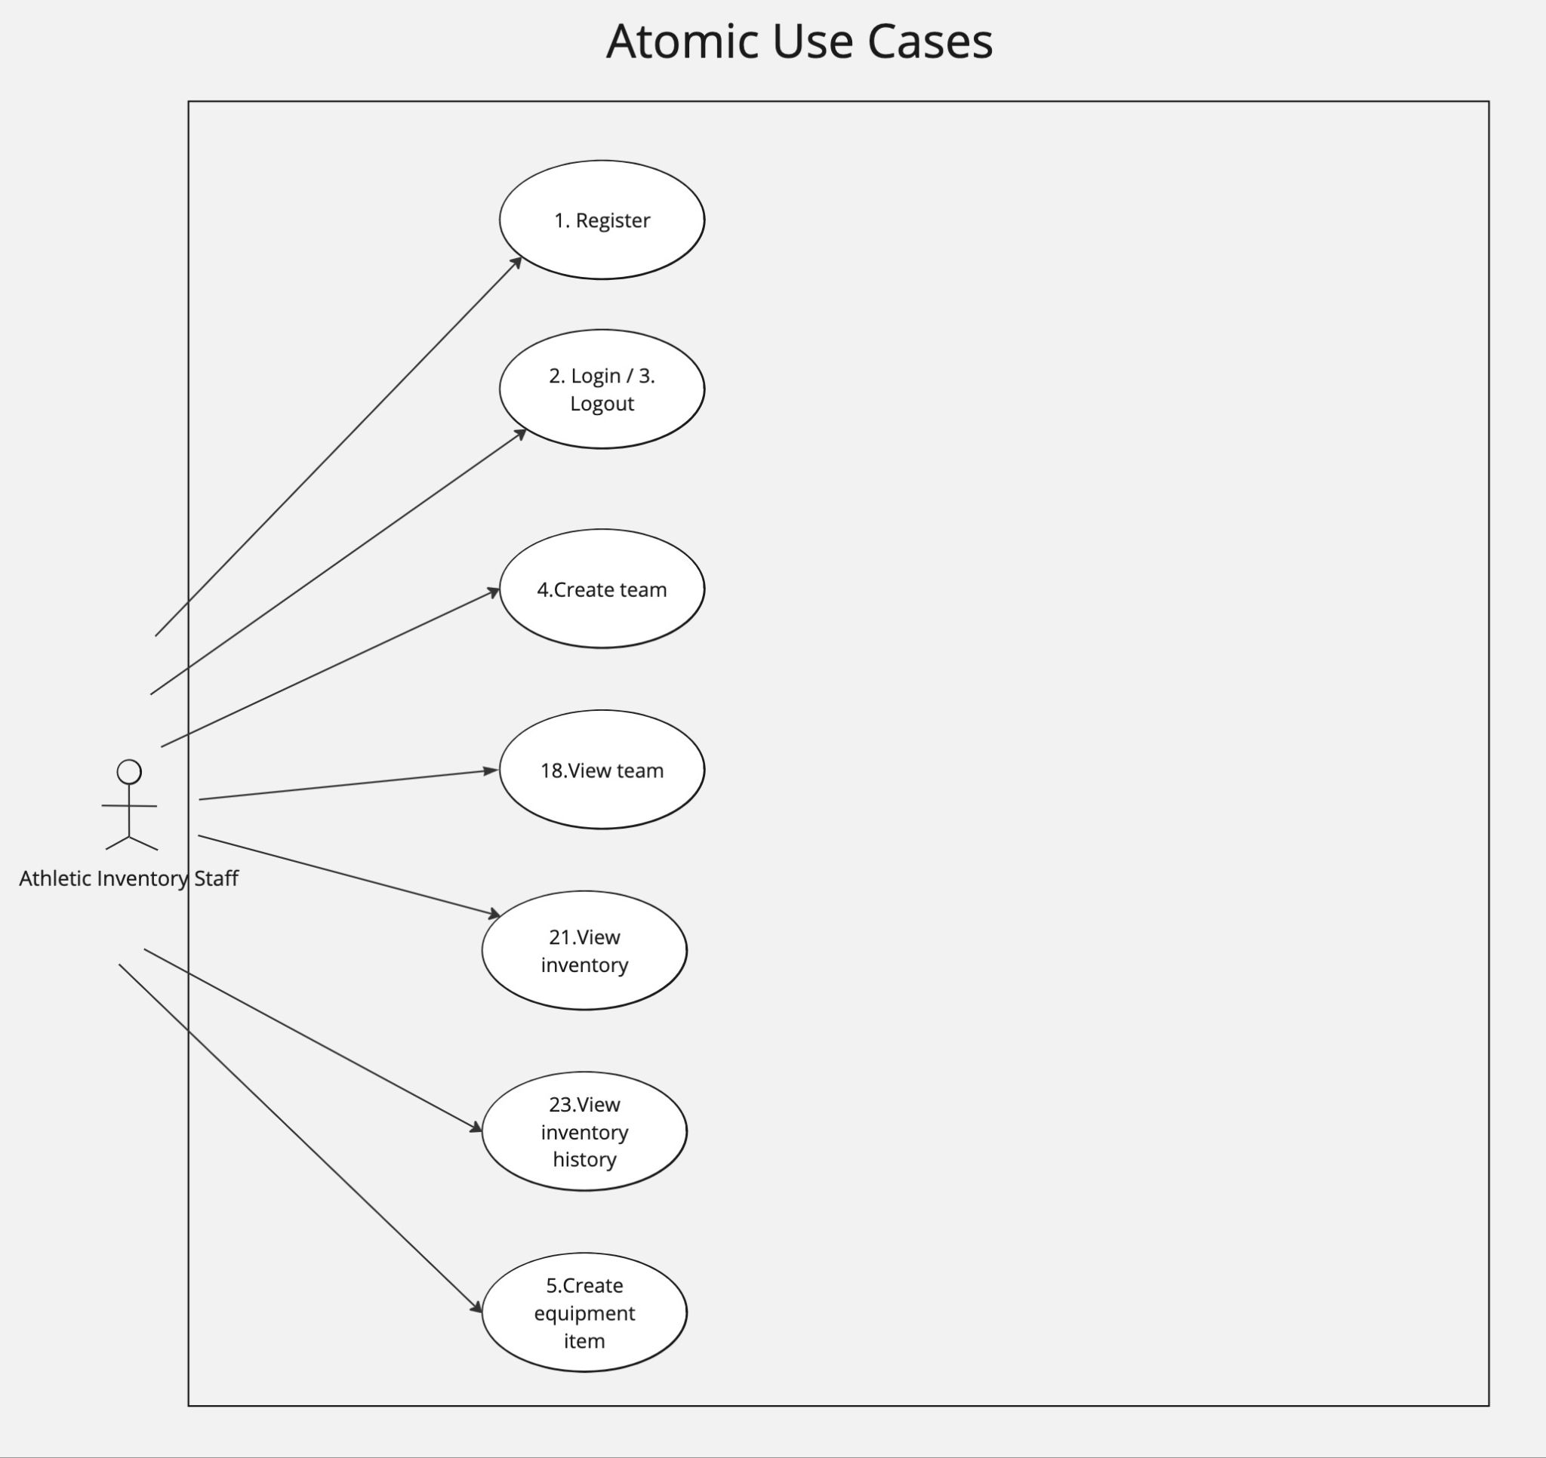

Figure 1. Atomic Use Case Diagram

The atomic use case diagram represents the most critical features and elements of the application. These features will be used regularly and will be easily accessible through the user interface.

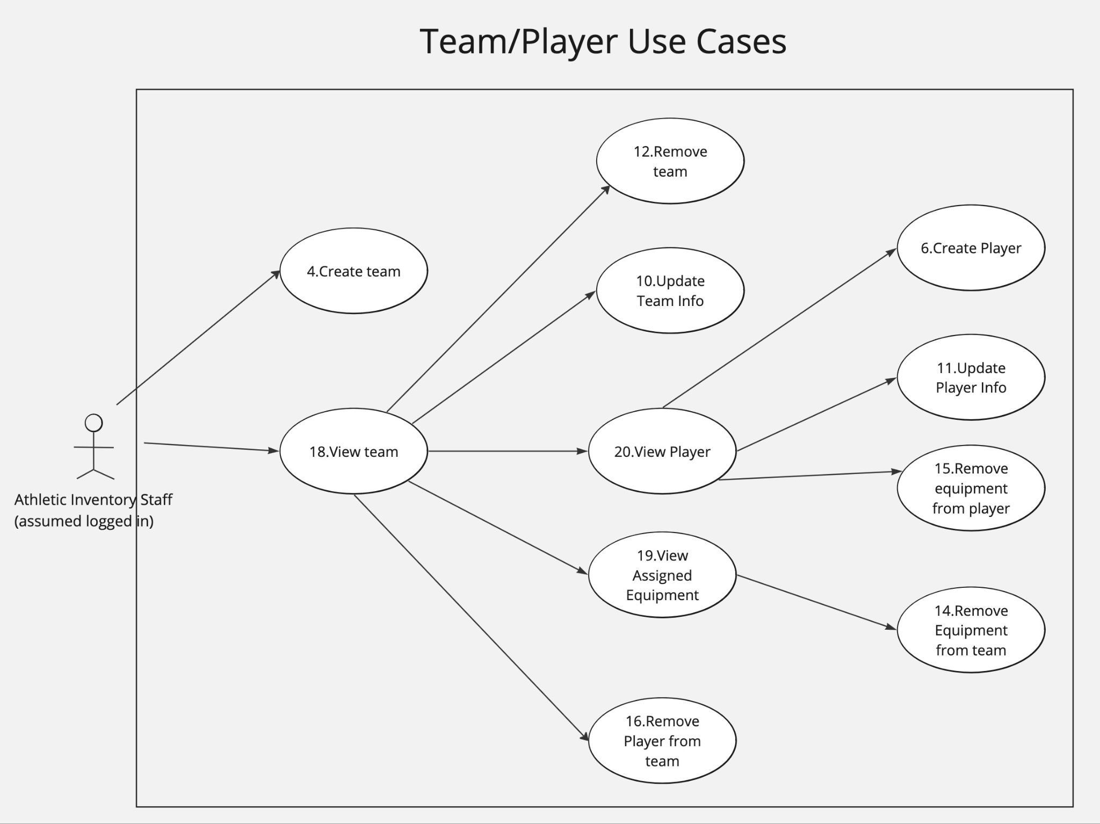

Figure 2. Team and Player Use Cases

The Team and Player use case diagram represents product features related to sports teams and the players on those teams. These actions mainly include the removal and update of equipment, teams, and players.

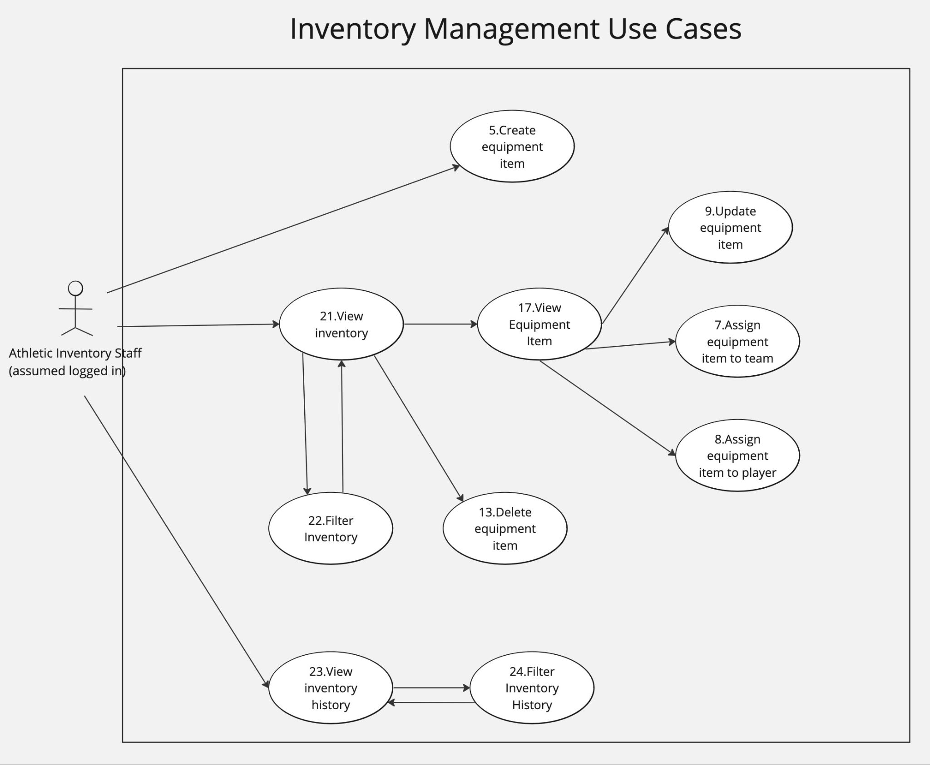

Figure 3. Inventory Management Use Cases

The Inventory Management use case diagram represents the standard behaviors of an inventory system including input of new inventory, output of inventory to teams and players, and viewing all products that are currently being stored.

# 2. Functional Requirements

Functional requirements define the features and use cases that the system possesses to meet customer needs. Our use case descriptions expand on the top level use case diagrams in Section 1.4. The functional requirements describe how users can interact with the system and what the expected preconditions and postconditions will be. Furthermore, we define test cases to verify that our system meets requirements.

## 2.1 Use Case Descriptions

| **Number** | 1 | |
| --- | --- | --- |
|  |  | |
| Name | Register | |
| **Summary** | User registers account in the system’s database | |
| **Priority** | 5 | |
| **Preconditions** | User must be on the website  User must have a valid maine.edu email | |
| **Postconditions** | User has created a registered account in the system | |
| **Primary Actor** | Athletic Inventory Staff | |
| **Secondary Actors** |  | |
| **Trigger** | User clicks “Register” on web page | |
| **Main Scenario** | **Step** | **Action** |
|  | 1 | User clicks “Register” button |
|  | 2 | User enters maine.edu email |
|  | 3 | User creates password for account |
|  | 4 | Account creation is approved by system admin |
|  | 5 | Account is successfully created |
| **Extensions** | **Step** | **Branching Action** |
|  | 2a | Chosen maine.edu email already has an account:   * System displays a message stating “That maine.edu email already has a registered account. Choose another email or log in with the selected account”. |
|  | 2b | Chosen email isn’t a maine.edu email:   * System displays message saying “Please enter a maine.edu email” |
|  | 3a | Users password doesn’t contain an uppercase letter, lowercase letter, number, and a special character contained in it, and/or it is less than nine characters long:   * System requests that the user changes the password so that it meets the requirements above |
|  | 4a | Account creation isn’t approved by system admin:   * User’s account is not established in the system |
| **Open Issues** | Will registering and logging in be done through a portal to the maine.edu system, such as with brightspace and maine street? Or will users be able to set up a new password different from their umaine.edu password? | |
| **Test Case** | Query the database to confirm there is a record associated with the created account. | |

| **Number** | 2 | |
| --- | --- | --- |
|  |  | |
| Name | Log in | |
| **Summary** | User logs into website in order to access other functions | |
| **Priority** | 5 | |
| **Preconditions** | User must be on the website  User must not be logged in already  User must have a valid account | |
| **Postconditions** | User is logged in | |
| **Primary Actor** | Athletic Inventory Staff | |
| **Secondary Actors** |  | |
| **Trigger** | User clicks “Log in” button on web page | |
| **Main Scenario** | **Step** | **Action** |
|  | 1 | User clicks “Log in” button |
|  | 2 | User inputs maine.edu email and password |
|  | 3 | User confirms log in and presses “continue” |
|  | 4 | User is redirected to homepage logged in |
| **Extensions** | **Step** | **Branching Action** |
|  | 2a | User clicks “forgot password”:   * “Reset Password” use case is triggered and user is redirected |
|  | 3a | User’s login credentials are incorrect:   * User is redirected to log in page and message saying “invalid credentials” appears |
| **Open Issues** | Decide how many attempts are allowed for the user to log in and what should be done when the threshold is met | |
| **Test Case** | Scan the HTML document to see if the user is no longer on the log in page. | |

| **Number** | 3 | |
| --- | --- | --- |
|  |  | |
| Name | Log out | |
| **Summary** | User logs out of website and returns to homepage signed out | |
| **Priority** | 5 | |
| **Preconditions** | User must be on the website  User must be logged in | |
| **Postconditions** | User is logged out | |
| **Primary Actor** | Athletic Inventory Staff | |
| **Secondary Actors** |  | |
| **Trigger** | User clicks “Log out” button on web page | |
| **Main Scenario** | **Step** | **Action** |
|  | 1 | User clicks “Log out” button |
|  | 2 | User is redirected to homepage logged out |
| **Extensions** | **Step** | **Branching Action** |
|  | N/A |  |
| **Open Issues** | Should users be logged out of their account after a certain amount of time idle on the website? If so, how long should this timer be? | |
| **Test Case** | Scan the HTML document to see if the user is on the log in page. | |

| **Number** | 4 | |
| --- | --- | --- |
|  |  | |
| Name | Create a new team | |
| **Summary** | Input a new sports team along with team details | |
| **Priority** | 5 | |
| **Preconditions** | User is logged in. | |
| **Postconditions** | The database will contain a record matching the created team object. | |
| **Primary Actor** | Athletic Inventory Staff | |
| **Secondary Actors** |  | |
| **Trigger** | The user clicks a button titled “Add a new team” | |
| **Main Scenario** | **Step** | **Action** |
|  | 1 | User clicks “Add a new team” |
|  | 2 | User inputs team details (sport, gender, season, etc.) |
|  | 3 | User clicks a confirmation button |
| **Extensions** | **Step** | **Branching Action** |
|  | 2a | A team already exists with the exact same parameters(sport, gender season, etc.):   * System displays a message saying “A team with these parameters already exists. Please choose different parameters or delete the previous team” * Creation of the new team is prevented until the parameters aren’t the same as another team |
|  | 3a | Not all required parameters are set for the team:   * System tells the user they must fill out all required parameters before the team can be created |
| **Open Issues** | What parameters should be required when making a team? | |
| **Test Case** | Query the database to confirm it contains a record matching the created team object. | |

| **Number** | 5 | |
| --- | --- | --- |
|  |  | |
| Name | Create an equipment item | |
| **Summary** | Input a new equipment item along with its equipment details | |
| **Priority** | 5 | |
| **Preconditions** | User is logged in. | |
| **Postconditions** | The database will contain a record matching the created equipment item object. | |
| **Primary Actor** | Athletic Inventory Staff | |
| **Secondary Actors** |  | |
| **Trigger** | The user clicks a button titled “Add new equipment item” | |
| **Main Scenario** | **Step** | **Action** |
|  | 1 | User clicks “Add new equipment item” |
|  | 2 | User inputs equipment details (name, description, quantity, etc.) |
|  | 3 | User clicks a confirmation button |
| **Extensions** | **Step** | **Branching Action** |
|  | 2a | An item already exists containing the same name:   * System informs the user that an item with the same name already exists * System prevent creation of the new item until the name is changed to something not already taken |
| **Open Issues** |  | |
| **Test Case** | Query the database to confirm it contains a record matching the created equipment item object. | |

| **Number** | 6 | |
| --- | --- | --- |
|  |  | |
| Name | Create a new player | |
| **Summary** | Input a new athlete along with their details, and assign them to a sports team. | |
| **Priority** | 5 | |
| **Preconditions** | At least 1 sports team must have been created.  User is logged in. | |
| **Postconditions** | The database will contain a record matching the created player object. | |
| **Primary Actor** | Athletic Inventory Staff | |
| **Secondary Actors** |  | |
| **Trigger** | The user clicks a button titled “Add a new player” | |
| **Main Scenario** | **Step** | **Action** |
|  | 1 | User clicks on the team they wish to assign a player. |
|  | 2 | User clicks “Add a new player” |
|  | 3 | User inputs player details (name, height, weight, class, etc.) |
|  | 4 | User clicks a confirmation button |
| **Extensions** | **Step** | **Branching Action** |
|  | N/A |  |
| **Open Issues** | What if two players have the same name? Should they automatically be numbered 1 and 2 in the system? Or should the user be responsible for differentiating the two players? | |
| **Test Case** | Query the database to confirm it contains a record matching the created player object. | |

| **Number** | 7 | |
| --- | --- | --- |
|  |  | |
| Name | Assign equipment item to team | |
| **Summary** | An existing equipment item will be assigned to a sports team. | |
| **Priority** | 5 | |
| **Preconditions** | At least 1 equipment item must have been created.  At least 1 team must have been created.  User is logged in. | |
| **Postconditions** |  | |
| **Primary Actor** | Athletic Inventory Staff | |
| **Secondary Actors** |  | |
| **Trigger** | The user clicks a button titled “Assign equipment to team” | |
| **Main Scenario** | **Step** | **Action** |
|  | 1 | User clicks on an equipment item |
|  | 2 | User clicks “Assign equipment to team” |
|  | 3 | User clicks the team they wish to assign equipment to |
|  | 4 | User enters desired amount |
|  | 5 | User clicks a confirmation button |
| **Extensions** | **Step** | **Branching Action** |
|  | 4a | The desired amount of the item isn’t available:   * System displays message saying “Only X amount of this item is available for assignment”, X being the quantity of the item unassigned to teams |
| **Open Issues** |  | |
| **Test Case** | Query the database to confirm it contains a relationship between the desired team and the desired equipment item. | |

| **Number** | 8 | |
| --- | --- | --- |
|  |  | |
| Name | Assign equipment to player | |
| **Summary** | A player will be assigned equipment specific to them | |
| **Priority** | 4 | |
| **Preconditions** | At least 1 equipment item must exist  At least 1 team must exist  At least 1 player must have been assigned to a team  User is logged in. | |
| **Postconditions** |  | |
| **Primary Actor** | Athletic Inventory Staff | |
| **Secondary Actors** |  | |
| **Trigger** | The user clicks a button titled “Assign equipment to player” | |
| **Main Scenario** | **Step** | **Action** |
|  | 1 | User clicks on an equipment item |
|  | 2 | User clicks “Assign equipment to player” |
|  | 3 | User clicks on the players associated team |
|  | 4 | User clicks on the player they wish to assign equipment to |
|  | 5 | User enter quantity of the item to be assigned to the player |
|  | 6 | User clicks a confirmation button |
| **Extensions** | **Step** | **Branching Action** |
|  | 5a | The desired amount of the item isn’t available:   * System displays message saying “Only X amount of this item is available for assignment”, X being the quantity of the item unassigned to players out of the team’s assigned equipment |
| **Open Issues** |  | |
| **Test Case** | Query the database to confirm it contains a relationship between the desired player and the desired equipment item. | |

| **Number** | 9 | |
| --- | --- | --- |
|  |  | |
| Name | Update equipment item | |
| **Summary** | Update the details of a previously created equipment item | |
| **Priority** | 4 | |
| **Preconditions** | At least 1 equipment item must have been created  User is logged in. | |
| **Postconditions** | The database will contain an updated record matching the updated equipment object. | |
| **Primary Actor** | Athletic Inventory Staff | |
| **Secondary Actors** |  | |
| **Trigger** | The user clicks a button titled “Update equipment item” | |
| **Main Scenario** | **Step** | **Action** |
|  | 1 | User clicks on an equipment item |
|  | 2 | User clicks “Update equipment item” |
|  | 3 | User updates fields with desired detail changes. |
|  | 4 | User clicks a confirmation button |
| **Extensions** | **Step** | **Branching Action** |
|  | 3a | User changes name of the item to a name already being used by another item:   * System displays message saying “Name is already in use, please choose another name” * System prevents item from being updated until the name is different from other names in the database |
| **Open Issues** |  | |
| **Test Case** | Query the database to confirm if the record associated with the equipment item was updated correctly. | |

| **Number** | 10 | |
| --- | --- | --- |
|  |  | |
| Name | Update team info | |
| **Summary** | Update details of a sports team | |
| **Priority** | 4 | |
| **Preconditions** | At least 1 team must have been created  User is logged in. | |
| **Postconditions** | The database will contain an updated record matching the updated team object. | |
| **Primary Actor** | Athletic Inventory Staff | |
| **Secondary Actors** |  | |
| **Trigger** | The user clicks a button titled “Update team details” | |
| **Main Scenario** | **Step** | **Action** |
|  | 1 | User clicks on the sports team they wish to update |
|  | 2 | User clicks “Update team details” |
|  | 3 | User updates desired team details (sport, gender, season, etc.) |
|  | 4 | User clicks a confirmation button |
| **Extensions** | **Step** | **Branching Action** |
|  | 3a | Updated parameters are the same as another existing team:   * System displays a message saying “A team already exists with the same parameters. Please choose different parameters” * System prevents user from updating the team before changing the parameters |
| **Open Issues** |  | |
| **Test Case** | Query the database to confirm if the record associated with the team was updated correctly. | |

| **Number** | 11 | |
| --- | --- | --- |
|  |  | |
| Name | Update player info | |
| **Summary** | Update details of an athlete | |
| **Priority** | 4 | |
| **Preconditions** | At least 1 player must have been created  User is logged in. | |
| **Postconditions** | The database will contain an updated record matching the updated player object. | |
| **Primary Actor** | Athletic Inventory Staff | |
| **Secondary Actors** |  | |
| **Trigger** | The user clicks a button titled “Update player info” | |
| **Main Scenario** | **Step** | **Action** |
|  | 1 | User clicks on team containing player that they wish to update |
|  | 2 | User clicks on the player they wish to update |
|  | 3 | User clicks “Update player info” |
|  | 4 | User updates desired player details (name, height, weight, class, etc.) |
|  | 5 | User clicks a confirmation button |
| **Extensions** | **Step** | **Branching Action** |
|  | N/A |  |
| **Open Issues** |  | |
| **Test Case** | Query the database to confirm if the record associated with the player was updated correctly. | |

| **Number** | 12 | |
| --- | --- | --- |
|  |  | |
| Name | Remove Team | |
| **Summary** | User removes athletic team from the system | |
| **Priority** | 4 | |
| **Preconditions** | Team desired to be deleted is in the system  User is logged in | |
| **Postconditions** | Deleted team is removed from the system | |
| **Primary Actor** | Athletic Inventory Staff | |
| **Secondary Actors** |  | |
| **Trigger** | User clicks “remove team” below team display | |
| **Main Scenario** | **Step** | **Action** |
|  | 1 | System asks user to enter their password |
|  | 2 | User must confirm they wish to remove the team once more |
|  | 3 | Team is deleted from the system |
|  | 4 | User is redirected back to “view teams” page |
| **Extensions** | **Step** |  |
|  | 1a | User’s password is incorrect:  System displays “incorrect password and lets the user try again” |
| **Open Issues** | Decide how many attempts are given to the user to enter their password and what should be done when the threshold is met  Are players assigned to that team also deleted?  Is equipment assigned to the deleted team and its players deleted or made available for assignment to other teams? | |
| **Test Case** | Query the database to confirm a record does not exist for the desired team. | |

| **Number** | 13 | |
| --- | --- | --- |
|  |  | |
| Name | Remove equipment item from inventory | |
| **Summary** | Removing an equipment item from the entire inventory and the teams and players that were assigned the equipment. | |
| **Priority** | 5 | |
| **Preconditions** | An equipment item must have been created  User is logged in. | |
| **Postconditions** | The database will no longer contain a record matching the equipment item.  The equipment item will no longer be assigned to any teams.  The equipment item will no longer be assigned to any players. | |
| **Primary Actor** | Athletic Inventory Staff | |
| **Secondary Actors** |  | |
| **Trigger** | The user clicks a button titled “Delete equipment item” | |
| **Main Scenario** | **Step** | **Action** |
|  | 1 | User clicks on an equipment item |
|  | 2 | User clicks “Delete equipment item” |
|  | 3 | User receives a warning and clicks a confirmation button |
| **Extensions** | **Step** | **Branching Action** |
|  | N/A |  |
| **Open Issues** |  | |
| **Test Cases** | Query the database to confirm a record does not exist for the desired equipment item. | |

| **Number** | 14 | |
| --- | --- | --- |
|  |  | |
| Name | Remove equipment item from team | |
| **Summary** | Removing an equipment item from a team to which it was assigned. | |
| **Priority** | 4 | |
| **Preconditions** | At least 1 equipment item must have been assigned to the team.  User is logged in. | |
| **Postconditions** |  | |
| **Primary Actor** | Athletic Inventory Staff | |
| **Secondary Actors** |  | |
| **Trigger** | The user clicks a button titled “Remove equipment item from team” | |
| **Main Scenario** | **Step** | **Action** |
|  | 1 | User clicks on a team they wish to remove equipment from. |
|  | 2 | User clicks on “Assigned Equipment” |
|  | 3 | User clicks on the equipment item they wish to remove |
|  | 4 | User clicks “Remove equipment item from team” |
|  | 5 | User receives a warning and clicks a confirmation button |
| **Extensions** | **Step** | **Branching Action** |
|  | N/A |  |
| **Open Issues** |  | |
| **Test Case** | Query the database to confirm a relationship does not exist between the desired equipment item and the desired team. | |

| **Number** | 15 | |
| --- | --- | --- |
|  |  | |
| Name | Remove equipment item from a player | |
| **Summary** | Removing an equipment item from a player to which it was assigned | |
| **Priority** | 4 | |
| **Preconditions** | At least 1 equipment item must have been assigned to the player  User is logged in. | |
| **Postconditions** |  | |
| **Primary Actor** | Athletic Inventory Staff | |
| **Secondary Actors** |  | |
| **Trigger** | The user clicks a button titled “Remove equipment item from player” | |
| **Main Scenario** | **Step** | **Action** |
|  | 1 | User clicks on a team with the desired player |
|  | 2 | User clicks on the player they wish to remove equipment from |
|  | 3 | User clicks on the equipment item they wish to remove |
|  | 4 | User clicks “Remove equipment item from player” |
|  | 5 | User receives a warning and clicks a confirmation button |
| **Extensions** | **Step** | **Branching Action** |
|  | N/A |  |
| **Open Issues** |  | |
| **Test Case** | Query the database to confirm a relationship does not exist between the desired equipment item and the desired player. | |

| **Number** | 16 | |
| --- | --- | --- |
|  |  | |
| Name | Remove player from team | |
| **Summary** | Removing player from the team they were assigned | |
| **Priority** | 5 | |
| **Preconditions** | At least 1 player must be assigned to a team  User is logged in. | |
| **Postconditions** |  | |
| **Primary Actor** | Athletic Inventory Staff | |
| **Secondary Actors** |  | |
| **Trigger** | The user clicks a button titled “Remove player from team” | |
| **Main Scenario** | **Step** | **Action** |
|  | 1 | User clicks on the team containing the player they wish to remove |
|  | 2 | User hovers over player they wish to remove |
|  | 3 | User clicks “Remove player from team” |
|  | 4 | User receives a warning and clicks a confirmation button |
| **Extensions** | **Step** | **Branching Action** |
|  | N/A |  |
| **Open Issues** | What happens to equipment assigned to the deleted player? Is it returned to the team unassigned or deleted? | |
| **Test Case** | Query the database to confirm a relationship does not exist between the desired player and the desired team. | |

| **Number** | 17 | |
| --- | --- | --- |
|  |  | |
| Name | Viewing Equipment Item | |
| **Summary** | The user can view equipment item details, including name, description, quantity, image, color, etc. | |
| **Priority** | 5 | |
| **Preconditions** | An equipment item must have been created  User is logged in. | |
| **Postconditions** |  | |
| **Primary Actor** | Athletic Inventory Staff | |
| **Secondary Actors** |  | |
| **Trigger** | The user clicks on an equipment item | |
| **Main Scenario** | **Step** | **Action** |
|  | 1 | User clicks on an equipment item |
| **Extensions** | **Step** | **Branching Action** |
|  | N/A |  |
| **Open Issues** |  | |
| **Test Case** | Scan the HTML document and query the database to confirm the data displayed on the screen matches the data associated with the equipment record. | |

| **Number** | 18 | |
| --- | --- | --- |
|  |  | |
| Name | Viewing a teams roster | |
| **Summary** | View all players listed on the roster for team | |
| **Priority** | 5 | |
| **Preconditions** | A team must have at least 1 player assigned to it  User is logged in. | |
| **Postconditions** |  | |
| **Primary Actor** | Athletic Inventory Staff | |
| **Secondary Actors** |  | |
| **Trigger** | The user clicks the team for which roster they want to view | |
| **Main Scenario** | **Step** | **Action** |
|  | 1 | User clicks on a team |
| **Extensions** | **Step** | **Branching Action** |
|  | N/A |  |
| **Open Issues** |  | |
| **Test Case** | Scan the HTML document and query the database to confirm the data displaying on the screen matches the data associated with the team record. | |

| **Number** | 19 | |
| --- | --- | --- |
|  |  | |
| Name | Viewing a teams assigned equipment | |
| **Summary** | View all the equipment items that have been assigned to a team | |
| **Priority** | 5 | |
| **Preconditions** | At least 1 equipment item must have been assigned to the team  User is logged in. | |
| **Postconditions** |  | |
| **Primary Actor** | Athletic Inventory Staff | |
| **Secondary Actors** |  | |
| **Trigger** | The user clicks on “Assigned Equipment” | |
| **Main Scenario** | **Step** | **Action** |
|  | 1 | User clicks on a team for which they wish to view assigned equipment |
|  | 2 | User clicks “Assigned Equipment” |
| **Extensions** | **Step** | **Branching Action** |
|  | N/A |  |
| **Open Issues** |  | |
| **Test Case** | Scan the HTML document and query the database to confirm the data displaying on the screen matches the data associated with the relationship between the team and its assigned equipment. | |

| **Number** | 20 | |
| --- | --- | --- |
|  |  | |
| Name | Viewing a player | |
| **Summary** | View the details associated with a player | |
| **Priority** | 5 | |
| **Preconditions** | At least 1 player must be assigned to a team  User is logged in. | |
| **Postconditions** |  | |
| **Primary Actor** | Athletic Inventory Staff | |
| **Secondary Actors** |  | |
| **Trigger** | The user clicks on a players name on the team roster list | |
| **Main Scenario** | **Step** | **Action** |
|  | 1 | User clicks on a team containing the player they wish to view |
|  | 2 | User clicks on the players name they wish to view |
| **Extensions** | **Step** | **Branching Action** |
|  | N/A |  |
| **Open Issues** |  | |
| **Test Case** | Scan the HTML document and query the database to confirm the data displayed on the screen matches the data associated with the player record. | |

| **Number** | 21 | |
| --- | --- | --- |
|  |  | |
| Name | Viewing general inventory | |
| **Summary** | The user can view all of the current equipment items in the inventory room, assigned to a team, or assigned to a player. | |
| **Priority** | 5 | |
| **Preconditions** | An equipment item must have been created  User is logged in. | |
| **Postconditions** | The user is shown all equipment items in the system | |
| **Primary Actor** | Athletic Inventory Staff | |
| **Secondary Actors** |  | |
| **Trigger** | The user clicks a button titled “Inventory” | |
| **Main Scenario** | **Step** | **Action** |
|  | 1 | User clicks on “Inventory” |
| **Extensions** | **Step** | **Branching Action** |
|  | N/A |  |
| **Open Issues** |  | |
| **Test Case** | Scan the HTML document to confirm the user is on the inventory screen. | |

| **Number** | 22 | |
| --- | --- | --- |
|  |  | |
| Name | Filter general inventory | |
| **Summary** | The user can filter the general inventory by name, team equipment, and type | |
| **Priority** | 3 | |
| **Preconditions** | User is on equipment inventory screen  User is logged in. | |
| **Postconditions** | Inventory on screen is updated to show only equipment that matches the filters | |
| **Primary Actor** | Athletic Inventory Staff | |
| **Secondary Actors** |  | |
| **Trigger** | User clicks “filter”while viewing inventory | |
| **Main Scenario** | **Step** | **Action** |
|  | 1 | User selects desired filters |
|  | 2 | User confirms filter |
|  | 3 | Display is updated to show filtered equipment |
| **Extensions** | **Step** | **Branching Action** |
|  | 3a | No equipment matches selected filters:  System displays message saying no equipment matches search |
| **Open Issues** | Decide important filter options for the user | |
| **Test Case** | Query the database to confirm the returned, filtered records match the equipment items displayed on the screen. | |

| **Number** | 23 | |
| --- | --- | --- |
|  |  | |
| Name | Viewing inventory history | |
| **Summary** | Viewing a history of all previous inventory transactions including creating an item, assigning an item, updating an item, and deleting an item. This also includes team and player transactions. | |
| **Priority** | 5 | |
| **Preconditions** | At least 1 previous inventory action must have been taken  User is logged in. | |
| **Postconditions** |  | |
| **Primary Actor** | Athletic Inventory Staff | |
| **Secondary Actors** |  | |
| **Trigger** | The user clicks a button titled “Inventory History” | |
| **Main Scenario** | **Step** | **Action** |
|  | 1 | User clicks on “Inventory History” |
| **Extensions** | **Step** | **Branching Action** |
|  | N/A |  |
| **Open Issues** |  | |
| **Test Case** | Scan the HTML document to confirm the user is on the inventory history screen. | |

| **Number** | 24 | |
| --- | --- | --- |
|  |  | |
| Name | Filtering Inventory History | |
| **Summary** | Filtering the inventory history on the inventory history page so the user can search for specific transactions | |
| **Priority** | 3 | |
| **Preconditions** | User is on inventory history page  User is logged in. | |
| **Postconditions** | System is displaying filtered inventory history | |
| **Primary Actor** | Athletic Inventory Staff | |
| **Secondary Actors** |  | |
| **Trigger** | The user clicks “filter” on inventory history page | |
| **Main Scenario** | **Step** | **Action** |
|  | 1 | User applies desired history filters including specific items, teams, players, date range, etc. |
|  | 2 | User confirms desired filters |
|  | 3 | Display is updated to show filtered history |
| **Extensions** | **Step** | **Branching Action** |
|  | 3a | No inventory history matches applied filters:  System displays message saying no transaction matches search |
| **Open Issues** |  | |
| **Test Case** | Query the database to confirm the returned, filtered records match the history records displayed on the screen. | |

# 3. Non-Functional Requirements

Non-Functional Requirements define aspects of how the system will perform. These requirements are imperative to ensuring the system functions with the desired quality and performance.

## 3.1 Non-Functional Requirements List

| **NFR-001** | **Priority:** 3 |
| --- | --- |
| **Description:** The system must provide data security for athlete and inventory information via encryption at rest and in transit. | |
| **Test Case:** Query the data without encryption keys to ensure the data is encrypted | |

| **NFR-002** | **Priority:** 3 |
| --- | --- |
| **Description:** The system should ensure a response time of under 3 seconds for the inventory item filter. | |
| **Test Case:** By running a repeated access attempt on different items and filters, we should be able to graph the response time of each access attempt. | |

| **NFR-003** | **Priority:** 5 |
| --- | --- |
| **Description:** The system must be available for use 99.9% of the time. | |
| **Test Case:** Having a downtime detector will allow for accurate graphing of real-time downage. | |

| **NFR-004** | **Priority:** 5 |
| --- | --- |
| **Description:** The system should be compatible with all major web browsers using Chromium 80.0.3987.33 and later. | |
| **Test Case:** Running the application on major browsers such as Edge, Chrome, and OperaGX will show compatibility with other browsers running on Chromium. | |

| **NFR-005** | **Priority:** 5 |
| --- | --- |
| **Description:** The system should support at least 10 concurrent users. | |
| **Test Case:** By using third-party software, we can write scripts to have multiple ghost users sign into the application and use it at will, testing a number higher than 10 is ideal. | |

| **NFR-006** | **Priority:** 5 |
| --- | --- |
| **Description:** The system should not have any major vulnerabilities. | |
| **Test Case:** We will conduct a penetration test of the service that scans the system dependencies for CVEs, checks for XSS attack capabilities, and validates there are no unsanitized data inputs. The team will leverage the MITRE ATT&CK matrix to track what additional TTPs we need to address. | |

| **NFR-007** | **Priority:** 5 |
| --- | --- |
| **Description:** The system should have user authentication through a “maine.edu” email address and password combination. | |
| **Test Case:** Testing accounts not affiliated with the university to make sure they cannot get access is ideal, as well as making sure the “maine.edu” accounts sync with the UMaine database for password syncing. | |

| **NFR-008** | **Priority:** 3 |
| --- | --- |
| **Description:** The system must have a responsive and user-friendly interface, ensuring that user actions result in fast visual feedback. | |
| **Test Case:** Having continuous tests with end users to get feedback and improve until the desired product is achieved. | |

| **NFR-009** | **Priority:** 5 |
| --- | --- |
| **Description:** The system must allow for the addition of new items and users. | |
| **Test Case:** General testing for adding items and users through the user interface, as well as testing the overall speed at which you can add those items and users. | |

| **NFR-010** | **Priority:** 4 |
| --- | --- |
| **Description:** The system shouldn’t have an error rate adding or modifying data exceeding 5%. | |
| **Test Case:** Write scripts to modify data at mass and have the script quantify how many fail. | |

| **NFR-011** | **Priority:** 4 |
| --- | --- |
| **Description:** The system should allow for multiple administrative users. | |
| **Test Case:** We will create multiple administrative users using scripts, then have those users do admin-level activities and see if there are any issues. | |

| **NFR-012** | **Priority:** 5 |
| --- | --- |
| **Description:** The system should be able to be maintained by administrators through the user interface. | |
| **Test Case:** Having an end user quality test our product as an admin would be best here. | |

| **NFR-013** | **Priority:** 4 |
| --- | --- |
| **Description:** The system should be able to handle an increasing number of inventory items without any performance degradation. | |
| **Test Case:** By writing scripts to add items constantly, we can see the time it takes to create those items and the time it takes to access as more and more are added. | |

| **NFR-014** | **Priority:** 2 |
| --- | --- |
| **Description:** The system should be maintained in the most cost-effective manner. | |
| **Test Case:** By remaining within the budget we are allotted. | |

| **NFR-015** | **Priority:** 3 |
| --- | --- |
| **Description:** The system shall be easily configurable by user administrators. | |
| **Test Case:** End user testing. | |

| **NFR-016** | **Priority:** 1 |
| --- | --- |
| **Description:** The system should provide accurate data analytics with timetables. | |
| **Test Case:** By having both the timestamps of items created and/or modified, we can compare the timestamps and tables in the graphs to the actual data using scripts. | |

# 4. User Interface

See *Athletic Department Inventory Management System User Interface Design Document*

# 5. Deliverables

A preliminary overview of the planned deliverables for the product. This list is subject to change as the project moves forward.

## 5.1 List of Deliverables and Dates

| **Item** | **Date** |
| --- | --- |
| System Requirement Specification | 1 November 2023 |
| System Design Document | 15 November 2023 |
| User Interface Design Document | 29 November 2023 |
| Critical Design Review Document | 15 December 2023 |
| User Manual | Early 2024 |
| Administrator Manual | Early 2024 |
| All source code | March 2024 |
| Complete Program | April 2024 |

# 6. Open Issues

The open issues section details what problems we have come across but are yet to address.

## 6.1 List of Issues and Dates

| Sign agreement between customer and contractor | 8 November 2023 |
| --- | --- |
| Team Sign-off | 1 November 2023 |

# Appendix A – Agreement Between Customer and Contractor

**Agreement Between Customer and Contractor**

**1. Parties:** This agreement made on “10/30/2023” is by and between

**Client:** University of Maine Athletic Department

**AND**

**Contractor:** Inventory Management Software Group

**2. Term:** The terms of this agreement shall commence on November 5th, 2023, and conclude on May, 2024.

**3. Services:** The Contractor agrees to provide the following services for the betterment of the Customer: The Contractor will create an inventory management system that allows the Customer to visualize and manage their inventory through an online webpage. Further details are presented in the System Requirements Specification document.

**4. Expenses:** There are no initial expenses. When expenses are incurred, the Contractor will communicate and get approval from the Customer to use funds allotted to them if available.

**5. Agreement:**

By signing this document, all parties agree to the requirements presented in this document. All parties also agree that the deadlines presented are tentative, and are subject to change as the program is developed.

**Customer Signature:**

Date: Printed:

X:  *KEvin Ritz 11/8/23*

**Contractor Signature:** Date: Printed:

X: *Collin Rodrigue* 10/30/2023Collin Rodrigue

X: *Gabriel A. Poulin*  10/30/2023 Gabriel A. Poulin

X: *Brennan Poitras*  10/30/2023 Brennan Poitras

X: *Sean Radel*  10/30/2023 Sean Radel

X:*Graham Bridges*  10/30/2023 Graham Bridges

# Appendix B – Team Review Sign-off

**Team Agreement Sign Off**

Team IMSG has thoroughly reviewed the System Requirements Document for the Athletic Inventory System and has agreed that the following information is accurate and achievable. Collectively we have no major contentions in the information stated in the document. By signing this agreement, one acknowledges all the terms and conditions outlined in the document and understands the importance of effective team collaboration, communication, and shared accountability when achieving the goals of the project. By signing below, we pledge our dedication to the success of the team and the project we plan to undertake. We agree to work collaboratively, and support each other to uphold the guidelines and expectations set forth in the agreement.

**Signature:** Date: Printed:

X: *Collin Rodrigue* 10/30/2023Collin Rodrigue

X: *Gabriel A. Poulin*  10/30/2023 Gabriel A. Poulin

X: *Brennan Poitras*  10/30/2023 Brennan Poitras

X: *Sean Radel*  10/30/2023 Sean Radel

X:*Graham Bridges*  10/30/2023 Graham Bridges

# Appendix C – Document Contributions

| **Name** | **Date** | **Contribution** | **Version** |
| --- | --- | --- | --- |
| Sean Radel | 10/22/23 | Developed Multiple Sections of the document, | 0.1 |
| Collin Rodrigue | 10/22/23 | Non-functional requirements | 0.1 |
| Brennan Poitras | 10/22/23 | Functional requirements and test cases | 0.1 |
| Gabriel Poulin | 10/22/23 | Non Functional Requirements | 0.1 |
| Graham Bridges | 10/22/23 | Functional Requirements | 0.1 |
| Brennan Poitras | 10/31/23 | Use Case diagrams and updates to Use Case tables | 0.2 |
| Sean Radel | 11/1/23 | Adjusted section 1.4 and introduction of section 1. Added test cases to functional and non-functional requirements | 0.2 |
| Graham Bridges | 11/1/23 | Updated Use Case diagrams, specifically alternate flows and open issues | 0.2 |
| Collin Rodrigue | 11/1/23 | Appendix B | 0.2 |
| Graham Bridges | 11/6/23 | Added logo | 0.3 |
|  |  |  |  |
|  |  |  |  |
|  |  |  |  |
|  |  |  |  |
|  |  |  |  |
|  |  |  |  |
|  |  |  |  |
|  |  |  |  |
|  |  |  |  |
|  |  |  |  |
|  |  |  |  |
|  |  |  |  |
|  |  |  |  |
|  |  |  |  |

# 