Login Window:

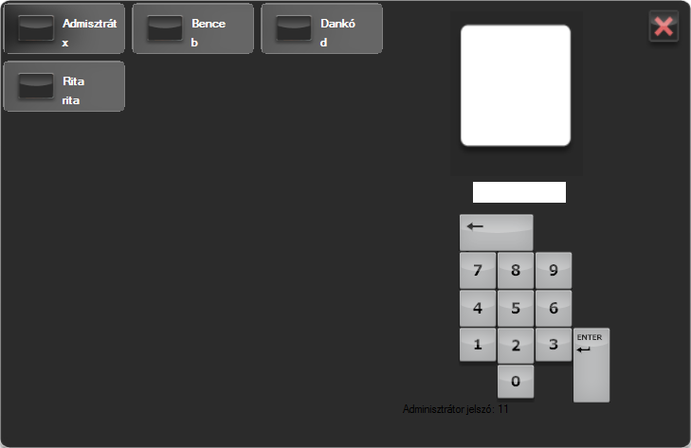

Main window

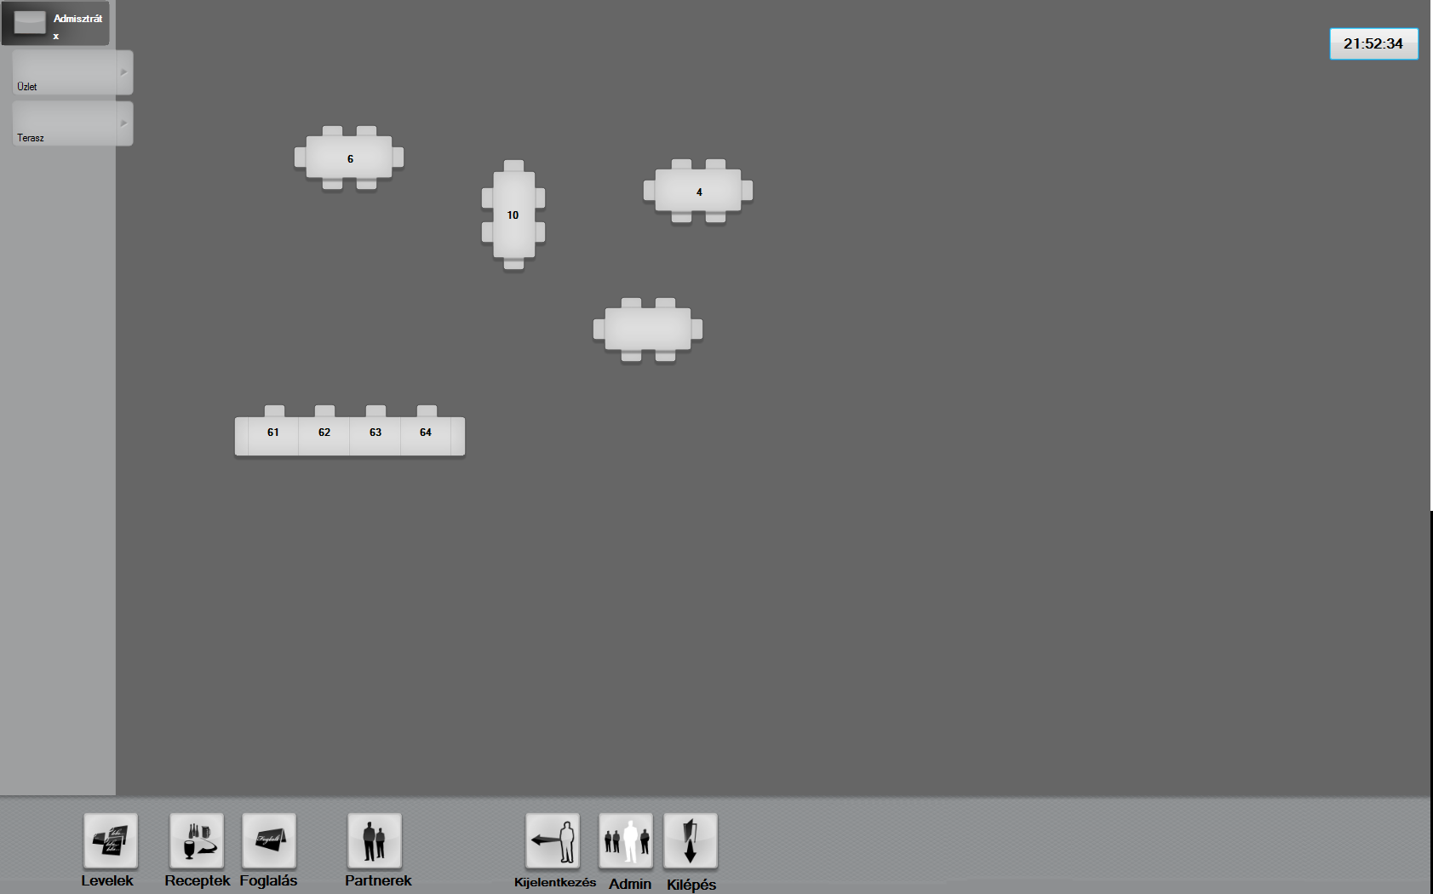

Make order

(by clicking a table)

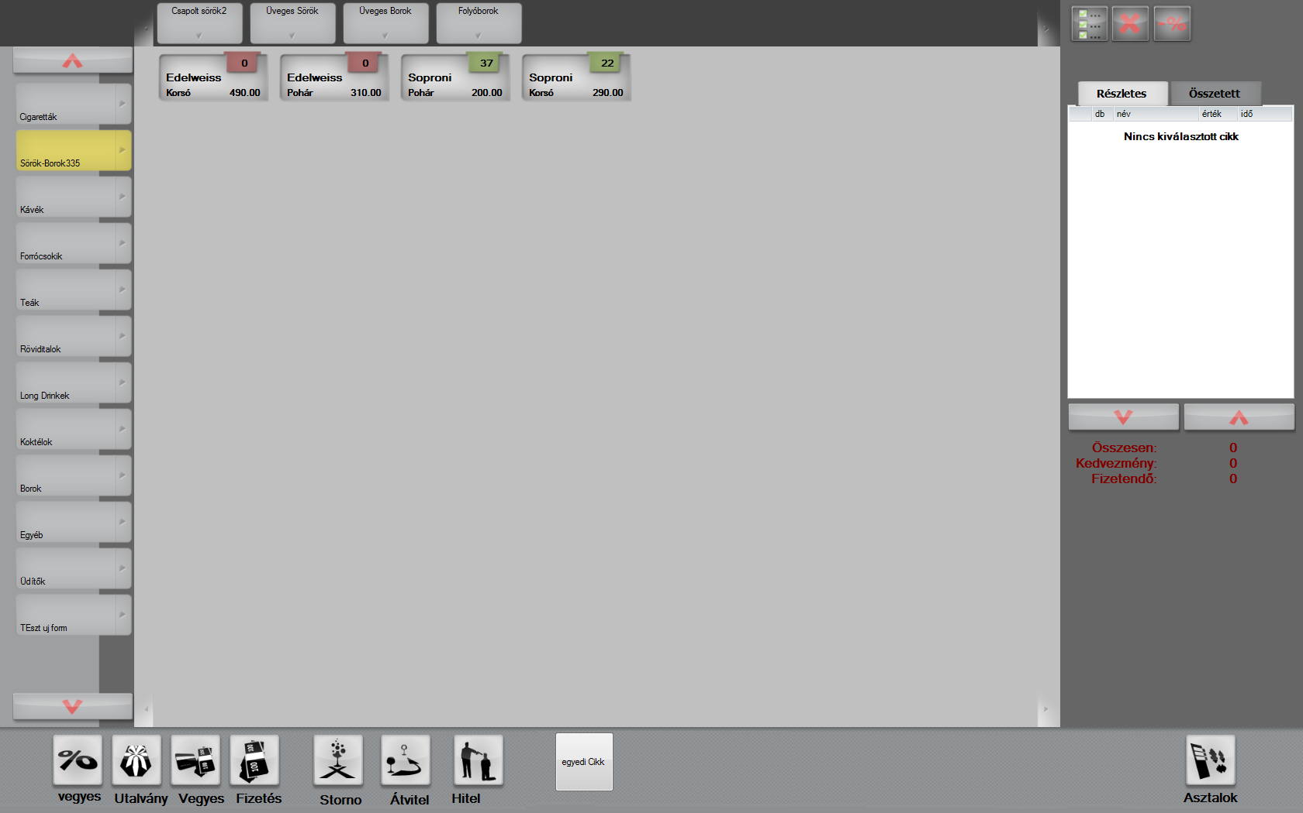

left: product groups

top: subgroups

center: articles

Reservations:

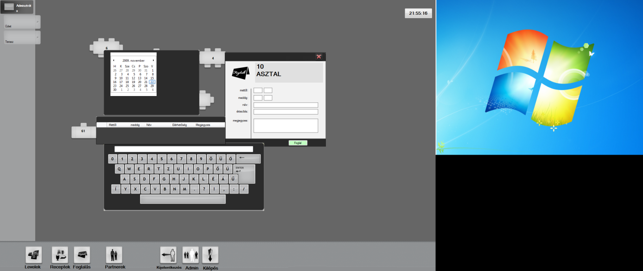

Mixed Products(Receptek Button in the main menu)

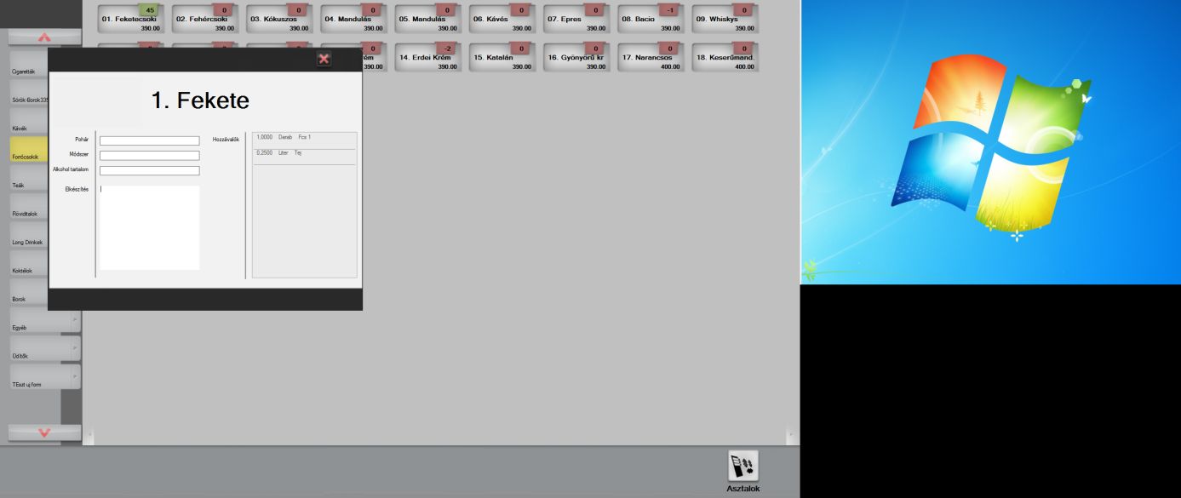

Partners:

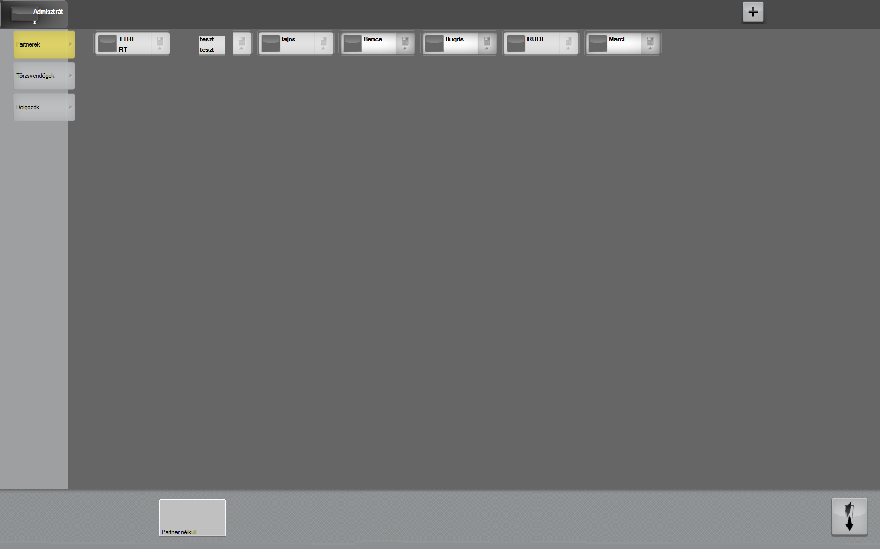

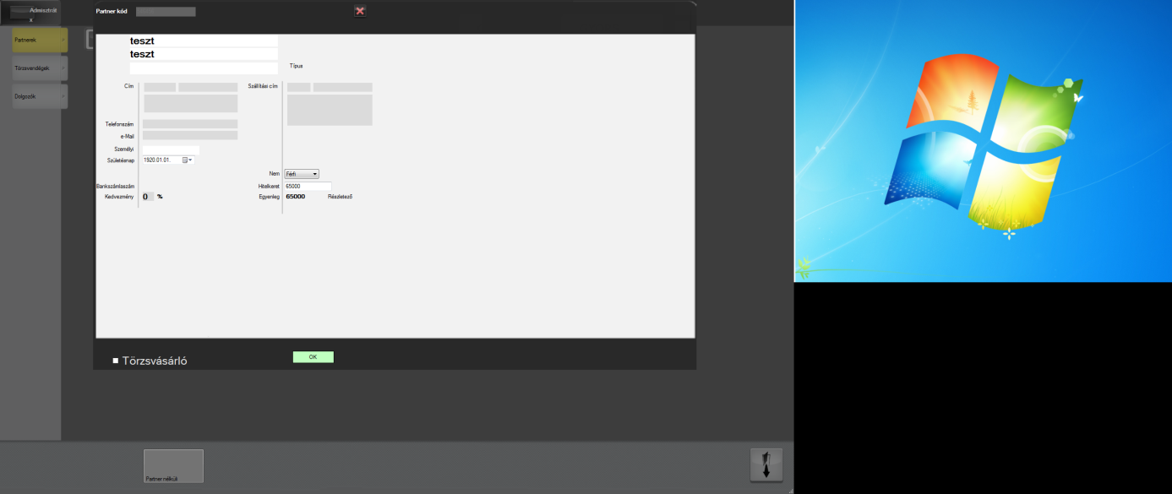

Payment:

print 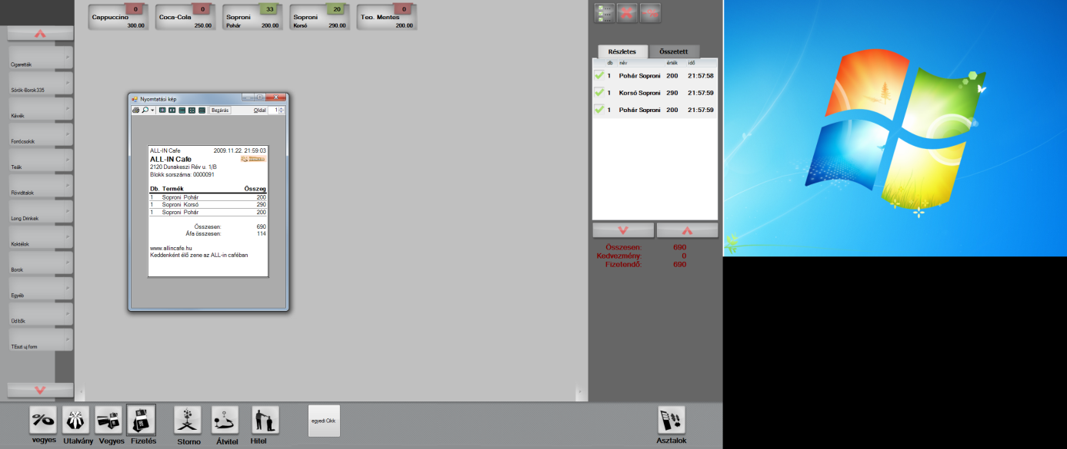

Print Report

Admin Funtionalities:

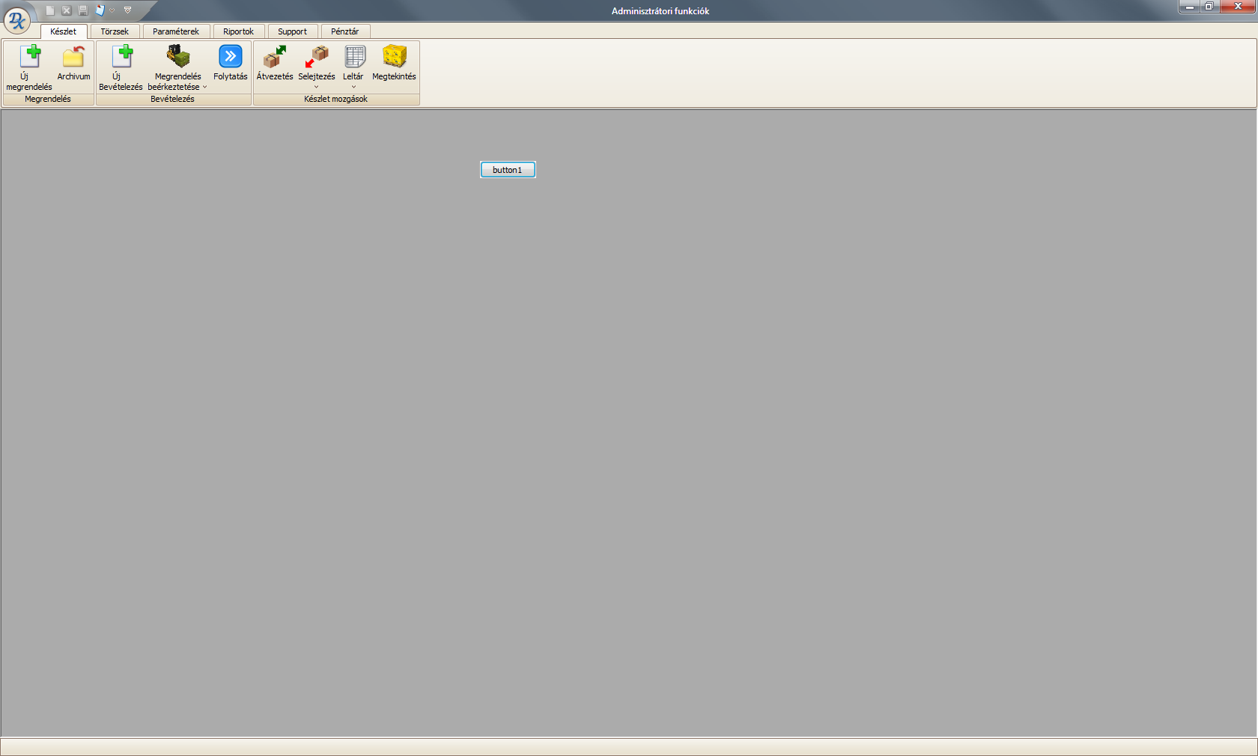

Stock management

Orders

Internal moovements between Stocks.

Masterdata

Settings

etc….

Reporting (I will do the Reports.)