**Front-Side Workflow**

1. **Login Window**

This is the window what comes at first after starting the programm

Touch screen keyborad for password input.

Thios window comes if the timer/screen saver automaticaly log out the user. (system parameter thi time for auto logout)

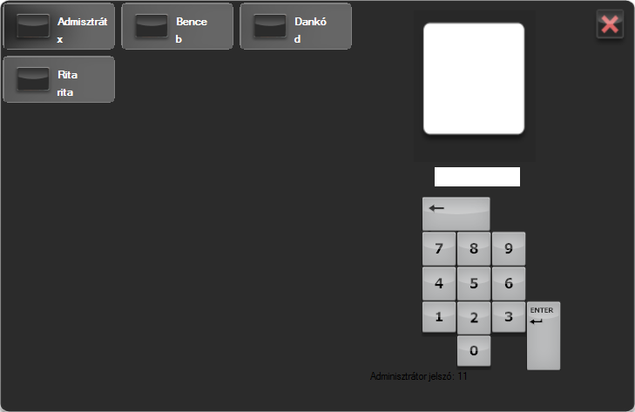

1. **Main window**

This is what is coming after the login

Buttons:

* User button (left up corner): by clicking comes the user change(1) login window
* Left buttons are the places (Rooms) int he Restaurant
* Center Screen: Tables, chairs. They are painted by me and can be stored in a Folder
  + Table colors:
    - red: reserved for the near future (can be set the delay how many times before should be red)
    - yellow: exisiting order at the table
    - grey: free

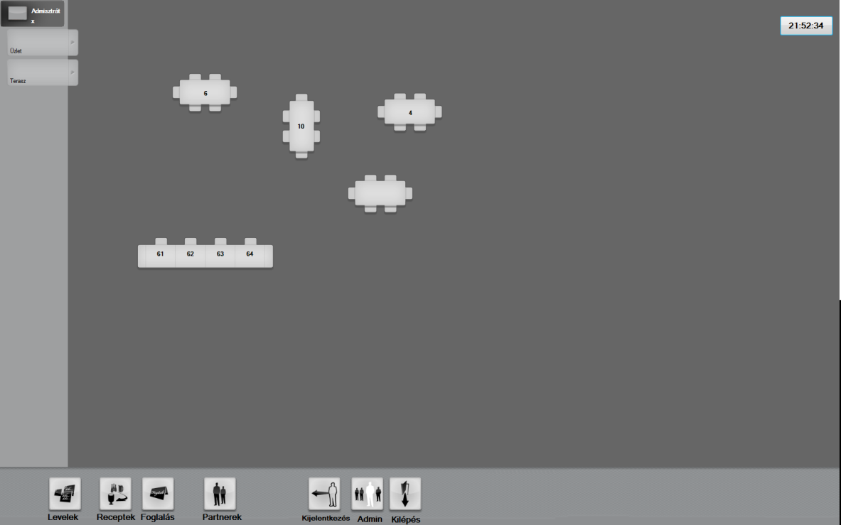

* Buttons Menu bar
  + 1. Internal messages window: Thera can be left „post its” for the other workers or remarks int he restaurand.
  + 2. ”How to Prepare”. a view for multiple products
  + 3. REservations: You click first this button then by clicking a table opens the reservation maker window(4)
  + 4. Partners: Opens the Partner windows, where can be editet and inserted a customer
  + 5. Logout
  + 6. Administrator
  + 7. Exit

By clicking a table opens the Order window (3)

If it is a red (reserved table) should ask that i want to release the reservation or not.

1. **Make order**

(by clicking a table)

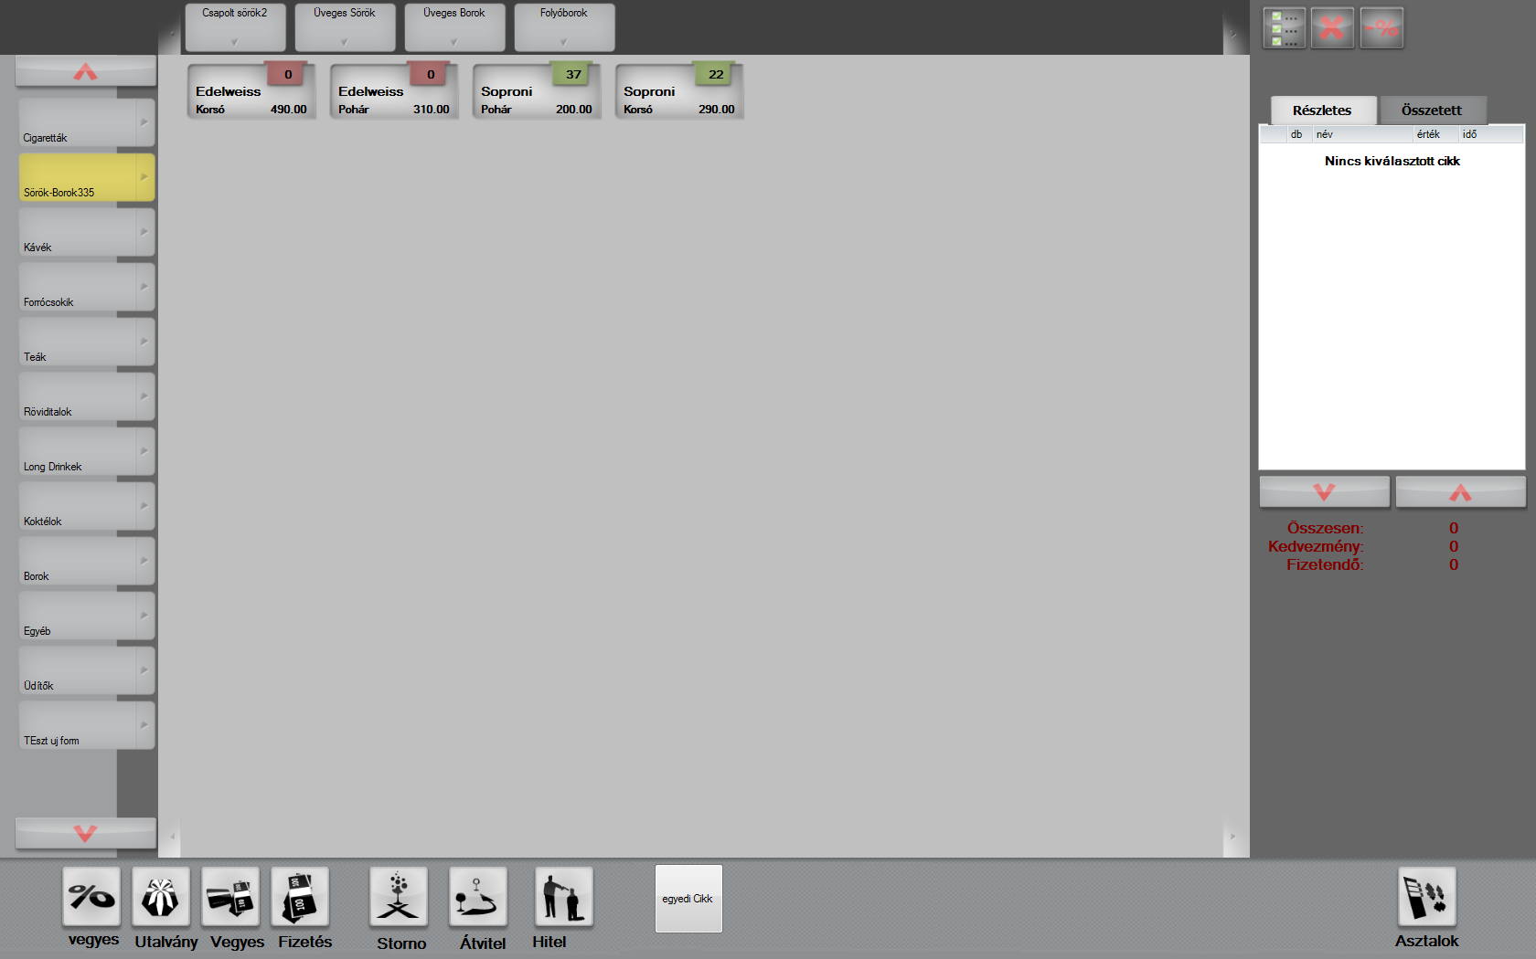

left side buttons: product groups

top buttons: subgroups if exists to the article goup

center: articles (standard and multi part articles)

Buttons:

* right top:
  + select all
  + delete row
  + discount for all or for the selected rows
* ordered grid:
  + 1. detailed
  + 2. summarized
* Article button – Adds to the grid (right) the touched article with Quantity

Article Qountaties can be set int he article master data Example: Vodka 0,3 ccl, 0,2 cc in this situation the Vodka will be schown 2 times int he order maker part, but ONE Article int he background.

* + right corner:
    - red: no Quantity int he default stock
    - green: enough on the main stock
* button under:
  + payment methods: 1-4 : Opens the same Invoice report with a differen parameter
  + 5 Storno. Will everithing book out to a trash stock
  + 6. Moove to an other table
  + 7. Write up to a customer if there are free credit limit for them. (Payment later)
  + 8. create own Article:

similar to the order window, but the articles will be added to a temporary aticle wich has a price. The part articles will be booked out from the stock if the article is ready.

Search functionality

Ready by touching the ready button.

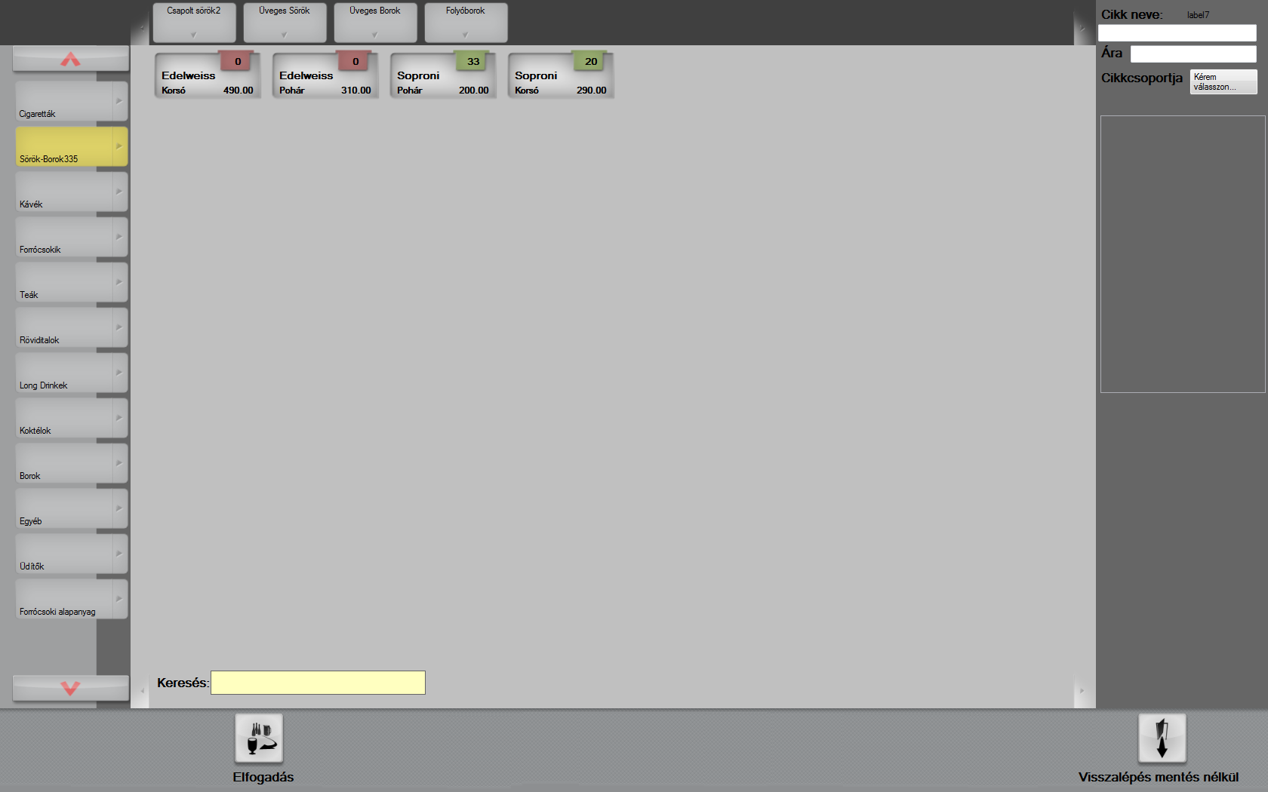

1. **Reservations:**

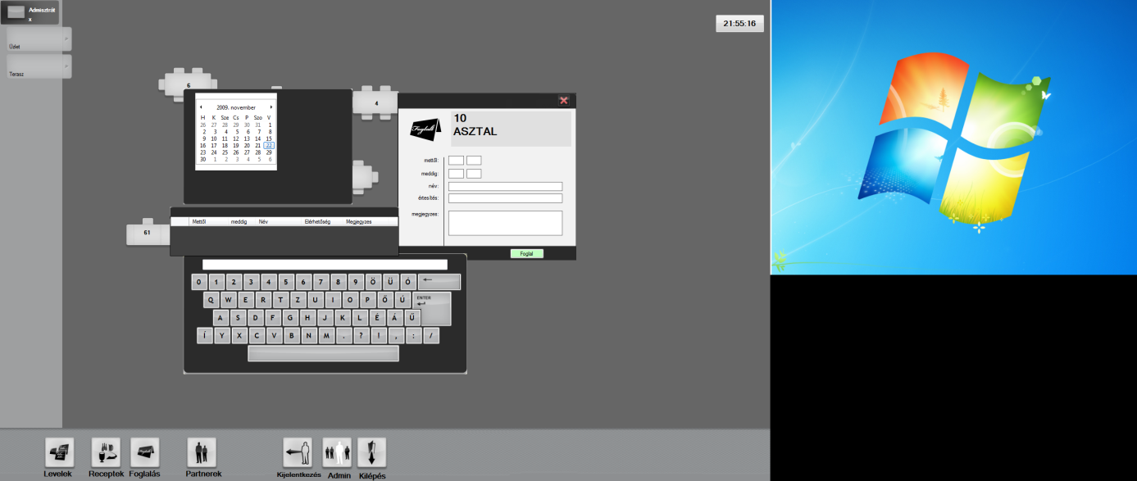

1. **Mixed Products(Receptek Button in the main menu)**

A description from the article master data for information to the mixer.

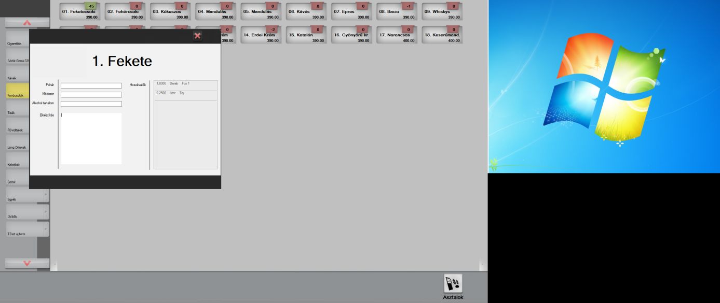

1. **Customers**

Right are the customer groups.

with the „+” button can a new customer added to the system.

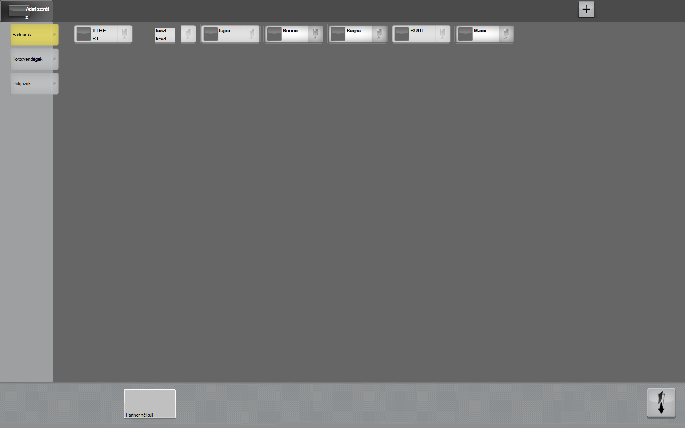

The buttons int he center are the customers to the selected customer groups.

Each partner button has two parts the left side: can edit 🡪 following window, right side you can create an order for the customer (🡪 window 3)

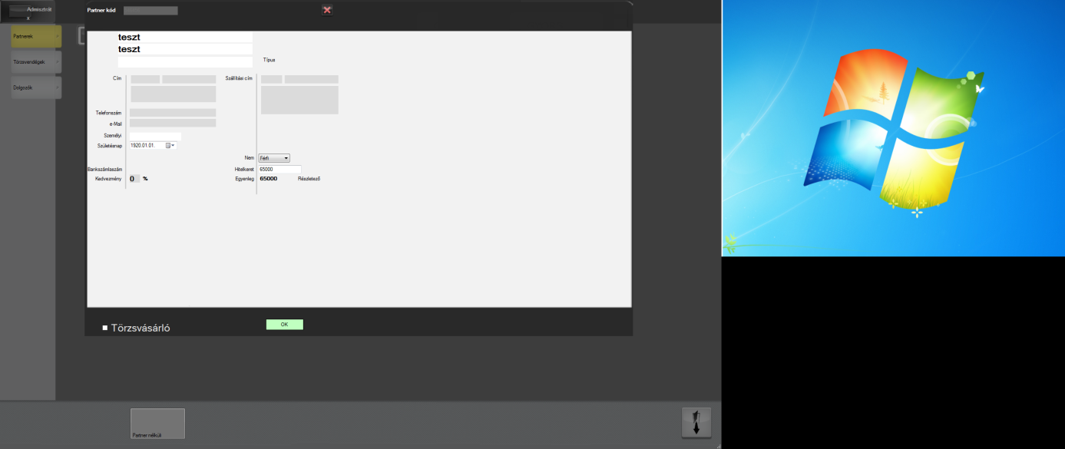

Her can be set the credit limit form them, or see the existing open invoices. By touching the button can be payed the selected invoice:

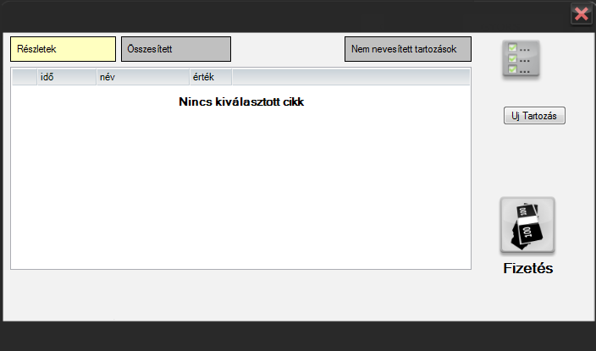

1. **Invoice**

print out an invoice report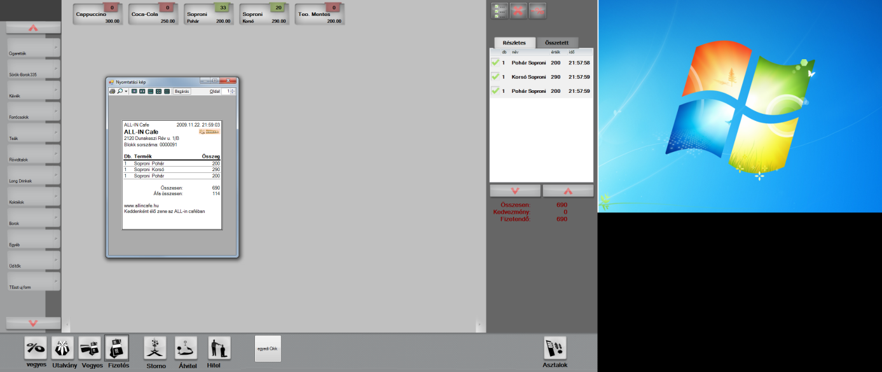

Report can be differ from the window above

**Admin Functionalities**

An example for the administrator part

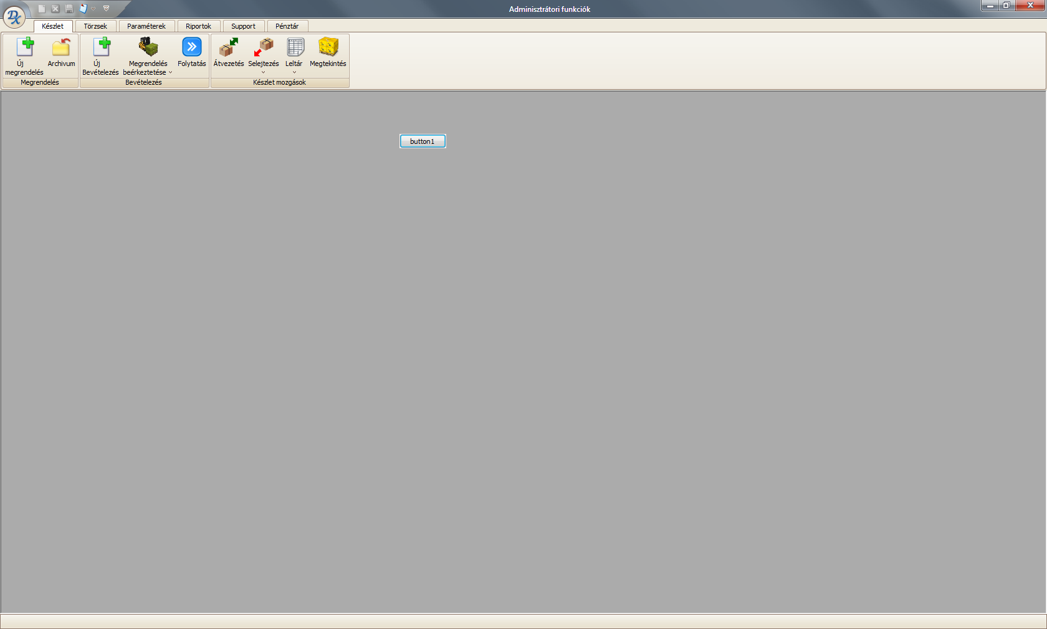

Functions:

* Parameters
* Master data
* Suppliers
* Articles (specification of the input data later…)
* Stock management:
  + buyin
  + move betveen stocks (internal)
  + inventory
  + order suppliers
    - Article can be added to supplieres and back (will automaticaly added if an order is made to an Article and to a suplier and the connection between not exists
    - Order to fill to optimal stock qty.
    - etc…
  + Moove out for internal use
* Users – Rights – Every funtion (touch) must be settable for every user
* Reports (this part can i do…)

Orders

Internal moovements between Stocks.

Masterdata

Settings

etc….

Reporting (I will do the Reports.)