Northern Oil and Gas Well Site Database

Background and Motivation
There is not a unified, publicly available database of operational or legacy oil and gas well sites in Canada’s north. This presents a challenge for local governments, regulators, and academics wishing to understand hazards associated with oil and gas infrastructure. This issue is particularly notable within the Inuvialuit Settlement Region (ISR), which seems to exist within an information “black hole” in regards to well locations, despite decades of oil and gas exploration in the area. While the because the NWT Office of the Regulator of Oil and Gas Operations (OROGO) does maintain the publicly accessible OROGO Well Status database, OROGO does not have jurisdiction over the ISR. The Canadian Energy Regulator has jurisdiction over well site data in the region, however however the majority of wells in the ISR has been excluded from their publicly accessible Basin Database. Here, we present a synthesis of publicly available records to yield the most comprehensive dataset of well sites in Northern Canada.

Data
A description of the source data which were incorporated into this database, described in Table 1, and a map of the well sites available partitioned by which dataset(s) they were sourced from is shown in ?@tbl-Figure1. The OROGO database contributed the largest number of records to the database, followed by the GSC open files and the Arktis report (which had substantial overlap), followed by the Basin database, and then the GeoYukon database. Additionally, the LTLC report provided supplemental information for a number of off-shore wells in the Beaufort Sea, however this report did not contain coordinates so the unique wells (n=2) in this dataset could not be geolocated.
Table 1: Sources used in compiling the databased
Source | Description | Citation
GSC | GSC open files with embedded well site data for the Mackenzie Delta and Beaufort Sea, primarily sourced from the Canadian Energy Regulator and/or Industry | Osadetz et al. (2005); Hu et al. (2013); hu_overpressure_detection_2021_a
OROGO | NWT Office of the Regulator of Oil and Gas Operation (OROGO) maintains a public database of all wells in the NWT outside of the Inuvialuit Settlement Region | OROGO (2026)
Basin | Database maintained by the Canadian Energy Regulator (CER) covering the central and eastern Arctic | Natural Resources Canada (2021)
GeoYukon | Yukon government data portal | Yukon (n.d.)
Arktis | Consultant report for the Inuvialuit Regional Corporation (IRC) with an embedded table of well site data | Van Gulck (2020)
LTLC | Consultant report for Aboriginal Affairs and Northern Development Canada with an embedded table of well site data | Callow (2013)

Table 2: Summary of record counts and record completeness within the database by data source(s). Hyphenated sources indicate records that were present in multiple sources. All records from each source included a name, so that column is not shown here.
Data_Source | n | Lat/Long | Depth | Status | Operator | Spud_Date | Geologic_Formation
OROGO | 682 | 100 | 0 | 100 | 100 | 100 | 0
GSC-Arktis | 171 | 100 | 93 | 100 | 100 | 100 | 97.7
Basin | 148 | 100 | 0 | 100 | 100 | 100 | 95.3
GSC-LTLC | 89 | 100 | 95.5 | 96.6 | 100 | 100 | 94.4
GeoYukon | 73 | 100 | 0 | 100 | 71.2 | 6.8 | 98.6
Basin-Arktis | 31 | 100 | 3.2 | 100 | 100 | 100 | 100
Arktis | 21 | 100 | 23.8 | 95.2 | 100 | 95.2 | 0
GSC | 5 | 100 | 60 | 100 | 60 | 0 | 100
GSC-OROGO | 3 | 100 | 100 | 100 | 100 | 100 | 100
GSC-GeoYukon-Arktis | 3 | 100 | 100 | 100 | 100 | 100 | 100
LTLC | 2 | 0 | 0 | 0 | 100 | 100 | 0
GSC-Arktis-LTLC | 1 | 100 | 100 | 100 | 100 | 100 | 100

import geopandas as gpd
import matplotlib.pyplot as plt
import geodatasets
import contextily as cx
WellSites = gpd.read_file('source_data/wells/NorthernWellSites.geojson').to_crs('EPSG:3978')
# ISR_poly = gpd.read_file('data/Region_inuite_Inuit_Region.shp')
# ISR_poly = ISR_poly.loc[ISR_poly['REGION']=='Inuvialuit'].to_crs('EPSG:3978')
fig,ax=plt.subplots(figsize=(10,10))
for source in WellSites['Data_Source'].unique():
Wp = WellSites.loc[WellSites['Data_Source'] == source].copy()
cax = ax.scatter(Wp.geometry.x,Wp.geometry.y,edgecolor='black',s=50,alpha=0.5,label=source)
offset = 1e5
xmin,xmax,ymin,ymax=WellSites.geometry.x.min()-offset,WellSites.geometry.x.max()+offset,WellSites.geometry.y.min()-offset,WellSites.geometry.y.max()+offset
# ISR_poly.plot(ax=ax,color='None',edgecolor='k')
ax.set_xlim(xmin,xmax)
ax.set_ylim(ymin,ymax)
cx.add_basemap(ax,crs = WellSites.crs , source=cx.providers.Esri.WorldImagery)
ax.set_title("Well Sites in the Northern Canada")
ax.axis('off')
ax.legend('Wells by data source(s)')
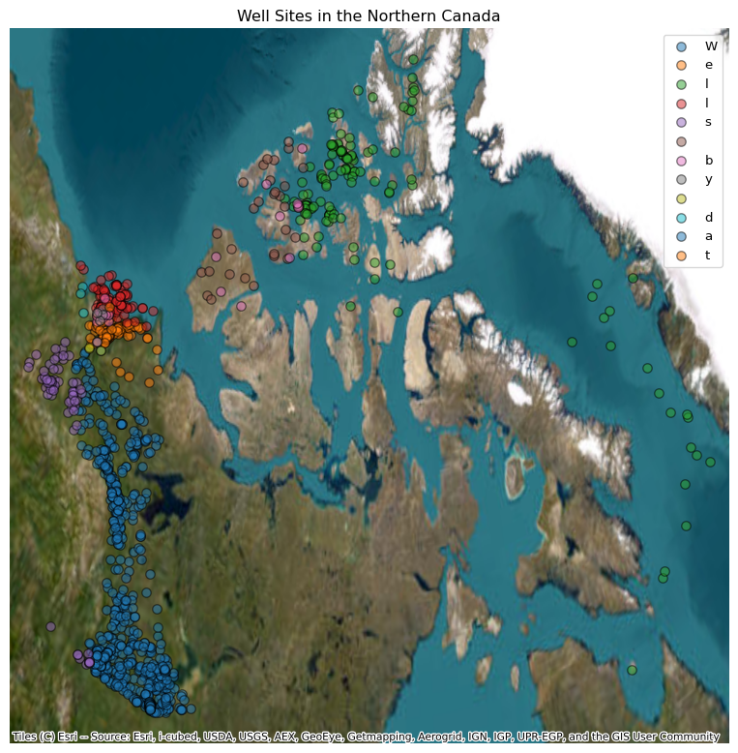
Figure 1: Map of well sites in Canada north of 60 degrees Latitude.
Callow, Lin. 2013. “Oil and Gas Exploration & Development Activity Forecast Canadian Beaufort Sea 2013 – 2028.” LTLC Consulting. https://beaufortrea.ca/working-groups/climate-change/.
Hu, K., D. R. Issler, Z. Chen, and T. A. Brent. 2013. “Permafrost investigation by well logs, and seismic velocity and repeated shallow temperature surveys, Beaufort-Mackenzie Basin,” November. https://ostrnrcan-dostrncan.canada.ca/handle/1845/159674.
Natural Resources Canada, Geological Survey of Canada. 2021. “BASIN contains a wealth of geological, geophysical and engineering information related to many years of petroleum exploration.” October 7, 2021. https://basin.marine-geo.canada.ca/wells/basin.gdr.nrcan.gc.ca.
OROGO. 2026. “OROGO Well Status | Office of the Regulator of Oil and Gas Operations.” April 10, 2026. https://www.orogo.gov.nt.ca/en/orogo-well-status.
Osadetz, Kirk, Jim Dixon, J.R. Dietrich, Lloyd Snowdon, Scott Dallimore, and Jacek Majorowicz. 2005. A Review of Mackenzie Delta-Beaufort Sea Petroleum Province Conventional and Non-Conventional (Gas Hydrate) Petroleum Reserves and Undiscovered Resources: A Contribution to the Resource Assessment of the Proposed Mackenzie Delta-Beaufort Sea Marine Protected Area.
Van Gulck, Jamie. 2020. “Inuvialuit Settlement Region; Drilling Sumps Failure and Climate Change Report.” Arktis Solutions. https://www.google.com/url?sa=t&rct=j&q=&esrc=s&source=web&cd=&cad=rja&uact=8&ved=2ahUKEwiT35ezmLKWAxVyoisGHbwrKCEQFnoECA0QAQ&url=https://irc.inuvialuit.com/wp-content/uploads/2023/10/IRC_Drilling-Sumps-Failure-and-Climate-Change-Report.pdf&usg=AOvVaw0j_-_UcZ_u18z3As721IPS&opi=89978449.
Yukon, Government. n.d. “Geocortex Viewer for HTML5.” Accessed August 24, 2026. https://mapservices.gov.yk.ca/GeoYukon/index.html?layerTheme=9.

