1) docker-compose up –d

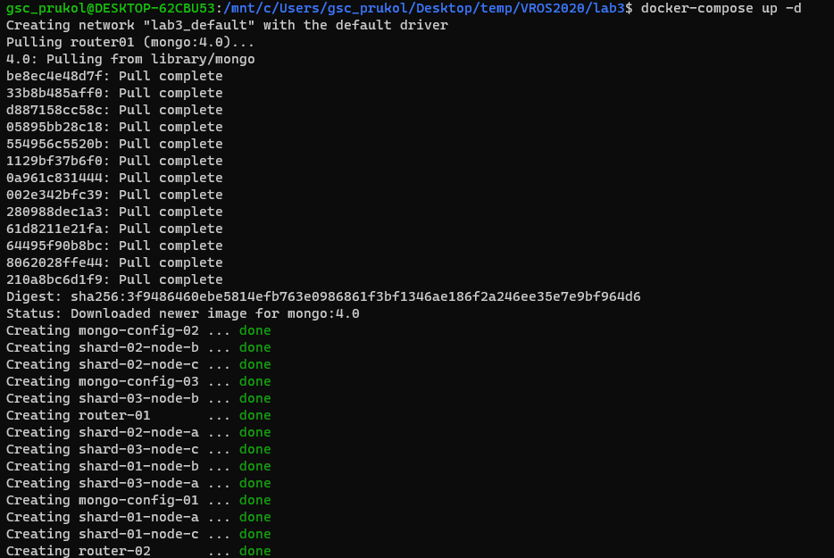

2) sudo sh init_rs.sh

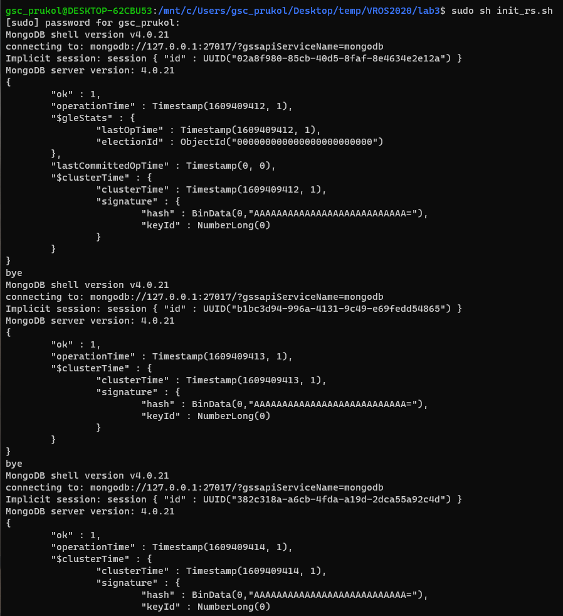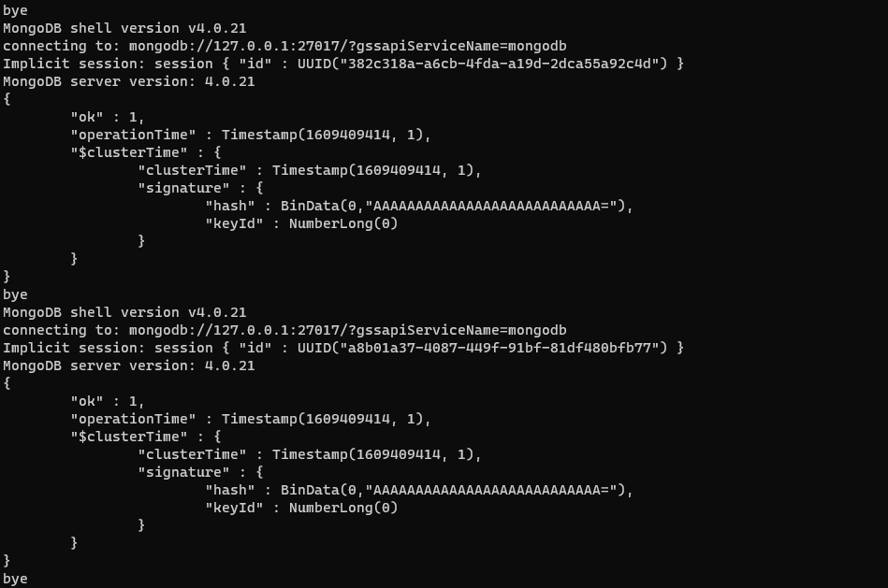

3) docker-compose exec router01 sh -c “mongo < .scripts/init-router.js”

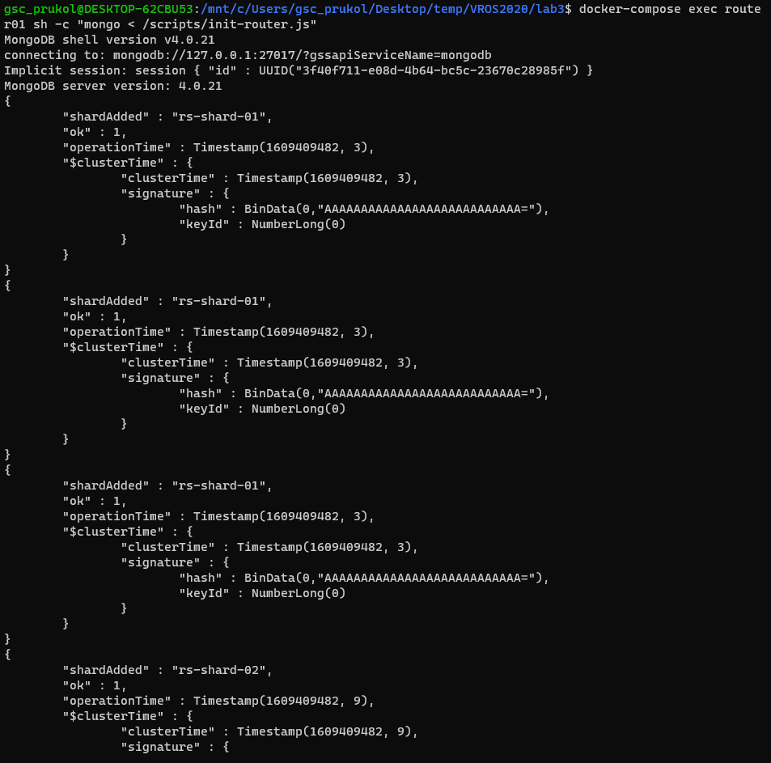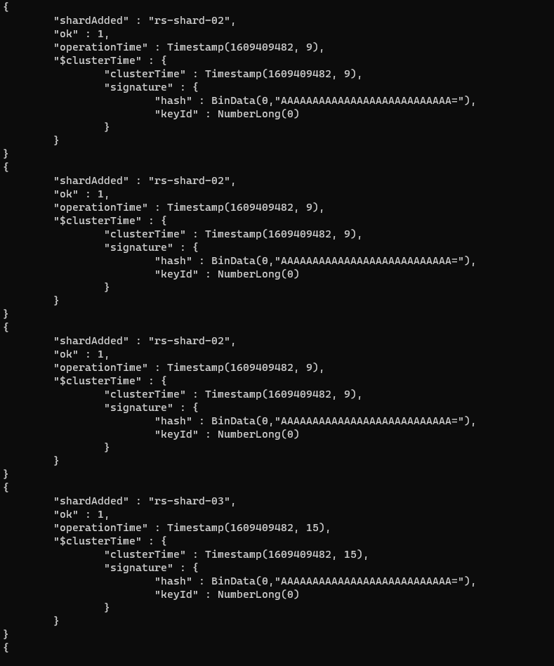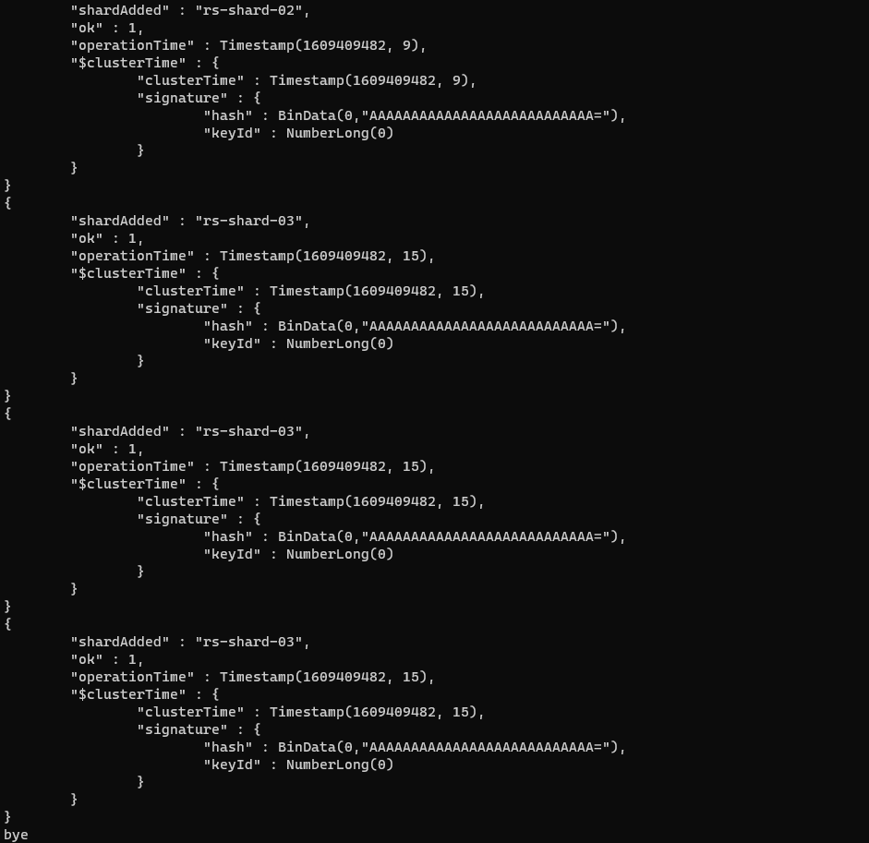

4) generate rides data using London_postcodes.csv

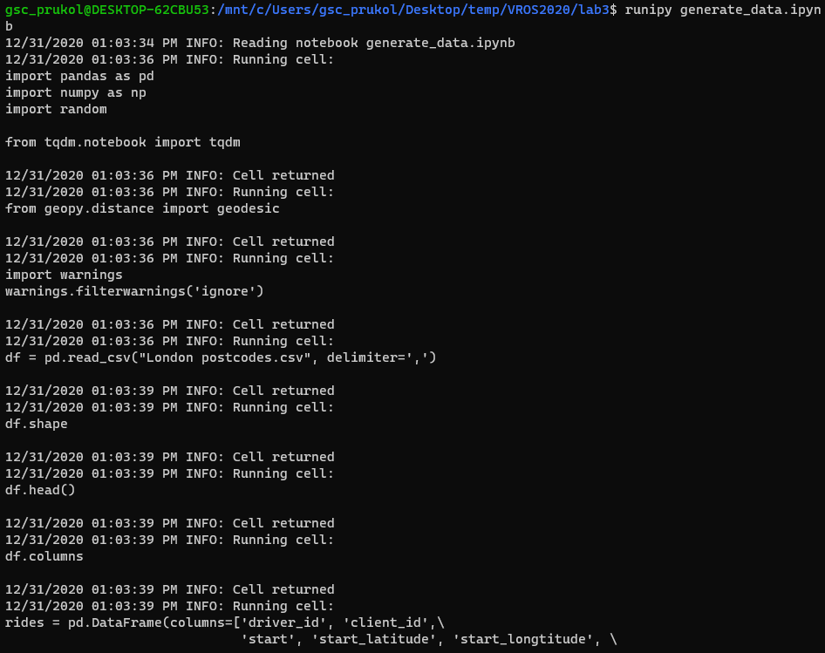

***



5) sudo sh import_and_query_data.sh

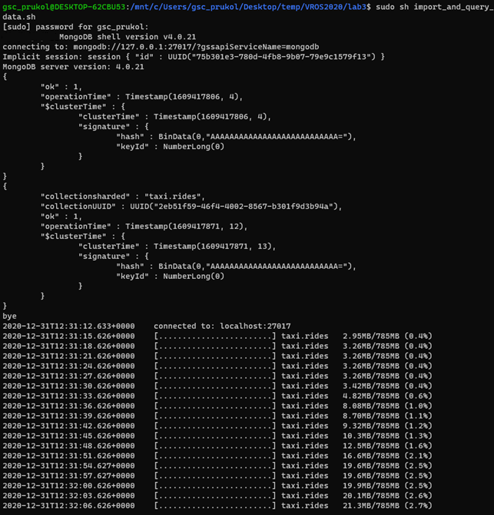

***

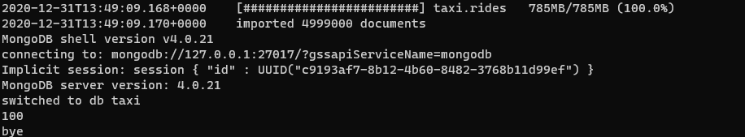

6) docker-compose down -v --rmi all --remove-orphans

