[19sp]:

* (Placeholder for todos added from Slack)

-- 17fa --

* ~~[DF]: MAJOR THING--fix auto-tests for contains~~
* 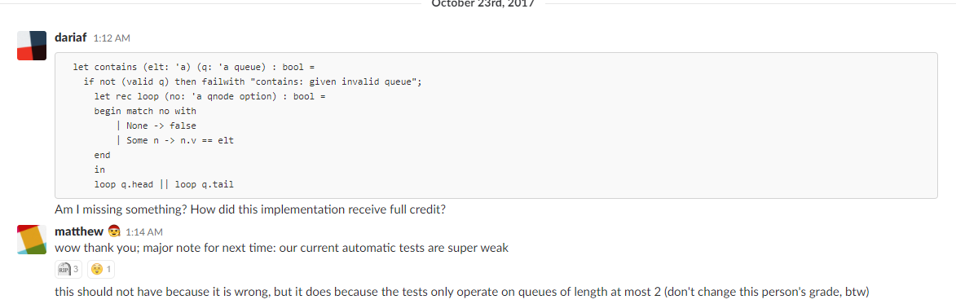
* [MC]: check all the other auto-tests too

-- various semesters --

**HW4 -**

* ~~Include in instructions for delete_first/delete_last/delete that if element is not present data structure should stay the same as before~~
* ~~JC: We need to clarify in the instructions what list library functions they are allowed to use and where they are allowed to use it.~~
* ~~Queues: “continue the story” about interfaces and abstraction from hw03, queue and deque - explore this, making it more explicitly the same format as hw03~~
  + ~~DONE (feb 2017 thanks to MC.) -BH~~
* ~~Referential equality vs structural equality- why do we use referential for truncate (queues), but structural for delete_first/last? Give a good explanation and/or change, and potentially tell them explicitly which one to use for delete_first/last. -BH~~
* ~~(MC) pretty sure this `contains` got full points for `contains` tests, let's change the tests to check for elements out-of-order and/or let's ensure the queue isn't mutated after calling contains~~
  + 