Free University of Bozen - Bolzano
Universitätsplatz 1 - piazza Università
I - 39100 Bozen - Bolzano

First name: Gregory
Last name: Scontras
○ male  female
Address: 108 Gabrielino Dr.
Postcode & city: Irvine, CA, 92612, USA
E-Mail address: gscontras@gmail.com
Date & place of birth: 18 July 1986, USA
Social Security Number / codice fiscale:

Reimbursement for travel, board and lodging based on documented expenses

Assignment: Lecturer at ESSLLI 2016
Faculty: Computer Science |  | Period: 15.-26.08.2016
Letter of assignment of: 01.08.2016 |  | Prot. no.: 3573

Travel expenses: | €
a) Car (please use form on page 2 for detailed description)
b) Flight | 846.91  (951.16 USD)
c) Train
d) Bus
e) Other 1 (please specify)
f) Other 2 (please specify)
TOTAL TRAVEL EXPENSES | 846.91

Housing from _14_ to _29_ August: | €
Price per night | 93.49  (105 USD)
Number of nights | 15
TOTAL HOUSING EXPENSES | 1515.79  (1694 USD)

TOTAL EXPENSES TO BE REIMBURSED (Travel + Housing): | 2362.70 €

Revenue stamp duty will be applied virtually according to the authorization from the local tax agency, protocol number 2010/50577 from May 31st 2010.

I declare, that the mentioned activity is subject to special regulations as of art. 67, c. 1, lett. l) of D.P.R. 917/1986 and therefore is VAT-exempt in conformity with art. 5 of D.P.R. 633/72.

Amount payable to:
Bank account holder | Gregory Scontras
Name of the Bank | Bank of America
IBAN
SWIFT/BIC
Other

_______7 September 2016________ ________________________________
Date Signature

List of travels by car
Please note: refund is Euro 0,30.- per kilometer for a maximum of 300 kilometers for the outward journey and 300 kilometers for the return journey

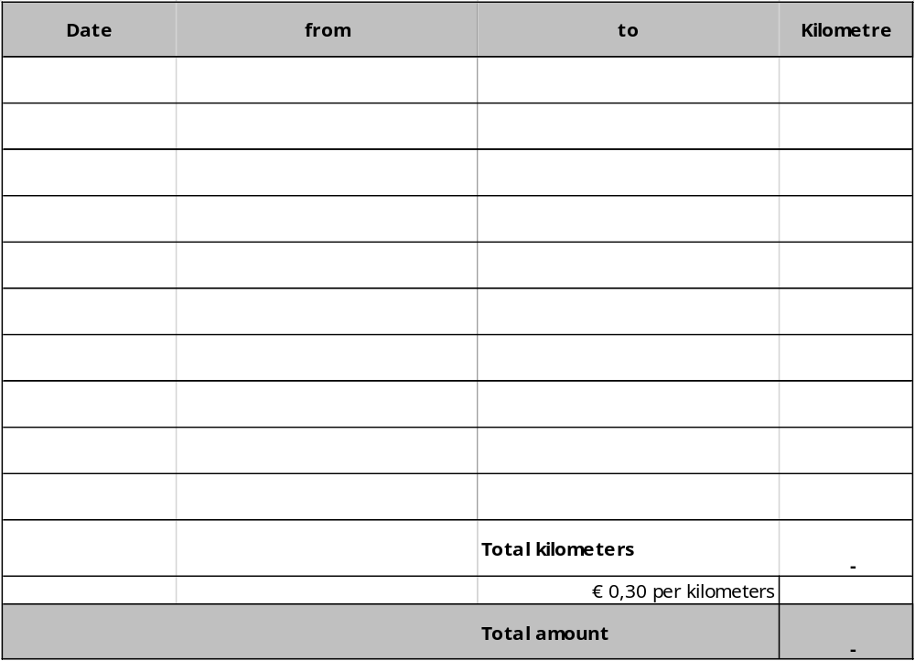

Date Signature

